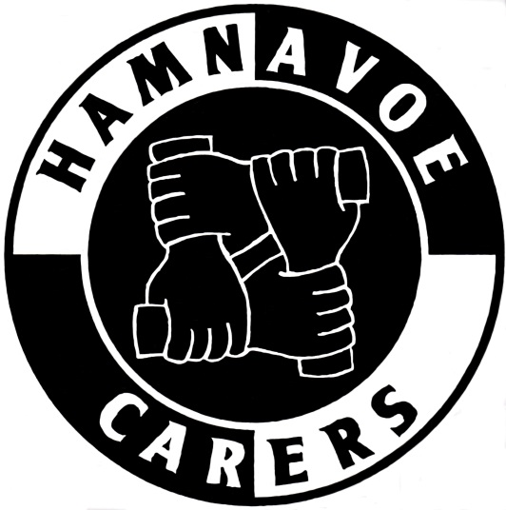
HAMNAVOE CARERS – STROMNESS
Chair Annual Report 2025

The work of the Hamnavoe Carers continued throughout 2025 and it remains well supported by the customers and the community.

Committee members continue to do a wonderful job in running and catering the monthly whist drives which continue to prove popular. They are a good opportunity to contribute social activity to the community. The drivers work hard to make things easy for their passengers and the shopping trips also add a social perspective to folks’ lives.

The summer trips this year were to the Dashing Deer restaurant in Deerness for lunch and to the Dounby Show.

The December Christmas dinner held in the Golf Club was, yet again, very well received - despite bringing in a new caterer. It was well attended and much appreciated. I also welcome it as a way of thanking the committee and the drivers for their work throughout the year. A free meal is a small token.

During the year, an opportunity arose for the funding of a new electric bus. At an initial meeting of committee members (when the offer to apply for funding was first received), it was agreed to apply for the funding and, if we were successful, to decide then if we were in favour of the switch to electric. This first decision was in the light of a number of significant reservations on behalf of some committee members. The application was successful and, at a subsequent meeting (and after canvassing the drivers), a very extensive discussion took place about whether or not an electric bus was our way forward.
The present bus was 6 years old with low mileage. The option of managing two buses was considered, as were the issues of maintenance and warranty difficulties, the limited experience with electric buses – both by local garage mechanics and by drivers – and the perceived issues of safety, battery disposal and costs. In principle, no one was seriously against the idea but, with the technology, local expertise and maintenance of electric buses seen as being in its infancy, the final vote decided that we would not pursue this idea at this time.

Our finances remain in a healthy state with local organisations, including the Ladies Darts, Lodge Mercantile, the British Legion, the Peedie Kirk, Orkney Renewables and the Ladies Golf making donations over the year. Our particular thanks go to the Co-op for their grant of £7868 and to Teesh for making the application to them. There have been no significant expenses this year but we tested a market, asking a new broker to quote for one insurance policy but they could not better the quote we had been given, so we remain with Nord Dallas as our insurance broker.

My thanks will always go to the committee of the Hamnavoe Carers and to the drivers of the bus. All that they contribute to our community cannot be underestimated,

To our great regret, Frazer has decided to stand down from his work with the organisation, both as Transport Convenor and a committee member. He will be very much missed. I personally want to thank him for all the help and support he has given me, and the work of the Carers, over the years and I don’t doubt the other committee members feel the same.

Sally Bartkowiak
Chair
January 2026

