GLASGOW SENIOR CITIZENS ORCHESTRA
Annual Report for OSCR 2025-26
The Glasgow Senior Citizens Orchestra was founded in 1963 to provide an opportunity for older people to play music together and to provide entertainment for community groups of the elderly, based on the recognition that involvement in live music is beneficial to mental health and wellbeing. It has maintained this focus throughout its existence and in 2025 became a registered charity. It plays mainly light classical music as well as music from shows and films and arrangements of popular music. Weekly rehearsals are held, in recent years in Knightswood Community Centre, from September to May and are open to the public. Up to a dozen performances are given each year, some by invitation to community groups of senior citizens, and others open to the public. All performances are free to attend and take place on weekdays during the day to ease attendance for the elderly.
In recent years, opportunities to provide entertainment for community groups by invitation has diminished as the number of such groups has fallen and the orchestra has grown in membership (60-70 playing members) to the extent that fewer groups can provide suitable accommodation. The focus has now shifted to inviting community groups to attend concerts in larger venues. This has proved successful as these events have often been oversubscribed. A particularly successful concert was held in December 2025, in a collaboration with the Glasgow Singergie Community Choir. The New Auditorium in Glasgow’s Royal Concert Hall was hired (with partial funding assistance from Age Scotland), and several community groups for the elderly throughout Glasgow were invited. The concert celebrated Christmas and Glasgow’s 850th anniversary. The 380 available seats were oversubscribed and the reaction of all who attended was overwhelmingly positive, both for the free live musical entertainment, and the opportunity for a sociable group outing.

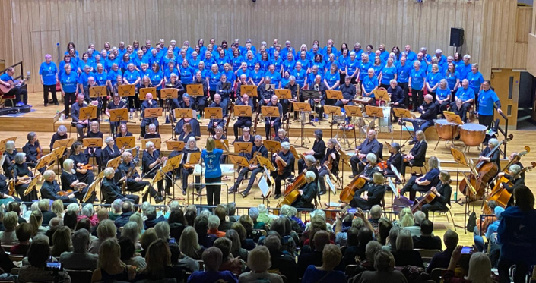
Christmas concert by GSCO with the Singergie Choir in the New Auditorium of Glasgow’s Royal Concert Hall
In addition to that gala concert, three concerts were given to community groups for the elderly at locations in the Glasgow area, including at the David Cargill day care centre run by Glasgow’s Golden Generation. Another oversubscribed concert was held at Knightswood Community Centre, and, in a new departure for the orchestra, we were invited to give a concert at a local school to promote inter-generational activity and to encourage musical development. The season concluded with our regular annual concert held in Glasgow’s City Chambers at the invitation of the Lord Provost. Over 300 elderly people from a range of community groups throughout Glasgow and beyond attended.
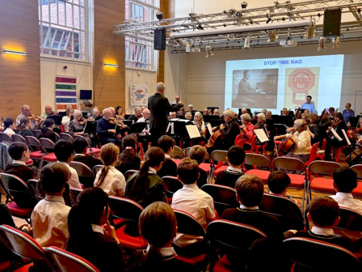
Bridging the generation gap with a concert at a school (a new venture in 2025-26)

These concerts provided free entertainment in a social setting for approximately 1,100 people, the great majority elderly. For many this is their only opportunity to experience live music making.

The orchestra itself is a mutually supportive community, particularly for some of the more vulnerable members. For many players, the rehearsal is the highlight of their week. Two quotes from members illustrate this:
“Many thanks for a wonderful year of music and fun! We have both thoroughly enjoyed being members of GSCO and playing such creative programmes of lovely music to appreciative audiences who might otherwise be unable to access concerts.”

“Joining GSCO has been a wonderful opportunity for him, the first time he has felt able to play his violin with others since the pandemic put him right off orchestras. Thank you to everyone for being so welcoming and patient with him - we really appreciate your kindness.”
Some sample quotes from audiences:
“Many thanks for the tickets for the fantastic musical afternoon. My friends and I had never been in this hall before, but it added so much to the incredible performance. We have been to the Community Centre several times to hear the Orchestra but the difference in hearing them in this lovely hall was just amazing. A wonderful time was had by all, and we look forward to more performances to uplift us like this again.
Many thanks again for letting us enjoy this afternoon of wonderful sounds.”

“The concert today was amazing! All my friends loved it and joined in with the singing. Orchestra and choir were superb, and we look forward to next year.”

“Myself and friends are so thankful for the tickets to the wonderful performance in the City Chambers last week.”

“ thanks for the tickets, all my friends loved the concert, looking forward to next year.”
“Thank you very much for the visit from all of the orchestra. The service users here had a fantastic day. Many thanks (David Cargill)”.

A comment from a guest player at the concert in the City Chambers:

“I thought it was a lovely event, and it was really interesting to hear the Lord Provost speak about what a great institution the GCSO is.”

And comments from members of the Glasgow Singergie Community Choir:

“Just wanted to say a massive thank you again for giving Singergie such an amazing experience yesterday!”

“It was a real privilege to work with you and sing with the orchestra in that incredible venue. The audience definitely loved it, and we all had a great time despite the logistics!”

