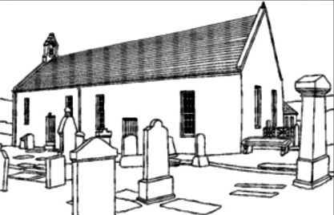
THE FRIENDS OF ST CALLAN’S
Trustees Annual Report 2025
The Friends of St Callan’s is a Scottish Charitable Incorporated Organisation (SCIO) regulated by the Office of the Scottish Charity Regulator (OSCR)- SCO53850.
The Friends of St Callan’s (FOSC) purpose is the advancement of education, culture and heritage. This will be achieved by using and maintaining the building as a key community asset.
FOSC was formed in late 2024 when the Church of Scotland announced that the building was to close. FOSC has spent the year negotiating the purchase of the church from its owners. We have also been assuring the transfer of a legacy bequeathed for the express purpose for the upkeep of St Callan’s. We have had regular contact with principal funder Gordonbush Community Fund to prepare a funding application for the purchase.
FOSC will ensure the building is available for community and educational events, and also for funerals, both religious and secular. The cemetery around the church will continue to remain in the ownership of The Highland Council.
Full membership is open to all residents of the parish of Rogart and is free. We finished the year with 42 members, plus 9 associate members from outwith Rogart.
During the year in conjunction with Rogart Heritage Society we stored and began documenting the John Macdonald local history archive which is stored in the building.
The local primary school continues to identify the building as a safe haven in the event of terrorist attack or similar event.
We received donations from three sources in the year: a collection at a funeral and donations for teas served at two community events.
We also had a building condition report completed pro bono by a local contractor.
Frank Roach Chair Friends of St Callan’s 18 March 2026

