FOOL ON TRUSTEES’ ANNUAL REPORT
AND ACCOUNTS FOR THE YEAR ENDED
30 NOVEMBER 2025

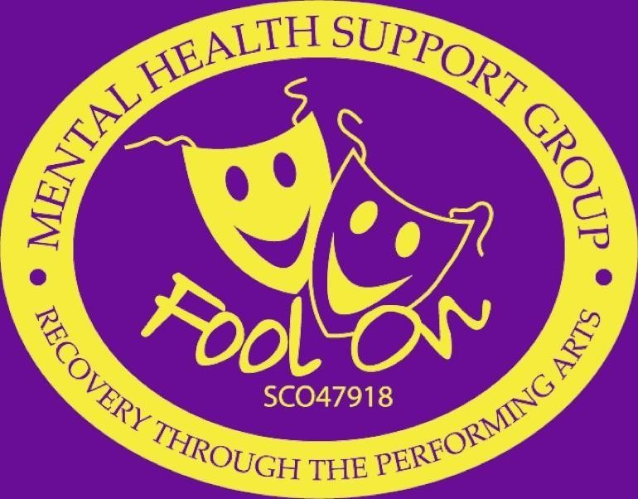

TRUSTEES REPORT YEAR ENDING 30.11.2025

Fool On is a charity operating in the North Lanarkshire community and our studio in Coatbridge offering free performing arts sessions to those aged 16 and over to encourage creativity to boost self-esteem and confidence and build up resilience while recovering from mental health illness.
Throughout the year, we delivered free weekly performing arts workshops in Wishaw, Bellshill, Cumbernauld and Motherwell. These sessions have supported individuals in recovery by helping them rebuild confidence, form social connections and regain a sense of purpose.
Our programme includes comedy, creative writing, guitar tutoring, karaoke, songwriting and keyboard workshops, offering members a broad range of creative opportunities.
In Bellshill, our dedicated comedy group continues to run every Tuesday evening, led by professional comedian Raymond Mearns. This group remains one of our most established and wellattended sessions. We also operate a weekly guitar tutoring group, supporting members to develop their musical skills in a structured and accessible way.
Members from our main groups and from the comedy programme achieved significant milestones this year, performing at both the Glasgow Comedy Festival and the Edinburgh Fringe. These opportunities highlight the progress made by individuals who have developed their confidence through participation in Fool On’s activities.
The charity continues to hold regular performance events where members can showcase singing, poetry, comedy and acoustic sets to peers, family and friends. These events form an important part of our recovery-based approach, offering encouragement, achievement and positive reinforcement.
We have continued to operate our Coatbridge studio, which provides two rehearsal and recording rooms. The studio is used for practice, collaboration and the recording of original music, and remains a central resource for members seeking structured creative progression.
In addition to our weekly sessions, Fool On has maintained regular outreach performances in NHS mental health wards and care homes across Lanarkshire, providing live music, entertainment and social interaction for individuals who may not otherwise access the arts.
Fool On remains committed to supporting people in recovery by using the performing arts to promote connection, self-expression and improved mental wellbeing.

FOOL ON SCOTTISH CHARITY NUMBER SC047918 TRUSTEES’ ANNUAL REPORT AND ACCOUNTS FOR THE YEAR ENDED 30 NOVEMBER 2025

GOVERNING DOCUMENT Fool On is a SCIO (Scottish Charitable Incorporated
Organisation) governed by its constitution, dated (10.11.17)

MEMBERSHIP AND MANAGEMENT The business of the group is directed by a management committee comprising between 3 and 10 members, appointed by the members at the Annual General Meeting to serve for one year, all being eligible for re-election. The committee meets not less than 10 times a year. A chairperson, secretary and treasurer are appointed by the management committee.

CURRENT The business of the group is directed by a management committee comprising between 3 and 10 members, appointed by the members at the Annual General Meeting to serve for one year, all being eligible for re-election. The committee meets not less than 4 times a year.

A chairperson, secretary and treasurer are appointed by the management committee; no person may hold any office for more than 3 years. The management committee may co-opt up to 3 further members, where deemed necessary, to serve until the following AGM.

Those currently serving as members of the management committee are:-

Name | Position | Start Date | End Date
Stuart Doig | Chairperson | July 2015
James Cowan | Vice Chairperson | September 2017
Robert Gilles | Treasurer | August 2024
Elle Stevley | Secretary | March 2024

CONTACT ADDRESS:

Block 10 Unit 2, Dundyvan Industrial Estate, ML5 4AQ

CHARITABLE PURPOSES The organisation is established for charitable purposes only, and in particular, the objects are; to relieve need of those suffering from distress and anxiety of living with mental health issues, improving confidence, self-esteem and wellbeing for all through the performing arts in comedy, singing, music and writing.

FOOL ON SCOTTISH CHARITY NUMBER SC047918 TRUSTEES’ ANNUAL REPORT AND ACCOUNTS FOR THE YEAR ENDED 30 NOVEMBER 2025

FINANCE

Income for the year was £40,396 (£71,886 2023-2024). Restricted grant income was £30,835 and Unrestricted grant income was £9,561. All income is detailed in the notes. Expenditure for the year was £63,473 (£58,553 2023-2024) Restricted expenditure £47,275 Unrestricted expenditure £16,198. All expenditure is detailed in the notes.

The above activity generated a Deficit of £22,858 (Surplus £13,333 2023-2024) Restricted deficit £16,440 and Unrestricted surplus of £6,418. Total reserves carried forward to 01.12.25 are £23,087. Restricted reserves are at £8,551 and unrestricted reserves are at £14,536.

RESERVES POLICY The Trustee’s policy is to maintain reserves of around £10,000 this is 3 months of normal running costs in order to meet commitments for staff costs and office lease and cover any unexpected expenditure. The charity has met this for overall reserves but not for unrestricted reserves.

Signed on behalf of the board of trustees

NAME

DATE

FOOL ON SCOTTISH CHARITY NUMBER SC047918 TRUSTEES’ ANNUAL REPORT AND ACCOUNTS FOR THE YEAR ENDED 30 NOVEMBER 2025

2025 2025 2025 2024
 |  | Unrestricted Funds (£) | Restricted  Funds (£) | Total £ | Total £
RECEIPTS | Notes
Grant Income | (4) | 4,650 | 30,835 | 35,485 | 65,537
Donations | (5) | 500 |  | 500 | 1,280
Fundraising | (6) | 4,411 |  | 4,411 | 5,069
Income Charitable Act. (7)  TOTAL |  | 9,561 | 30,835 | 40,396 | 71,886
PAYMENTS  Charitable Activities (8) |  | 15,979 | 47,275 | 63,254 | 58,553
Fundraising  TOTAL |  |  |  | 63,254 | 58,553
SURPLUS OR DEFICIT |  | (6,418) | (16,440) | (22,858) | 13,333

FOOL ON SCOTTISH CHARITY NUMBER SC047918 TRUSTEES’ ANNUAL REPORT AND ACCOUNTS FOR THE YEAR ENDED 30 NOVEMBER 2025

STATEMENT OF BALANCES AT 30.11.2025

CASH AT BANK AND IN HAND

2025  Unrestricted  Funds (£) | 2025  Restricted  Funds (£) | 2025  Total £ | 2024  Total £

Opening Balances 20,954 24,991 45,945 32,612 Surplus Deficit for Year

(6,418) (16,440) (22,858) 13,333
CLOSING BALANCES  (30.11.2025) | 14,536 | 8,551 | 23,087 | 45,945
REPRESENTED BY | 2025  Unrestricted  Funds (£) | 2025  Restricted  Funds (£) | 2025  Total £ | 2024  Total
Bank | 14,097 | 3,392 | 17,489 | 40,566
Cash | 219 |  | 219 | 219
CLOSING BALANCES (30.11.2025) | 14,288 | 3,392 | 17,708 | 40,785

Restricted Funds Breakdown 30.11.20 | 24 |  | 2025 |  | 2024
 |  |  | £ |  | £
National Lottery |  |  | 30,835 |  | 15,487
Robertson Trust |  |  |  |  | 11,550
 |  | 30,835 |  |  | 27,037

FOOL ON SCOTTISH CHARITY NUMBER SC047918 TRUSTEES’ ANNUAL REPORT AND ACCOUNTS FOR THE YEAR ENDED 30 NOVEMBER 2025

1. BASIS OF ACCOUNTING

These accounts have been prepared on the receipts and Payments Basis in accordance with the charities and Trustee investment (Scotland) Act 2005 and the Charities Accounts (Scotland), Regulations 2006 (as amended)

2. NATURE AND PURPOSE OF FUNDS
Income mainly comes from restricted grant income we all so have unrestricted income from donations and fundraising activities as well as income from charitable activities. Income is used to pay for premises, salaries and tutor as well as any other expense to further enhance the groups charitable activities.

3. RELATED PARTY TRANSACTIONS
No remuneration has been paid to any trustees in accordance with section 67 of the Charities and Trustee investment (Scotland) Act 2005. There were no other salaries paid to any connected persons during the year.

4. GRANT INCOME

Unrestricted Restricted

Funds £ Funds £ Total £

National Lottery Community | 30,835 | 30,835
Coatbridge 4,650 |  | 4,650
Total 4,650 | 30,835 | 35,485

FOOL ON SCOTTISH CHARITY NUMBER SC047918 TRUSTEES’ ANNUAL REPORT AND ACCOUNTS FOR THE YEAR ENDED 30 NOVEMBER 2025

5. DONATIONS
 | Unrestricted  Funds £ | Restricted  Funds £ | Total £
Specialist Building | 500 |  | 500
Total £ | 500 |  | 500
6. FUNDRAISING | Unrestricted  Funds £ | Restricted Funds £ | Total £
Fundraising | 2,883 |  | 2,883
Events | 1,278 |  | 1,278
North Lanarkshire Lotto 250 250
Total
£

4,411

4,411

7. INCOME FROM CHARITABLE ACTIVITIES

Income from Charitable activities is NIL.

FOOL ON SCOTTISH CHARITY NUMBER SC047918 TRUSTEES’ ANNUAL REPORT AND ACCOUNTS FOR THE YEAR ENDED 30 NOVEMBER 2025

8. CHARITABLE ACTIVITIES

Unrestricted Restricted
Funds £ Funds £ Total £
Salaries  Tutor Costs | 290 | 16,423  3,710 | 16,713 3,710
Premises Lease | 1,103 | 23,977 | 25,080
Premises Costs | 1,661 | 172 | 1,833
Insurance | 465 | 945 | 1,410
Telephone | 322 |  | 322
Equipment & Maintenance | 705 | 36 | 741
Minibus Expenses | 1,640 | 752 | 2,392
Solicitor fees | 2,160 |  | 2,160
Volunteer Expenses | 5,826 | 235 | 6,061
Accounting | 216 |  | 216
Training | 240 | 1,025 | 1,265
Other | 1,350 |  | 1,350
Total £ | 15,978 | 47,275 | 63,254
9. CAPITAL PURCHASES | Unrestricted  Funds £ | Restricted  Funds £ | Total £

Equipment 219 219

10. FIXED ASSET POLICY

Fool On establishes £150 as the threshold amount for minimum before being added to Fixed asset register. All items of a capital nature are expensed in the Receipts and Payments accounts. Assets are currently valued at historic cost.

Assets as 30.11.2025  Equipment  IT Equipment  Minibus | £  21,876  2,537 29,800
Total | 54,213

FOOL ON SCOTTISH CHARITY NUMBER SC047918 TRUSTEES’ ANNUAL REPORT AND ACCOUNTS FOR THE YEAR ENDED 30 NOVEMBER 2025

12. LEASE AGREEMENT

The group have a five-year lease from Industrials Proco for the sum of £13,687 pa which re- news annually.

13. LIABILITIES
HMRC Taxes Included in salary figures and was paid up to date. The charity has no other liabilities at this time.

The outstanding accountancy liability for the year is £597.

Receipts and Payments accounts and Statement of balances are approved by the trustees on
31/03/26

Signed on behalf of the board of trustees Stuart Doig

NAME Stuart Doig

Independent Examiner's Report to the Trustees of Fool On (SCIO)

I report on the accounts for the period 1 December 2024 to 30 November 2025 set out in the attached accounts.

Respective responsibilities of trustees and examiner
The charity's trustees are responsible for the preparation of the accounts in accordance with the terms of the Charities and Trustee Investment (Scotland) Act 2005 and the Charities Accounts (Scotland) Regulations 2006 (as amended). The charity's trustees consider that the audit requirement of Regulation 10(1)(a) to (c) of the Accounts Regulations does not apply. It is my responsibility to examine the accounts as required under Section 44(1)(c) of the Act and to state whether particular matters have come to my attention.

Basis of the independent examiner's report
My examination was carried out in accordance with Regulation 11 of the Charities Accounts (Scotland) Regulations 2006. An examination includes a review of the accounting records kept by the charity and a comparison of the accounts presented with those records. It also includes consideration of any unusual items or disclosures in the accounts, and seeking explanations from you as trustees concerning any such matters. The procedures undertaken do not provide all the evidence that would be required in an audit, and consequently I do not express an audit opinion on the view given by the accounts.

Independent examiner's statement
In connection with my examination, no matter has come to my attention :

(1) which gives me reasonable cause to believe that, in any material respect, the requirements

- to keep accounting records in accordance with Section 44(1)(a) of the 2005 Act and Regulation 4 of the 2006 Accounts Regulations; and
- to prepare accounts which accord with the accounting records and to comply with Regulation 8 of the 2006 Accounts Regulations
have not been met; or

(2) to which, in my opinion, attention should be drawn in order to enable a proper understanding of the accounts to be reached.

Alliah Hamid

SWAN Accountants
Studio 208, Embroidery Mill
Seedhill
Paisley
PA1 1TJ
Date: 31st March 2026

