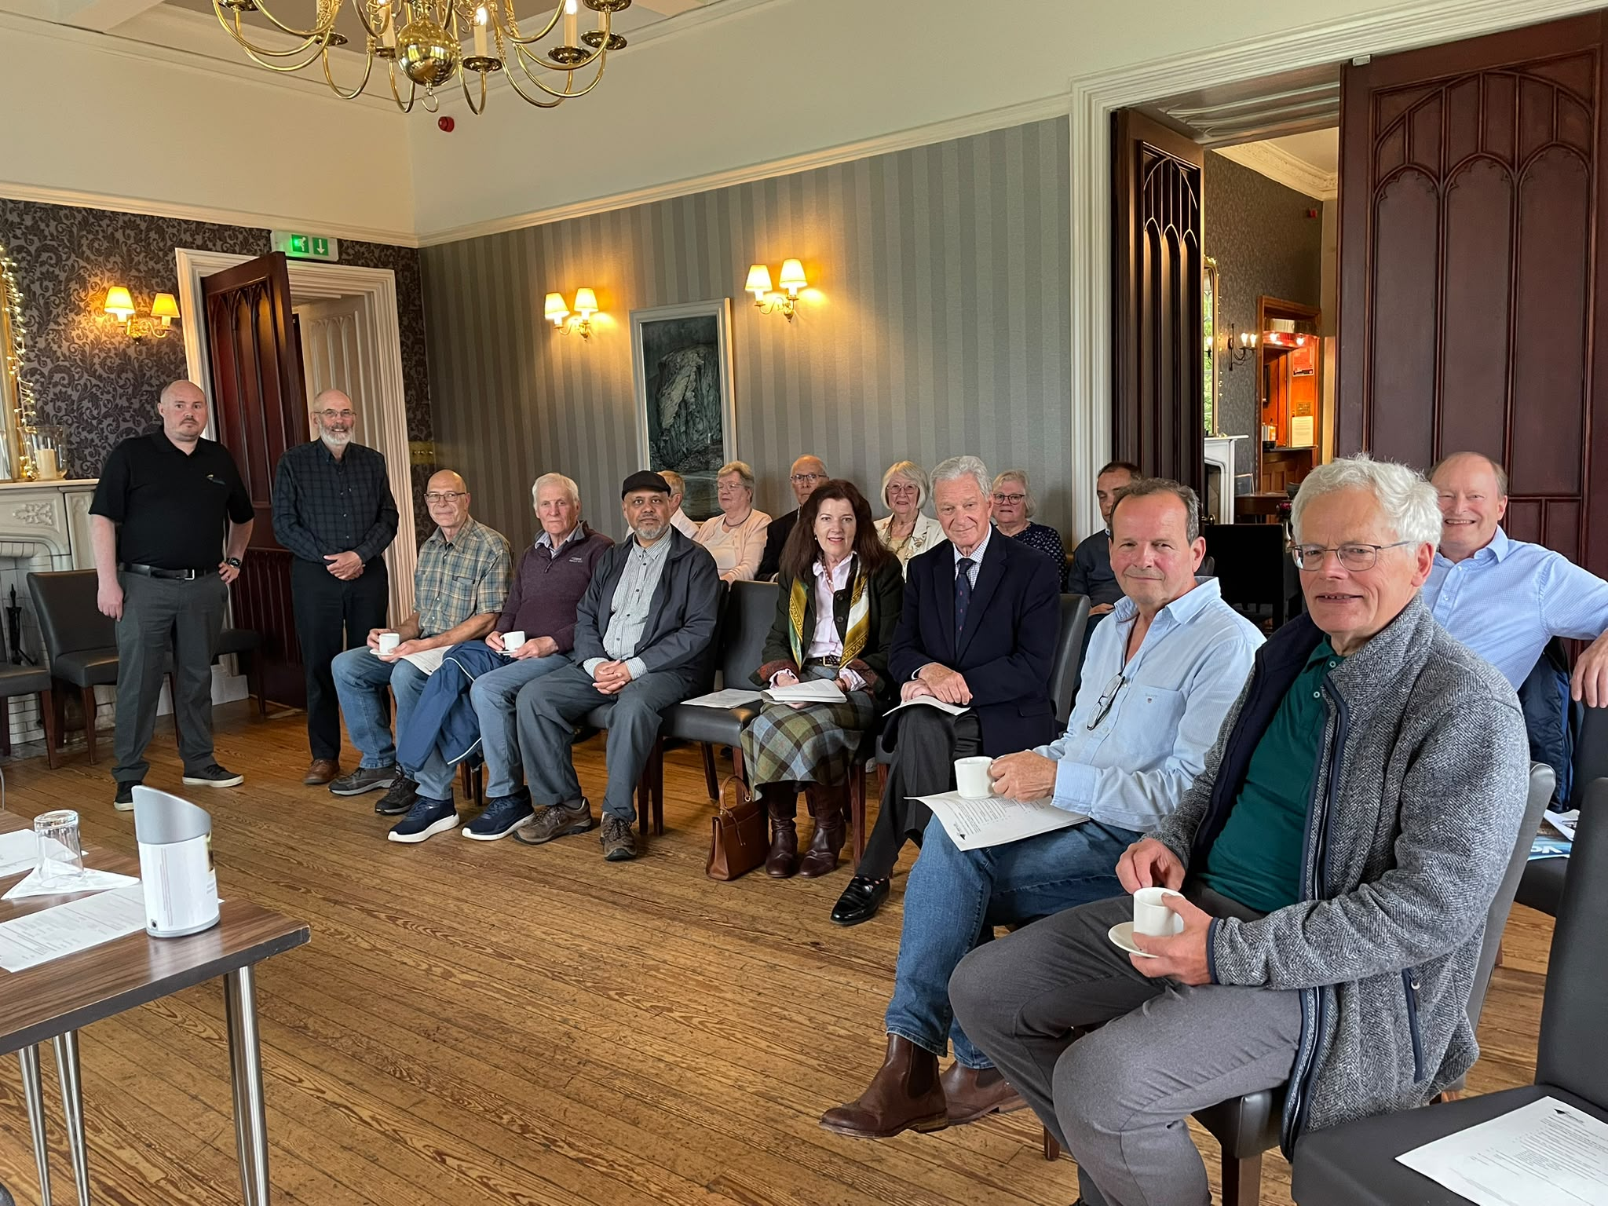

FRIENDS OF LOCH LOMOND & THE TROSSACHS

ANNUAL REPORT

For the YEAR ENDED 31 DECEMBER 2025

FRIENDS OF LOCH LOMOND & THE TROSSACHS

Page

Contents

Office Bearers etc. 3

Notice of Annual General Meeting 4

Minutes of 2026 Annual General Meeting 5-6

Chairman’s Report 7-11

Annual Accounts 12-15
Independent Examiners Report 16-17

FRIENDS OF LOCH LOMOND & THE TROSSACHS

Office Bearers etc.

Honorary President - Sir Malcolm Colquhoun Bart.

Honorary Vice-President - Lord John McFall of Alcluith

Office Bearers

Mr John Urquhart – Chair
Mr Stewart Gibb – Vice Chair
Ms Shona Millar -Treasurer

Executive Council

Ms Sheila Winstone
Mr Duncan MacLachlan
Dr Roddy Yarr
Dr Majid Anwar

Staff Member

Lloyd Weir

Office

Carrochan, Carrochan Road, Balloch G83 8EG
Tel. No: 07496 433134
Email address: info@lochlomondtrossachs.org.uk
Website: www.lochlomondtrossachs.org.uk

Bankers
Royal Bank of Scotland, 37 High Street, Dumbarton

Independent Examiner
George Murray, Helensburgh

Scottish Charities Registration Number: SC015389

FRIENDS OF LOCH LOMOND & THE TROSSACHS

Notice of Meeting – AGM 2026

Notice is hereby given that the forty fifth Annual General Meeting of the Friends of Loch Lomond and The Trossachs will be held at Ross Priory, Gartocharn on Monday the 1st of June, 2026 at 7.00pm, for the transacting of the following business:

- Receive apologies for absence.

- To approve the minutes of the last AGM

- Matters Arising
- Resignation of David Thorpe as Trustee

- Receive the Chairman’s Report

- Receive the Treasurer’s Report and approve the independently examined Accounts for the year ended 31 December 2025

- To approve no increase in the Annual Membership fees

- To re-appoint the office bearers and trustees and endorse other nominations

- To re-appoint existing Trustees seeking re-election:
Mr John Urquhart – Chair
Mr Stewart Gibb – Vice Chair
Ms Shona Millar - Treasurer
Ms Sheila Winstone
Mr Duncan MacLachlan
Dr Roddy Yarr
Dr Majid Anwar

- To transact any other competent business

- Revised constitution to be approved by FOLLATT members before it is sent to OSCR

By order of the Executive Council

John Urquhart
Chair

Monday 1st of June 2026 at 7.00pm at Ross Priory, Gartocharn

Chair: John Urquhart (JU).

Committee Present: S Winstone (SW); S Gibb (SG), M Anwar (MA), Duncan Maclachlan (DM)

In Attendance: L Weir (LW)

Present: S Fraser (SF), A Urquhart (AU), A Kerr (AK), Sir Malcom Colquhoun (SMC), Lady Katharine Colquhoun (LKC), David Henderson (DH), Paul Saunders (PS), Marion Brown (MB), Malcolm Brown (MB), Margaret MacGillivray (MM), Sandy MacGillivray (SM),

Apologies: Roddy Yarr, Shona Millar, Shauna Moore, Terence Brownrigg, Caroline Johnston, Will Oakley, Andy Macleod, Gayle Kerr, Nicky MacEwan, Jennifer Smith, Gayle Turnbull, Jennifer Plunkett, Elizabeth Morgan, David Morgan, David Brown, Niall Colquhoun, Sandra Cunningham, Kate Sankey

1. Welcome

JU welcomed those present to the meeting and thanked them for their attendance. Apologies were also noted.

2. Minutes of last AGM

The minutes of the last AGM were approved with no queries arising. They were proposed by SF and seconded by SW.

3. Matters Arising

Resignation of David Thorpe from Board
JU advised that David Thorpe has decided to step down from her role as trustee and thanked him for his contribution to the Friends.

4. Receive the Chairman’s Report

JU started his Chairman’s Report with the activity over the last year, and this was accompanied by a PowerPoint presentation highlighting some of the Friends’ projects and initiatives and a range of current topical issues.

JU was sad to announce the passing earlier this year of our trustee and former treasurer, Elizabeth Bain. He also spoke of the passing of member and longtime member, Alistair Macintyre.

5. Treasurers Report for year ending 31 December 2025

Accounts for 2025 have been audited by Geroge Murray of Helensburgh and were approved by MA and seconded by SF.

6. Membership Fees

It was agreed that annual membership fees should remain the same - £20 for individual membership and £28 for family membership.

7. Re-appointment of Office Bearers

- DT is retiring from the board of trustees
- All other trustees to remain in post

8. Any Other Competent Business

A revised constitution has been presented to the membership and was approved by all in attendance.

JU concluded the meeting at 19:55 and thanked everyone for their attendance.

June 2026

Chairman’s annual report
June 2026

This has been a busy and productive session for FOLLAT and we are ending it on a much stronger financial footing than last year. Membership currently stands at around 130 members with many of these being Life Members who may not be all that active. We are always on the lookout for new members so please spread the word.

But first, two items of sad news. Elizabeth Bain, our Treasurer, passed away earlier this year and Trustee, Majid Anwar, Lloyd Weir, our new Project Officer, Jennifer Plunkett (our previous Project Officer) and myself attended her funeral at Cardross on the 18th of May, just 3 weeks ago. Elizabeth was a pillar of her Lochgoilhead community and will be sorely missed there. It goes without saying that we too will miss her steady support looking after our financial matters.

Recently we also lost Alistair MacIntyre who was a long-term Friends supporter and contributor to Voice magazine.

Happily, our Tom Weir’s Rest picnic site at Balmaha continues to attract large numbers of people, but at 10 years old, the wooden framed interpretation panels were deteriorating markedly. Before she moved on, Jennifer Plunkett had assembled the funding to replace them and this year Lloyd Weir oversaw the installation of 6 shiny new ceramic and aluminium ones.

Friends’ stalwart and retired Trustee, Joyce Deans, keeps in touch, but finds it difficult to get out and about now due to her failing eyesight, so it seemed a good idea to invite her to accompany Lloyd and me when we visited Balmaha to inspect the newly installed panels. Thanks are due to the Oak Tree Inn’s Sandy Fraser and his team for carrying out the installation work and for providing us all with tea and cake when we came with Joyce for our inspection!

Financial impropriety is in the news so I thought I should admit that The Friends has been doing a bit of money laundering recently! It turned out the collecting box in one of our Tom Weir’s Rest donation posts had been installed the wrong way around and the money people were putting in was missing the box and ending up in the mud inside the base of the post. Ever resourceful, we hit on the solution of sucking it out with a vacuum cleaner. It worked, but the muddy money did have to be laundered before it went to the bank!

Lloyd has really embraced our MADD (Make a Difference Day) Volunteer Programme, arranging no less than 5 events which may be a record. Lay-by and beach litter cleared around Loch Lubnaig, weeds removed from Tom Weir’s Rest at Balmaha, overgrowing vegetation cleared from the Three Lochs Way Great Trail, marine litter tackled at Arrochar and rhododendrons reduced at Loch Katrine are some of the MADD outcomes achieved. Going forward, plans are in hand to clear litter gathering around the A82 lay-bys and nearby beaches, tackle vegetation damaging the ruins of the historic Macfarlane stronghold on Island I Vow near the north end of Loch Lomond and to deal with litter and knotweed which is an issue near the head of the Loch, south of Ardleish. We are also talking to the Mountain Bothy Association regarding how our volunteers might be able to help them in their work.

Our A82 “Keep The Banks Bonnie” lay-by bin scheme has come to an end. Rising costs, diminishing support from private sector sponsors and a complete absence of support from the local authorities has meant we had to curtail it. As the previously mentioned MADD plan indicates, this does not mean we are abandoning the A82 litter issue. However, with an annual servicing cost around £25K, the bins were a financial millstone around our necks which we could not sustain. Their removal puts us on a much more secure footing. Also contributing to our better fortunes and perhaps stimulated by some TV exposure of the bins story, we have recently received a substantial donation from the Wiseman Fund.

Without any doubt our stand-out project this year has been the Aber Dam Bridge. A wooden bridge had been installed there around 25 years ago by the forerunner of the National Park, but softwood timber had been used and it had quickly
succumbed to rot and had been in a dangerous condition for at least the last 10 years. The bridge was a key element of walking access between Aber and Gartocharn, but the National Park was making no progress with replacing it. Late in 2025 an opportunity arose for us to step in and negotiate a deal, breaking the impasse which had been preventing progress. We acted immediately and despite an initial tussle with the planners, soon had an agreement and a funding package assembled - thanks to the National Park and to the Dr Hannah Stirling Loch Lomond Fund, a legacy linked with our deceased founder. A new concrete structure is now in place which I suspect will outlast us all, but now we are wrestling with the National Park planners again over permission to fix the muddy core path which connects the bridge to Gartocharn.

Our constitution places on us a duty to monitor major planning applications like the Lomond Banks one lodged by the Flamingoland company. As it offers so many potential economic and conservation benefits on and around the brownfield post-industrial land which has been zoned for mixed use tourism and recreation development, we have always supported the general thrust of their scheme, rejecting the sensationalism of the “Save Loch Lomond” campaign which some politicians have so effectively promoted, turning the application into a political football so that it remains stalled on the desk of who-ever is the responsible minister now we have a new Scottish Government. We make no apology for featuring it again in the Winter edition of Voice, where we again pointed out some of the obvious planning gains which the National Park and ill-advised politicians seem so unwilling or unable to see.

In complete contrast we congratulate the planners on their recent go-ahead decision for the mixed-use tourism and recreation scheme for the derelict and dangerous Arrochar Torpedo Station, another brownfield site which has languished for far too long while it seemed officials and/or politicians dithered.

The National Park is writing its next Park Plan and has requested ideas for land and sites. We have responded with a document listing a variety of sites and strategic development ideas around the Park and appealing for a much more joined up approach from the planners and other agencies.

The Friends will be 50 in2028 and we are working with the marketing and tourism information specialists, Destination Helensburgh, looking into how we might celebrate this significant anniversary.

Last, but we hope by no means least, we have been talking to ACRUX, the company operating the newly re-opened Cononish Gold Mine, near Tyndrum. This resulted in an exclusive interview with their CEO which features in the soon to be published summer edition of Voice.

Thanks to all our members, trustees and Lloyd Weir, our hardworking Project Officer, all of whom make possible the good work of the Friends.

June 2026

John Urquhart

Chairman
Friends of Loch Lomond and The Trossachs

Financial Statements

For the Year Ended 31st December 2025

