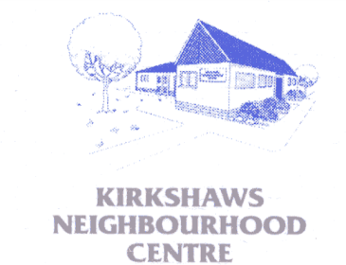
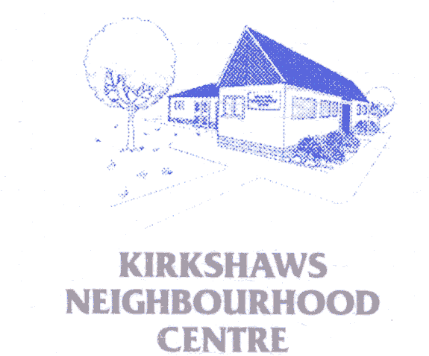
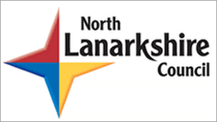

Kirkshaws Neighbourhood Centre SCIO

Scottish Charity No. SCO47669

Annual report and Financial Statement

For the year ended 31st August 2025



Trustees Annual Report
For the year 31st August 2025

The trustees have pleasure in presenting this report together with the financial statement and independent examiners report for the year ended 31st August 2025 and take this opportunity to thank all involved for their passion, commitment and dedication to our service.

Reference & Administrative Information

Charity Name:
Kirkshaws Neighbourhood Centre SCIO

Charity No:
SCO47669

Address:
Kirkshaws neighbourhood Centre, 25 Haddington Way, Coatbridge,
ML5 5BF

Current Trustees:

Theresa Strain Chairperson
Lorraine Barbour Member
Julie O’Byrne Secretary
Jodie Anderson Member
Anne Cully Treasurer
Jillian Arbuckle Member
Richard Burns Honorary Member
Alfie Hooper Honorary Member
John Colquhoun Honorary Member

Structure Governance & Management

Constitution
The Charity was granted SCIO status on 24th August 2017 in order to comply with legal requirements of the Community Asset Transfer Programme.

Appointment of Trustees

The Board of Trustees, meets on a bi-monthly basis, are the charity trustees; membership of the management committee is open to all centre users, local residents. Trustees are elected at the AGM. Under the constitution there must be a minimum of five elected trustees. The trustees may co-opt other trustees if they consider it would be in interest of the organisation to do so.

Management
The trustees are responsible for the strategic direction and governance of the organisation, while day to day running is delegated to the Project manager and his staff, who are paid members of staff. The project Manager attends the trustees meetings to discuss progress and development.

Objectives & Activities
Kirkshaws Neighbourhood Centre (SCIO) aims to promote the benefit of the inhabitants of Kirkshaws and the wider South Coatbridge area by advancing education and providing facilities in the interest of social welfare, recreation and other activities to improve the quality of life for local people and Centre users.

Activities
Our activities are user and community led and based on the needs of the people and to this we provide a wide range of services and activities. We operate 6 days per week and a wide range of use/community groups operate from the centre. In summary and in accordance with North Lanarkshire partnership plan we provide the following:
- Childcare services (Care Commission Regulated)
- Community café with emphasis on healthy eating
- IT Classes and lending library
- Cookery food preparation workshop and training unit
- Outdoor play area
- A range of sporting, physical and educational activities for children & adults
- Volunteering opportunities
- AK Street/Dance
- Community Fridge
- Kirkshaws Womens Health and Well-being Group
- Alternative to Violence Programme
- Hope 2 Help Benefits Advisory Service
- Cool School Uniforms project
- Bazooka Arts Project
- Childrens holiday programme
- After School Programme

Note from Chair
This year’s report highlights the difficulty the third/voluntary sector are facing in these difficult times. However our staff have worked tirelessly throughout the year to make sure people who used and relied on our service could count on its continued support and safe in the knowledge that a helping hand was close by.
For this I commend and thank them all.

Plans for Future/funding restraints
The trustees will continue and develop the services of the KNC and will always strive to be an organisation which responds to the needs of its members, users and local community at the forefront of what it does and in this year of unprecedented and challenging events we aim to transform our ways of working to ensure we off the services our community relies on.

THIS REPORT WAS COMPILED BY: William McBride, Project Manager on 21/01/2026

