Forth Canoe Club SCIO Annual Financial Report 2025.
FCC started the year with £41,097.11 in funds. These funds were held in three different accounts, the FCC SCIO Savings Account, a Savings Account for the Boat House Project and the FCC Current Account.
During 2025 we managed a full program of activities, we also bought £8,616 of new equipment (mainly a new trailer).
We ran a summer of try out sessions and a significantly increased number of adult and community try out sessions (Open nights).
We mainly spent our money on contracted for coaching fees and this allowed our members to enjoy another year of excellent coaching opportunities.
We continued the process of exploring the possibilities for redeveloping our boat house and this required us to open a separate account to hold funds raised specifically for this task. This year we spent significant funds on archaeological and environmental studies which is the second in the redevelopment process.
We received grants from Foundation Scotland to buy disability aids and a trailer, along with grants from Edinburgh Council for training to deliver Paddle Safer sessions.
We ended the year with £39,655.20, a loss of £1,441.91.
The club remains in a healthy financial position with reserves capable of covering around 12 months of operations. It should be noted we had no outstanding unpaid invoices at the end of the 2025. financial year.
During 2025, we continued to use the RBS FreeAgent software package to track our invoices and expenses. Our accounts are transparent able to be fully monitored real time. Our Independent Examiner has 24/7, 365 access to the accounts via the FreeAgent software ensuring there is a constant opportunity for independent review of all FCC transactions. We now have virtually no physical cash movements and during 2025 only £100 was received as cash from the ceilidh.
Notes to the Accounts
1. Basis of Accounting
These accounts have been prepared on the Receipts and Payments basis in accordance with the Charities and Trustee Investment (Scotland) Act 2005 and the Charities Accounts (Scotland) Regulations 2006 (as amended).
2. Nature and Purpose of Funds
Unrestricted funds are those that may be used at the discretion of the trustees in furtherance of the objects of the charity. Restricted funds may only be used for specific purposes. Although the trustees maintain a Bank Account and associated Cash, the receipts and payments system include coding to separately identify restricted and unrestricted monies. During this financial period there were no restricted funds.
3. Reserves policy
The trustees’ policy is to retain £5,000 of reserves in order to pay for approximately 3 months’ worth of normal running costs. The trustees believe this is still in an acceptable amount but will continue to monitor the position.

Summary Club Financial Position
This financial report relates to the period 01/01/2025 to 31/12/2025.
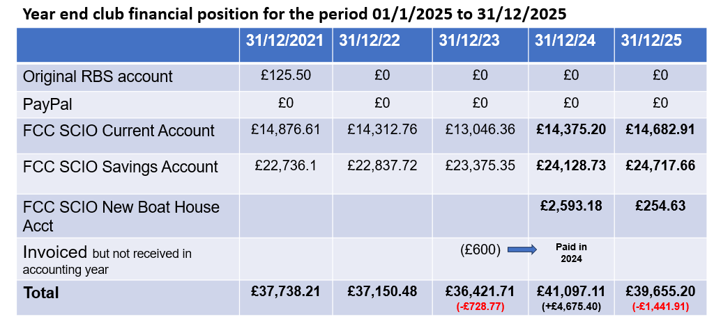
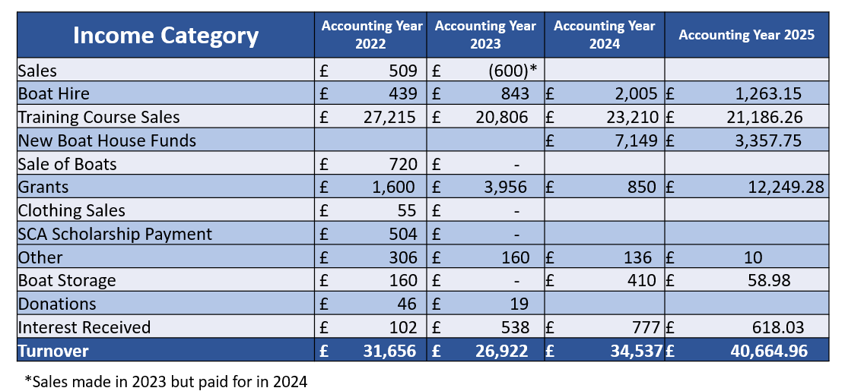
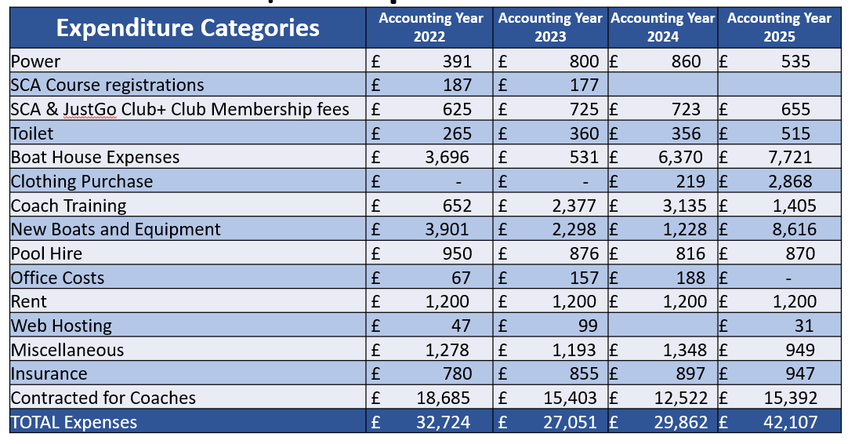
Financial Statements Pages 1-6
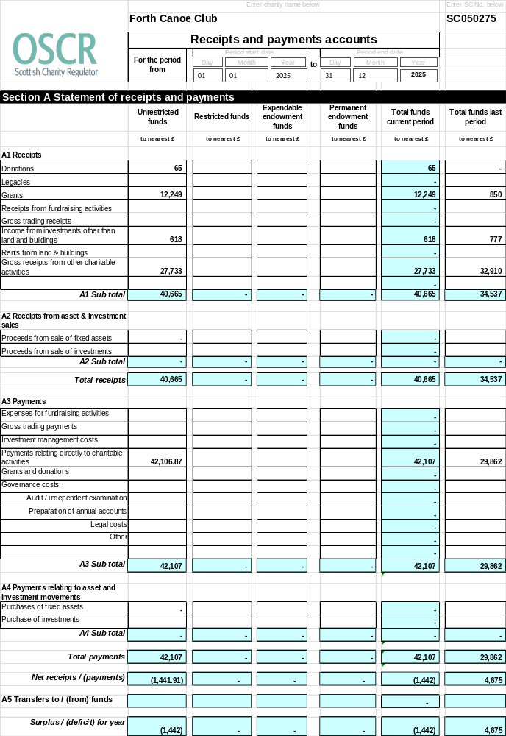
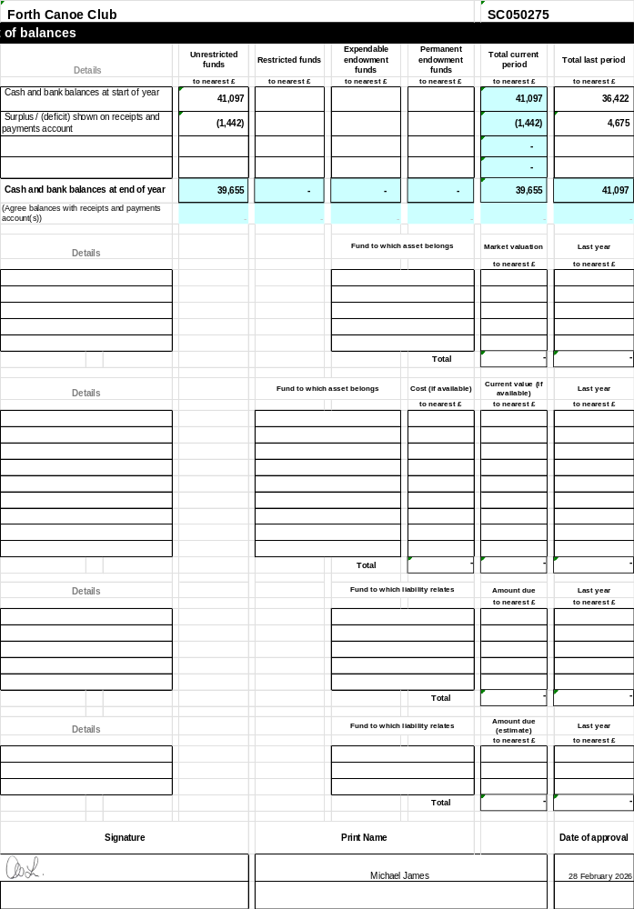
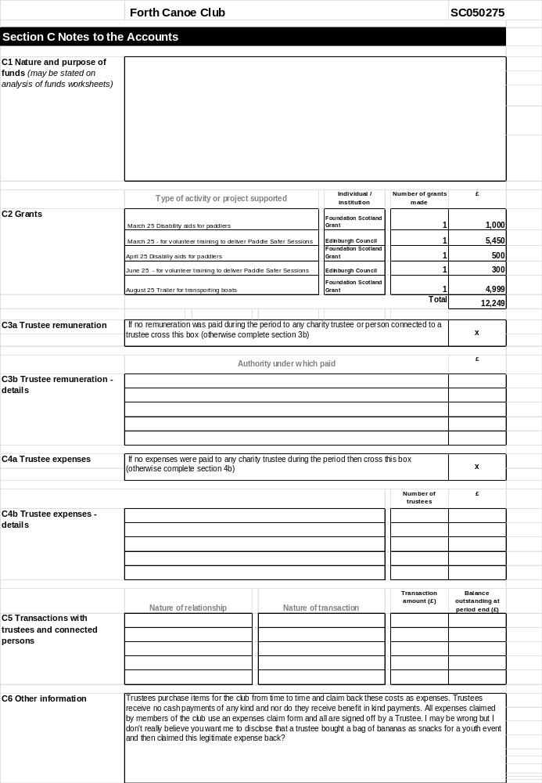
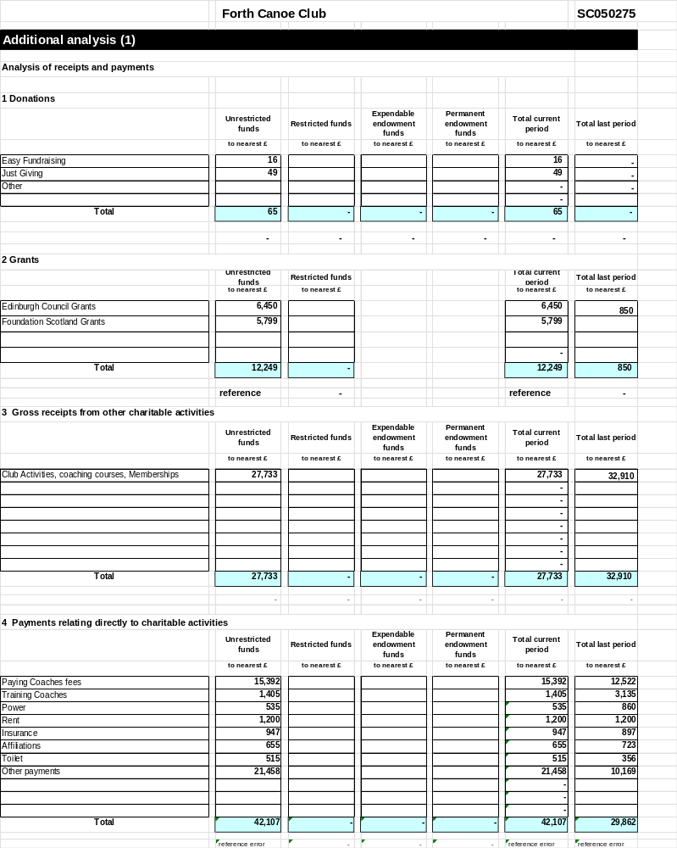
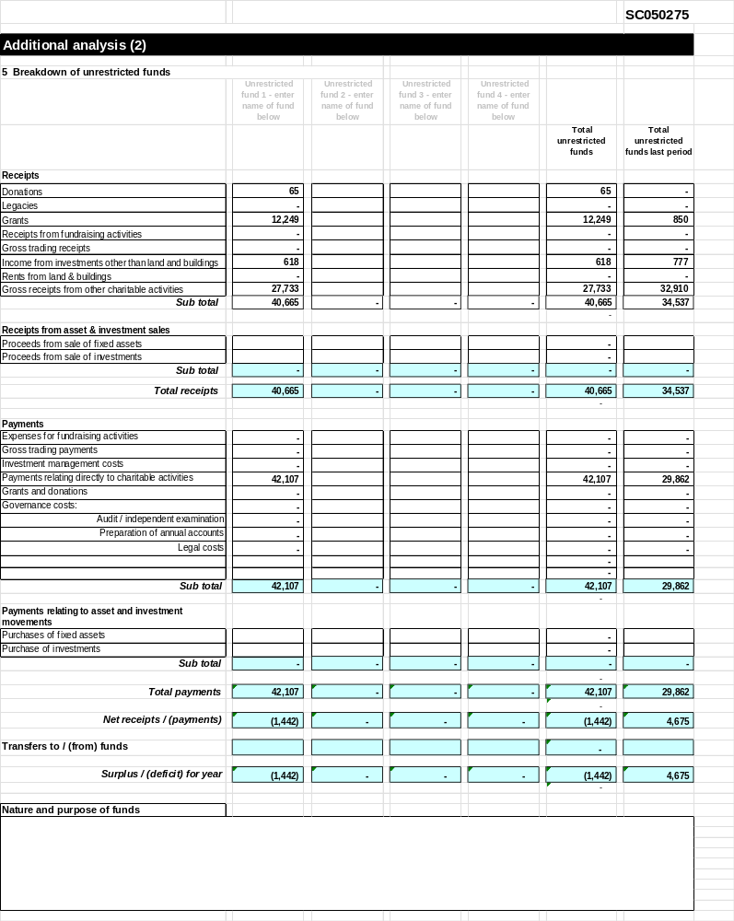
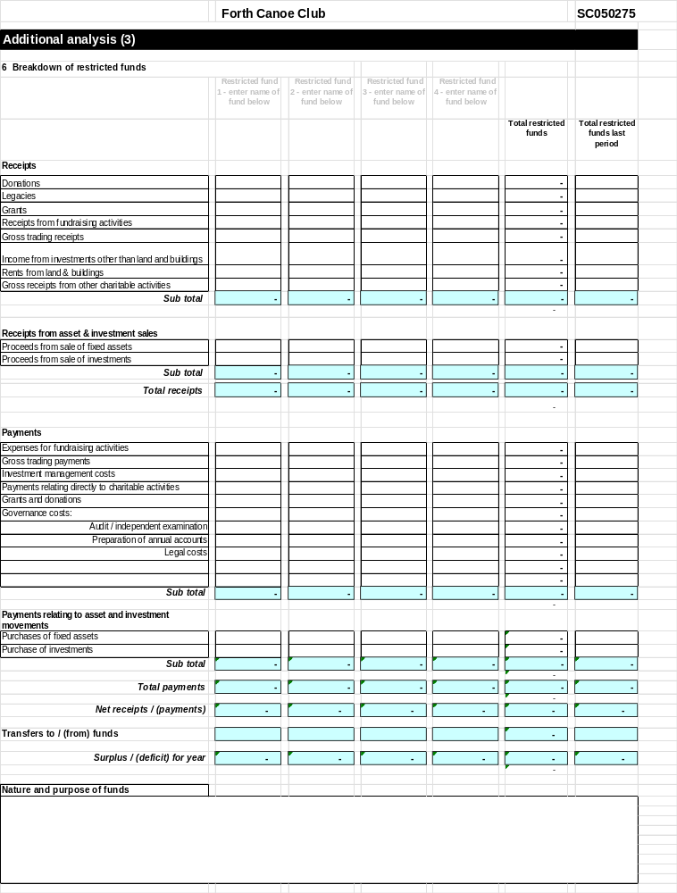

APPENDIX 3



 | Independent examiner’s report on the accounts V2
Report to the trustees/members of | Charity name  Forth Canoe Club
Registered charity number | SC050275
On the accounts of the charity for the period | Period start date |  |  |  | Period end date
On the accounts of the charity for the period | Day | Month | Year |  | Day | Month | Year
On the accounts of the charity for the period | 01 | January | 2025 | to | 31 | December | 2025
Set out on pages |  |  |  |  |  | (remember to include the page numbers of additional sheets)
Respective responsibilities of trustees and examiner | The charity’s trustees are responsible for the preparation of the accounts in accordance with the terms of the Charities and Trustee Investment (Scotland) 2005 Act and the Charities Accounts (Scotland) Regulations 2006 (as amended). The charity trustees consider that the audit requirement of Regulation 10(1) (d) of the Accounts Regulations does not apply. It is my responsibility to examine the accounts as required under section 44(1) (c) of the Act and to state whether particular matters have come to my attention.
Basis of independent examiner’s statement | My examination is carried out in accordance with Regulation 11 of the 2006 Accounts Regulations. An examination includes a review of the accounting records kept by the charity and a comparison of the accounts presented with those records. It also includes consideration of any unusual items or disclosures in the accounts and seeks explanations from the trustees concerning any such matters. The procedures undertaken do not provide all the evidence that would be required in an audit and, consequently, I do not express an audit opinion on the view given by the accounts.
Independent examiner’s statement | In the course of my examination, no matter has come to my attention [other than that disclosed on the attached page*]  1. which gives me reasonable cause to believe that in any material respect the requirements:  • to keep accounting records in accordance with section 44(1) (a) of the 2005 Act and Regulation 4 of the 2006 Accounts Regulations, and  • to prepare accounts which accord with the accounting records and comply with Regulation 9 of the 2006 Accounts Regulations  have not been met, or  2. to which, in my opinion, attention should be drawn in order to enable a proper understanding of the accounts to be reached.
Signed: | 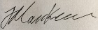 | Date: | 28-2-26
Name: | Marcus Kneen
Relevant professional qualification(s) or body (if any): | Institute of Chartered Accountants of Scotland
Address: | 41b Priestfield Road
 | Edinburgh
 | EH16 5HX

*Please delete the words in the brackets if they do not apply. If the words do apply, set out those matters which have come to your attention on the following page.

APPENDIX 3

Disclosure section

Only complete if the examiner needs to highlight material problems.

Give here brief details of any items that the examiner wishes to disclose

