REGISTERED COMPANY NUMBER: SC231988 (Scotland) REGISTERED CHARITY NUMBER: SC032051
Report of the Trustees and
Unaudited Financial Statements for the Year Ended 31 March 2026 for
Crossroads (North Arqyll) Care Attendant
Scheme
Mackay & Co CA
120 George Street
Oban
Argyll
PA34 5NT
Contents of the Financial Statements for the Year Ended 31 March 2026
Page
Report of the Trustees i to 8
Independent Examiner's Report 9 to 10
Statement of Financial Activities 11
Balance Sheet 12 to 13
Notes to the Financial Statements 14 to 20
Detailed Statement of Financial Activities 21 to 22

The trustees who are also directors of the charity for the purposes of the Companies Act 2006, present their report with the financial statements of the charity for the year ended 31 March 2026. The trustees have adopted the provisions of Accounting and Reporting by Charities: Statement of Recommended Practice applicable to charities preparing their accounts in accordance with the Financial Reporting Standard applicable in the UK and Republic of Ireland (FRS 102) (effective 1 January 2019).
Introduction
The Board wishes to record its sincere thanks to all our Care Attendants: Ali, Ann, Colin, Debra, Frances, Graham, Helen, Jim, Maggie, Mairi, Maureen G, Maureen 0% Mhairi, Peter, Ronaldä, Sue and Tina. We also extend our gratitude to our Mull-based staff: Adeline, Carole, Elaine, Heather, Karen and Kim.
We are fortunate to have such hardworking and caring members of staff. Crossroads North Argyll is immensely proud of the dedication they show every day. Without their commitment, we could not provide our essential service to unpaid carers and those they support.
During the year, we welcomed several new staff members. Kim returned to the organisation after a short period away and now coordinates our service on Mull. We also welcomed Liz Von Kleistenfel on Mull and Clare Bailey in the Oban area.
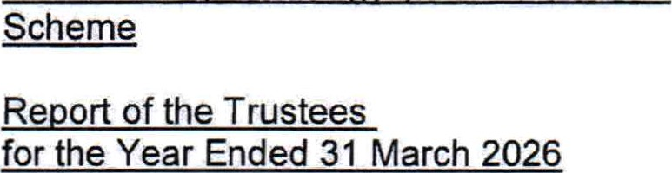
We said goodbye to several valued colleagues. Adeline left the Mull service, while Karen stepped down from her role as Mull Coordinator. Karen played a key role in developing the service on Mull alongside Linda and Joan, and she will be greatly missed. Liz MacKay left due to ill health and Fiona left our Tiree service. As the Tiree service did not receive sufficient referrals to become sustainable, the decision was made to discontinue it. We also marked the retirement of Ronalda, our longest-serving member of staff, after many years of dedicated service. We wish her a long and happy retirement.
At the end of the year, Crossroads North Argyll employed 26 members of staff, representing 13 whole-time equivalent (WTE) posts.
During the year, we deregistered from the Care Inspectorate after confirming that our service does not require registration, as we do not provide personal care or administer medication. As a result, staff are no longer required to register with the Scottish Social Services Council (SSSC).
The Board would like to thank Joan, Linda, Sharon and Irianni, whose hard work and dedication have enabled Crossroads North Argyll to continue developing and expanding during a particularly busy year.

OBJECTIVES AND ACTIVITIES
Objectives and aims
The mission of Crossroads North Argyll is to provide a high quality service in our community to enable carers to take time off from caring when needed.
Our objective is to relieve stress on the persons or families caring for the elderly or people with physical, mental or sensory impairments.

OBJECTIVES AND ACTIVITIES
How we achieve our goals
We aim to have a person centred re-ablement approach. This means we treat everyone as an
individual with individual likes, dislikes, needs and aspirations. Also we try to do things with people rather than to them - e.g. if possible, helping them to do it for themselves.
The nature of our support therefore varies from client to client. Before starting our service, we meet both carer and 'cared for' and gain a sense of their personal history, individual health issues and stresses plus what they want to gain from our service.
Mainly carers want a break from their caring role to have time to do other things. These might be practical things such as shopping, banking, post office or might be social things such as meeting a friend for coffee, going to hairdressers etc. Some carers want us to stay in the home with their cared for person. Other carers ask us to take their cared for person out for a walk, drive and/or to a cafe.
For some clients we are part of a network of support and we provide additional social support. For other clients we are the only support they have,
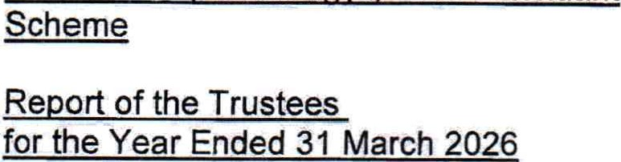
We are independently inspected by The Care Inspectorate.
ACHIEVEMENTS AND PERFORMANCE
What we achieved in 2025/26
During the year we secured funding from Creative Breaks, the Third Sector Interface Communities Mental Health and Wellbeing Fund, The Crerar Trust, Oban & Lorn Dementia Support Group, the Postcode Lottery and the Duncan MacKiIlop Trust. We also entered our second year of funding from the National Lottery.
We were delighted to receive an increased number of donations through funeral collections and general donations. In addition to providing valuable financial support, these donations demonstrate growing awareness and recognition of our work within the local community.
Key achievements during the year included:
Supporting 132 unpaid carers and 132 cared-for individuals.
- Providing 14,460 hours of face-to-face respite support.
- Travelling 34,000 miles and delivering 1,128 hours of travel time to reach individuals across our extensive geographical area.
- Welcoming 40 new clients to the service.
Supporting clients through changing circumstances, with 24 individuals leaving the service due to moving into residential care or bereavement.
ACHIEVEMENTS AND PERFORMANCE

Mull Service
Our Mull service continues to thrive, with seven staff members providing 83 hours of respite support each week to 23 unpaid carers. Given the size of the island, staff are based across Craignure, Tobermory, Salen, Dervaig and Bunessan to ensure local access to support
Group Activities
The Dementia Craft Group has enjoyed another successful year, exploring a wide variety of creative activities. As well as providing valuable respite for carers, participants produce many handmade gifts and keepsakes.
The Gypsy/Traveller Crafting Connections Group has also been highly successful, attracting between eight and twelve participants every fortnight. Basket weaving was chosen as a traditional craft that encourages reminiscence, celebrates cultural heritage and creates opportunities for social connection.
Our Monday Group continues to go from strength to strength, with nine regular attendees. New members who joined during the year have settled in well and become valued members of the group.
Community Engagement and Fundraising
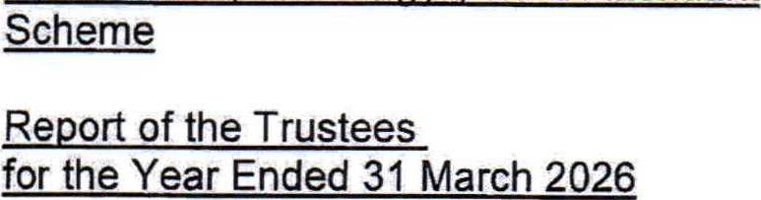
Crossroads North Argyll participated in Oban's Winter Festival for the first time. Activities included a fundraising Bingo Night at the Corran Halls, a community basket-weaving workshop and an exhibition celebrating Gypsy/Traveller lives and culture. These events were extremely well attended and raised El,727.
We also hosted our annual Bacon Roll and Bucks Fizz Morning for unpaid carers, cared-for individuals and partner organisations. This remains a popular event and provides an enjoyable opportunity for people to come together.

Financial Stability
In October 2025, the Board agreed to introduce a service charge of E 10 per hour, effective from 1
April 2026. This decision was taken to help address projected funding shortfalls anticipated in the 2027/28 financial year. External funding will, however, remain essential to the sustainability of the organisation.
In January 2026, we were asked by Argyll and Bute TSI and the Health and Social Care Partnership (HSCP) to provide impact reports outlining the consequences of proposed funding reductions. These reports were submitted alongside those of other third-sector organisations facing a potential 15% funding cut. For Crossroads North Argyll, this represents a reduction of just over El 1,000 in core HSCP funding.

ACHIEVEMENTS AND PERFORMANCE
Administration
During the year we introduced Charitylog, a client relationship management (CRM) system that enables us to store and manage information within a single secure database. The system assists with referrals, interventions, reporting and service monitoring, providing improved oversight and efficiency.
Most staff now use Charitylog to submit timesheets, weekly records and client updates. This allows office staff and management to remain informed about client needs and service delivery and provides valuable information for meetings and reporting purposes.
ACHIEVEMENTS AND PERFORMANCE
Feedback from Unpaid Carers
Feedback received during the year included:
- ''To get a break from 24-hour caring is invaluable to mental health. It is also good for the person being cared for to have someone else to talk to."
- "During these two afternoons a week I feel that I can switch off from the caring mindset and concentrate on work and other matters unrelated to Dad's care."
- "l could not have achieved the things I have needed without this service."
"Sharon is an absolute gem. She communicates really well about forthcoming activities and we really enjoy her company."
These comments demonstrate the significant impact respite support has on the wellbeing of unpaid carers and those they care for.
Feedback from Partners
Partner organisations described the service as:
"Invaluable" in helping carers maintain their wellbeing and enabling families to remain together for longer.
- "An essential support to unpaid carers" that helps prevent crises and reduce social isolation.
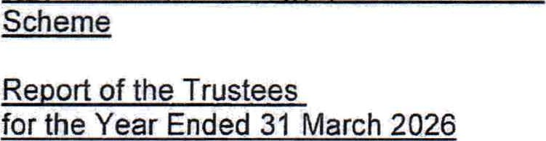
- A service that significantly reduces pressure on community nursing teams through preventative support and close partnership working.
"An amazing service" that makes a meaningful difference to people's lives.
Partnership Working
We believe the most effective way to support unpaid carers is through strong partnership working.
Our principal partners include North Argyll Carers Centre, the Dementia Team, Social Work Services, The Dove Centre, local GP practices, District Nurses and Occupational Therapists.
Our Manager, Joan, also participates in the Frailty Group at Lorn Medical Centre. This multidisciplinary forum brings together GPs, Occupational Therapists, Social Workers, Pharmacists, the Dementia Team, North Argyll Carers Centre and Crossroads North Argyll. The group enables organisations to coordinate support, reduce duplication and identify unmet needs at an early stage.
Membership Organisations
Crossroads North Argyll is a member of the Coalition of Carers in Scotland (COCiS), which promotes the voice of carers and connects local carer organisations with decision-makers at both local and national levels. Through this membership, we help ensure that the views of carers in rural and island communities are represented and heard.
We are also members of Carers Trust Scotland, a UK-wide network committed to transforming the lives of unpaid carers through collaboration, advocacy and service development.
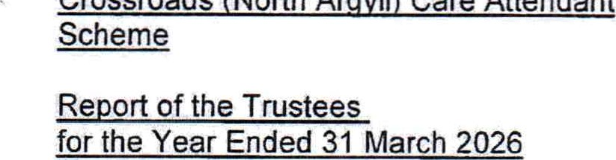
FINANCIAL
REVIEW
Financial position
The charity suffered a deficit on its general funds of E25,357 (2025 - E29,531) in the year under review. The restricted funds show a surplus of 26,558 (2025 - deficit of El ,209).
The Trustees were expecting a deficit in the last two years as the service comes under additional demand pressures while having funding cut.
At the end of the year the charity had E 139,511 (2025 - E 164,868) in unrestricted funds and the trustees consider to this to be adequate for the immediate ongoing needs of the charity.
Investment policy and objectives
In accordance with the Memorandum and Articles of Association, the company has the power to make any investments which the Trustees see fit. The Trustees consider the return on investments to be satisfactory.
Reserves policy
The policy is aimed at ensuring the organisation has sufficient reserves to meet the following commitments in the event of unforeseen circumstances. It is consistent with the obligations of the Trustees that an appropriate level of reserves is built up and maintained to enable the organisation to meet committed expenditure or closure costs.
The policy takes account of the following:
The costs of maintaining and running the organisation at a basic level whilst funding is sought to replace lost funding - i.e. rent, overheads, telephone, salaries, utilities and any other standing commitments.
It assumes that the organisation would retain a minimum level of staffing i.e. the manager plus one administrator who would work with the Trustees to secure fresh funding and reshape the organisation.
As employers we are responsible for staff, both as a continuing organisation and in any circumstances where we have to close down some or all projects.
Reserves should be a minimum amount that allows for the running of the organisation for 3 months. Given the slowness of funding decision-making and deadlines, it is appropriate that Crossroads North Argyll retain sufficient reserves for a 3 month period.
Going concern
The Trustees regularly review finances at their monthly board meetings and forecast ahead to ensure upcoming expenditure can be met. Like many charities, we are reliant on grant funding and are at the mercy of funders' changing fortunes and priorities. We do our best to maintain relationships with our main funders and seek complimentary funding where we can. Currently there are no issues surrounding going concern.

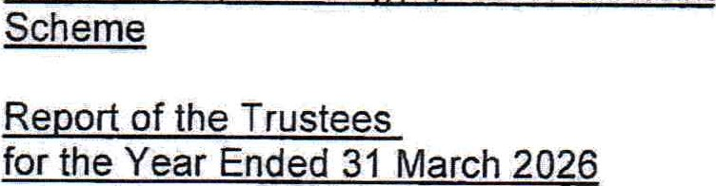
STRUCTURE, GOVERNANCE AND MANAGEMENT
Governing document
The charity is controlled by its governing document, a deed of trust, and constitutes a limited company, limited by guarantee, as defined by the Companies Act 2006.
Charity constitution
As set out on the Articles of Association, one third of the Trustees retire by rotation each year and are elected by the members of the charitable company. The company is limited by guarantee without a share capital. The liability of each member in the event of a winding up is limited to El.
Recruitment and appointment of new Trustees
The recruitment of new Trustees is regularly discussed at Board meetings. We try to identify individuals who will bring relevant skills as well as their time to our charity. When an individual is identified, it is discussed at Board level before someone from the charity will make a request to the individual to join the Board.
Organisational structure
The charity is run by its Board of directors who meet once a month. The charity employs a manager and the day to day running of things is delegated to them. Oversight is provided by the Board members during their monthly meetings as well as more informal visits to the office in between.
Running of the organisation
Crossroads North Argyll benefits from a highly active and committed Board of Directors, who meet monthly and play a central role in the organisation's development and strategic direction.
Risk management
The trustees have a duty to identify and review the risks to which the charity is exposed and to ensure appropriate controls are in place to provide reasonable assurance against fraud and error.
In particular, the charity is reliant on grant funding and efforts are made to ensure we have enough money via regular funding applications.
REFERENCE AND ADMINISTRATIVE DETAILS
Registered Company number
SC231988 (Scotland)
Registered Charity number sc032051
Registered office
2 Gibraltar Street
Oban
Argyll
PA34 4AY
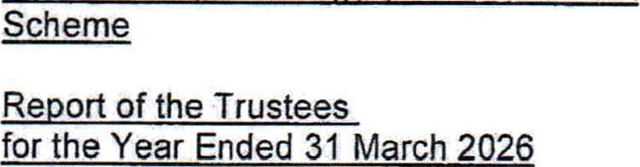
Trustees
S B A Grieve Director
F Miller Director
J G Robertson Director
E M Robertson Director
P White Director
K Duncan (appointed 23.6.25)
M MacKinnon (appointed 23.6.25)
Company Secretary L J Duncan
Independent Examiner

David Ross CA
Mackay & co CA
120 George Street
Oban
Argyll
PA34 5NT
Closing paragraph
As Chair or Crossroads North Argyll I am a member of the Joint Working Partnership (JWP) which consists of the four chairs of the Carers' Centres, MAYDS and Crossroads. We have regular meetings with the HSCP addressing matters pertaining to third sector organisations providing a service to unpaid carers and those requiring care. This includes legislation, finance and provides a platform for the chairs to work together to provide services to those in need. The JWP are engaged looking at meaningful ways in which to work more collaboratively, make best value of the limited resources available and through initiatives.
I would like to thank all Board members for their support, commitment and dedication throughout what has been both a productive and challenging year. Their guidance and enthusiasm continue to be instrumental in the success and future development of Crossroads North Argyll.
Approved by order of the board of trustees on 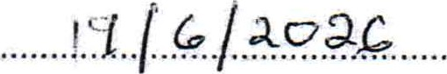 and signed on its behalf by:
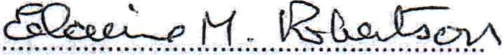
E M Robertson - Trustee
Independent Examiner's Report to the Trustees of
Crossroads (North Arqvll) Care Attendant Scheme
I report on the accounts for the year ended 31 March 2026 set out on pages eleven to twenty.
Respective responsibilities of trustees and examiner
The charity's trustees are responsible for the preparation of the accounts in accordance with the terms of the Charities and Trustee Investment (Scotland) Act 2005 and the Charities Accounts (Scotland) Regulations 2006 (as amended). The charity's trustees consider that the audit requirement of Regulation 10(1)(a) to (c) of the Accounts Regulations does not apply. It is my responsibility to examine the accounts as required under Section 44(1)(c) of the Act and to state whether particular matters have come to my attention,
Basis of the independent examiner's report
My examination was carried out in accordance with Regulation 11 of the Charities Accounts (Scotland) Regulations 2006. An examination includes a review of the accounting records kept by the charity and a comparison of the accounts presented with those records. It also includes consideration of any unusual items or disclosures in the accounts, and seeking explanations from you as trustees concerning any such matters. The procedures undertaken do not provide all the evidence that would be required in an audit, and consequently 'l do not express an audit opinion on the view given by the accounts.
Independent examiner's statement
In connection with my examination, no matter has come to my attention
- which gives me reasonable cause to believe that, in any material respect, the requirements
to keep accounting records in accordance with Section 44(1)(a) of the 2005 Act and Regulation 4 of the 2006 Accounts Regulations; and to prepare accounts which accord with the accounting records and to comply with Regulation 8 of the 2006 Accounts Regulations have not been met; or
- to which, in my opinion, attention should be drawn in order to enable a proper understanding of the accounts to be reached.
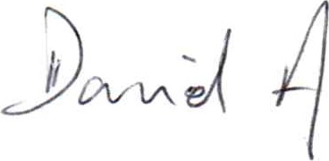

David Ross CA
The Institute of Chartered Accountants of Scotland
Mackay & Co CA
120 George Street
Oban
Argyll
PA34 5NT
Date• 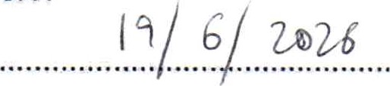

Statement of Financial Activities for the Year Ended 31 March 2026
 |  |  |  | 31.3.26 | 31.3.25
 |  | Unrestricted | Restricted | Total | Total
INCOME AND ENDOWMENTS FROM | Notes | funds | funds | funds | funds as restated
Donations and legacies  Charitable activities | 3 | 8,543 | 1 ,500 | 10,043 | 6,486
Respite support of carers |  | 239,551 | 109,046 | 348,597 | 298,314
Investment income | 2 | 1 ,092 |  | 1,092 | 1,604
Total | 249,186 | 110,546 | 359,732 | 306,404
EXPENDITURE ON
Raising funds  Charitable activities | 3,250 |  | 3,250 | 4,750
Respite support of carers | 271 ,293 | 103,088 | 374,381 | 332,394
Total | 274,543 | 103,088 | 377,631 | 337,144
NET INCOME/(EXPENDITURE)  RECONCILIATION OF FUNDS | (25,357) | 7,458 | (17,899) | (30,740)
Total funds brought forward | 164,868 | 55,130 | 219,998 | 250,738
TOTAL FUNDS CARRIED FORWARD 139,511 62,588 202,099 219,998 Balance Sheet
31 March 2026
 |  |  |  | 31.3.26 | 31.3.25
 |  | Unrestricted | Restricted | Total | Total
FIXED ASSETS | Notes | funds | funds | funds | funds as restated
Tangible assets  CURRENT ASSETS | 8 |  |  |  | 22
Debtors | 9 | 1 ,934 |  | 1 ,934 | 1,901
Cash at bank |  | 139,017 | 62,588 | 201 ,605 | 219,515
CREDITORS |  | 140,951 | 62,588 | 203,539 | 221,416
Amounts falling due within one year | 10 | (1 ,440) |  | (1 ,440) | (1 ,440)
NET CURRENT ASSETS  TOTAL ASSETS LESS CURRENT | 139,511 | 62,588 | 202,099 | 219,976
LIABILITIES | 139,511 | 62,588 | 202,099 | 219,998
NET ASSETS  FUNDS  Unrestricted funds: | 1 1 | 139,511 | 62,588 | 202,099 | 219,998
General fund |  |  |  | 82,679 | 109,053
Designated fund |  |  |  | 56,832  139,511 | 55,815  164,868
Restricted funds |  |  |  | 62,588 | 55,130
TOTAL FUNDS 202,099 219,998

The charitable company is entitled to exemption from audit under Section 477 of the Companies Act 2006 for the year ended 31 March 2026.
The members have not required the company to obtain an audit of its financial statements for the year ended 31 March 2026 in accordance with Section 476 of the Companies Act 2006.
Balance Sheet continued
31 March 2026
The trustees acknowledge their responsibilities for
- ensuring that the charitable company keeps accounting records that comply with Sections 386 and 387 of the Companies Act 2006 and
- preparing financial statements which give a true and fair view of the state of affairs of the charitable company as at the end of each financial year and of its surplus or deficit for each financial year in accordance with the requirements of Sections 394 and 395 and which otherwise comply with the requirements of the Companies Act 2006 relating to financial statements, so far as applicable to the charitable company.
These financial statements have been prepared in accordance with the provisions applicable to charitable companies subject to the small companies regime.
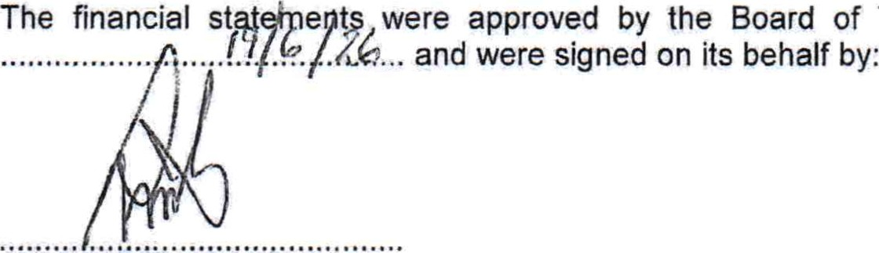Trustees and authorised for issue on
P White - Trustee

1. ACCOUNTING POLICIES
Basis of preparing the financial statements
The financial statements of the charitable company, which is a public benefit entity under FRS 102, have been prepared in accordance with the Charities SORP (FRS 102) 'Accounting and Reporting by Charities: Statement of Recommended Practice applicable to charities preparing their accounts in accordance with the Financial Reporting Standard applicable in the IJK and Republic of Ireland (FRS 102) (effective 1 January 2019)', Financial Reporting Standard 102 'The Financial Reporting Standard applicable in the UK and Republic of Ireland' and the Companies Act 2006. The financial statements have been prepared under the historical cost convention.
Income
All income is recognised in the Statement of Financial Activities once the charity has entitlement to the funds, it is probable that the income will be received and the amount can be measured reliably.
Expenditure
Liabilities are recognised as expenditure as soon as there is a legal or constructive obligation committing the charity to that expenditure, it is probable that a transfer of economic benefits will be required in settlement and the amount of the obligation can be measured reliably. Expenditure is accounted for on an accruals basis and has been classified under headings that aggregate all cost related to the category. Where costs cannot be directly attributed to particular headings they have been allocated to activities on a basis consistent with the use of resources,
Tangible fixed assets
Depreciation is provided at the following annual rates in order to write off each asset over its estimated useful life.
Plant and machinery 25% on reducing balance
Taxation
The charity is exempt from corporation tax on its charitable activities.
Fund accounting
Unrestricted funds can be used in accordance with the charitable objectives at the discretion of the trustees.
Restricted funds can only be used for particular restricted purposes within the objects of the charity. Restrictions arise when specified by the donor or when funds are raised for particular restricted purposes.
Further explanation of the nature and purpose of each fund is included in the notes to the financial statements.
- ACCOUNTING POLICIES - continued
Pension costs and other post-retirement benefits

The charitable company operates a defined contribution pension scheme. Contributions payable to the charitable company's pension scheme are charged to the Statement of Financial

Activities in the period to which they relate.
- INVESTMENT INCOME
 |  | 31.3.26 | 31.3.25 as restated
 | Deposit account interest | 1 ,092 | 1,604
3. | INCOME FROM CHARITABLE ACTIVITIES
 | Activity | 31.3.26 | 31.3.25 as restated
 | Invoiced income Respite support of carers | 3,910
 | Grants Respite support of carers | 328,872 | 268,581
 | Travel/mileage for clients Respite support of carers | 11,547 | 8,786
 | SDS Funded Respite support of carers | 4,268 | 20,947
Grants received, included in the above, are as follows: | 348,597 | 298,314
 | 31.3.26 | 31.3.25 as restated
ABC Core Funding | 88,784 | 88,784
TSI Third Sector Grant | 7,824 | 7,138
NACC Funded |  | 2,000
ABC - Care at home | 95,042 | 55,284
SCS Creative Breaks | 34,903 | 34,747
National Lottery | 66,319 | 64,378
NHS Highland |  | 1 ,250
Crerars Trust |  | 15,000
Duncan McKilIip Trust | 6,000
Postcode Community | 30,000
 | 328,872 | 268,581
4. NET INCOME/(EXPENDITURE)
Net income/(expenditure) is stated after charging/(crediting):
 | 31.3.26 | 31.3.25 as restated
Depreciation - owned assets | 22 | 4
INCOME AND ENDOWMENTS FROM | funds | funds | funds as restated
Donations and legacies  Charitable activities | 6,486 |  | 6,486
Respite support of carers | 192,051 | 106,263 | 298,314
Investment income | ,604 |  | ,604
Total  EXPENDITURE ON | 200, 141 | 106,263 | 306,404
Raising funds  Charitable activities | 4,750 |  | 4,750
Respite support of carers | 224,922 | 107,472 | 332,394
Total | 229,672 | 107,472 | 337, 144
NET INCOME/(EXPENDITURE) | (29,531) | (1 ,209) | (30,740)

5. TRUSTEES' REMUNERATION AND BENEFITS
There were no trustees' remuneration or other benefits for the year ended 31 March 2026 nor for the year ended 31 March 2025.
Trustees' expenses
There were no trustees' expenses paid for the year ended 31 March 2026 nor for the year ended 31 March 2025.
6. COMPARATIVES FOR THE STATEMENT OF FINANCIAL ACTIVITIES
Unrestricted Restricted Total

6. COMPARATIVES FOR THE STATEMENT OF FINANCIAL ACTIVITIES - continued
 |  | Fixtures
 | Plant and | and
COST | machinery | fittings | Totals
At April 2025 and 31 March 2026 | 7,786 | 1,313 | 9,099
DEPRECIATION
At 1 April 2025 | 7,765 | 1,312 | 9,077
Charge for year | 21 | 1 | 22
At 31 March 2026 | 7,786 | 1,313 | 9,099
NET BOOK VALUE
At 31 March 2026
At 31 March 2025 | 21 | 1 | 22
IJnrestricted Restricted Total
RECONCILIATION OF FUNDS  Total funds brought forward | funds | funds | funds as restated
As previously reported | 139,371 | 111 ,367 | 250,738
Prior year adjustment | 55,028 | (55,028)
As restated | 194,399 | 56,339 | 250,738
TOTAL FUNDS CARRIED FORWARD | 164,868 | 55,130 | 219,998

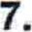PRIOR YEAR ADJUSTMENT
During the preparation of the accounts, it came to light restricted expenditure had been understated in the prior year in the SCS Creative Breaks and National Lottery funds. As a consequence, the restricted fund balances were too high at the end of March 2024, and general funds too low. Corrections were made to the comparatives to show less cash was held in restricted funds at the end of March 2024 and more in unrestricted funds.
8. TANGIBLE FIXED ASSETS
 | 55,130 | 7,458 | 62,588
TOTAL FUNDS | 219,998 | (17,899) | 202,099

9. DEBTORS: AMOUNTS FALLING DUE WITHIN ONE YEAR
 |  |  | 31.3.26 | 31.3.25 as restated
 | Prepayments and accrued income |  | 1 ,934 | 1,901
10. | CREDITORS: AMOUNTS FALLING DUE WITHIN ONE YEAR
 |  |  | 31.3.26 | 31.3.25 as restated
11. | Accrued expenses  MOVEMENT IN FUNDS |  | 1 ,440  Net movement | 1 ,440  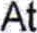
 | Unrestricted funds | At 1.4.25 | in funds | 31.3.26
 | General fund | 109,053 | (26,374) | 82,679
 | Designated fund | 55,815 | 1,017 | 56,832
 | Restricted funds | 164,868 | (25,357) | 139,511
 | Health & wellbeing fund - TSI | 6,898 | 4,254 | 11,152
 | SCS Creative Breaks | 15,697 | 869 | 16,566
 | National Lottery |  | 1,941 | 34,355
 | Inspiring Scotland - _NHS Highland | 121 |  | 121
 | Dementia Craft Group |  | 394 | 394
11. MOVEMENT IN FUNDS - continued
Net movement in funds, included in the above are as follows:

 | Incoming | Resources | Movement
Unrestricted funds | resources | expended | in funds
General fund | 248,169 | (274,543) | (26,374)
Designated fund | 1,017 |  | 1,017
Restricted funds | 249,186 | (274,543) | (25,357)
Health & wellbeing fund - TSI | 7,824 | (3,570) | 4,254
SCS Creative Breaks | 34,903 | (34,034) | 869
National Lottery | 66,319 | (64,378) | 11941
Dementia Craft Group | 1 ,500 | (1 06) | 394
 | 110,546 | (103,088) | 7,458
TOTAL FUNDS  Comparatives for movement in funds |  | 359,732  prior year | (377,631)  Net movement | (17,899)
Unrestricted funds | At 1.4.24 | adjustment | in funds | 31.325
General fund | 85,123 | 55,028 | (31,098) | 109,053
Designated fund | 54,248 |  | 1 ,567 | 55,815
Restricted funds | 139,371 | 55,028 | (29,531) | 164,868
Health & wellbeing fund - TSI | 10,000 | (1 ,667) | (1 ,435) | 6,898
SCS Creative Breaks | 35,450 | (19,500) | (253) | 15,697
National Lottery | 65,796 | (33,861) | 479 | 32,414
Inspiring Scotland - NHS Highland | 121 |  |  | 121
111,367 (55,028) (1 ,209) 55,130
TOTAL FUNDS 250,738 (30,740) 219,998


11, MOVEMENT IN FUNDS - continued
Comparative net movement in funds, included in the above are as follows:
 | Incoming | Resources | Movement
Unrestricted funds | resources | expended | in funds
General fund | 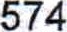 | (229,672) | (31,098)
Designated fund | 1,567 |  | 1 ,567
Restricted funds | 200,141 | (229,672) | (29,531)
Health & wellbeing fund - TSI | 7,138 | (8,573) | (1 ,435)
SCS Creative Breaks | 34,747 | (35,000) | (253)
National Lottery | 64,378 | (63,899) | 479
 | 106,263 | (107,472) | (1 ,209)
TOTAL FUNDS | 306,404 | (337, 144) | (30,740)
Designated funds
In accordance with the reserves policy, the charity has set aside a sum of 250,000 to ensure that, in the current difficult funding climate, sufficient funds are held to allow time for alternative funding sources to be accessed, or where new funding cannot be found, either a restructuring of activities, or an orderly voluntary winding up to be implemented. Since being set aside the sum has attracted interest and this has been added to the amount set aside. At the end of the year the amount set aside for this purpose is E56,832

12. RELATED PARTY DISCLOSURES
There were no related party transactions for the year ended 31 March 2026.
Detailed Statement of Financial Activities for the Year Ended 31 March 2026
INCOME AND ENDOWMENTS  Donations and legacies | 31.3.26 | 31.3.25 as restated
Donations  Investment income | 10,043 | 6,486
Deposit account interest  Charitable activities | 1,092 | 1 ,604
Invoiced income | 3,910
Grants | 328,872 | 268,581
Travel/mileage for clients | 1 1 ,547 | 8,786
SDS Funded | 4,268 | 20,947
 | 348,597 | 298,314
Total incoming resources  EXPENDITURE  Raising donations and legacies | 359,732 | 306,404
Development & fundraising  Charitable activities | 3,250 | 4,750
Wages | 294,059 | 247,738
Pensions | 3,423 | 3,058
Insurance | 2,721 | 2,610
Light and heat | 1 ,880 | 11642
Telephone | 2,979 | 3,861
Postage and stationery | 4,003 | 9,683
Rent | 9,504 | 9,793
Other motor/travel costs | 42,250 | 36,756
Other costs | 3,750 | 5,198
Reminiscence/Monday group |  | 7,520
Water rates | 745 | 661
Bank charges | 216 | 150
Crafting Connections Group | 3,570
Carried forward | 369,100 | 328,670

This page does not form part of the statutory financial statements Detailed Statement of Financial Activities for the Year Ended 31 March 2026
Charitable activities | 31.3.26 | 31.3.25 as restated
Brought forward | 369,100 | 328,670
Dementia craft group costs | 1,139
Plant and machinery | 21 | 4
Fixtures and fittings | 1
Support costs  Governance costs | 370,261 | 328,674
Accountancy and legal fees | 2,706 | 2,376
Affiliation and regulatory | I .414 | I , 344
 | 4,120 | 3,720
Total resources expended | 377,631 | 337,144
Net expenditure | (17,899) | (30,740)
This page does not form part of the statutory financial statements

