Fostering Compassion S.C.I.O
Scottish Charity No. SC046975

The Trustees Annual Report and Financial Statements for
The Year Ended 31st December 2025

Contents

Trustees Annual Report Page 3-7

Independent Examiner’s Report Page 8

Statement of Receipts and Payments Page 9

Statement of Balances Page 10

Notes to the Financial Statements Page 11-13

Trustees Annual Report

The Trustees have pleasure in presenting their report together with the financial statements and the Independent Examiner’s report for the year ended 31st December 2025
Reference and Administration Details

Charity Name: Fostering Compassion
Charity No: SC046975

Principal Address: 1D Cockburn Halls
Ormiston
East Lothian
EH35 5JB

Charity Trustees serving on the date of approval of the Trustees Annual Report :

Professor Jo Williams
Professor Andrew Gardiner BVM&S, Cert SAS, MSc, PhD, Dipl ECAWBM, MRCVS
Dr Heather Bacon BSc (Hons), BVSc, Cert Zoo Med, MRCVS
Christine Mill
Sandra Ovens
Sheila Dales
Holly Kilday
Julie Samuel
Elspeth Wallace (appointed September 2025)

Structure, Governance and Management

Constitution

Fostering Compassion began as the humane education project of the Winton
Foundation for the Welfare of Bears (SCIO) Registered Charity No: SC042614. It
was then separated from the Foundation and established as a charity in its own right
on 11th November 2016 and is now known as Fostering Compassion (SCIO)
Registered Charity No: SC046975 and is governed by its own constitution. The
Trustees are the only members and they make up the Board.

Trustee Appointment

Charity Trusteeship is open to;

- any person aged 16 or over, and/or
- any individual who has been nominated for membership by an unincorporated organisation; and/or
- any corporate body,

who subscribes to the purposes of the organisation and wishes to see them fulfilled.

Applications must be in writing and will be considered at the subsequent board meetings. All Trustees step down at the annual AGM but are eligible to be re-elected.

Objectives and Activities

The organisation is established for charitable purposes only, and in particular, the object is to advance animal welfare, the advancement of education and the advancement of health. In furtherance of these purposes the organisation will:-

- Undertake work through the 'Fostering Compassion' humane education project and other methods to encourage children, with a special focus on looked-after children, to see animals as sentient beings who can share similar emotions as they do. By sharing the stories of rescued animals we will work to address the links between animal abuse, child abuse and domestic violence, to reverse the cycle of abuse and help turn worrying behaviour into nurturing and compassionate behaviour. We will raise awareness, through educational and informative means, of the animals and environment we share the planet with. The project is designed to help the children gain a greater understanding of their own circumstances through sharing the stories of rescued animals, instilling compassion and empathy.

- Look at and study attachment to pets, especially in relation to the vulnerable, compassion towards pets and pets helping with transitions during a change of circumstances. We will undertake to promote a stable relationship between human and animal and protecting the bond and attachment.

Summary of the main activities in relation to these objects

2025 has been another busy year for Fostering Compassion as we continue to deliver workshops, activities and Support Sessions throughout the year. Our group activities take place throughout the school holidays and we now offer these during the February break, Easter and Summer Holidays and the October break. We invite up to 20 children to attend our animal themed activities. These may be individual children who have previously benefited from our one to one sessions, children who fare better in a group setting or already established groups of children who already know each other. We are pleased to be able to provide the comfort of familiar groups and also the opportunity to meet new children and make friends. We are in the unique position of being able to cater to each child’s individual needs to ensure they are at their most comfortable.

We hold all of our activities in our beautiful Woodland Haven room which is directly opposite our office and provides a warm, comforting and child friendly setting. In addition to this, we have created a ‘quiet area’ in our office which sets aside a small sofa, toys, fairy lights and a partition for any child who may feel a little overwhelmed during the main group activity. This has proved extremely beneficial allowing an anxious child a separate area to decompress until they feel comfortable enough to rejoin the main group.

Our one-to-one Support Sessions for children who don’t fare so well in group environments are still proving very popular. These sessions are called ‘Working with Worry’, ‘Coping with Change’, ‘Fostering Resilience’ and ‘Moving on from Mistakes’ are really popular and sought after, complementing our existing services nicely. We are currently developing another batch of four Support Sessions themed around nature and the environment and additional stand alone Support Sessions themed around loss, bereavement and making friends which can be offered when appropriate. Children being taken into care, often suffer a sense of real loss, even if that is a separation from a neglectful parent. Many children also suffer a sense of loss if separated from a companion animal.

Our firm favourite group workshops including ‘Mr T’s Tickles’, ‘Hollydays’, ‘Animal Heroes’ and ‘Horsing Around - Why the Long Face’ provide the children the opportunity for some animal interaction which they adore. We are provided with lovely therapy dogs and therapy ponies through our longstanding relationships with Canine Concern Scotland Trust and Therapy Ponies Scotland. Our Animal Assisted Activities provide a wonderful opportunity for the children to have some hands on experience with the animals and learn all about their care and their needs.

Our wonderful relationship with the Royal (Dick) School of Veterinary Studies at Edinburgh University continues with the current students continuing to develop and host our much loved ‘Be A Vet for the Day’ workshop. This relationship goes back ten years, only stopping during the pandemic. The Fostering Compassion children are so lucky to be allowed access to the Clinical Skills Lab at the school and are allowed to see where the students learn to become vets, diagnose animal ailments and administer treatments. The children get to dress up in scrubs so they are properly playing the part of a vet for the day. The children rotate around all the different ‘stations’ the students make up and take turns learning a variety of skills. The children are all asked to bring their favourite teddies so they can practice bandaging them! We hope, with the amazing help of the students, we are playing a part in creating the vets of the future.

Throughout 2025 we have continued to build on relationships with our many referral agencies and have made connections with new ones. We receive referrals from Social Work, Local Authorities, medical professionals, schools, Third Sector Children’s Charities and self referrals. We continue to receive a number of individual referrals from families desperate for support and with nowhere else to turn having excellent results with a number of these children.

We continue to nurture and develop our relationship with the Young Carers Service within East Lothian Council and welcome them to bespoke workshops and activities for their already established groups. There are thousands of Young Carers in East Lothian and we are delighted to partner with the Local Council to help provide them and their families with support. There are currently 670 Young Carers registered with our Local Authority but it is thought there are at least 4000 young carers in East Lothian. We aim to provide as much support to them as possible.

We continue our excellent relationship with Edinburgh University and will be working again with their students to conduct more up to date research to ensure that Fostering Compassion continues to deliver robust and evidence based services that are the best they can be for our service users.

During 2025 we continued to implement our succession plans as our current CEO begins to move towards retirement. With the assistance of funding from the National Lottery and our unrestricted resources we were able to recruit a Volunteer Development Officer and a Fundraising Development Co-ordinator in 2024 and appointed a Deputy CEO towards the end of 2025. Our new Volunteer Recruitment Programme is ensuring we reach many more individuals looking to volunteer with us and this and the development of our infrastructure will ensure we continue to grow and move forward in as strong a position as possible.

Financial Review
We continue to work hard to raise funds and increase awareness of our work to help diversify income streams. The recruitment of our new Fundraising Development Co-ordinator has been a huge help in taking much of the fundraising pressure off our CEO who in the past has been solely responsible for raising funds. This addition to the team has resulted in a healthy number of funding applications now being submitted on a regular basis to potential funders. We continue to try to raise unrestricted funding to help us continue with our expansion and succession plans allowing us to broaden our service delivery, help many more children and secure the financial future of the charity. We are gradually securing longer term funding over 2 - 3 year periods which helps hugely with forward planning

We continue to try to increase direct debit giving and community fundraising. As the new Volunteer Development Officer continues to recruit more volunteers we will be able to broaden this area of fundraising.

During the accounting period our income totalled £105.946. We received grants from the Robertson Trust (£15,000), the CRH Trust (£35,000) The National Lottery (£30,000) Weir Charitable Trust (£7,727) Albert Hunt Trust (£5,000) Wanderwide Trust (£4,000), Stafford Trust (£3,250) John Lewis Trust (£1,250) Scottish Children’s Lottery £1,000) and Timpson’s Trust £300 We received donations totalling £410 and raised £2,661 through fundraising and activities. Some of these funds were restricted and this has been reflected accordingly in the financial statements.

Our charitable expenditure for the accounting period was £71,097 which was made up of
staff wages, session delivery costs, administrative, running and governance costs. We
continue to rent two rooms at Cockburn Halls, Ormiston - our main office at 1d and our
Woodland Haven room at 1a which is the perfect setting for workshops, activities, training and meetings.

The Committee has reserves, funds freely available to meet the running costs of the charity
of £48,106, taking into account listed liabilities. All paid staff are now employees.

Reserves Policy

The charity has no real assets and have agree to maintain reserves of £15,000 to allow a cushion of at least 3 month running costs. They have achieved that this year.

Future Plans

Fostering Compassion continued to thrive during 2025 providing services throughout the year for vulnerable and care experienced children aged 3 - 25 years often helping children with nowhere else to turn. We will be continuing to provide our full level of services to Local Authorities, third sector Children’s Charities, schools in areas of socioeconomic
depravation and welcoming self referrals. We are keen to continue developing our activities for East Lothian’s Young Carers given the clear level of need.

We will continue implementing our succession planning to cement the future of Fostering Compassion. We are working to bring in more volunteers to help us meet the continually increasing demand for our services

We are hopeful that the appointment of a Fundraising Development Co-ordinator, will lead to a more stable flow of income to assist us with longer term planning and we will continue to work to diversify our sources of income so that we become less reliant on Grant funding. There is no doubt fundraising is getting harder and harder with more competition for limited pots of funds.

We are delighted to have appointed our new Depute CEO as we go through a transition process as part of our succession planning. This will allow our current CEO to gradually pass her knowledge on to her Depute and allow her to move towards full retirement while securing the future of the charity.

Moving forward, we will continue to cement our presence in our immediate locality of East and Midlothian offering services and the use of our Woodland Haven room to our local community and children’s services. The concept of ‘The Link’ and the strength and importance of the human-animal bond continue to heavily underpin all our work. Our work in general will continue to promote the benefits of the human-animal bond and care, compassion and empathy for animals and the environment we share.

We will continue to raise awareness of the work of Fostering Compassion through local and
international talks and presentations, information days and stalls, social and mainstream media and our website. We continue to build a strong infrastructure of sessional staff and
volunteers to meet the constantly increasing demand for our services.

 | Independent Examiner’s Report on the Accounts
Report to the  trustees/members of | Fostering Compassion S.C.I.O
Registered charity number | SC046975
On the financial statements of the  charity for the year ended | 31st December 2025
Respective  responsibilities of  trustees and examiner | The charity’s trustees are responsible for the preparation of the accounts in accordance with the terms of the Charities and Trustee Investment (Scotland) Act 2005 (‘the 2005 Act’) and the Charities Accounts (Scotland) Regulations 2006(as amended) (‘the 2006 Accounts regulations’ ) The charity trustees consider that the audit requirement of Regulation 10(1) (d) of the Accounts Regulations does not apply. It is my responsibility to examine the accounts as required under section 44(1) (c) of the 2005 Act and to state whether particular matters have come to my attention..
Basis of independent  examiner’s statement | My examination is carried out in accordance with Regulation 11 of the 2006 Accounts Regulations. An examination includes a review of the accounting records kept by the charity and a comparison of the accounts presented with those records. It also includes consideration of any unusual items or disclosures in the accounts and seeks explanations from the trustees concerning any such matters. The procedures undertaken do not provide all the evidence that would be required in an audit and, consequently, I do not express an audit opinion on the accounts.
Independent examiner’s  statement | In the course of my examination, no matter has come to my attention :  1. which gives me reasonable cause to believe that in any material respect the requirements:  - to keep accounting records in accordance with section 44(1) (a) of the 2005 Act and Regulation 4 of the 2006 Accounts Regulations, and  - to prepare accounts with accord with the accounting records and comply with Regulation 9 of the 2006 Accounts Regulations have not been met, or  2. to which, in my opinion, attention should be drawn in order to enable a proper understanding of the accounts to be reached
Signed: |  | Date: | 16/04/2026
Name: | Krzysztof Cieselielka
Address: | 51 Adam Drive  East Calder  EH53 0PX

Statement of Receipts and Payments for the year ended 31st December 2025

Receipts | Notes | Unrestricted  funds | Restricted fund | Total funds  2025 | Total funds  2024
Grants  Donations  Fundraising  Income from Charitable Activities  Gift Aid | 3  4 | 14,800  410  2,661  348  - | 87,727 | 102,527  410  2,661  348  - | 80,204  978  6,349  414  3,509
Total Receipts |  | 18,219 | 87,727 | 105,946 | 91,454
Payments
Cost of Charitable Activities  Governance | 5  6 | 1,074  22,015 | 214  47,794 | 1,288  69,809 | 73,945  1,081
Total Payment |  | 23,089 | 48,008 | 71,097 | 75,026
Surplus / (Deficit) |  | (4,870) | 39,719 | 34,849 | (16,428)

The notes on page 12-14 form an integral part of these financial statements.

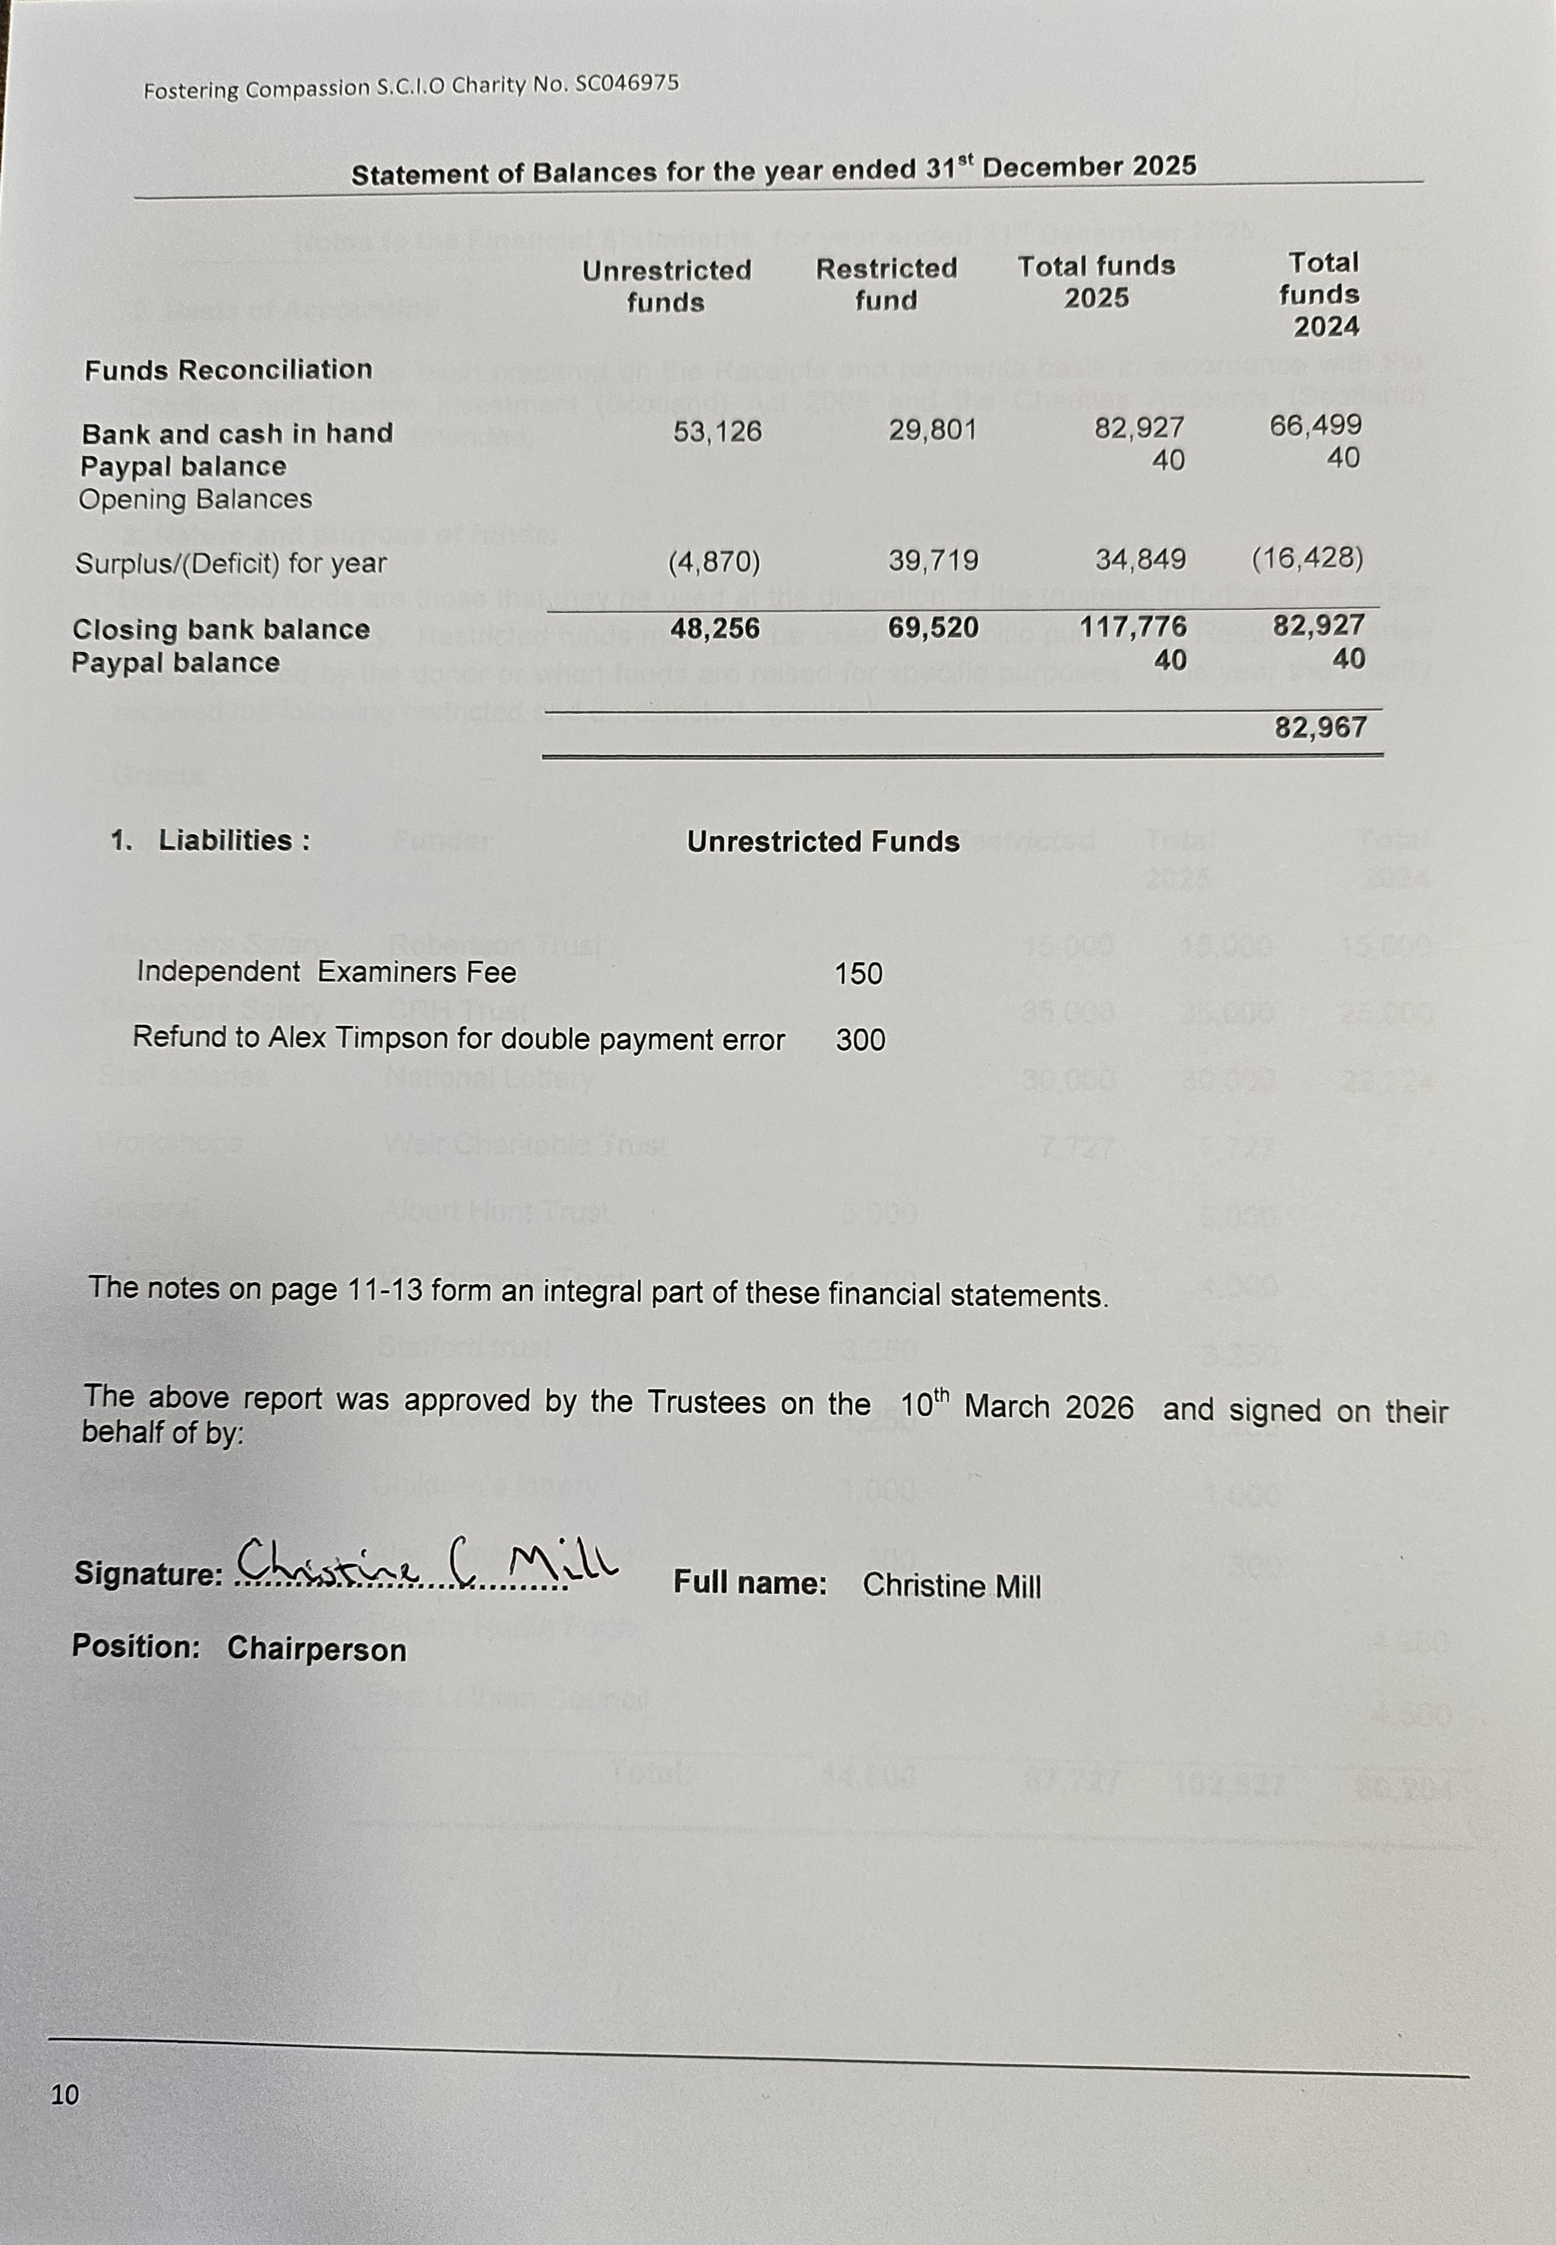

Notes to the Financial Statements for year ended 31st December 2025

2. Basis of Accounting

These accounts have been prepared on the Receipts and payments basis in accordance with the Charities and Trustee Investment (Scotland) Act 2005 and the Charities Accounts (Scotland) Regulations 2006 (as amended)

3. Nature and purpose of funds:

Unrestricted funds are those that may be used at the discretion of the trustees in furtherance of the objects of the charity. Restricted funds may only be used for specific purposes. Restrictions arise when specified by the donor or when funds are raised for specific purposes. This year the charity received the following restricted and unrestricted grants.
Grants
Purpose | Funder | Unrestricted | Restricted | Total 2025 | Total 2024
Managers Salary | Robertson Trust |  | 15,000 | 15,000 | 15,000
Managers Salary | CRH Trust |  | 35,000 | 35,000 | 25,000
Staff salaries | National Lottery |  | 30,000 | 30,000 | 29,224
Workshops | Weir Charitable Trust |  | 7,727 | 7,727 | -
General | Albert Hunt Trust | 5,000 |  | 5,000 | -
General | Wanderwide Trust | 4,000 |  | 4,000 | -
General | Stafford trust | 3,250 |  | 3,250 | -
General | John Lewis Trust | 1,250 |  | 1,250 | -
General | Children’s lottery | 1,000 |  | 1,000 | -
General | Alex Timpson Trust | 300 |  | 300 | -
General | Bauers Radio Forth |  |  |  | 4,980
General | East Lothian Council |  |  |  | 4,500
 | Total: | 14,800 | 87,727 | 102,527 | 80,204

4. Donations
Purpose | Donor |  |  | Unrestricted | Restricted | Total 2025 | Total 2024
General |  | Lady Sarah Ward |  | - |  | - | 5,000
General |  | Individual |  | 410 |  | 410 | 978
 |  |  | Total: | 410 |  | 410 | 5,978

5. Cost of Charitable Activities
 |  | Unrestricted | Restricted | Total 2025 | Total 2024
 | Manager Salary |  | 28,232 | 28,232 | 47,320
 | Contracted staff costs | 2,654 | 8,888 | 11,542 | 2,467
 | Tax and pension |  | 10,269 | 10,269 | -
 | Rent & utilities | 12,384 |  | 12,384 | 12,384
 | Sessional & volunteer hours | 1,273 |  | 1,273 | 2,841
 | Resources & equipment | 2,103 | 405 | 2,508 | 1,541
 | HR Services | 628 |  | 628 | -
 | Website | 506 |  | 506 | 1,042
 | Phone & broadband fees | 1,071 |  | 1,071 | 810
 | Service delivery | - |  | - | 2.265
 | Travel & accommodation | 28 |  | 28 | 94
 | Insurance & fees | 1,270 |  | 1,270 | 1,426
 | Donation to fund bursary | - |  | - | 1,000
 | Marketing & fundraising costs | 18 |  | 18 | 755
Training |  | 80 |  | 80 | -
Total |  | 22,015 | 47,794 | 69,809 | 73,945

6. Governance | Unrestricted | Restricted | Total 2025 | Total 2024
Monitoring and Preparation of accounts | 913 |  | 913 | 900
Independent Examination | 161 |  | 161 | 150
Accounts package |  | 214 | 214 | 31
 | 1,074 | 214 | 1,288 | 1,081

7. Trustees Remuneration
One Trustee was paid £1,200 over the financial year for administration support and £60 for storing resources for the charity.

