Errol Primary School Parent Council Charity
Scottish Charity Number: SC050267
Trustees’ Annual Report
For the year ended 31 March 2026
1. Introduction
The trustees are pleased to present the annual report for Errol Primary School Parent Council Charity for the year ended 31 March 2026.
The Parent Council Charity exists to support the pupils and wider school community of Errol Primary School by helping to provide opportunities, resources and activities that enhance the school experience for children and their families.
The charity currently supports approximately 170 pupils and aims to work closely with the school, parents, carers and the wider community.
2. Events and Activities During the Year
During the year, the Parent Council continued to encourage involvement from parents, carers and school staff through a range of social, community and fundraising events.
A particular highlight was our Bingo Tea, which was very well supported by both parents and members of staff. The event provided an enjoyable opportunity for families and staff to come together socially and strengthen the school community. It was a lively and welcoming event, with children and adults taking part together.
We also held a Quiz Night with a raffle, which was very well supported by parents and teachers. The evening provided another opportunity for members of the school community to come together, enjoy a fun social event and support the work of the Parent Council.
The Parent Council also organised a Christmas Wreath Making event, giving parents and members of the school community the opportunity to get together and enjoy a festive activity. The event helped create a warm and welcoming atmosphere within the school community and was a lovely way to celebrate the Christmas season together.
The trustees would like to thank everyone who attended, helped organise these events or contributed in any way to their success.
Bingo Tea
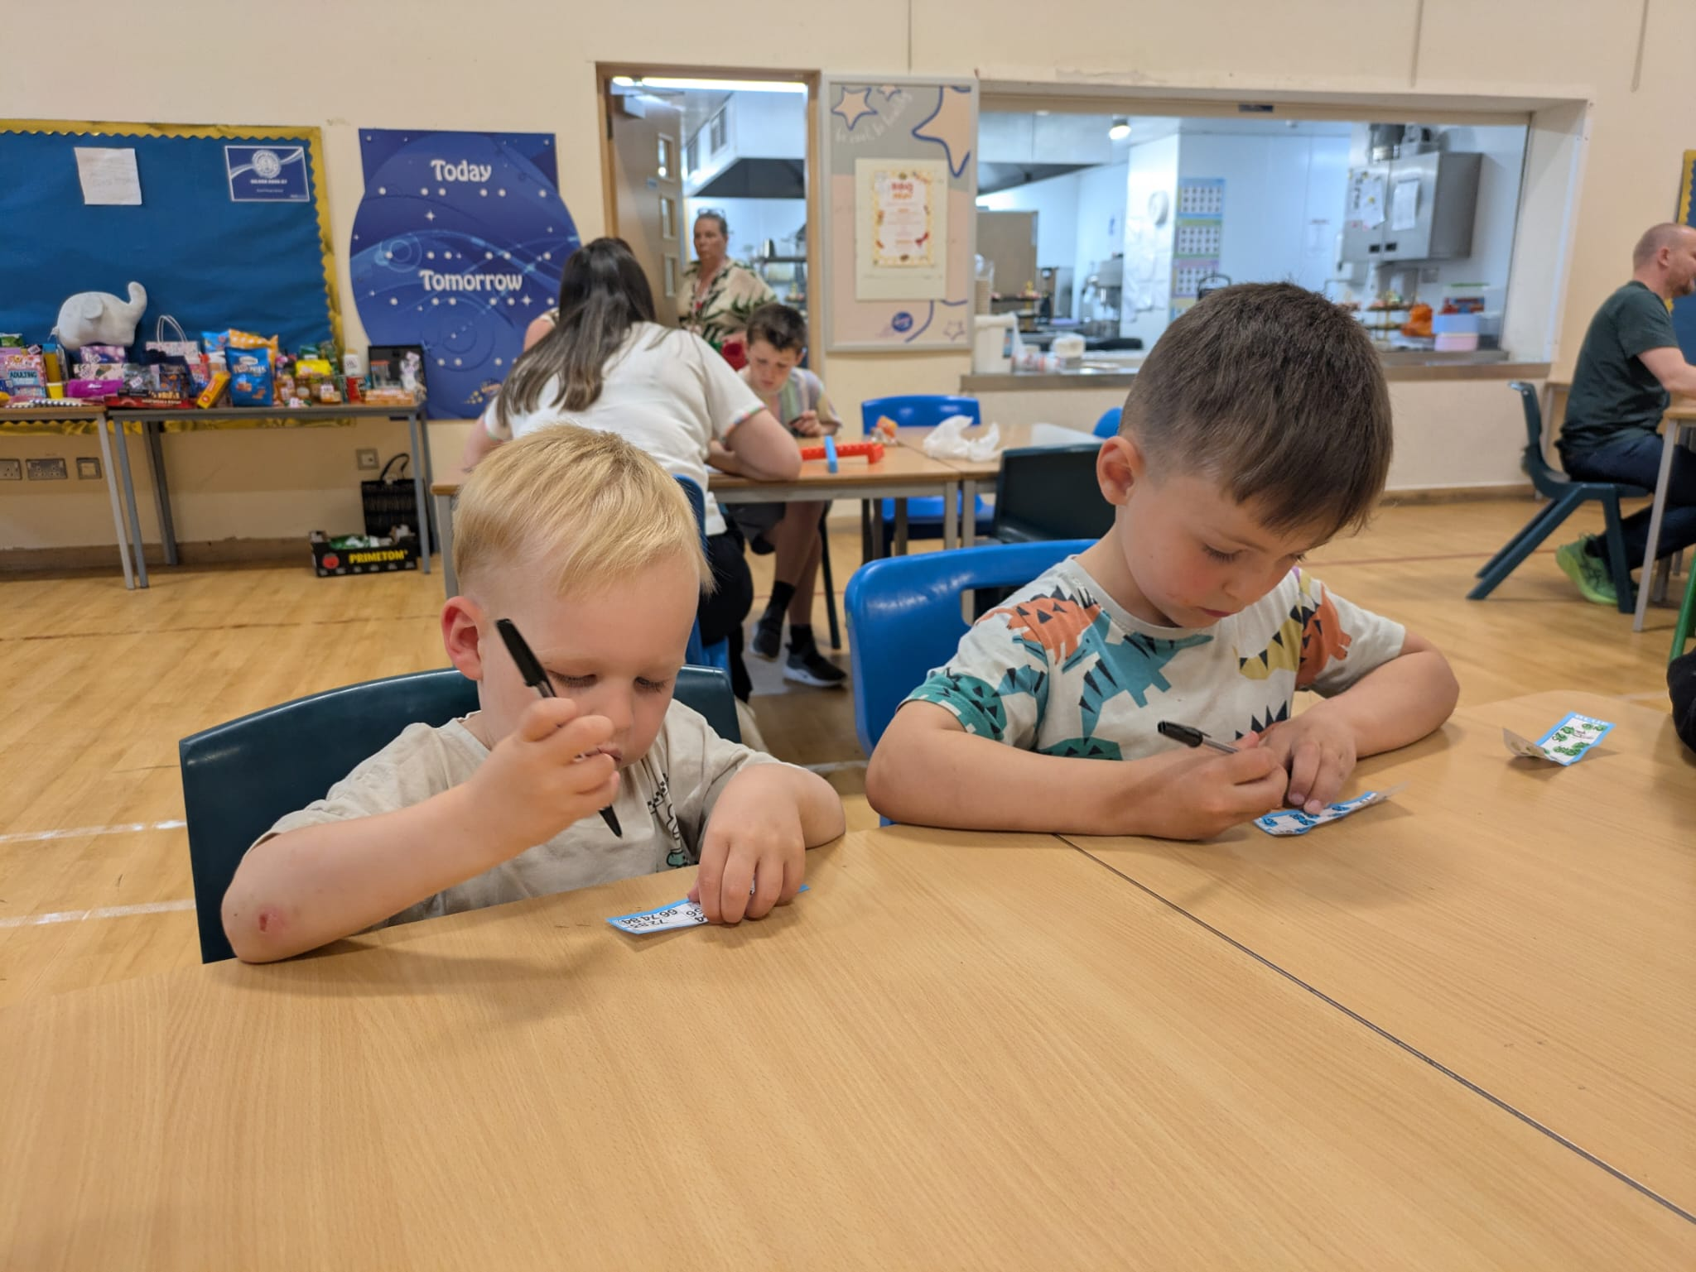
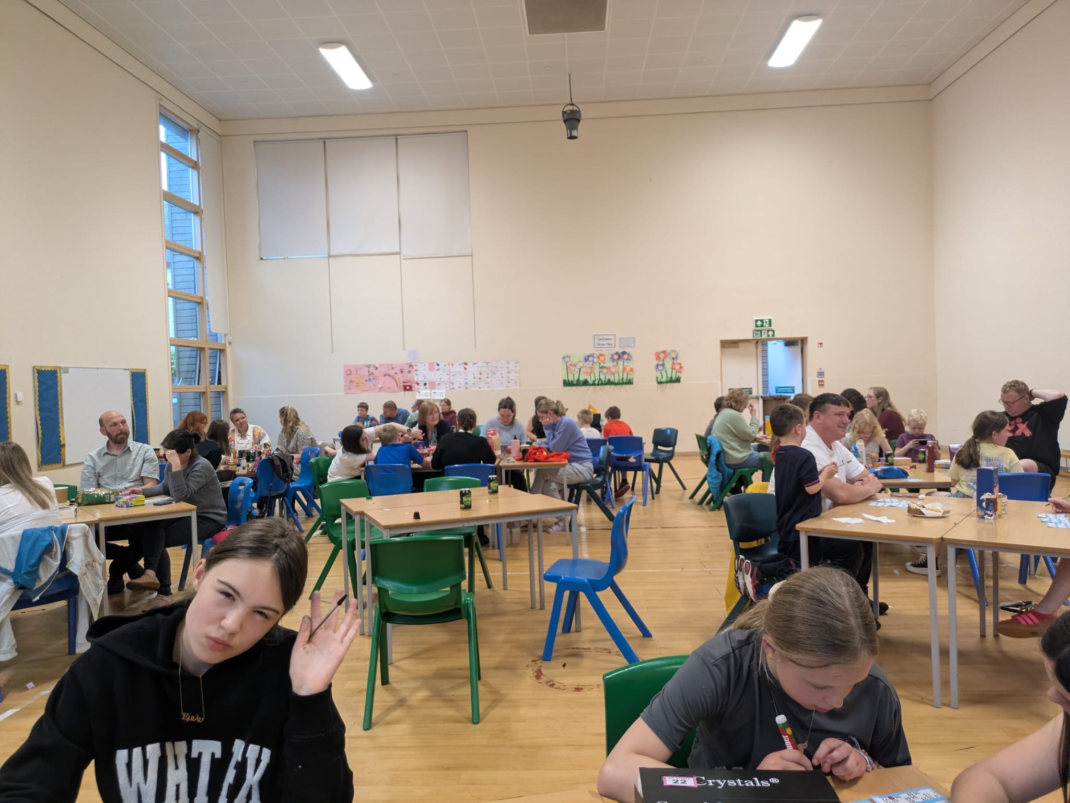
Photos from the Bingo Tea event, showing pupils, parents and members of the school community taking part.
3. Beneficiaries
The principal beneficiaries of the charity are the pupils of Errol Primary School, with approximately 170 children benefiting from the work and activities of the Parent Council Charity.
The charity seeks to support the children’s education, wellbeing and wider school experience.
4. Community Engagement
Community events are an important part of the Parent Council's work. They provide opportunities for parents, carers and staff to come together and build positive relationships within the school community.
The support for the Bingo Tea, Quiz Night and Christmas Wreath Making event demonstrated the continued enthusiasm and involvement of parents, teachers and the wider school community.
The trustees are grateful to all parents, carers, staff and volunteers who have supported the Parent Council throughout the year.
5. Governance and Management
The charity is managed by its trustees in accordance with its charitable purposes and applicable requirements.
The trustees are responsible for ensuring that the charity is managed appropriately and that its activities continue to benefit the pupils of Errol Primary School.
The Parent Council continues to rely on the commitment and goodwill of volunteers, parents and school staff to organise events and support the charity's activities.
6. Looking Ahead
The trustees intend to continue supporting the pupils of Errol Primary School during the coming year.
The Parent Council will seek to organise further community events and activities, while continuing to work with the school to identify opportunities that provide meaningful benefits to pupils.
The trustees hope to build on the success of the past year and continue to encourage strong participation from parents, carers, teachers and the wider school community.
7. Acknowledgements
The trustees would like to express their sincere thanks to all parents, carers, school staff and volunteers who have supported Errol Primary School Parent Council Charity during the year.
In particular, we are grateful to everyone who supported the Bingo Tea, Quiz Night and Christmas Wreath Making event, helping to make these successful and enjoyable occasions for the school community.
The continued support of our school community enables the Parent Council Charity to provide valuable opportunities and support for the approximately 170 pupils of Errol Primary School.

Approved by the Trustees of Errol Primary School Parent Council Charity
Date: 29/9/26

Cameron Pitcaithly
Chairman

