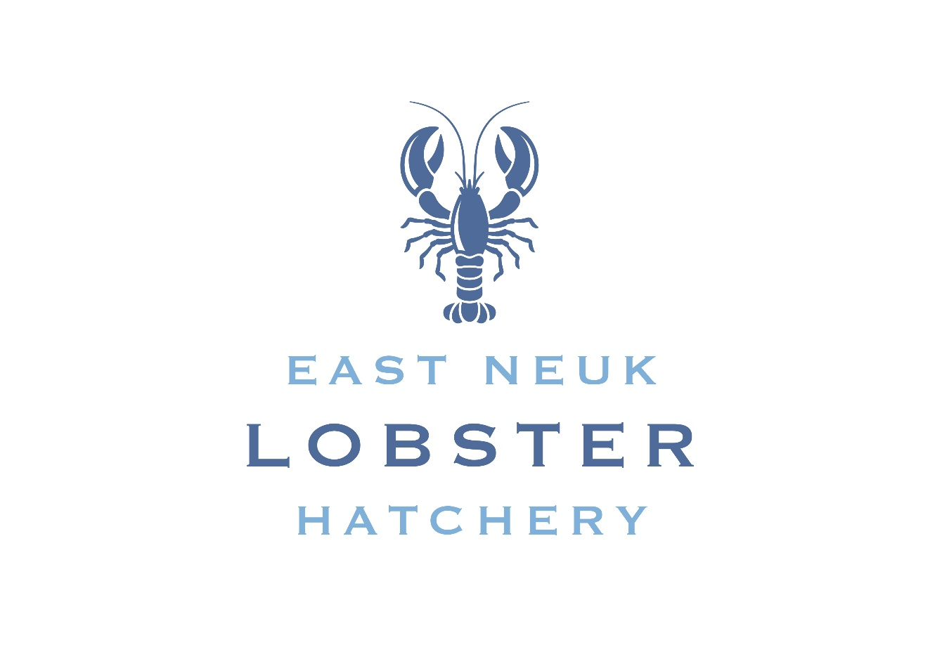
Trustees’ Annual Report
For the year ended 31 December 2025
Scottish Charity Number SC053024
Scottish Charitable Incorporated Organisation (SCIO)

Prepared for submission to the Office of the Scottish Charity Regulator (OSCR)

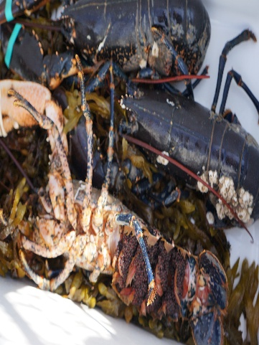
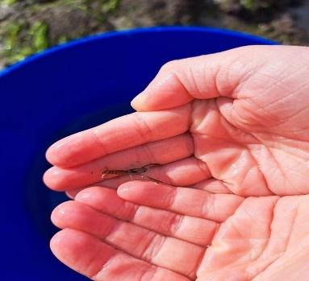
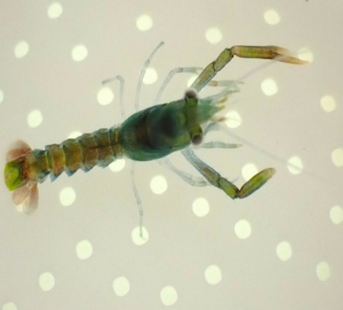

1. Reference and statutory basis
This Trustees’ Annual Report has been prepared for East Neuk Lobster Hatchery for the financial year ended 31 December 2025. The report is intended to form part of the charity’s annual accounts and to meet the narrative reporting requirements applicable to a Scottish charity preparing receipts and payments accounts.
The report has been structured around the information required by Schedule 2 of the Charities Accounts (Scotland) Regulations 2006 and current OSCR guidance.

2. Charity reference details
Charity name | East Neuk Lobster Hatchery
Scottish Charity Number | SC053024
Constitutional form | Scottish Charitable Incorporated Organisation (SCIO)
Principal office / address | 22 Peter Howling Place, Anstruther, Fife, KY10 3YQ
Main operating area | East Neuk of Fife and the Firth of Forth
Financial year | Year ended 31 December 2025
Telephone | 07807431030
Email | info@fifelobsterhatchery.com
Website | www.fifelobsterhatchery.com

3. Trustees
The following individuals served as charity trustees during the financial year, based on the charity’s 2025 meeting records:
Trustee | Role / office held
Shaun Suttie | Chairperson
Ellis Jaffray | Treasurer
Daryl Wilson | Secretary
Claire Doig | Trustee

4. Governing document and constitution
East Neuk Lobster Hatchery is constituted as a Scottish Charitable Incorporated Organisation (SCIO). Its governing document is its constitution, which sets out the charity’s purposes, governance arrangements and the way in which trustees are appointed.

5. Trustee recruitment and appointment
Trustees are recruited and appointed in accordance with the charity’s constitution. At the Annual General Meeting held on January 15th, 2025, Daryl Wilson, Claire Doig and Ellis Jaffray retired and were re-elected. Shaun Suttie was appointed Chairperson, Ellis Jaffray Treasurer and Daryl Wilson Secretary. During the year the committee also welcomed additional members of the public to support the development of the charity.
- 2025 AGM followed the appointment and re-election procedures set out in the constitution.
- Chris Lewis expressed an interest in joining the committee and was subsequently participating in committee meetings.
- Alisdair Busby participated in committee work and provided support on funding, planning and external contacts.

6. Charitable purposes
The charity’s purposes, as recorded on the Scottish Charity Register, are to advance education and public understanding regarding lobsters, their life cycle and marine environment; advance the fishing heritage of the East Neuk of Fife and Firth of Forth; advance community development and involvement; and advance marine conservation, environmental protection and sustainability through lobster hatchery, release, monitoring and related activities.

7. Objectives and activities during 2025
During 2025 the trustees concentrated on developing the project from an early-stage community initiative towards a technically and financially viable lobster hatchery. The main workstreams were:
- Feasibility and technical development of the proposed lobster hatchery.
- Community consultation and engagement with fishermen, educational organization’s and local stakeholders.
- Development of a suitable site and progression towards planning permission for two containers: a hatchery/production unit and an educational/community unit.
- Research into hatchery suppliers and identification of North Bay Innovations as the preferred system provider following investigation of available options.
- Fundraising and identification of potential grant programmes to meet capital and development costs.
- Development of the charity’s website and public communications.
- Development of education, conservation, volunteering and community engagement opportunities.
- Exploration of future research and monitoring opportunities relating to lobster stocks and marine biodiversity.

8. Main achievements and outcomes

Feasibility study
A feasibility study was commissioned from Lobster Aquatic. The trustees considered the consultant’s experience and quotation and agreed to proceed. The study included stakeholder engagement and a public survey. The trustees received positive feedback from those consulted, providing reassurance that the proposed hatchery was welcomed locally. The study identified further actions including community consultation, harbour engagement, planning, securing start-up capital, educational engagement and development of an initial business plan.

Hatchery development
The trustees investigated available hatchery systems and visited the North Bay Innovations facility at Comrie. Following comparison with other options, the trustees considered North Bay Innovations to offer the most suitable containerised system for the charity’s requirements. By October 2025, an updated cost breakdown for the complete hatchery system and potential solar add-ons had been obtained, providing a basis for future funding applications.

Planning and location
The trustees continued to work towards establishing the hatchery on the pier in Anstruther. During the year, professional input was obtained to assist with preparation of a planning application for the proposed two-container development. The external appearance and livery of the containers were also considered, including the proposed use of the ENLH logo and social media information.

Community and education
The charity developed relationships with local organisations and community stakeholders. Waid Academy’s science department expressed interest in involvement. The trustees also explored beach-clean activities, educational opportunities and public presentations. The charity took part in community events, including the Cellardyke Pool Party, which was reported as successful for raising awareness and publicity.

Website and communications
Work progressed throughout the year on the charity website. Members compiled content and worked with the website developer and content contributors. Filming was completed for website material, a voiceover was produced, a blog section was approved and a donation facility was added. The trustees viewed the website as an important tool for public education, consultation, fundraising and communicating the charity’s aims.

Fundraising
The trustees pursued a range of potential funding sources during 2025. Funding and support discussed or pursued included Community Kist, Fife Council Community Project Funding, university community funding, local community funds, the Crown Estate Fund, Fife Rural Development funding, Marine Fund Scotland, the Scottish Marine Environment Enhanced Fund and charitable trusts. Several applications were unsuccessful or unavailable, but the trustees continued to develop a pipeline of future applications.
The charity also raised funds through community fundraising activity. The Christmas raffle was reported to have raised £1,204.

9. Public benefit
The trustees consider that the activities undertaken during 2025 furthered the charity’s purposes and provided, or are intended to provide, public benefit. The project is designed to benefit the wider community through increased understanding of lobster life cycles and the marine environment, engagement with local fishing heritage, opportunities for volunteering and education, and the longer-term conservation of marine resources in the East Neuk and Firth of Forth.

10. Governance, meetings and management
The trustees met during the year to oversee the development of the charity, consider finances, fundraising, planning, feasibility work, communications and stakeholder engagement. Meeting records show that declarations of interest were considered at the meetings recorded in 2025, with no declarations noted.
The trustees also progressed governance matters including safeguarding arrangements and a reserves policy. The 2025 accounts were signed off and submitted to OSCR, and trustee details were updated.

11. Financial review
The charity prepares receipts and payments accounts. The trustees’ financial oversight during 2025 focused on preserving available funds while progressing the feasibility, planning, communications and hatchery-development work.
The meeting records show a balance of £2,210.77 at one stage of the year. Expenditure included website development, the feasibility study and domain costs. The records also identify a further £1,250 due to Lobster Aquatics on completion of the feasibility study.
Income recorded in the meeting minutes included £2,000 from Fife Council Community Project Funding, £200 from the BP Welfare Fund, £50 from a donated raffle prize and £174 raised through the Christmas raffle. The trustees also pursued numerous grant and funding applications.

12. Reserves policy
The trustees adopted a reserves policy during 2025. The policy is intended to ensure that the charity retains sufficient unrestricted funds to meet essential short-term commitments and maintain continuity of its charitable activities while it seeks substantial external funding for the proposed hatchery.
The trustees recognise that the charity is at an early development stage and that available unrestricted funds are limited relative to the capital requirements of the proposed hatchery. Funds are therefore managed carefully and expenditure is authorised with regard to the charity’s purposes, available resources and future funding requirements.

13. Deficit
The trustees have not identified a deficit requiring a specific explanation in this report. The final position should be checked against the signed 2025 receipts and payments accounts.

14. Donated services and facilities
The charity benefited from voluntary contributions and professional assistance during the year. For example, committee members undertook project development, fundraising, stakeholder engagement and website/content work without charge, and professional knowledge was made available to assist with the planning application. These contributions supported the charity’s activities and reduced the cash cost of progressing the project.

15. Related parties and conflicts of interest
The 2025 meeting records note that declarations of interest were considered and no declarations were recorded at the meetings covered by the supplied minutes. Trustees should confirm against the charity’s register of interests and final accounts whether there were any related-party transactions or other matters requiring disclosure.

16. Plans for the future
The trustees’ principal objective remains to establish a community lobster hatchery in the East Neuk of Fife. Priorities following the 2025 reporting period include:
- Progressing planning and associated technical requirements for the proposed hatchery site.
- Securing capital funding for the hatchery system and education/community facilities.
- Continuing community consultation and stakeholder engagement.
- Developing educational and outreach activities with local schools and community organisations.
- Developing the charity’s website and public communications.
- Exploring appropriate marine conservation, stock assessment and long-term monitoring projects.
- Strengthening governance, fundraising and operational planning so the charity is ready to move into implementation when funding and permissions allow.

17. Independent examination / external scrutiny
The independent examiner’s report is provided separately with the charity’s annual accounts.
[David Nuttall, 22 Queens Gardens, Anstruther, KY10 3BU]
Independent examiner

18. Approval of the Trustees’ Annual Report
This Trustees’ Annual Report was approved by the charity trustees on the date shown below and signed on behalf of all the charity trustees.

Declaration
Signed on behalf of the charity trustees:
SSSSSSHAUN SUTTIE

SHUAN SUTTIE
Print name
CHAIRMAN
Designation
27th September 2025
Date

