DALMUIR PARK HOUSING ASSOCIATION LIMITED

REPORT AND FINANCIAL STATEMENTS
FOR THE YEAR ENDED 31 MARCH 2026

Registered Housing Association Number: HAL 98
Charity Registration Number: SC033471
FCA Reference Number: 1917 R S
Property Factor Number : PF000397

DALMUIR PARK HOUSING ASSOCIATION LIMITED

CONTENTS Page

MEMBERS OF THE BOARD OF MANAGEMENT, EXECUTIVES AND ADVISERS |  | 3
REPORT FROM THE BOARD OF MANAGEMENT |  | 4-8
REPORT BY THE AUDITORS ON  CORPORATE GOVERNANCE MATTERS |  | 9
INDEPENDENT AUDITORS REPORT TO THE BOARD OF MANAGEMENT |  | 10-12
STATEMENT OF COMPREHENSIVE INCOME |  | 13
STATEMENT OF FINANCIAL POSITION |  | 14
STATEMENT OF CASH FLOWS |  | 15
STATEMENT OF CHANGES IN EQUITY |  | 16
NOTES TO THE FINANCIAL STATEMENTS |  | 17-36

The Board of Management, Executives and Advisers
For the Year Ended 31 March 2026

MEMBERS OF THE BOARD OF MANAGEMENT

Chair | Gavin Waddell | Resigned 31/03/2026
Chair | Nick Jardine | Appointed 02/09/2025
Vice Chair | Francis Polding | Resigned 02/09/2025
Vice Chair | David McIndoe
Appointed Member | Tolu Falade | Appointed 02/09/2025
Board Member | John (Ian) Lennox | Resigned 02/09/2025
Board Member | Michelle Donnelly
Board Member | Anita Williamson | Resigned 02/09/2025
Board Member | Dr Ata Rahmani | Appointed 02/06/2025
Board Member | David Edgar | Resigned 30/11/2025
Board Member | Stephen Boag
Board Member | Jade Murray | Resigned 25/11/2025
Board Member | Sonia Smith
Board Member | Karen Dyson
Appointed Member | Ronnie Docherty | Appointed 25/11/2025
Appointed Member | Graham Burns | Appointed 24/03/2026
Appointed Member | Thomas McGowan | Appointed 28/04/2026
SECRETARY | Anne Marie Brown  Colin McCulloch | Resigned 05/04/2026  Appointed 05/04/2026
EXECUTIVE OFFICERS
Chief Executive Anne Marie Brown Resigned 05/04/2026
Colin McCulloch Appointed 23/03/2026

REGISTERED OFFICE/PRINCIPAL ADDRESS

Beardmore House
631 Dumbarton Road
Dalmuir
Clydebank
G81 4EU

AUDITOR SOLICITORS
AAB Audit & Accountancy Ltd TC Young
Statutory Auditor Merchants House
133 Finnieston Street 7 West George Street
Glasgow Glasgow
G3 8HB G2 1BA

BANKERS
Bank of Scotland
42-44 Sylvania Way
Clydebank
G81 2TL

Report from The Board of Management
For the Year Ended 31 March 2026

The Board of Management presents their report and the audited Financial Statements for the year ended 31 March 2026.

Objectives and Strategy

The Association is a Registered Social Landlord and Scottish Charity. In September 2020, our Shareholding members approved revised Rules based on the SFHA’s (Scottish Federation of Housing Association’s) Charitable Model Rules (Scotland) 2020. The core objects as set out in our Rules are to provide for the relief of those in need by reason of age, ill-health, disability, financial hardship or other disadvantage through the provision, construction, improvement and management of land and accommodation and the provision of care.

Our Business Plan, 2024 to 2029 was approved by the Board in July 2024 and contains six strategic goals and objectives:

- Goal/Objective 1: Desirable Homes - Provide warm, dry, safe and affordable homes
meeting tenants’ needs.
- Goal/Objective 2: High Quality Services - Deliver a wide range of high performing
services which are positively received by customers.
- Goal/Objective 3: Satisfied Customers - Support customers to engage with us and actively seek their feedback.
- Goal/Objective 4: Proud Community - Promote community involvement and local partnerships for the benefit of the local area
- Goal/Objective 5: Effective Leadership - Invest in our people to develop their talents and
raise our performance
- Goal/Objective 6: Resilient Organisation - Ensure robust financial management and sound governance

Our Business Plan is supported by a Strategic Delivery Plan (SDP), with progress reported to the Board on a quarterly basis in terms of developing, implementing and reviewing the key projects and actions contained within the SDP.

Legal Status

The Association is registered as a non-profit making Association under the Co-operative and Community Benefit Societies Act 2014 No.1917R(S). The Association is governed under its Rules. The Association is a registered Scottish Charity with the charity number SC033471. We are also a registered Property Factor with the Property Factor ID PF000397.

Review of business and future developments

2025/26 proved to be a challenging year, with ongoing pressures on the Association and the wider sector from stubborn inflation, an ongoing cost of living crisis affecting many of our tenants and instability across the UK and abroad. The ongoing housing emergency at local and national levels has placed unprecedented demand on our services, and we continue to develop new ways to meet these challenges.

Our focus for the Association during 2025/2026 continued to be investing in our people and the Dalmuir community. In partnership with another two housing associations, we continue to employ a Head of People and Culture. This is an innovative and creative partnership approach to the provision of people services which has been celebrated through the sector. Our Head of People and Culture has led on the development of our Wellbeing Strategy, as well as on the successful recruitment of our new Chief Executive and refreshed leadership team. Our new leadership team, once in post over summer 2026, will include the new posts of Head of Assets and Head of Housing to further focus on continuous operational performance in our core services.

Report from The Board of Management - Continued
For the Year Ended 31 March 2026

We also saw change in our Board; our previous chair, Gavin Waddell, stepped down on 31 March 2026, and was succeeded by existing board member, Nick Jardine. Gavin played an integral role in the development of our Business Plan and ensuring our organisation remained strong and secure, and we are grateful for all his hard work and dedication during his time on our Board as Chair. Nick brings a new perspective to the leadership of our Board, after an extensive career which included service as a Chief Executive of a community-based housing association.

We have begun to implement our Digital Strategy, moving to create services and ways of working which are accessible to all and more responsive to the changing needs of our community. This includes our new website, social media presence, and internal digital working improvements.

We have also worked to implement our Community Investment Plan and are working hard to deliver that commitment to our customers and wider stakeholders through a programme of events, funding initiatives, and community benefits drawn from our external contracts.

In addition to the above, the following is a summary of some of the Association’s key achievements during 2025/2026:

- Our Engagement Plan published on 31 March 2026 by the Scottish Housing Regulator confirms that the Association is compliant with its Regulatory and Legal Requirements
- We achieved near 100% compliance with tenant health and safety requirements. Where compliance was not achieved in a handful of tenancies, we have worked closely with the tenants to ensure all necessary measures are undertaken to ensure their health and safety were completed as quickly as possible.
- We continued to receive external assurance through our various external and internal audit processes.
- 91% of our tenants were satisfied with the overall service provided by the Association.
- We implemented phase 2 of Rent Harmonisation on the 28 March 2026.
- We published our Asset Management Strategy and will be working closely with our staff team, tenants, and contractors to implement this.

Financial Review

These financial results cover the Association’s forty second year of operations. The Association made a surplus for the year of £117,636 (2025: surplus of £97,007) before other comprehensive income which has resulted in Total Comprehensive Income for the year of £153,636 (2025: £114,007). During the year, £727,385, was spent on planned maintenance (which has been capitalised) bringing the total spend on our Investment Programme to £36.4 million.

Turnover of £4.6 million (2025: £4.4m) was generated in the year (of which £3.1 million relates to the income from the letting of properties at affordable rents). Rent increases during 2025/26 were 4.3%.

At 31 March 2026 £8.8 million was held in reserves (2025 : £8.6m).

Future Plans

We are a strong and resilient organisation, which is well governed by a diverse and skilled Board. Our Board is very aware of the ongoing need to keep management costs as low as possible, rents affordable, and still ensure that we can maintain and improve its standards of service delivery and homes to our customers.

Our Board has been refreshed, with a new Chair and other new members drawn from the sector, our local community and beyond. We will review our Business Plan later in 2026, to ensure that key assumptions are still relevant and that our objectives are tuned correctly to challenges facing us.

Report from The Board of Management - Continued
For the Year Ended 31 March 2026

Going forward, we will continue to take a self-aware, proactive, and pragmatic approach to strategic decision-making.

We will focus on:
- building on our strengths and maximising opportunities, including development opportunities
- developing the strategic outlook of Board and Leadership Team
- identifying and responding to threats to our business
- managing risks effectively, while continuing to put our people first.

This approach will help ensure that DPHA remains a resilient and successful organisation.

The following are some key projects that we will take forward in 2026/2027:

- Implementing Asset Management Strategy and developing our approach to Net Zero
- Reviewing our approach to working in our community, with a focus on more customer-facing time by our Housing and Assets team to build our relationships and knowledge of our tenants
- Implementing our Digital Strategy & Community Investment Plan
- Further improving our digital offer, including development of our new website to include new customer service functionality, as well as the launch of our customer portal and increasing our online presence.
- Reviewing the business model for our Dalmuir Out of Schools Care Group (DOSCG), with the aim of ensuring the service’s long-term future and sustainability.
- Developing a People Strategy
- Investors in People re-accreditation

Our Board is forward thinking and is prepared to explore opportunities for growth and change while staying true to our values and ensuring that tenants’ interests are at the heart of what we do.

Risks and uncertainties

In terms of risk management, the Association continues to embed its well-established approach to risk management throughout the organisation. The Association’s Strategic Risk Register includes scoring relating to risk appetite, risk maturity and risk tolerance.

Specifically, we will continue to manage key strategic risks connected to the following:

- Covenant compliance.
- Cyber security.
- Financial management and maximising income.
- Governance and regulatory compliance.
- National and global economic and political uncertainties.
- New build development opportunities.
- Pension liabilities.
- Rent affordability and VFM.
- Service delivery, customer satisfaction and achieving KPIs.
- Scottish Housing Quality Standard and net zero.
- Tenant and resident Health & Safety.

Prudent treasury management will continue be one of the Association’s top priorities to manage cash flow in these continued challenging times.

Principal Activity

The principal activity of the Association is to maximise its impact as a social landlord in the local community through the provision of wide-ranging quality services.

Report from The Board of Management- Continued
For the Year Ended 31 March 2026

Statement of Board of Management’s responsibilities

The Co-operative and Community Benefit Act 2014 and the Housing (Scotland) Act 2010 require the Board of Management to prepare Financial Statements for each financial year which give a true and fair view of the state of affairs of the Association and of the surplus or deficit of the Association for that year. In preparing those Financial Statements, the Board of Management is required to:-

- Select suitable accounting policies and then apply them consistently;
- Make judgements and estimates that are reasonable and prudent;
- State whether applicable accounting standards have been followed, subject to any material departures disclosed and explained in the Financial Statements;
- Prepare the Financial Statements on the going concern basis unless it is inappropriate to presume that the Association will continue in business;
- Prepare a statement on Internal Financial Control.

The Board of Management is responsible for keeping proper accounting records which disclose with reasonable accuracy at any time the financial position of the Association and to enable them to ensure that the Financial Statements comply with the Co-operative and Community Benefit Societies Act 2014, the Housing (Scotland) Act 2010 and Determination of Accounting Requirements 2024. They are also responsible for safeguarding the assets of the Association and hence for taking reasonable steps for the prevention and detection of fraud and other irregularities. It is also responsible for ensuring the Association's suppliers are paid promptly.

The Board of Management must in determining how amounts are presented within items in the income and expenditure account and balance sheet, have regard to the substance of the reported transaction or arrangement, in accordance with generally accepted accounting practices.

In so far as the Board of Management are aware:

- There is no relevant audit information (information needed by the Housing Association’s auditors in connection with preparing their report) of which the Association’s auditors are unaware, and

- The Board of Management have taken all steps that they ought to have taken to make themselves aware of any relevant audit information and to establish that the Housing Association’s auditors are aware of that information.

Statement on Internal Financial Control

The Board of Management acknowledges its ultimate responsibility for ensuring that the Association has in place a system of controls that is appropriate for the business environment in which it operates. These controls are designed to give reasonable assurance with respect to:

- The reliability of financial information used within the Association, or for publication;

- The maintenance of proper accounting records; and

- The safeguarding of assets against unauthorised use or disposition.

It is the Board of Management’s responsibility to establish and maintain systems of Internal Financial Control. Such systems can only provide reasonable and not absolute assurance against material financial mis-statement or loss. Key elements of the Association's systems include ensuring that:

- Formal policies and procedures are in place, including the ongoing documentation of key systems and rules relating to the delegation of authority, which allow the monitoring of controls and restrict the unauthorised use of Association’s assets;

Report from The Board of Management - Continued
For the Year Ended 31 March 2026

- Experienced and suitably qualified staff take responsibility for important business functions and annual appraisal procedures have been established to maintain standards of performance;

- Forecasts and budgets are prepared which allow the management team and the Board of Management to monitor key business risks, financial objectives and the progress being made towards achieving the financial plans set for the year and for the medium term;

- Quarterly financial management reports are prepared promptly, providing relevant, reliable and up to date financial and other information, with significant variances from budget being investigated as appropriate;

- Regulatory returns are prepared, authorised and submitted promptly to the relevant regulatory bodies;

- All significant new initiatives, major commitments and investment projects are subject to formal authorisation procedures, through the Board of Management;

- The Board of Management receive reports from management and from the external and internal auditors to provide reasonable assurance that control procedures are in place and are being followed and that a general review of the major risks facing the Association is undertaken; and

- Formal procedures have been established for instituting appropriate action to correct any weaknesses identified through internal or external audit reports.

The Board of Management has reviewed the effectiveness of the system of internal financial control in existence in the Association for the year ended 31 March 2026. No weaknesses were found in the internal financial controls which resulted in material losses, contingencies or uncertainties which require disclosure in the financial statements or in the auditor's report on the financial statements.

Independent Auditor

A resolution for the appointment of Cheine & Tait as auditor is to be proposed at the forthcoming Annual General Meeting.

By order of the Board of Management

Nick Jardine
Chair

Date: 26 August 2026

REPORT BY THE AUDITORS TO THE BOARD OF MANAGEMENT OF DALMUIR PARK HOUSING ASSOCIATION LIMITED ON CORPORATE GOVERNANCE MATTERS FOR THE YEAR ENDED 31 MARCH 2026

In addition to our audit of the Financial Statements, we have reviewed your statement on pages 7 and 8 concerning the Association’s compliance with the information required by the Regulatory Standards in respect of internal financial controls contained in the publication "Our Regulatory Framework" and associated Regulatory Advice Notes which are issued by the Scottish Housing Regulator.

Basis of Opinion

We carried out our review having regard to the requirements relating to corporate governance matters within Bulletin 2006/5 issued by the Auditing Practices Board. The Bulletin does not require us to review the effectiveness of the Association’s procedures for ensuring compliance with the guidance notes, nor to investigate the appropriateness of the reasons given for non-compliance.

Opinion

In our opinion the Statement on Internal Financial Control on pages 7 and 8 has provided the disclosures required by the relevant Regulatory Standards with the publication "Our Regulatory Framework" and associated Regulatory Advice Notes by the Scottish Housing Regulator in respect of internal financial controls and is consistent with the information which came to our attention as a result of our audit work on the Financial Statements.

Through enquiry of certain members of The Board of Management and Officers of the Association, and examination of relevant documents, we have satisfied ourselves that The Board of Management’s Statement on Internal Financial Control appropriately reflects the Association’s compliance with the information required by the relevant Regulatory Standards in respect of internal financial controls within the publication "Our Regulatory Framework" and associated Regulatory Advice Notes issued by the Scottish Housing Regulator in respect of internal financial controls.

AAB Audit & Accountancy Limited

Statutory Auditor
133 Finnieston Street
GLASGOW
G3 8HB

Date: 04/09/26

INDEPENDENT AUDITORS REPORT TO THE BOARD OF MANAGEMENT OF DALMUIR PARK HOUSING ASSOCIATION LIMITED FOR THE YEAR ENDED 31 MARCH 2026

OPINION

We have audited the financial statements of Dalmuir Park Housing Association Limited for the year ended 31 March 2026 which comprise a statement of comprehensive income, statement of financial position, statement of cash flows, statement of changes in equity and related notes including a summary of significant accounting policies. The financial reporting framework that has been applied in their preparation is applicable law and United Kingdom Accounting Standards including FRS 102 – The Financial Reporting Standard applicable in the UK and Republic of Ireland (United Kingdom Generally Accepted Accounting Practice).

In our opinion, the Financial Statements;
- give a true and fair view of the state of the Association’s affairs at 31 March 2026 and of its income and expenditure for the year then ended;
- have been properly prepared in accordance with United Kingdom generally accepted accounting practice; and
- have been properly prepared in accordance with the Co-operative and Community Benefit Societies Act 2014, Part 6 of the Housing (Scotland) Act 2010 and the Determination of Accounting Requirements 2024.

Basis for Opinion

We conducted our audit in accordance with International Standards on Auditing (UK) (ISAs UK) and applicable law. Our responsibilities under those standards are further described in the Auditor's responsibilities for the audit of the financial statements section of our report. We are independent of the housing association in accordance with the ethical requirements that are relevant to our audit of financial statements in the UK, including the FRC's Ethical Standard and we have fulfilled our ethical responsibilities in accordance with these requirements. We believe that the audit evidence we have obtained is sufficient and appropriate to provide a basis for our opinion.

CONCLUSIONS RELATING TO GOING CONCERN

In auditing the financial statements, we have concluded that the board members' use of the going concern basis of accounting in the preparation of the financial statements is appropriate.

Based on the work we have performed, we have not identified any material uncertainties relating to events or conditions that, individually or collectively, may cast significant doubt on the Association's ability to continue as a going concern for a period of at least twelve months from when the financial statements are authorised for issue.

Our responsibilities and the responsibilities of the board members with respect to going concern are described in the relevant sections of this report.

OTHER INFORMATION

The other information comprises the information contained in the trustees' report, other than the financial statements and our auditor's report thereon. The Board Members are responsible for the other information.

Our opinion on the financial statements does not cover the other information and, except to the extent otherwise explicitly stated in our report, we do not express any form of assurance conclusion thereon.

In connection with our audit of the financial statements, our responsibility is to read the other information and, in doing so, consider whether the other information is materially inconsistent with the financial statements or our knowledge obtained in the audit or otherwise appears to be materially misstated.

If we identify such material inconsistencies or apparent material misstatements, we are required to determine whether there is a material misstatement in the financial statements or a material misstatement of the other information. If, based on the work we have performed, we conclude that there is a material misstatement of this other information, we are required to report that fact.

We have nothing to report in this regard.

MATTER ON WHICH WE ARE REQUIRED TO REPORT BY EXCEPTION

We have nothing to report in respect of the following matters where the Co-operative and Community Benefit Societies Act 2014 requires us to report to you, if in our opinion:

- a satisfactory system of control over transactions has not been maintained; or,
- the Association has not kept proper accounting records; or,
- the financial statements are not in agreement with the books of account of the Association; or
- we have not received all the information and explanations we require for our audit.

RESPONSIBILITIES OF COMMITTEE MEMBERS

As explained more fully in the Board of Management’s responsibilities statement set out on page 7, the committee members are responsible for the preparation of the financial statements and for being satisfied that they give a true and fair view, and for such internal control as the Board of Management determine is necessary to enable the preparation of financial statements that are free from material misstatement, whether due to fraud or error.

In preparing the financial statements, the Board of Management are responsible for assessing the housing association's ability to continue as a going concern, disclosing, as applicable, matters related to going concern and using the going concern basis of accounting unless the committee members either intend to liquidate the housing association or to cease operations, or have no realistic alternative but to do so.

AUDITOR'S RESPONSIBILITIES FOR THE AUDIT OF THE FINANCIAL STATEMENTS

Our objectives are to obtain reasonable assurance about whether the financial statements as a whole are free from material misstatement, whether due to fraud or error, and to issue an Auditors' report that includes our opinion. Reasonable assurance is a high level of assurance but is not a guarantee that an audit conducted in accordance with ISAs (UK) will always detect a material misstatement when it exists. Misstatements can arise from fraud or error and are considered material if, individually or in the aggregate, they could reasonably be expected to influence the economic decisions of users taken on the basis of these financial statements.

Irregularities, including fraud, are instances of non-compliance with laws and regulations. We design procedures in line with our responsibilities, outlined above, to detect material misstatements in respect of irregularities, including fraud. The extent to which our procedures are capable of detecting irregularities, including fraud is detailed below:

We obtained an understanding of the legal and regulatory frameworks within which the Association operates, focusing on those laws and regulations that have a direct effect on the determination of material amounts and disclosures in the financial statements.

The laws and regulations we considered in this context were Cooperative and Community Benefits Societies Act 2014, the Housing (Scotland) Act 2010 and the Determination of Accounting Requirements – February 2024.

We identified the greatest risk of material impact on the financial statements from irregularities including fraud to be:
- Management override of controls to manipulate the association’s key performance indicators to meet targets
- Compliance with relevant laws and regulations which directly impact the financial statements and those that the company needs to comply with for the purpose of trading
Our audit procedures to respond to these risks included:
- Testing of journal entries and other adjustments for appropriateness
- Evaluating the business rationale of significant transactions outside the normal course of business
- Reviewing judgments made by management in their calculation of accounting estimates for potential management bias
- Enquiries of management about litigation and claims and inspection of relevant correspondence
- Reviewing legal and professional fees to identify indications of actual or potential litigation, claims and any non-compliance with laws and regulations
- Analytical procedures to identify any unusual or unexpected trends or relationship;
- Reviewing minutes of meetings of those charged with governance to identify any matters indicating actual or potential fraud

Because of the inherent limitations of an audit, there is a risk that we will not detect all irregularities, including those leading to a material misstatement in the financial statements or non-compliance with regulation. This risk increases the more that compliance with a law or regulation is removed from the events and transactions reflected in the financial statements, as we will be less likely to become aware of instances of non-compliance. The risk is also greater regarding irregularities occurring due to fraud rather than error, as fraud involves intentional concealment, forgery, collusion, omission or misrepresentation.

A further description of our responsibilities for the audit of the financial statements is located on the Financial Reporting Council's website at: https://www.frc.org.uk/auditorsresponsibilities. This description forms part of our auditor's report.

USE OF OUR REPORT

This report is made solely to the Association’s members, as a body, in accordance with Section 87 of the Cooperative and Community Benefit Societies Act 2014. Our audit work has been undertaken so that we might state to the Association’s members those matters we are required to state to them in an auditors’ report and for no other purpose. To the fullest extent permitted by law, we do not accept or assume responsibility to anyone other than the Association and the Association’s members as a body, for our audit work, for this report, or for the opinions we have formed.

AAB Audit & Accountancy Limited

Statutory Auditor
133 Finnieston Street
GLASGOW
G3 8HB

Date: 04/09/26

STATEMENT OF COMPREHENSIVE INCOME
FOR THE YEAR ENDED 31 March 2026

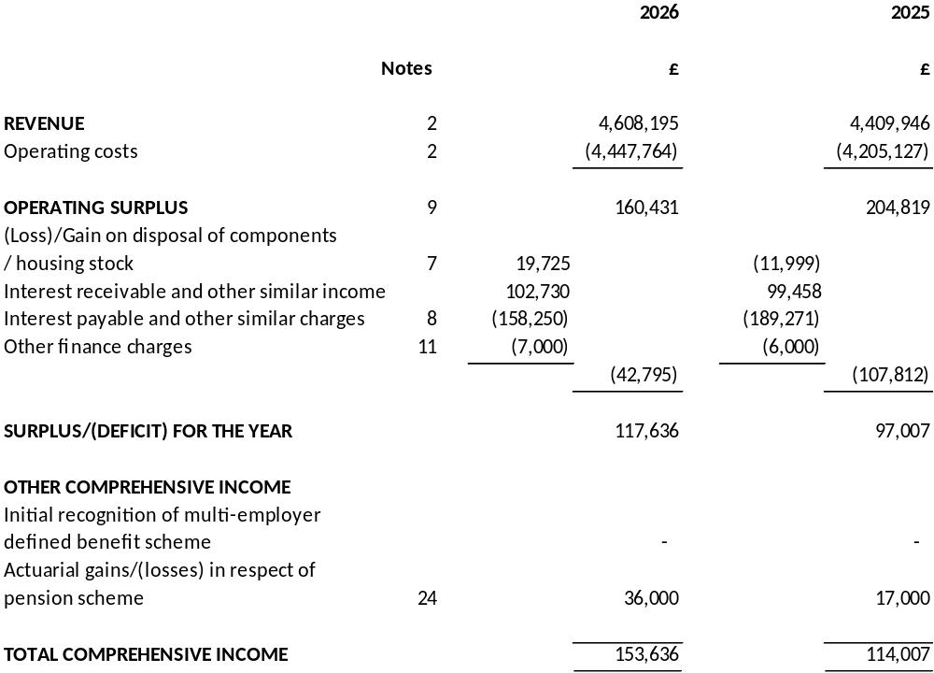

The results for the year relate wholly to continuing activities.

The financial statements were approved by the Board, authorised for issue, and signed on its behalf on 26 August 2026.

Nick Jardine David McIndoe Colin McCulloch
Chair Vice Chair Secretary

The notes on pages 17 to 36 form part of these financial statements.
STATEMENT OF FINANCIAL POSITION
AS AT 31 March 2026

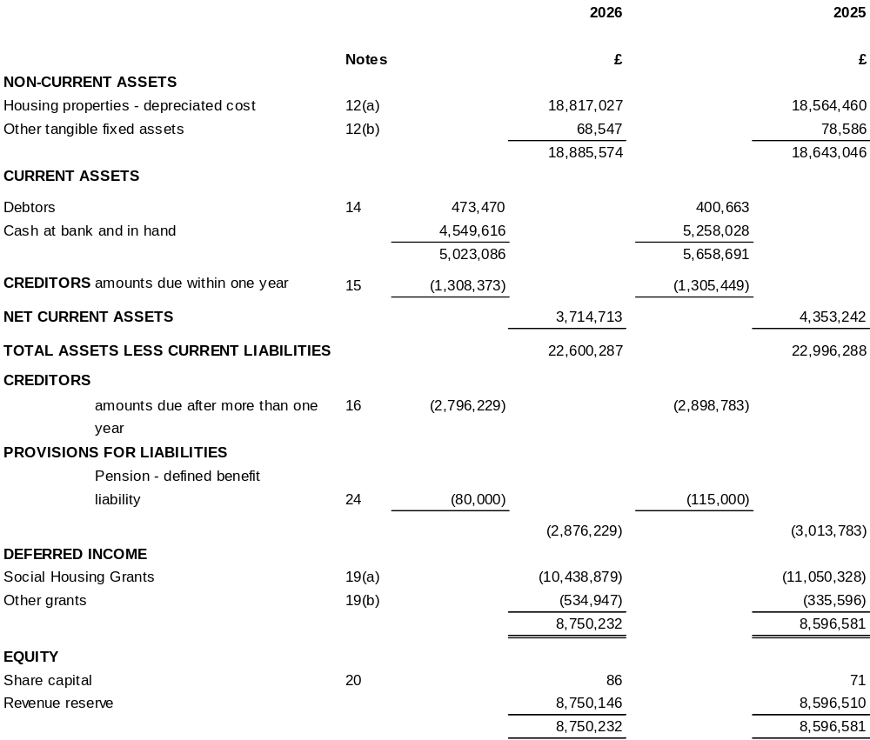

The financial statements were approved by the Board, authorised for issue, and signed on its behalf on 26 August 2026.

Nick Jardine David McIndoe Colin McCulloch
Chair Vice Chair Secretary

The notes on pages 17 to 36 form part of these financial statements.
STATEMENT OF CASH FLOWS
FOR THE YEAR ENDED 31 March 2026

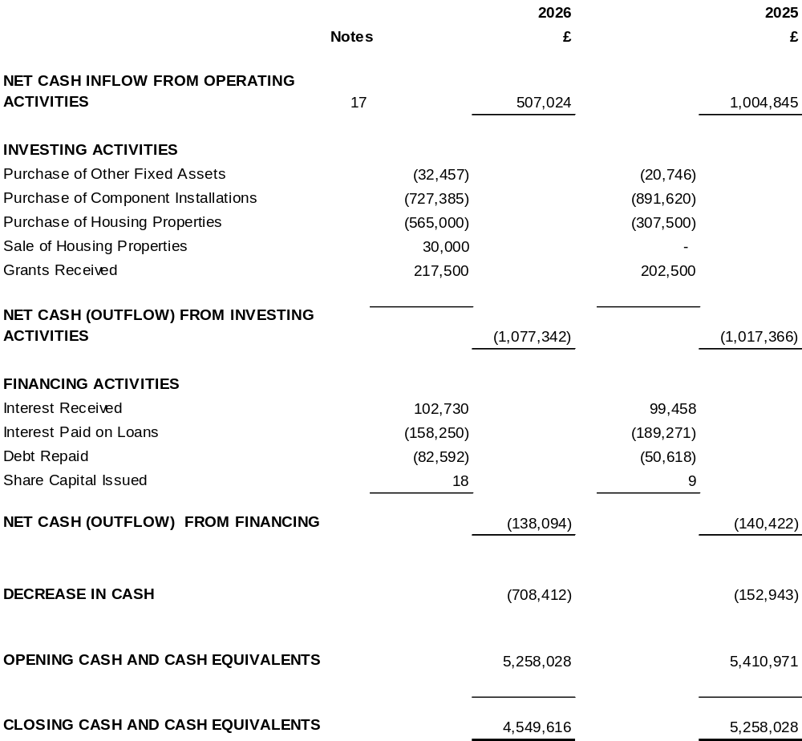

The notes on pages 17 to 36 form part of these financial statements.
STATEMENT OF CHANGES IN EQUITY
31 March 2026

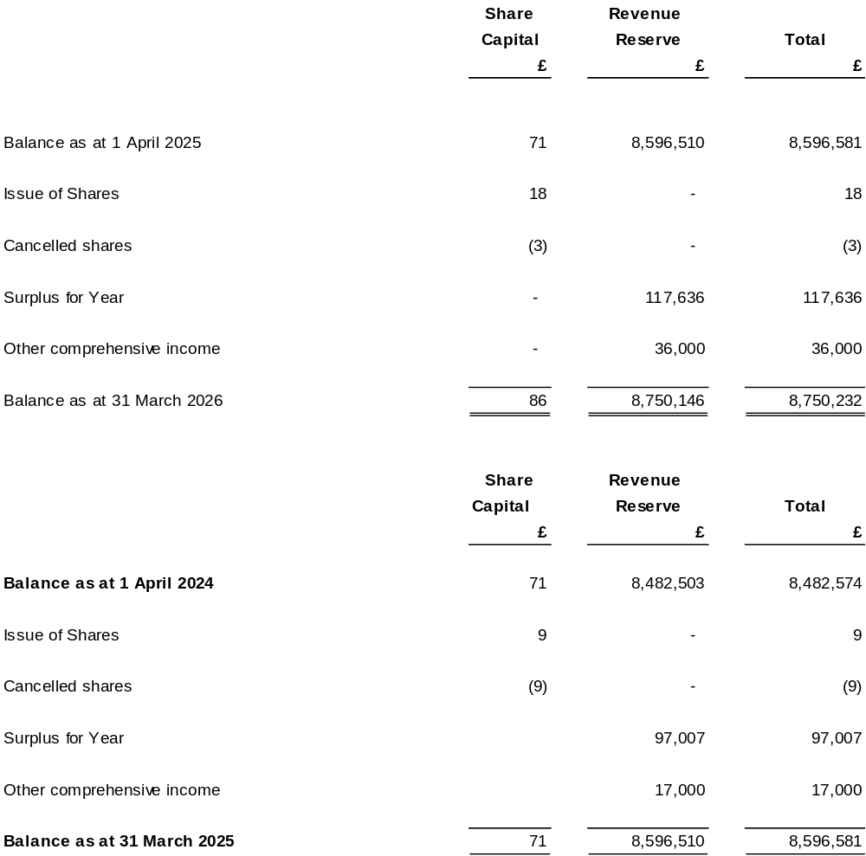

The notes on pages 17 to 36 form part of these financial statements.

- PRINCIPAL ACCOUNTING POLICIES

Legal Status
The Association is incorporated under the Co-operative and Community Benefits Societies Act 2014 and is registered by the Financial Conduct Authority. The Association is a Public Benefit Entity in terms of its compliance with Financial Reporting Standard 102.

Basis of Accounting
These financial statements were prepared in accordance with Financial Reporting Standard 102 - 'The
Financial Reporting Standard applicable in the UK and Republic of Ireland' and the Statement of Recommended Practice for Social Housing Providers 2018 and comply with the Scottish Housing Regulator Determination of Accounting Requirements 2024.

The preparation of financial statements in compliance with FRS 102 requires the use of certain critical accounting estimates. It also requires management to exercise judgement in applying the Association’s accounting policies (see below). The following principal accounting policies have been applied:

Going Concern
The Board of Management have assessed the Association’s ability to continue as a going concern and have reasonable expectations that the Association has adequate resources to continue in operational existence for the foreseeable future. Thus they continue to adopt the going concern basis of accounting in preparing these financial statements.

Revenue
The Association recognises rent receivable net of losses from voids. Service Charge Income (net of voids) is recognised as expenditure is incurred as this is considered to be the point when the service has been performed and the revenue recognition criteria is met.

Government Grants are released to income over the expected useful life of the asset to which it relates.

Retirement Benefits
The Association participates in the Scottish Housing Association Defined Benefits Pension Scheme and retirement benefits to employees of the Association are funded by the contributions from all participating employers and employees in the Scheme. Payments are made in accordance with periodic calculations by consulting Actuaries and are based on pension costs applicable across the various participating Associations taken as a whole.

The Association accounts for the pension scheme on a defined benefit basis based on its share of scheme assets and liabilities as determined by the actuary. Defined benefit costs are recognised in the Statement of Comprehensive Income within operating costs. Actuarial gains and losses are recognised in Other Comprehensive Income. Further details are disclosed in the notes to the accounts.

Valuation of Housing Properties
Housing Properties are stated at cost less accumulated depreciation. Housing under construction and Land are not depreciated. The Association depreciates housing properties by major component on a straight line basis over the estimated useful economic lives of each identified component. All components are categorised as Housing Properties within note 12. Impairment reviews are carried out if events or circumstances indicate that the carrying value of the components listed below is higher than the recoverable amount.

Component Useful Economic Life
Kitchens 15 years
Bathrooms 20 years
Central Heating 15 years
Windows 30 years
Structure 50 & 100 years
Roof Replacements 30 years

- PRINCIPAL ACCOUNTING POLICIES (Continued.)

Depreciation And Impairment Of Other Non-Current Assets
Non-Current Assets are stated at cost less accumulated depreciation. Depreciation is charged on a straight line basis over the expected economic useful lives of the assets at the following annual rates:-

Office Premises | 6 ⅔% Straight Line
Computers and other Office Equipment | 20% | Straight Line
Furniture and Fittings | 15% | Reducing Balance
Furniture for Furnished Accommodations | 33⅓% | Straight Line
Laundry Equipment in Sheltered Accommodations | 20% | Straight Line

The carrying value of non-current assets is reviewed for impairment at the end of each reporting year.

Social Housing Grant And Other Grants In Advance/Arrears
Social Housing Grants and Other Capital Grants are accounted for using the Accrual Method as outlined in Section 24 of Financial Reporting Standard 102. Grants are treated as deferred income and recognised in income on a systematic basis over the expected useful life of the property and assets to which it relates.

Social Housing Grant attributed to individual components is written off to the Income and Expenditure Account when these components are replaced.

Social Housing Grant received in respect of revenue expenditure is credited to the Income and Expenditure Account in the same year as the expenditure to which it relates.

Although Social Housing Grant is treated as a grant for accounting purposes, it may nevertheless become repayable in certain circumstances, such as the disposal of certain assets. The amount repayable would be restricted to the net proceeds of sale.

Sales Of Housing Properties
First tranche Shared Ownership disposals are credited to turnover on completion. The cost of construction of these sales is taken to operating cost. In accordance with the Statement of Recommended Practice, disposals of subsequent tranches are treated as non-current asset disposals with the gain or loss on disposal shown in the Statement of Comprehensive Income.

Disposals of housing property under the Right to Buy scheme are treated as a non-current asset disposals and any gain and loss on disposal accounted for in the Statement of Comprehensive Income.

Disposals under shared equity schemes are accounted for in the Statement of Comprehensive Income. The remaining equity in the property is treated as a non-current asset investment, which is matched with the grant received.

Estimation Uncertainty
The preparation of financial statements requires the use of certain accounting estimates. It also requires the Board of Management to exercise judgement in applying Dalmuir Park Housing Association’s Accounting Policies. The areas requiring a higher degree of judgement, or complexity, and areas where assumptions or estimates are most significant to the financial statements, is disclosed below:

Rent Arrears - Bad Debt Provision

The Association assesses the recoverability of rent arrears through a detailed assessment process which considers: tenant payment history, arrangements in place, and court action.

Life Cycle of Components
The Association estimates the useful lives of major components of its housing property with reference to surveys carried out by external qualified surveyors.

- PRINCIPAL ACCOUNTING POLICIES (Continued.)

Pension Liabilities
This has relied on the actuarial assumptions of qualified actuaries which have been reviewed and are considered reasonable and appropriate. Assumptions in respect of discount rates and inflation will vary from year to year, as will the value of assets and will be dependant on circumstances at the date of valuation.

Leases/Leased Assets
Costs in respect of operating leases are charged to the Statement of Comprehensive Income on a straight line basis over the lease term. Assets held under finance leases and hire purchase contracts are capitalised in the Statement of Financial Position and are depreciated over their useful lives.

Works to Existing Properties
The Association capitalises major repairs expenditure where these works result in an enhancement of economic benefits by increasing the net rental stream over the life of the property.

Development Interest
Interest incurred on financing a development is capitalised up to the date of practical completion of the scheme.

Key Judgements made in the application of Accounting Policies

a) The Categorisation of Housing Properties

In the judgement of the Board of Management the entirety of the Association's housing stock is held for social benefit and is therefore classified as Property, Plant and Equipment in accordance with FRS 102.

b) Identification of cash generating units

The Association considers its cash-generating units to be 686 in which it manages its housing property for asset management purposes.

c) Pension liability
In May 2026 the Association received details from the Pension Trust of its share of assets, liabilities and scheme deficit. The Association has used this information as the basis of the pension defined benefit disclosed in the accounts.

Financial Instruments – Basic
The Association only enters into basic financial instrument transactions that result in the recognition of financial assets and liabilities like rents, accounts receivable and payable, loans from banks and related parties. These are recognised in accordance with Section 11 of Financial Reporting Standard 102. The Association's debt instruments are measured at amortised cost using the effective interest rate method.

- PARTICULARS OF REVENUE, COST OF SALES, OPERATING COSTS AND OPERATING SURPLUS

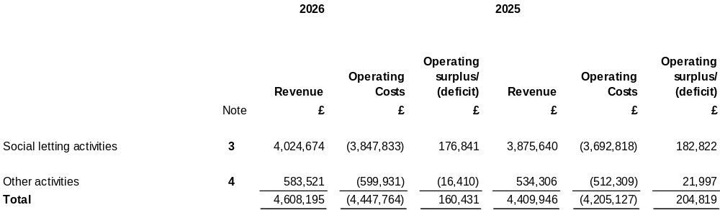

- PARTICULARS OF INCOME AND EXPENDITURE FROM SOCIAL LETTINGS

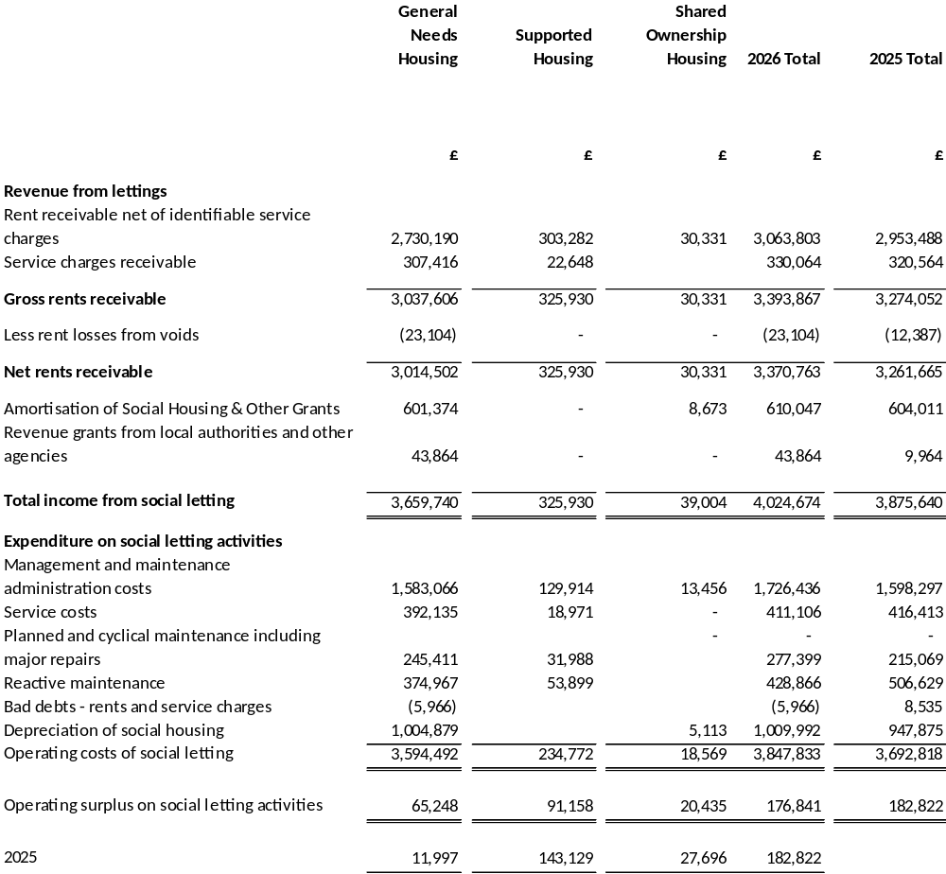
- PARTICULARS OF REVENUE, OPERATING COSTS AND OPERATING SURPLUS OR DEFICIT FROM OTHER ACTIVITIES

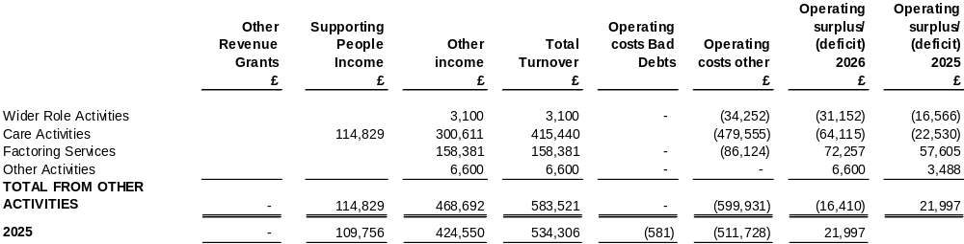

- COMMITTEE MEMBERS AND OFFICERS EMOLUMENTS

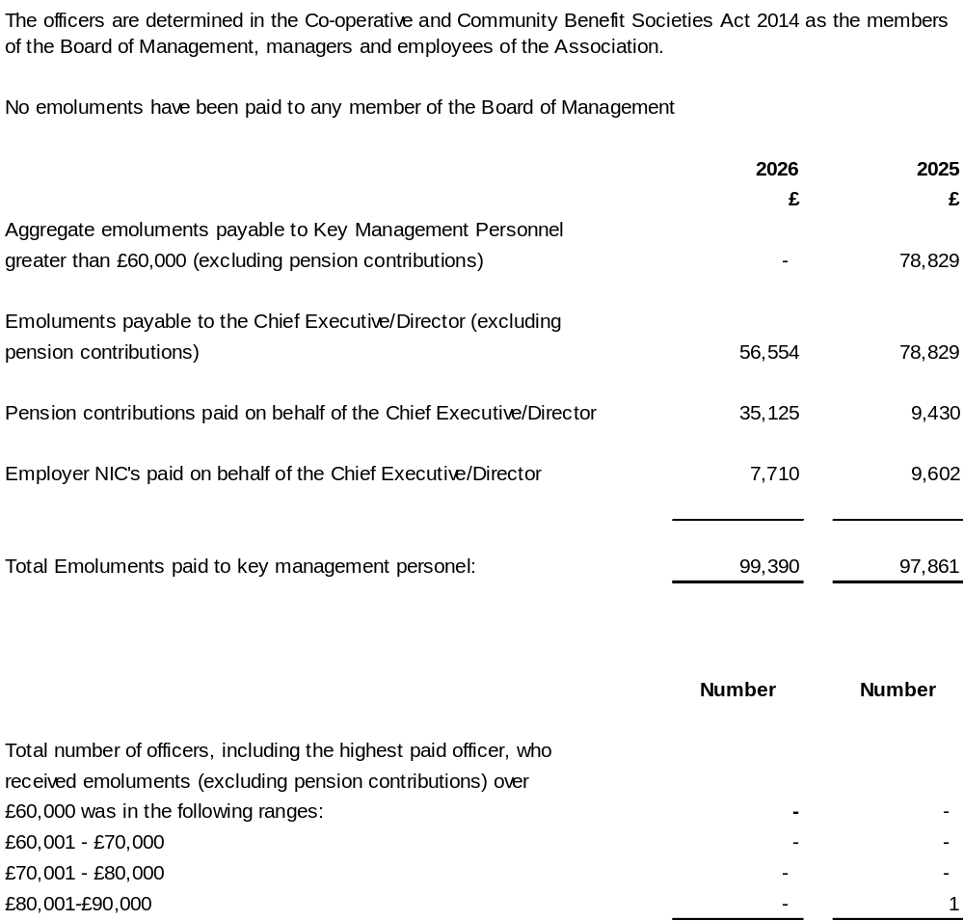

There were payments to board members during the year for reimbursement of expenses of £0 (2025 - £0)

- EMPLOYEE INFORMATION

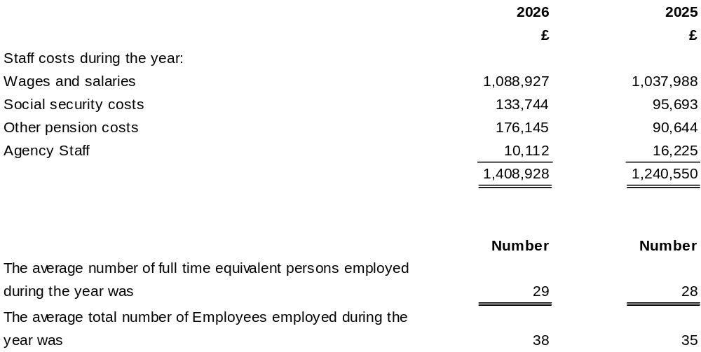

- (LOSS)/GAIN ON SALE OF PROPERTY, PLANT & EQUIPMENT

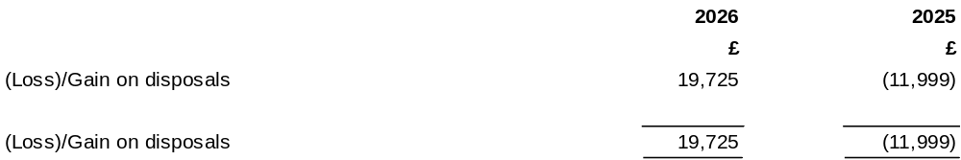

- INTEREST PAYABLE

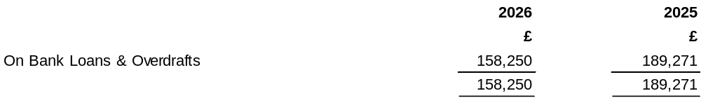
- OPERATING SURPLUS
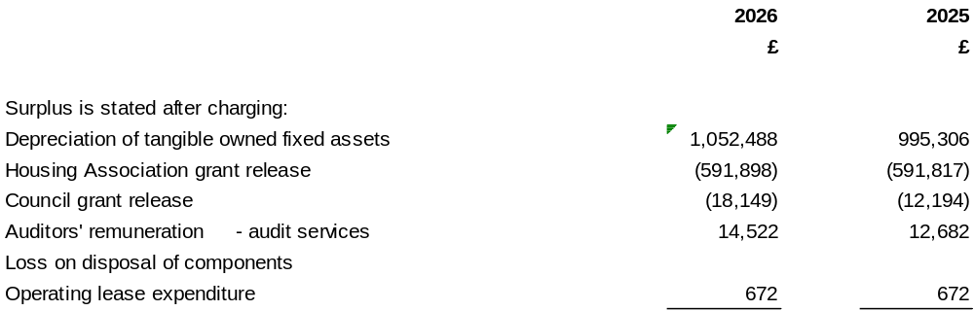

- TAX ON SURPLUS ON ORDINARY ACTIVITES

The Association is a Registered Scottish Charity and is not liable to United Kingdom Corporation Tax on its charitable activities.

- OTHER FINANCE CHARGES

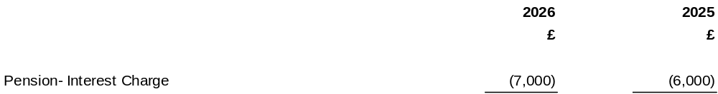

- FIXED ASSETS

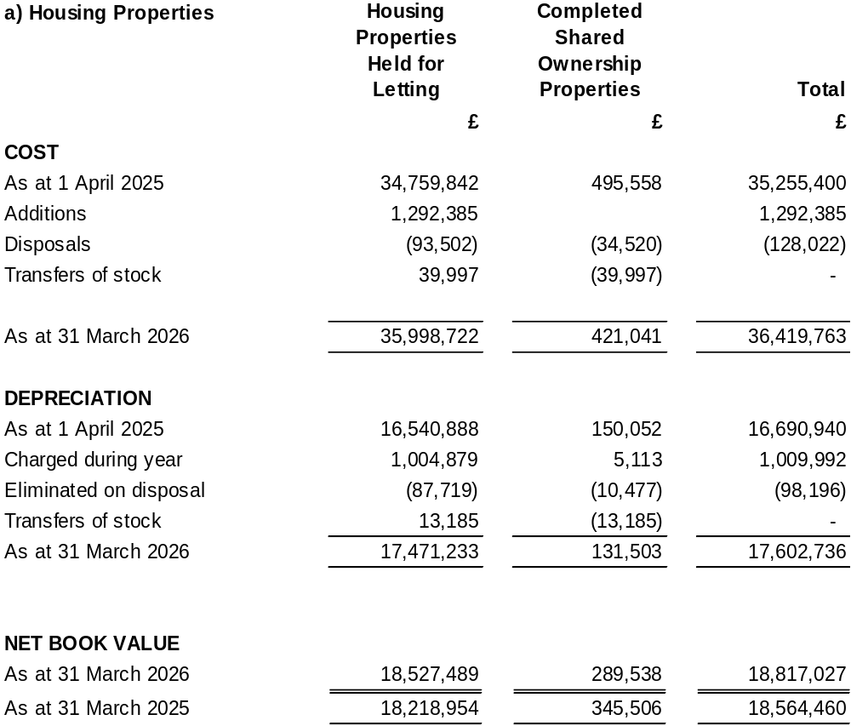

Total expenditure on existing properties in the year amounted to £1,408,235 (2025 - £1,613,318). The amount capitalised as component replacements is £727,385 (2025- £891,620), with the balance charged to the Statement of Comprehensive Income. The additions above of £1,292,385 also included five property purchases totalling £565,000.

The Association’s lenders have standard securities over housing properties with a carrying value of £3,363,002 (2025 – £3,406,062)

- FIXED ASSETS
(continued)

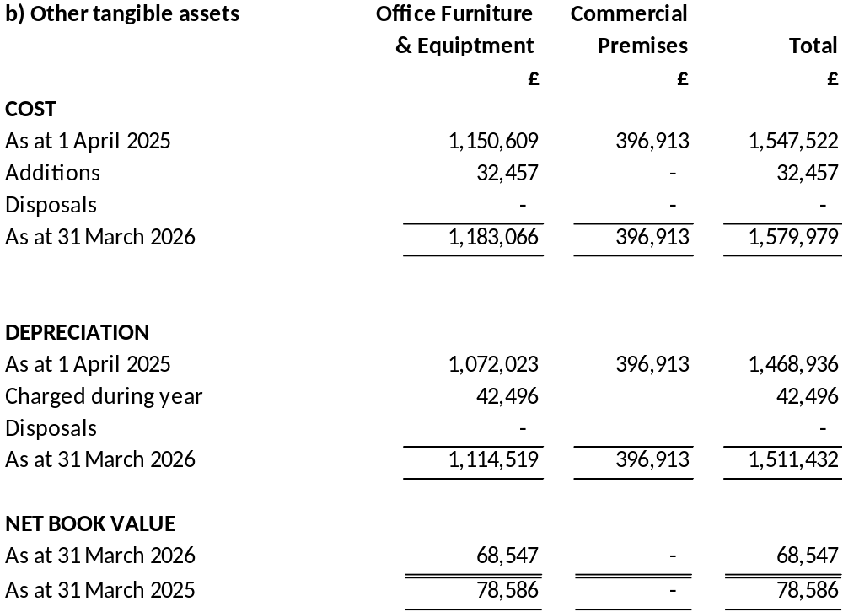

- COMMITMENTS UNDER OPERATING LEASES
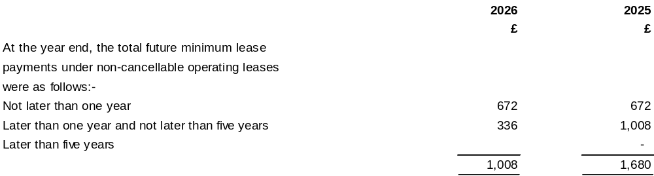

- DEBTORS

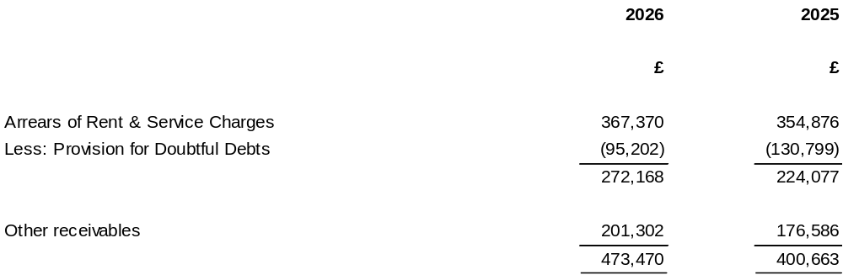

- CREDITORS AMOUNTS FALLING DUE WITHIN ONE YEAR
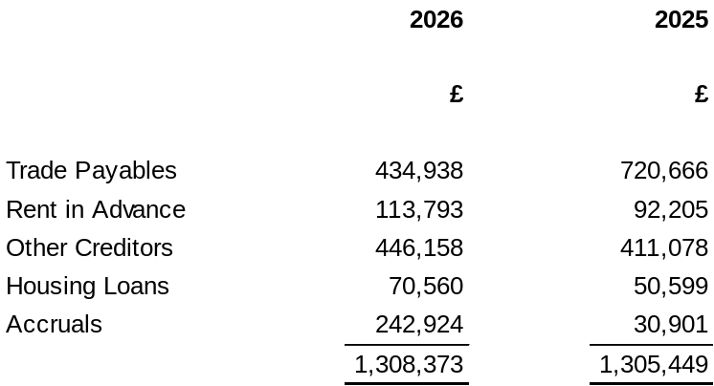

- CREDITORS AMOUNTS FALLING DUE AFTER ONE YEAR

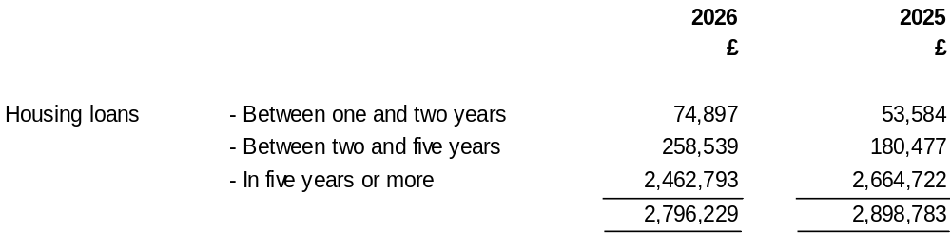

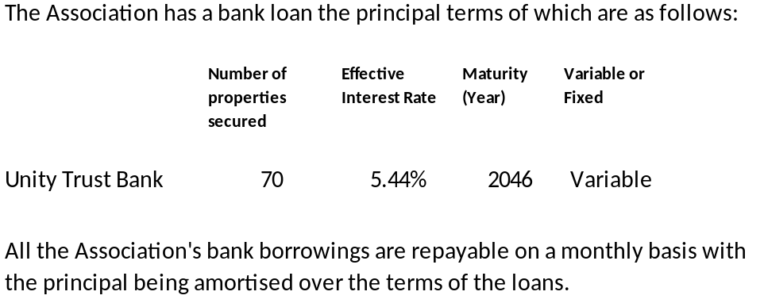

- STATEMENT OF CASHFLOWS

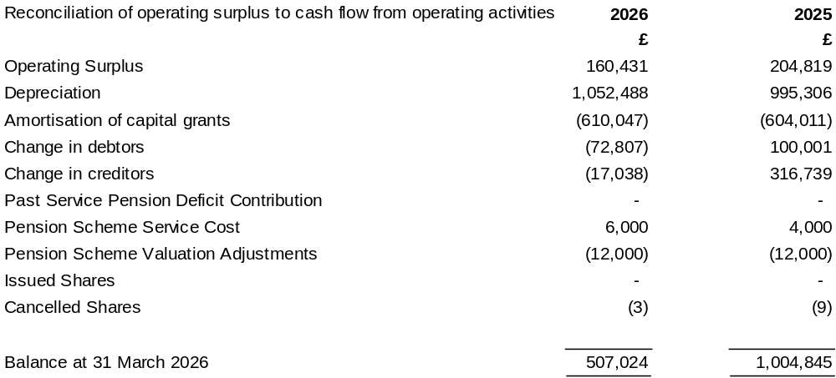

- ANALYSIS OF CHANGES IN CASHFLOWS

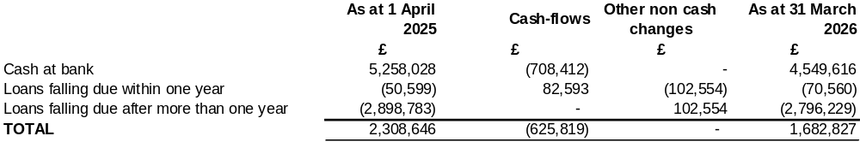
19. DEFERRED INCOME

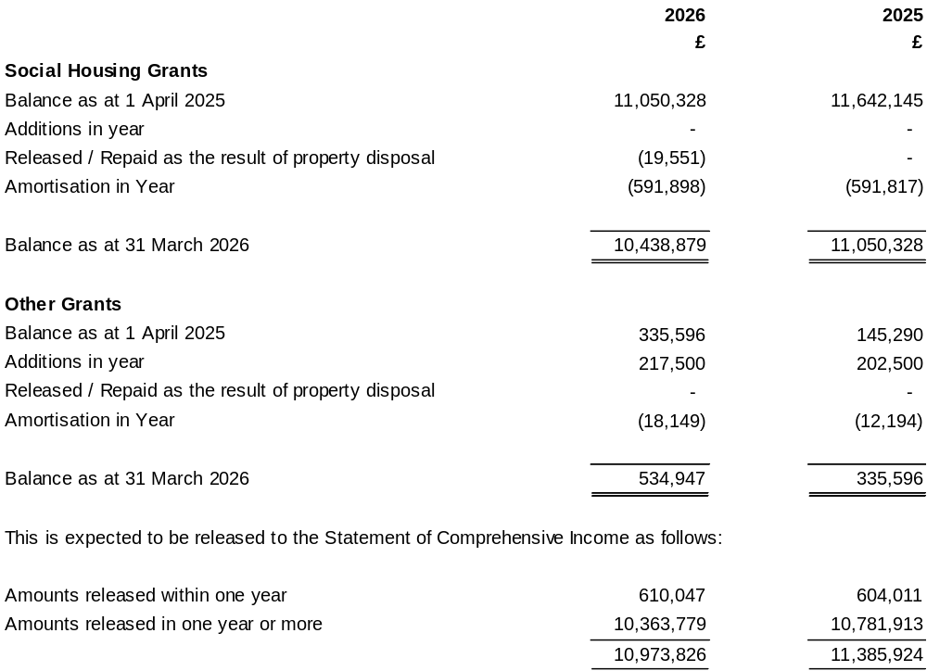
20. SHARE CAPITAL
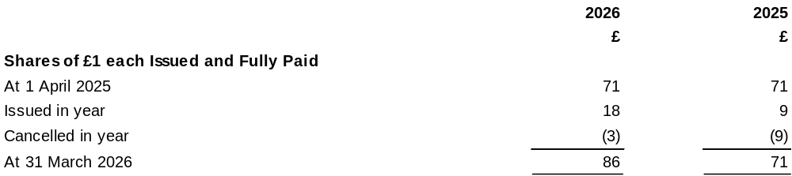

Each member of the Association holds one share of £1 in the Association. These shares carry no rights to dividend or distributions on a winding up. When a shareholder ceases to be a member that person’s share is cancelled and the amount paid thereon becomes the property of the Association. Each member has a right to vote at members’ meetings.

- HOUSING STOCK

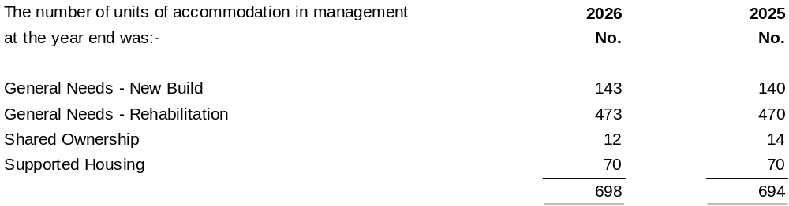

- RELATED PARTY TRANSACTIONS

Members of the Board of Management are related parties of the Association as defined by Financial Reporting Standard 102

The related party relationships of the members of the Board of Management are summarised as:

- Members are tenants of the Association - 0

- Members are factored owners - 0

- Board of Management members cannot use their position to their advantage. Any transactions between the Association and any entity with which a Board of Management member has a connection with is made at arm’s length and is under normal commercial terms.

- Transactions with Board of Management members were as follows:
Rent Received from Tenants on the Board : £0

At the year- end total rent arrears owed by the tenant members of the Board were £0

23. DETAILS OF ASSOCIATION

The Association is a Registered Society registered within the Financial Conduct Authority and is domiciled in Scotland.

The Association’s principal place of business is Beardmore House, 631 Dumbarton Road, Clydebank, G81 4EU.

The Association is a Registered Social Landlord and Scottish Charity that owns and manages social housing in Dalmuir, Clydebank.

The Association is a Registered Society with the Scottish Property Factors Register and is domiciled in Scotland.

24. RETIREMENT BENEFIT OBLIGATIONS

General

The Association participates in the Scottish Housing Associations’ Pension Scheme (the Scheme), a multi-employer scheme which provides benefits to some 150 non-associated employers. The Scheme is a defined benefit scheme in the UK.

The Scheme is subject to the funding legislation outlined in the Pensions Act 2004 which came into force on 30 December 2005. This, together with documents issued by the Pensions Regulator and Technical Actuarial Standards issued by the Financial Reporting Council, set out the framework for funding defined benefit occupational pension schemes in the UK.

The last triennial valuation of the scheme for funding purposes was carried out as at 30 September 2024. This valuation revealed a deficit of £79.5m. A Recovery Plan has been put in place to eliminate the deficit which ran to 31 March 2030.

The Scheme is classified as a 'last-man standing arrangement'. Therefore the company is potentially liable for other participating employers' obligations if those employers are unable to meet their share of the scheme deficit following withdrawal from the Scheme. Participating employers are legally required to meet their share of the Scheme deficit on an annuity purchase basis on withdrawal from the Scheme.

For accounting purposes, a valuation of the scheme is carried out with an effective date of 30 September each year. The liability figures from this valuation are rolled forward for accounting year-ends from the following 31 March to 28 February inclusive.

The latest accounting valuation was carried out with an effective date of 30 September 2025. The liability figures from this valuation were rolled forward for accounting year-ends from the following 31 March 2026 to 28 February 2027 inclusive.

The liabilities are compared, at the relevant accounting date, with the company’s fair share of the Scheme’s total assets to calculate the company’s net deficit or surplus.

24. RETIREMENT BENEFIT OBLIGATIONS
(Continued)

Pension Scheme Liability movements:

 | 2026 |  | 2025
 | £ |  | £
As at 1 April 2025 | 115,000 |  | 134,000
Current Service Cost | (3,000) |  | 4,000
Net Interest expense | 7,000 |  | 6,000
Expenses | 2,000 |  | 2,000
Deficit Contributions Paid | - |  | -
Impact of change in assumptions | (8,000) |  | 174,000
Amendment to the contribution schedule | (33,000) |  | (205,000)
As at 31 March 2026 | 80,000 |  | 115,000

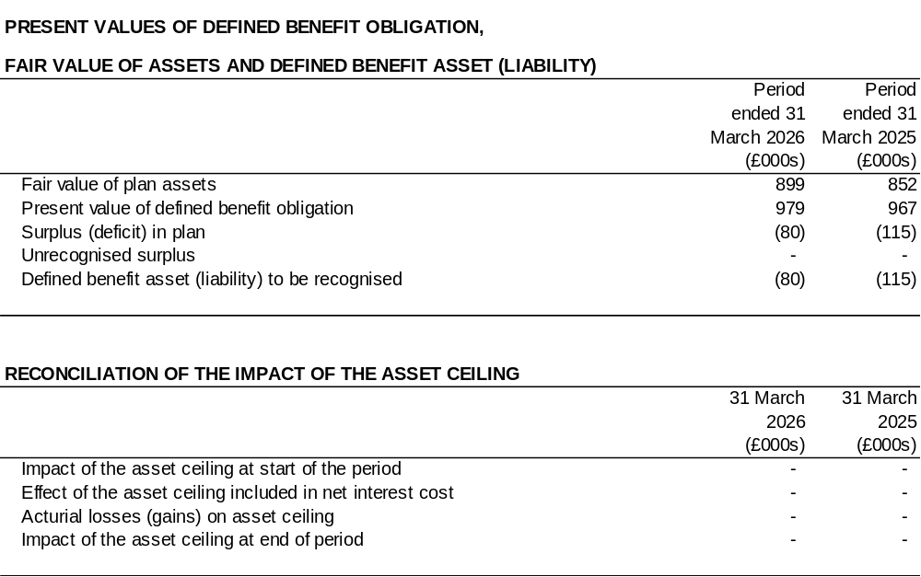
24. RETIREMENT BENEFIT OBLIGATIONS
(Continued)

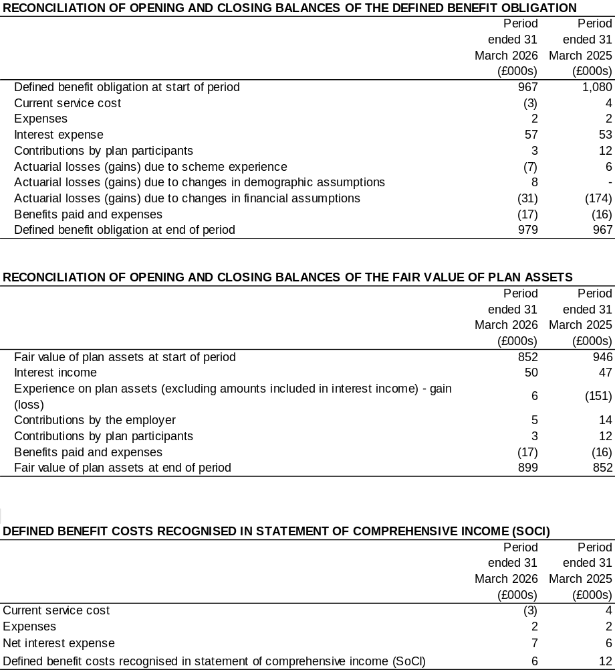

24. RETIREMENT BENEFIT OBLIGATIONS
(Continued)
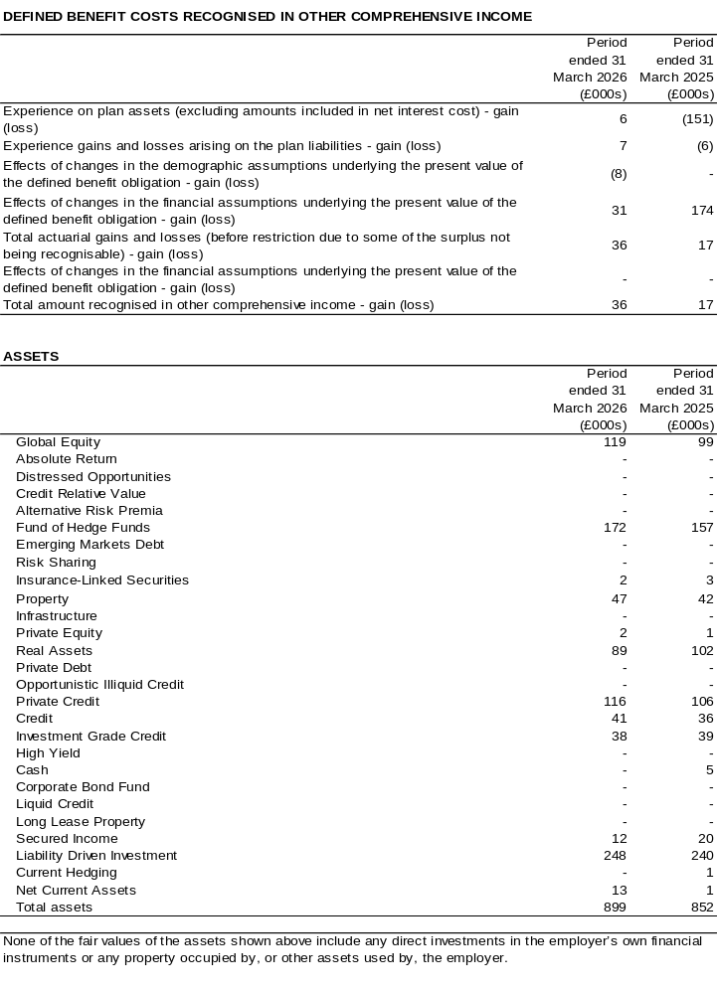

24. RETIREMENT BENEFIT OBLIGATIONS
(Continued)

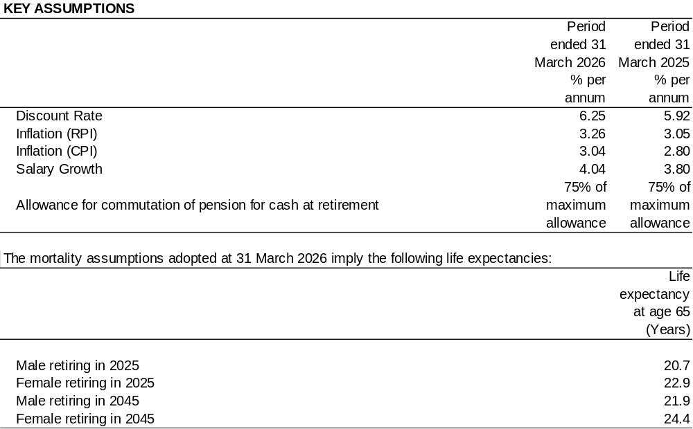

25. CAPITAL COMMITMENTS

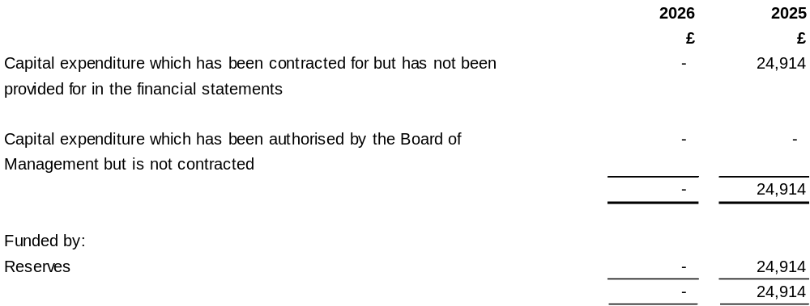

26. CONTINGENT LIABILITY

The Trustee has carried out a review comparing the benefits provided to the scheme members with the requirements of the Scheme documentation. It had received legal advice that there was sufficient uncertainty regarding the effect of some benefit changes that the Court should be asked to provide clarity, to provide the Trustee with the certainty it needs to properly administer the Scheme.

The Court hearing concluded in March 2025, with the Court’s determination expected later in 2026 after the Court of Appeal’s summer recess. The Trustee has been preparing for the judgement with the support of its advisers. It will write to employers after the judgement is issued to provide a high-level summary of the outcome. If the outcome means that changes are required to member benefits, the Trustee will then need to consider the judgement in more depth before communication in more detail with employers about how it will apply to the Scheme. The Trustee will also need to take advice on whether any further clarification is needed from the Court. employers.

Should the Court decide that the historic benefit changes need to be applied differently, then some member benefits would need to be increased, which would increase the value placed on Scheme liabilities. No allowance has been made for potential additional liabilities within the estimate provided above.
issue.

