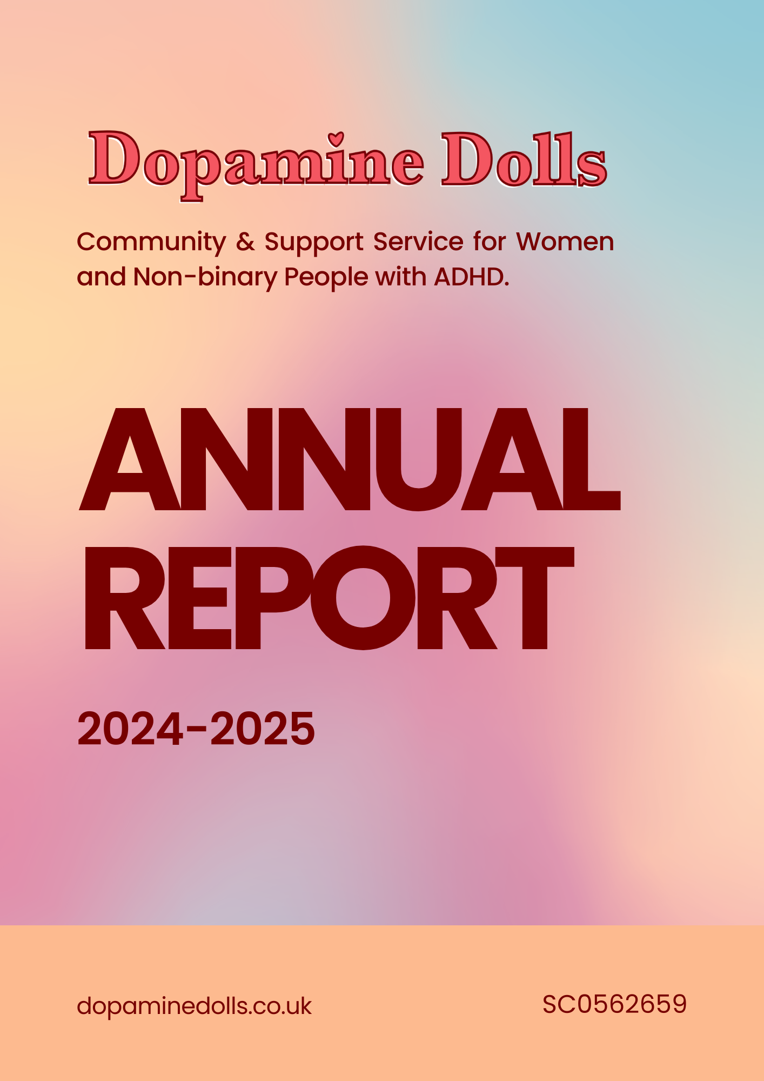

Charity Trustees:

- Ashley Hope, Chair
- Toni Hope, Treasurer
- Seonaid Baillie, Trustee
- Will Hope, Trustee
- Suz Elvey, Trustee
- Rosie Wade, Trustee
- Jen Lilley, Trustee

Objectives and Activities:

Dopamine Dolls was founded to create a supportive, empowering space for women and non-binary people with ADHD in the Scottish Highlands. Our purpose, as outlined in our governing document, is to build a community where people with ADHD can connect, share experiences and develop the tools to embrace their neurodiversity. We envision a world where people with ADHD feel valued and where barriers to support and understanding are actively dismantled.

Our Aims:
- Empower women and non-binary people with ADHD by fostering a safe, supportive community.
- Raise awareness about ADHD in adults, especially in remote and rural communities where support resources are limited.
- Break down stigma surrounding ADHD, encouraging acceptance, understanding and celebration of neurodiversity.

What We Do:
Our charity provides peer-led support services, workshops and community-building events that focus on equipping members with the tools and strategies they need to navigate life with ADHD. Our primary service is peer support, which brings together individuals with shared experiences to provide mutual support, a sense of acceptance and an open space to share resources.
Throughout the year, Dopamine Dolls has organised a wide range of programmes designed to build community, encourage connection and promote wellbeing. These included:
- Peer Support Groups – safe spaces for members to share experiences, seek advice and foster friendships.
- Coffee Catch Ups – informal meet-ups in local cafés, offering a relaxed environment for conversation and connection.
- Dopamine Daunders – group walks that encourage members to enjoy the outdoors, boost wellbeing and benefit from gentle exercise.
- Creative Workshops – skill-building sessions, such as crochet, that support creativity, relaxation and confidence.
Together, these activities have helped reduce isolation, improve mental health and empower our members to feel more connected, supported and valued within their community.

Who We Help:
Our services are open to women and non-binary people who either have an ADHD diagnosis or who experience ADHD-related traits. Understanding that diagnosis can be challenging to obtain, especially in remote areas like the Scottish Highlands, we welcome members regardless of their diagnostic status. By focusing on populations who often feel misunderstood in mainstream support systems, we provide a welcoming community that values each individual’s unique experiences and strengths.

Structure, Governance and Management:
Dopamine Dolls operates under a single-tier constitution, which serves as our charity’s governing document. This written statement outlines our charity’s purpose, structure and provides clear guidelines on how we operate. The constitution is a foundational document that ensures all activities, decisions and management practices align with our mission to support and empower adults with ADHD, particularly women and non-binary people in the Scottish Highlands.
Our trustees are committed to upholding the constitution and ensuring that all actions taken by the charity comply with the guidelines and requirements set forth in this document. This includes maintaining transparency, accountability and integrity across all levels of our organisation.

Trustee Recruitment and Appointment:
This year, Dopamine Dolls expanded its board, welcoming new trustees. Recruitment has been organic, with many volunteers expressing interest and later joining the board. This natural progression has allowed us to attract trustees who are deeply committed to our mission and bring a diverse range of skills and experiences. Our trustees collectively contribute expertise in areas including mental health, advocacy, social care, education and public relations, ensuring that our board remains equipped to provide effective oversight and strategic guidance.
Each trustee was selected for their dedication to supporting neurodiverse communities, particularly those in remote areas such as the Scottish Highlands, and their ability to contribute meaningfully to the governance and development of Dopamine Dolls.
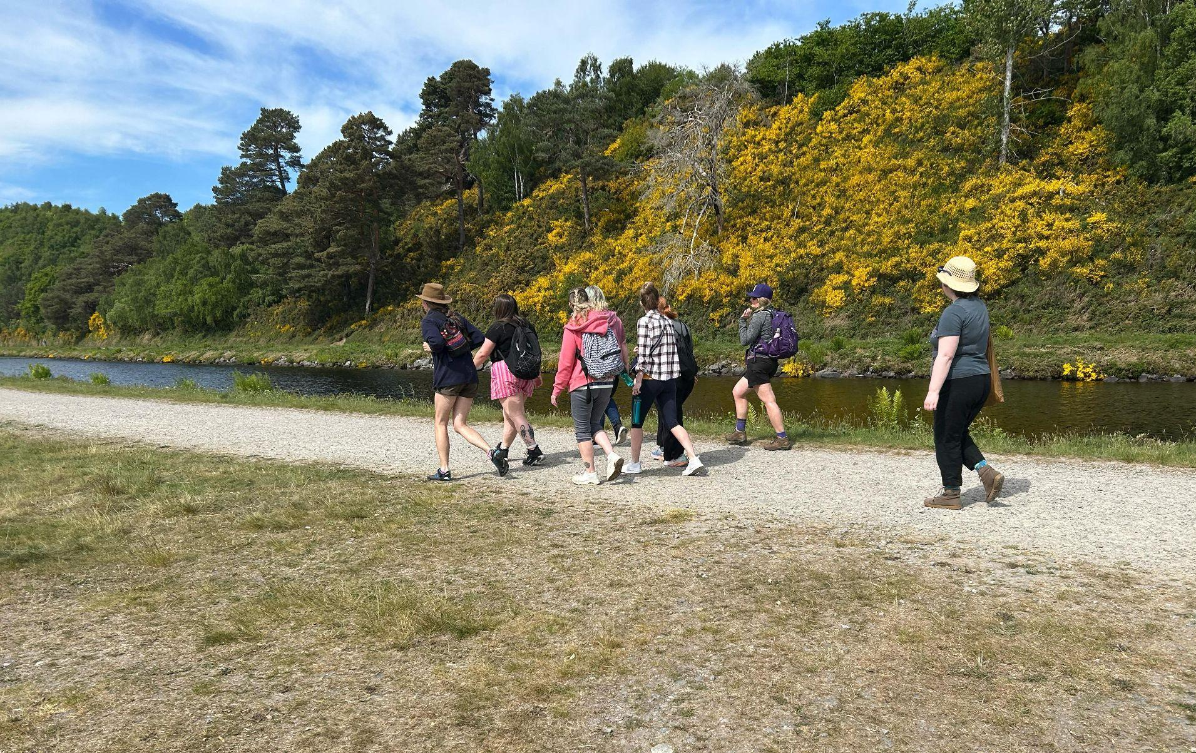
Achievements and Performance:
Over the past year, Dopamine Dolls has continued to grow in reach and impact, delivering meaningful support to women and non-binary individuals with ADHD. Our key achievements include:
Strengthening Community Connections – members have reported feeling more understood, supported and less isolated since joining our programmes.
Consistent Engagement – attendance at peer support groups, workshops, and social activities has steadily grown, reflecting the demand for safe spaces tailored to adults with ADHD.
Creative Collaborations – partnerships with local organisations and community groups have expanded our reach, combining creativity with mental health support to foster both expression and connection.
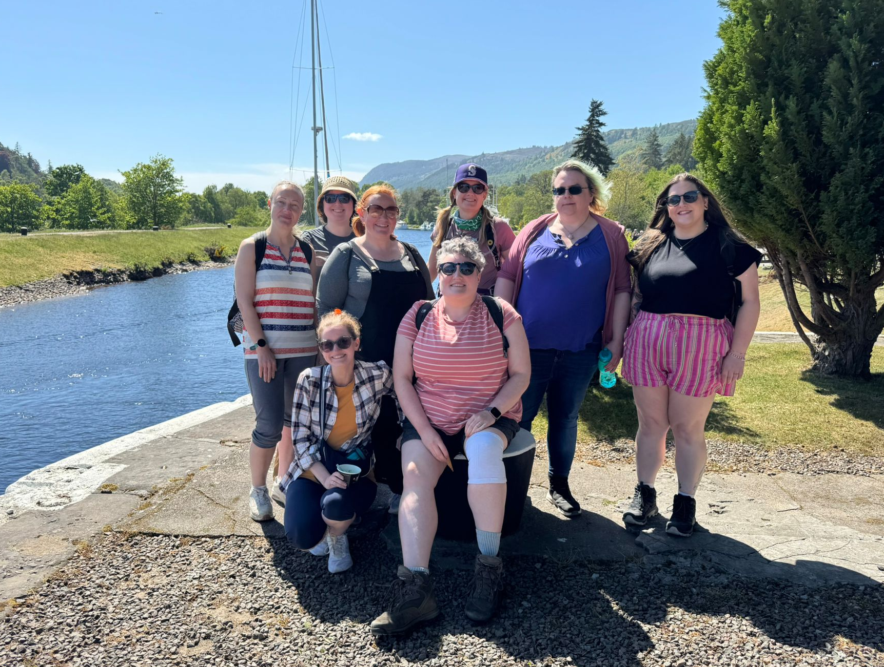
Raising Awareness – through events, social media, and local press, we have challenged stigma around ADHD and brought greater visibility to the unique challenges faced by adults, particularly women and non-binary individuals.

The difference this work has made is evident in the stories shared by our members: increased understanding and a stronger sense of belonging. These outcomes affirm the vital role of Dopamine Dolls in empowering neurodiverse communities across the Highlands.

Volunteer Achievements:
Our volunteers remain at the heart of Dopamine Dolls, dedicating their time, energy and talents to ensure our community thrives. This year, their contributions have been invaluable across every aspect of our work:

- Event Planning and Delivery – volunteers played a central role in organising and running workshops, social gatherings and community events, ensuring everything ran smoothly and inclusively.

- Peer Support Facilitation – volunteers supported our peer groups, creating safe and welcoming spaces where members could connect and share openly.

- Community Outreach – by engaging with local networks, promoting our activities online, and reaching new audiences, volunteers have helped expand our community and raise awareness of adult ADHD.

- Media and Advocacy – one of our volunteers contributed to building press relationships and securing media coverage, amplifying our message and visibility across the Highlands and beyond.
Their dedication has not only strengthened the charity’s impact but has also inspired a spirit of collaboration and empowerment that defines the Dopamine Dolls community.

Our Biggest Success:
This year, our greatest success has been our ability to sustain and deliver our core services despite ongoing challenges. In a climate where small charities often struggle to survive, Dopamine Dolls has continued to exist, support our members and provide a vital lifeline for neurodiverse adults in the Highlands. This stability has been a testament to the resilience of our community, the dedication of our volunteers and the value of the spaces we create together.

Looking Ahead:
As we move into the year ahead, our focus is on strengthening the sustainability and resilience of Dopamine Dolls. While we have not yet been able to commit to launching Dopamine Dudes, this remains an important aspiration for the future as we continue to recognise the need for peer support spaces tailored to men with ADHD.
Our immediate goals for this year are:
- Financial Sustainability – developing more consistent and secure funding streams to ensure the continuity of our core services.
- Local Collaboration – working more closely with other community organisations to deliver joint initiatives, expand our reach and deepen our impact across the Highlands.
By focusing on these priorities, we aim to build a stronger foundation for the future while continuing to provide the safe, supportive spaces that remain at the heart of Dopamine Dolls.

Financial Review:
Dopamine Dolls maintains reserves equivalent to three months’ operating costs to ensure stability and continuity of our services.
This year, we have managed our finances carefully while expanding programs and welcoming new trustees. Generous donations of space, materials and professional expertise continue to support our work, allowing us to deliver high-quality services to neurodiverse communities.
We are pleased to report that we have successfully secured grant funding from First Port, supported by Community Enterprise, focused on charitable enterprise to enhance the long-term stability of Dopamine Dolls. This funding will be put to effective use in the coming year to strengthen our programs and infrastructure.
Trustees continue to monitor expenditure closely and address any minor deficits through fundraising, grant applications and careful cost management, ensuring the ongoing sustainability of the charity and maximising our community impact.

Declaration
Signed on behalf of the charity trustees:
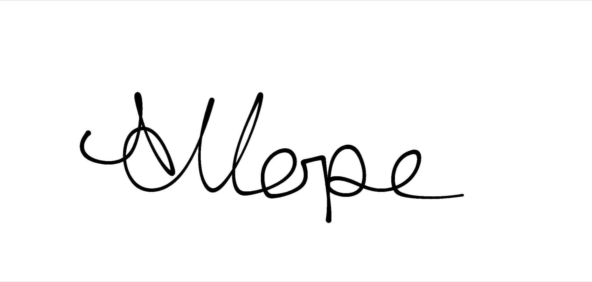
Print name: Ashley Hope
Designation: Chair
Date: 27/09/2025

