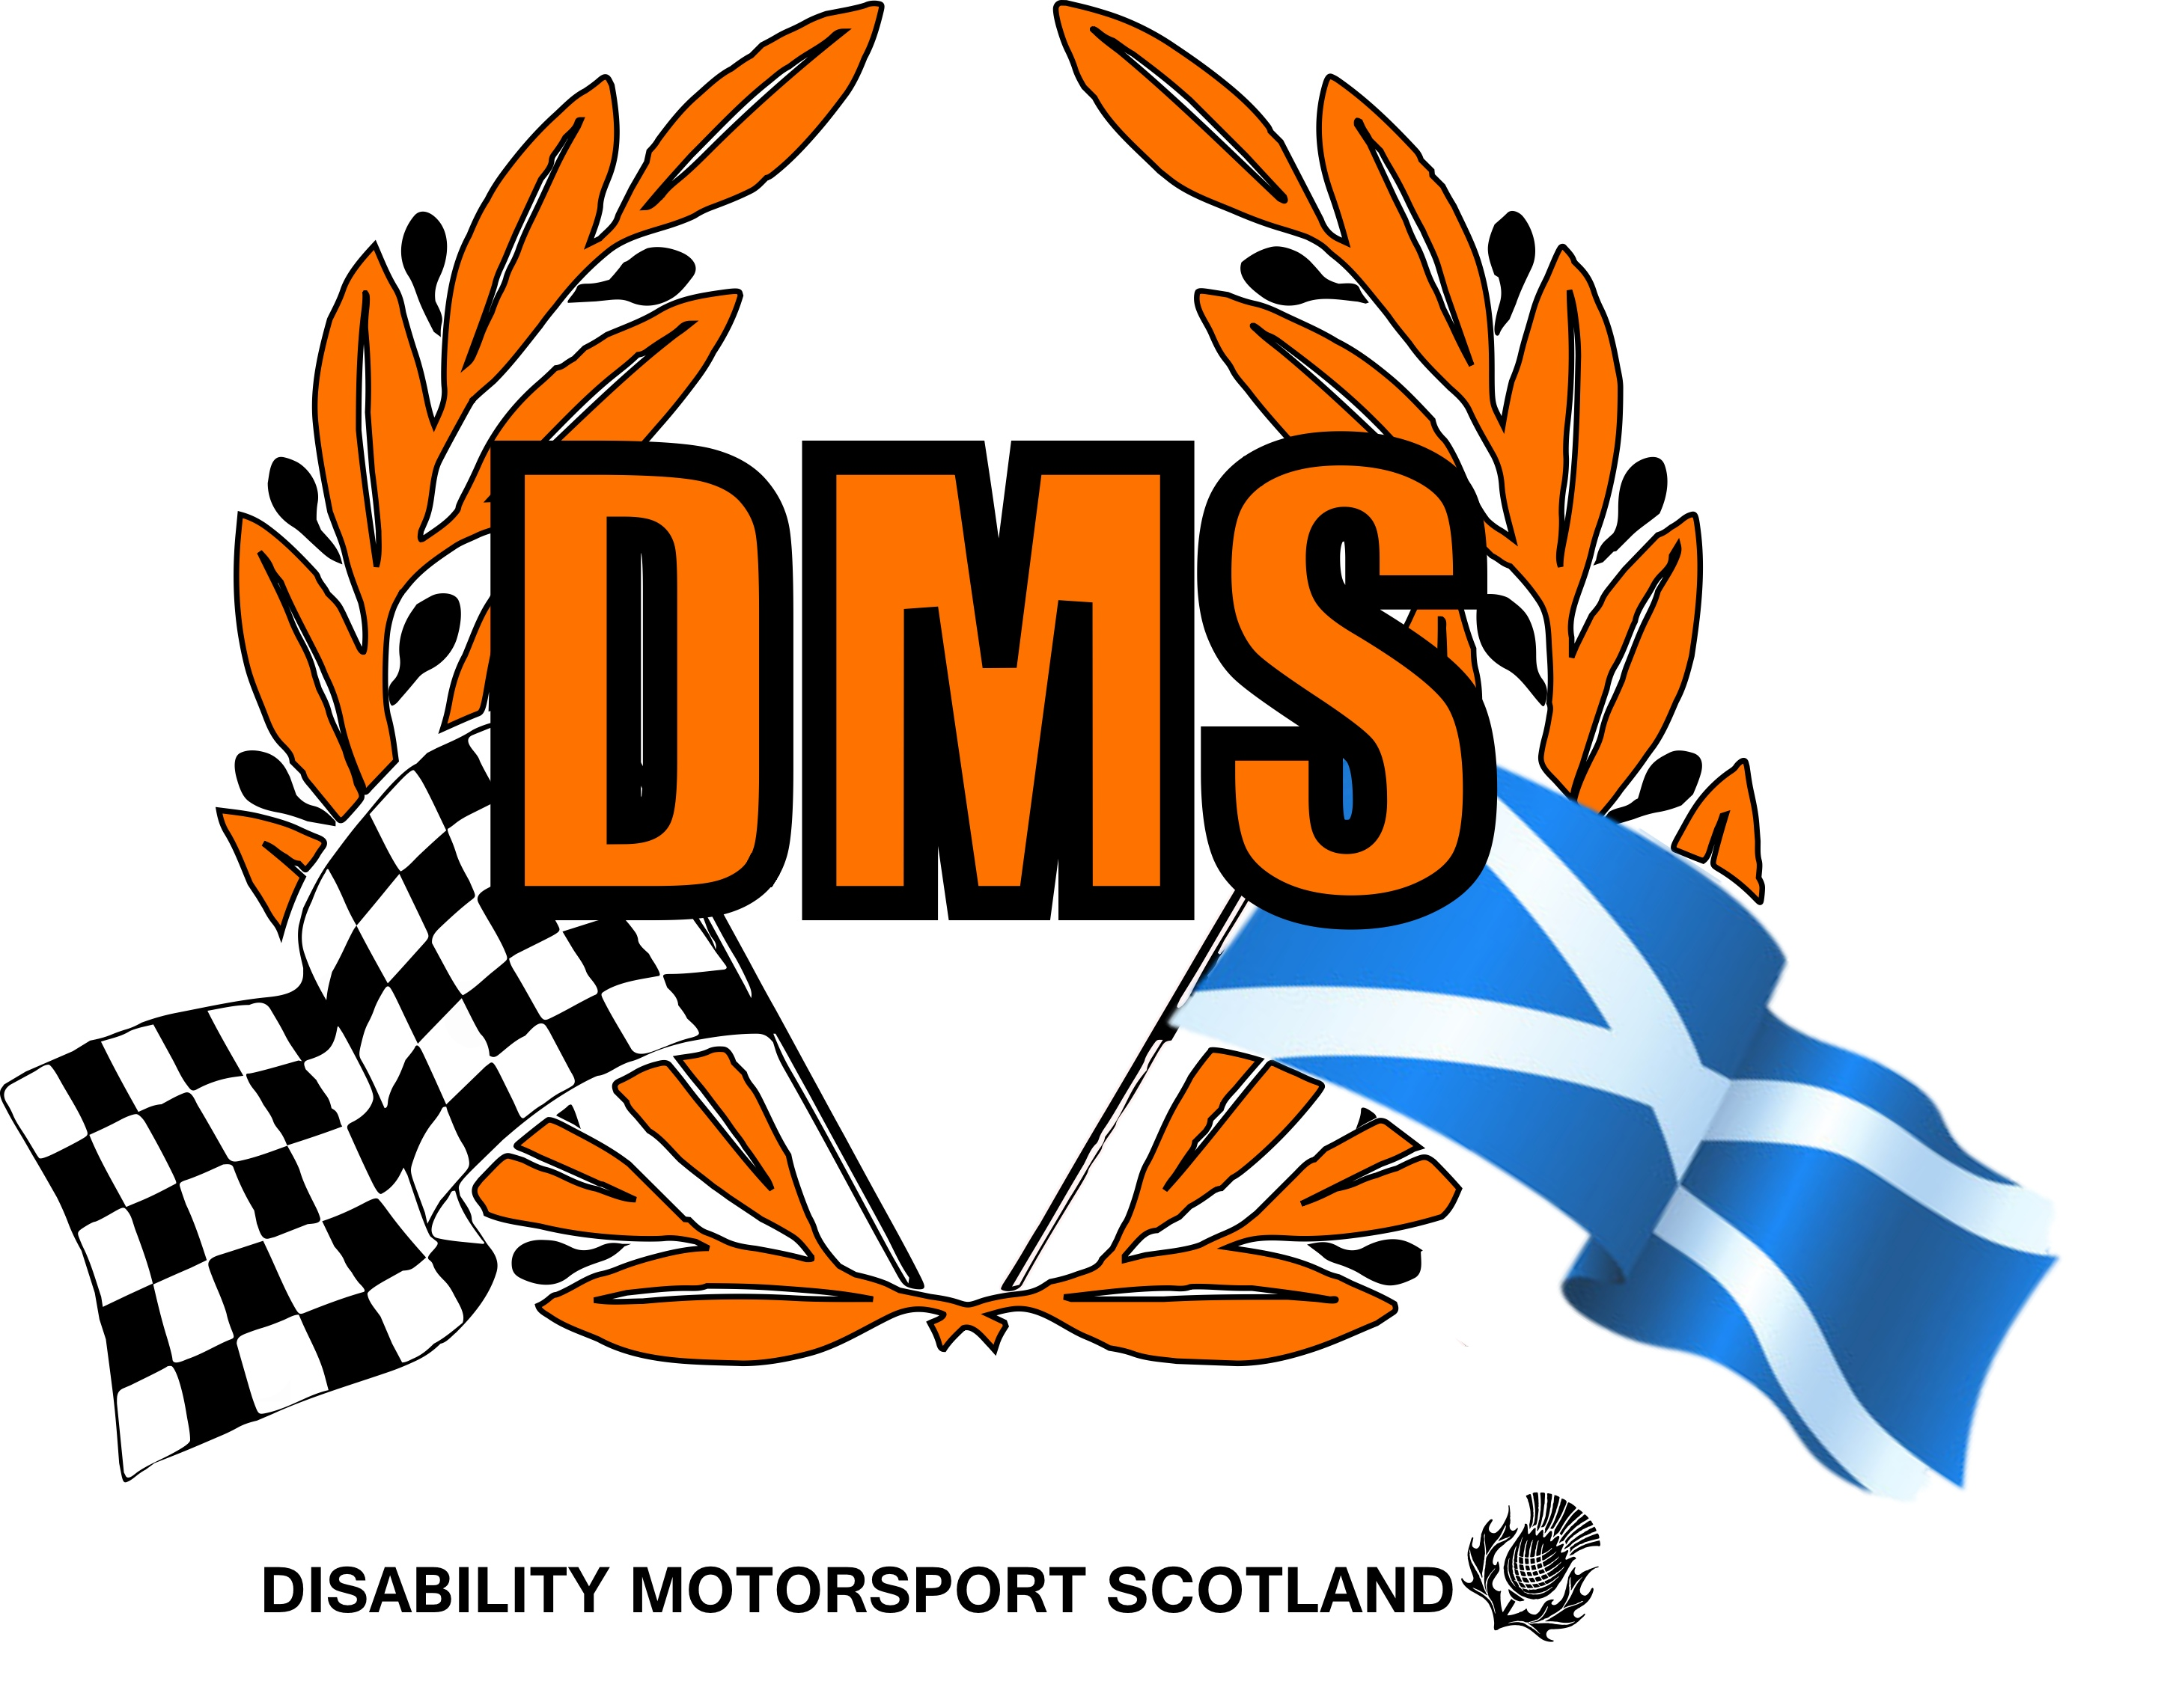
TRUSTEE REPORT
Disability Motorsport
Scotland SCIO
2025/26
From | Colin Duthie, Chairman, Disability Motorsport Scotland SCIO (DMS)
To | Scottish Charity Regulator
Date | 07/08/2026
“On track, for better mental health”

Charity background and current position

Disability Motorsport Scotland (DMS) became a Scottish Charity (SCIO) in November 2016, since then we have offered DMS taster session track experiences to hundreds of guests living with a disability or an additional support need as drivers or passengers. We also offer “Motorsport Inclusion Training” (MIT) for volunteers and officials, we also work with NGB’s of motorsport on accessibility and inclusion.
A typical DMS taster session season runs from March to October. DMS is open to all, our taster sessions in particular support guests with physical disability, learning needs, sensory impairment and mental health issues. We also support their families and friends by giving our guests an opportunity to feel free of their disability or impairment, even if for a short while.
Whilst it has been great to have so many individuals in our car over the years, it has also been noted from family and friends of our guests as to just how positive an impact our taster sessions have on family and friends too. We believe DMS is “On track, for better mental health”
Post Covid Impact

I feel it would be remiss of me not to mention that Disability Motorsport Scotland has had a very difficult time since March 2020 due to Covid19. As the pandemic took hold in 2020, DMS sought guidance from our national governing body (Motorsport UK) we closed with immediate effect. We then sought guidance from government which confirmed our actions as correct. DMS has had many updates from our governing body and from government. The rational for full closure of our services on track was due to the fact that most if not all our service users were “shielding” or having significant disability or medical conditions whereby attending an event could put them and our volunteers at risk. DMS has posted many updates to members via social media throughout this unprecedented period.
The covid impact on DMS, in many ways has been catastrophic, not least governance and finance, but also in terms of the lack of volunteers and officials.
In late 2021 we lost our biggest supporter and with that our base in NAC, basically we had no home, nowhere to store vehicles, our trailer and all our equipment. The situation was dire, however thanks to very kind hearted individuals and businesses we were able to spread all our equipment temporarily throughout Irvine. The board made the decision that the charity needed a new home, we had at that time sufficient unrestricted funds, so we looked for a commercial unit within NAC, we found one in Darly Ayrshire. The lease started on the 22nd July 2022 for a 5-year period.
2022–2025 | New Home

After 3 years with due diligence the trustees felt that we needed to enact the “lease break” option effective from July 2025. This decision was taken mainly due to the national financial and fundraising downturn and our own dwindling reserves. However, thanks to one of Disability Motorsport Scotlands longest standing volunteers and supporters we were offered a new “affordable” home in Irvine where we are currently preparing to get back to what we do best, help others through motorsport.
Why we do what we do | Inspirational People

We have had the privilege of meeting some very remarkable people over the years, here are just a few.
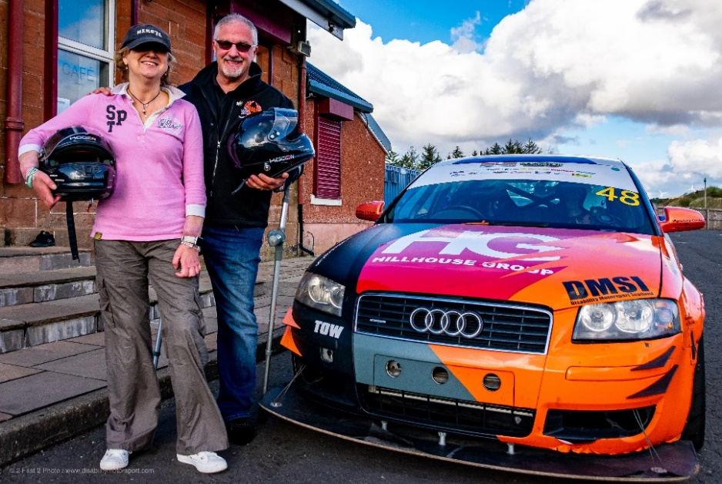 | Corrine. The first quadruple amputee, double hand transplant person to drive a race car, our very own DMS1.

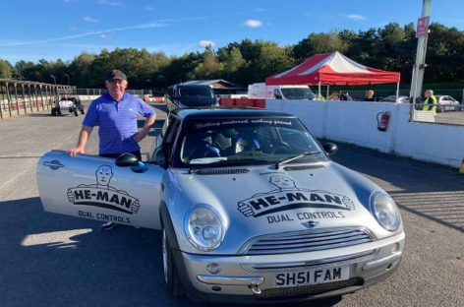 | Alex. Our first blind driver, such an inspiration, such determination. This was a challenge for Alex and DMS, however we found a wonderful sponsor He-Man Controls, they developed a dual steering control along with Alex which meant he could drive his car on track with a sighted passenger. Simply awesome.

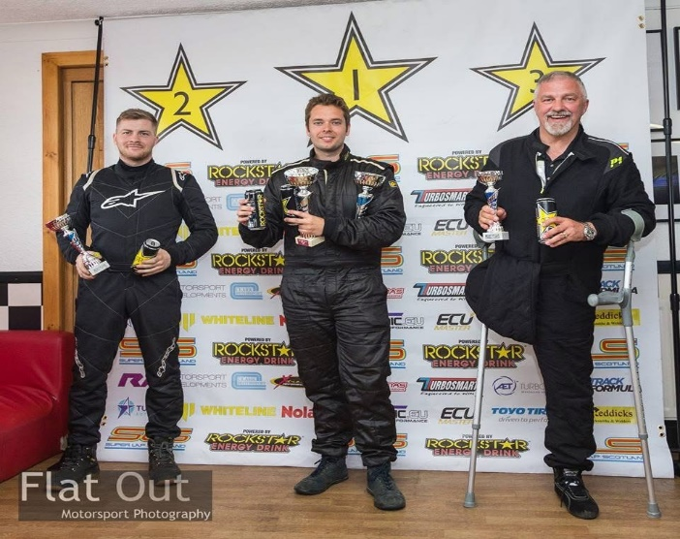 | Colin. Dreams can come true! Having thought he would never fulfil a bucket list item. Colin finally got the chance to race under DMS. DMS finished 4th in Super Lap Scotland, Colin was the first disabled person to enter the championship at Knockhill Racing Circuit.

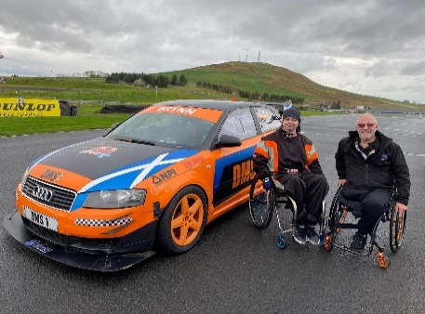 | Brynn. Brynn had the absolute thrill of driving DMS1 at Knockhill. A massive thanks to the circuit for facilitating this dream opportunity for Brynn.

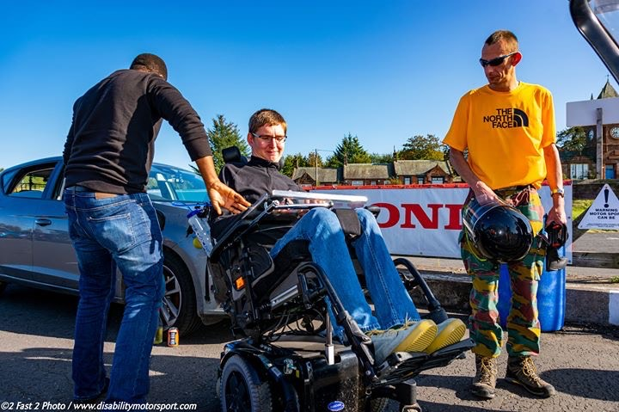 | Peter. Our first guest living with quadriplegia, this was a big challenge, however we did it thanks to our wonderful volunteers and Peters trust in them. Peter had a passenger experience in DMS1. Simply tears all around, for 10 minutes Peter laughed, cried and screamed just a little bit. He felt more alive in that 10 minutes than he had for a very long time. Peter is simply one of the most amazing human beings we have ever met.

Activity 2025

DMS has always been about people, behind every charity there is a group of hard-working volunteers who do a multitude of jobs, most of which the public never sees, my genuine thanks go out to all DMS volunteers and officials for their hard work and dedication.
- DMS started the year with a webinar entitled “Disability in Motorsport” DMS attends many Scottish Association of Motorsports Clubs (SAMSC) regional meetings online and face to face to promote our service and hear more about what MotorsportUK and motorsport clubs are doing across the country.
- Colin Duthie, chairman of DMS was delighted to be invited to join MSUK Disability & Inclusion Expert Committee. It is a privilege to be part of SAMSC.
- We were invited to attend a virtual FIA seminar on accessibility and Inclusion on an international level. It was fascinating to see how accessibility is perceived worldwide.
- We were very privileged to be invited to the launch of the new Scottish Motorsport Marshals Club ambulance. SMMC play a vital safety role at Knockhill Race Circuit and beyond.
- We attended a virtual seminar with MotorsportUK, the discussion was centered around Disability and Accessibility in motorsport. A very worthwhile discussion.
- We attended the SAMSC regional meeting which was very informative and looked at the current situation and at the future of motorsport clubs in Scotland. I then had a meeting with Professor Dan Wright MBE of The Jim Clark Memorial Motor Club.
- I met with Knockhill Racing Circuit to discuss circuit accessibility. DMS has been assisting the circuit with many aspects of accessibility, indeed the circuit has made many improvements over the years, we are delighted to be helping re disability access in particular.
- We met with Ally Chalmers Racing, a remarkable young man (16yrs) rookie driver from Glasgow who is looking to drive for Team Brit, we are assisting Ally with his driver development. Our chairman
- We met with GP Racing Simulators to discuss DMS Sim Racing proposals for 2025.
- FIA Disabled Mentoring Programme In 2025 Colin our chairman joined the FIA Sport Disability and Accessibility Commission as one of their mentors when they launched its Disability and Accessibility Mentoring Programme in partnership with One Up One Down, connecting disabled people across the motorsport community with experienced mentors. The inaugural programme engaged 64 participants from 22 countries, completing 85 successful mentorship matches and delivering more than 272 hours of mentoring across disciplines including driving, engineering, marketing and officiating. Building on that success, the programme entered its second year in 2026 with up to 100 places available - double the capacity of the first edition. Participants benefit from one-to-one mentoring, access to masterclasses and a growing global network of disabled professionals and competitors in motorsport. If you are interested in taking part as a mentor or mentee, please contact disability@fia.com .
- Governance 2025: As I mentioned earlier, volunteers are key to any charity and that includes committees and trustees. Sadly, two of our trustees stood down for personal reasons from their positions within DMS. We wished both gentlemen every success in the future and we are forever in debt to them for all their hard work.
- We are thrilled and delighted to announce that we now have a full new board of enthusiastic and professional trustees starting in early 2026. We are actively looking to further strengthen our board, volunteers and officials, if you are interested in finding out more about positions within DMS please contact colin.duthie19@gmail.com
Current position | January 2026

We are indebted to all our DMS friends in Ayrshire and further afield, in particular we have a new home in North Ayrshire (Irvine) where all our cars and equipment are stored at no cost to DMS. We are indebted to Allada Auto Styling Irvine for such compassion and generosity.
Disability Motorsport Scotland is also indebted to all our sponsors and supporters for their belief in our charity and indeed for their continued support.
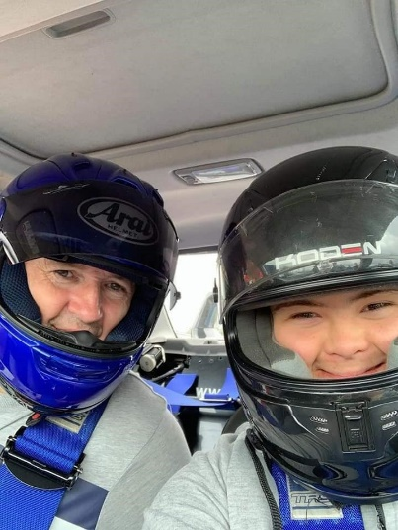 | 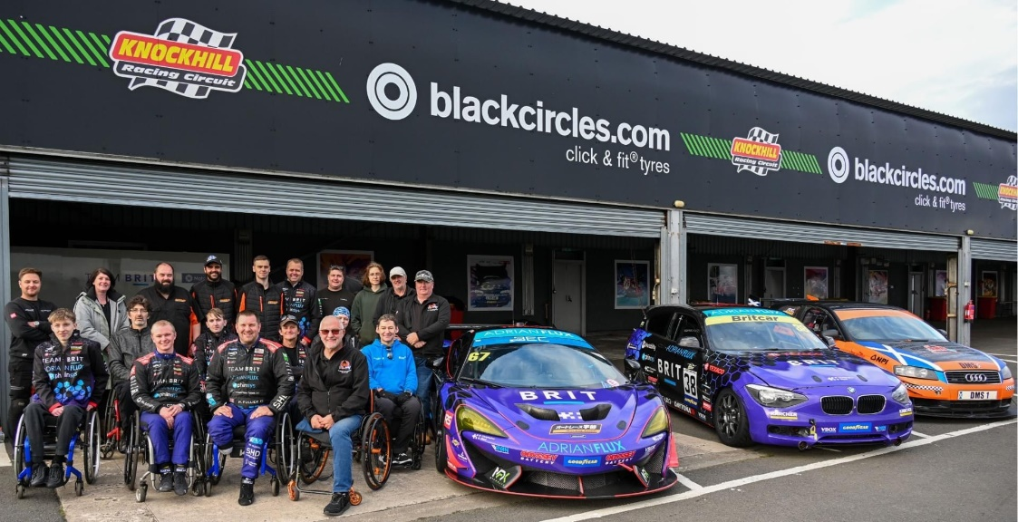 | 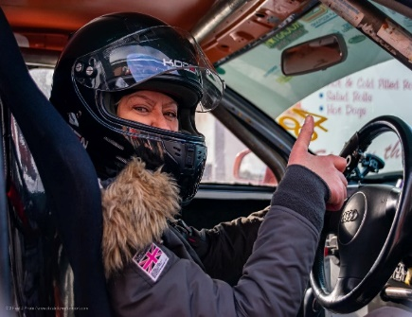
Everything we do is for the benefit of our guests. Our reward is simple: we get a SMILE!
Our guests gain independence, a “can do attitude”, confidence and above all self-belief.
DMS, ON TRACK FOR BETTER MENTAL HEALTH©
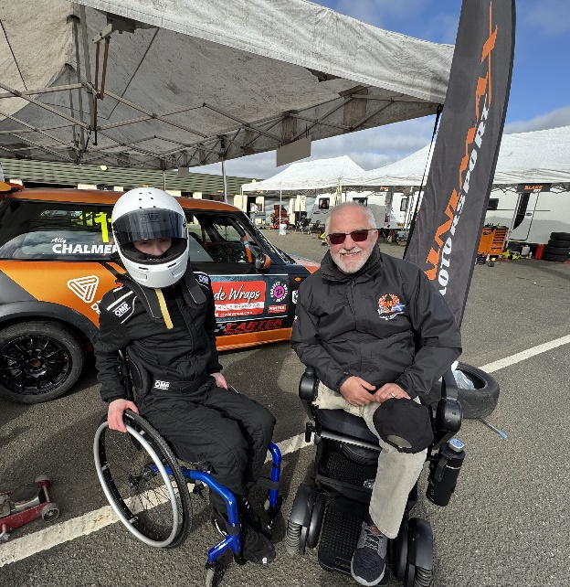 | Ally Chalmers Racing. We met Ally in 2025 and have supported him and his mum. Hopefully Ally will get a chance to drive DMS1 in the near future. Ally is a rising star in motorsport.

DMS Proposals 2026

Sim Racing: We have been working closely during 2025 with Brynn Hauxwell, “Breaking Down Barriers with Brynn” he is a young man who has a passion for motorsport especially Sim Racing. We aim to establish the DMS Sim Racing Community Hub, where disabled Individuals from all over the country and further afield can participate or compete for DMS online as part of our community. GP Racing Simulators has hand-controlled simulator rigs, one of which is fully VR at their HQ in East Kilbride where we hope to compete and socialize.
DMS Academy: In line with other motorsport pathways DMS looks to establish an accessible pathway for disabled motorsport drivers in Scotland.
Jim Clark Memorial Motor Club: We were absolutely thrilled and excited to announce that in 2025 we have been developing a partnership with JCMMC. We will be holding initial talks in 2026 to discuss further collaborative projects.
Motorsport Inclusion Training: DMS will be delivering MIT to as many motorsport clubs, volunteers and officials in Scotland as is required. Due to circumstances out with our control we have not able to deliver our training thus far, however we are revamping the training to reflect the changes in motorsport and indeed the wider context and are in the process of developing an online equality and diversity training module.
Disability Motorsport Scotland are indebted to all our sponsors and supporters for their continued belief in our charity and indeed for their continued support through 2025.

Conclusion

DMS has always been a forward-thinking charity, we will relaunch in Irvine Ayrshire and get back to what we do best, helping the community through motorsport, which can be life changing for some individuals, as it offers self-belief, courage and also trust in others, we also want to continue educating the motorsport world with better understanding of disability and the fact that anything is possible with a shared will and belief in each other.
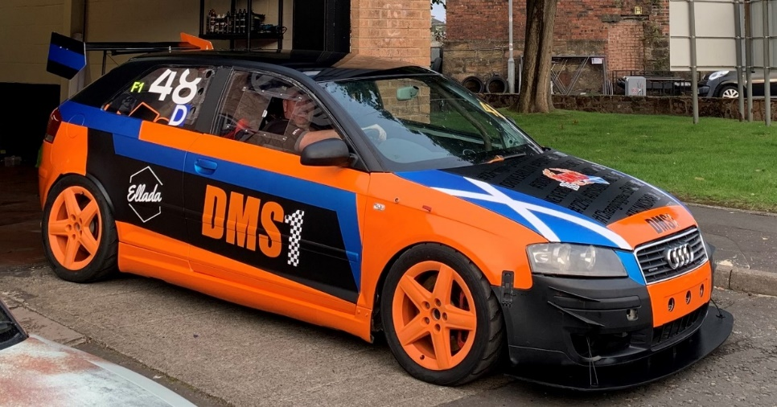
Our Famous DMS1 “Probably, the hardest working AUDI in the UK”
Colin Duthie
Chairperson/Trustee
Disability Motorsport Scotland
“changing gears, changing lives”

