Cowdenbeath Martial Arts Centre

AKA

Cowdenbeath Sport Karate

Trustees Annual Report 2026
Charity Ref SCO52599

The organisation is a non-profit charity whose main aim is to promote public participation in martial arts, particularly in the Cowdenbeath area of Fife. We provide recreational facilities and activities to improve people’s quality of life and create opportunities for all.
We work to advance the education, health and wellbeing of children, young people and adults by encouraging participation in martial arts, helping them develop physically and mentally while promoting healthier lifestyles.
We also support disadvantaged or underprivileged individuals to take part in community sport and learning activities, fostering community spirit and helping people play a positive role in their local area.
In summary: we seek to provide the best training and opportunities to all in our community, mainly young children, regardless of any individuals or families financial circumstances.

Centre Trustees:
Ben Smith
Elaine Bauld
Donna Shiels
Charles Pretorious

Trustees Ben, Elaine and Donna were appointed in March 2023 with Charles being appointed in December 2025. All are local people and volunteers who work full time in their own professions.

HOW WE FUNCTION:
Cowdenbeath Sport Karate (CSK) currently operate out of a leased building in Cowdenbeath, with the intention of purchasing our own premises in the community. This is currently ongoing and updates will be shared where possible. Classes are currently run in the evenings only due to the instruction team all working in their own jobs during the day. The centre runs classes on Tuesdays and Thursdays with classes for kids from 4 and upwards. We aim to provide further development and activities on weekends once we have a permanent premise to allow more flexibility. Instruction is provided by fully SKGB qualified and insured coaches Allan Goodwin and Ben Smith who are also qualified in child protection, teaching young persons and first aid as well as PVG requirements. We also have further black belt instructors who are currently undergoing these further qualifications to meet the SKGB criteria: John Forrest and Emma Duncan who have a wealth of experience and knowledge in martial arts. The collection of fees, hall costs and administration duties are carried out by Elaine Bauld and supported by the club committee. The club currently run Traditional Sport Karate classes as well as fitness and MMA sessions on Wednesday and Friday evenings. On occasion the club will also offer taster classes to local schools, free of charge.
The club also has an active competing team who travel throughout UK and often abroad in some of Europe’s most prestigious WKF competitions. We currently have 2 British medallists from 2025 and several former champions training and competing at the club.

WHAT WE DO:
As well as running normal kids’ classes we also run training camps, outdoor activities, seasonal parties and fun days to engage the kids and their families. We also provide training towards qualification in a structured and nationally recognised grading system also.

IN THE LAST PERIOD THESE ARE SOME OF THE ACTIVITIES WE HAVE CARRIED OUT:

Governance and Certification:
Maintain a regular cycle of 2–3 gradings and examinations each year to support progression and standards.
Outreach and Education:
Delivered taster sessions in local schools, including Crossgates Primary, and other nearby schools.
Talent Development:
Sent several students to monthly national squad training camps.
Attended invitational training at LKA in Lanarkshire & SKE in Dundee to broaden training insights.
Competitions and Performance:
Our developing team represented the organisation in a wide calendar of tournaments, spanning the UK (Sheffield, Glasgow, Durham, Manchester, Meadowbank, Motherwell) and international venues (Poland, Croatia, Italy), underscoring our commitment to player development and competitive excellence.
Notable results:
Scottish Nationals - Anna gold, Bison silver
Meadowbank - Anna and Bison Gold, Cole and Bailey silver, Emma, Emily, Quinn and Ethan Bronze
Meadowbank - Sofiia and Quinn gold, Kirstie silver, Bison, Carson, Bailey and Indi bronze
Penrith - Emily and RJ silver, Anna bronze x 2
Central Scotland Open - Indie and Kirstie Bronze, Emily silver, Anna and Carson gold
Central Scotland Open – Cole & Claye Gold, RJ, Bison & Anna Silver
Penrith - RJ and Emily bronze
SKGB Grand Prix - Anna gold, Kirstie bronze
SKGB Grand Prix - Allan and Emily gold, Bison silver, Cole and Kirstie Bronze
Cumbria open - Bison and Cole team gold, Emily silver
Croatia WKF Para Cup - RJ Silver
Anna & Cole Central Poland Open both 5th place
Elize Bauld - 2 x Gold Central Poland open, 2 x bronze polish open and European champion

Community Engagement:
Attended and supported local galas; delivered demonstration in Lochgelly.
Travel and Outreach:
Participation across regional and international events to raise profile and participation.
Equipment and Resources:
Purchased gym equipment and kits for young students. We have a new line of tracksuits also available with sponsorship pending.
Social Activities
Halloween party and Christmas party with Santa and the Grinch. Scheduled trip to Dundee Trampoline Park in October 26.

OUR EXPENDITURE AND INCOME
Our accounts are fully public to view on OSCR website under charity name Cowdenbeath Martial Arts Centre. Our main monthly expenses are rent (currently £545 per month), gas (rough average £175 per month) and electricity (roughly £65 per month), plus water charges. We also have to incur the full maintenance and upkeep of our leased hall in Broad Street.
Students’ fees make up most of our income which varies according to attendance. These are however subject to discount given individuals circumstances as we seek to try and give everyone the same opportunities regardless of financial circumstances.
We also cover competition costs, travel and entry fees to tournaments where we can as well as affiliation fees to governing bodies and insurances which allow us to function. This again runs into thousands of pounds over the course of the year but is mandatory and essential for the club students to develop.

We have also received various grants and donations:
Cowdenbeath Community Council for equipment £225
Local Business donation for new mats - £1700
RJ Great Scottish Run - £657
Claye Head shave - £480
Billy's funeral - £2000
Sky Dive - £2302

In Summary
CSK is a non-profit charity promoting participation in martial arts in Cowdenbeath and surrounding areas, providing accessible training to all ages to improve education, health, and wellbeing. We now operate from 39 Broad Street (The Fountain), Cowdenbeath, delivering classes and ensuring all sessions are led by SKGB-qualified, safeguarding-compliant coaches.
Our governance remains strong, with Ben Smith serving as Chair, supported by trustees Elaine Bauld, Charles Pretorious and Donna Shiels; we continue to invite new committee members to ensure broad representation at AGMs. In this period, we ran three gradings, school taster sessions, national squad camps, and UK/European tournaments, all supported by essential equipment purchases for our students. Our priorities going forward are to maximize the use of our new home, expand weekend activities, continue our active community outreach—including our gala demonstrations and fayre stalls—and maintain our commitment to safeguarding and support for disadvantaged participants

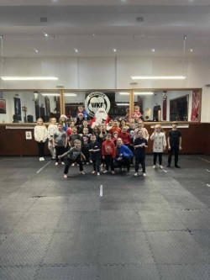
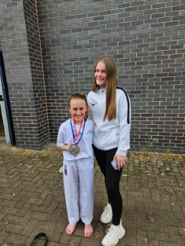
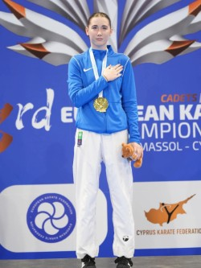
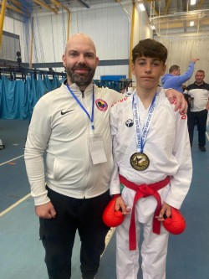
Please see below photos of our team throughout the last year:

