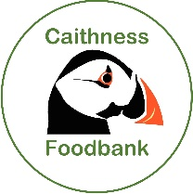
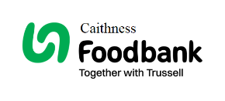
Caithness Foodbank SCIO AGM – 1st April 2026

Chairperson's Report

Thank you for coming along this evening to our AGM. It’s been wild weather so hopefully we see sunshine and blue skies again soon!

Our referrals to Caithness Foodbank have decreased ever so slightly from last year. Both centres are running at the same number of referrals overall. We have engaged much more collaboratively with Caithness Citizens Advice Bureau since the appointment of the Food Insecurity Adviser, and this is showing as a success from shared reports and regular meetings. Many clients being referred to CAB are gaining in a range of other supports including financial gains. The funding for this post is in place until January 2027 from Trussell. We hope to extend this.

Most of our referrals come from CAB, New Start, Highland Council Housing and Thurso Community Café with a significant number from Caithness Drug and Alcohol Service and the Mental Health Team.
There are 31 referral partners that we work alongside, and they now use our e-referral system which makes life easier for us and for them.
We endeavour to highlight our profile in the community by regular posts on our Facebook page, Tesco Collections and relevant community opportunities.

Our food donations mainly come from our Tesco supermarket drives at Christmas and the summer through links with Trussell.
Other major donations of food come individuals, churches, schools and Early Learning Centres as well as charity events.

This year we have had to purchase more food than in previous years. We also receive donations of money, which we use to buy food to top up our stock. We continue to receive donations from Cadbury at Christmas and Easter as well as a selection of books from the Scottish Book Trust.
We now use Just Giving as another means for money donations, through our website and this has been successful.
We continue to update our policies and Risk Assessments throughout the year, and I am grateful to our Trustees who undertake these tasks along with our Treasurer who manages the finances with precision!

We haven’t made any progress with the Boys Brigade Hall in Wick as our plans for a joint project fell through. We’re now looking at alternatives. We are also involved in community discussions about the future of the Carnegie Building.

A small group of Trustees and our lead volunteers have maintained good communication links with the Northern Cluster of Foodbanks – Shetland, Orkney, Highland and ourselves in Caithness. Last year we met up in Inverness and visited the Highland Foodbank – which is very similar to our operations but on a larger scale.

Further details are in the Trussell – Caithness Foodbank Data Pack 2025.

I thank the volunteers and Trustees for their dedication and support.
We wouldn’t be able to run Caithness Foodbank without them.

Grant Ramsay - Caithness Foodbank Chairperson - 1st April 2026

