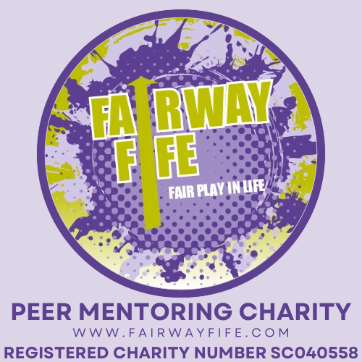

Chairperson’s Annual Report
FAIRWAY FIFE
For the year ended 30th September 2025
It is my pleasure, on behalf of the Board of Trustees, to present the Chairperson’s Annual Report for Fairway Fife.
This year has been one of continued commitment, learning, and resilience. Fairway Fife exists to support, young adults with learning disabilities and/or autism, to access social, leisure and educational events and activities throughout the year, the organisation has remained focused on providing safe, respectful, and person‑centred support via volunteer Peer Mentors within our local communities.
Review of the Year
Over the reporting period, Fairway Fife has continued to deliver its activities in line with its charitable purposes. Despite ongoing external pressures affecting the voluntary sector, including financial uncertainty and increased demand for support, the organisation has remained responsive and adaptable.
The dedication of our staff and volunteers has been central to this work. Their commitment ensures that Fairway Fife continues to provide a supportive environment where individuals are treated with dignity, listened to, and encouraged to build confidence, resilience and independence.
The Board is satisfied that the organisation has operated responsibly and in accordance with its governing document, maintaining a strong focus on safeguarding, good governance, and risk management throughout the year.
Our staff team remain focussed and dedicated to the aims and ethos of the Charity, providing the best outcomes for all our members and Volunteer Peer Mentors. Neil as Manager continues to develop the foundation of the Charity, support and encourage all staff and liaise with families, Trustees and associated partners as well as develop new partnerships with other similar agencies to the benefit of Fairway Fife.
Peer Mentor Volunteers are an integral part of our service delivery. They enable our members to develop trusting friendships and meaningful experiences in a natural, supportive way. Through their time, energy, and commitment, our Mentors play a vital role in fostering the social learning that is a fundamental human need. We greatly value and applaud their contribution, not only to our members but to society as a whole, as they help challenge misconceptions and reduce fear and misunderstanding surrounding people with learning disabilities and autism.
The Charity continues to develop relationships with other career and educational environments to engage with new Volunteers and support future potential care sector workers.
Governance and Trustees
The Trustees have met regularly to provide strategic oversight, ensure compliance with regulatory requirements, and support the organisation’s long‑term sustainability. Trustees have continued to act in the best interests of Fairway Fife, bringing a range of skills and experience to support informed decision‑making.
The Trustees for the period were;
Jaqueline Dow -Chairperson
Sharon Arthur – Treasurer and Vice Chair
Tony Boyle - Trustee
Joanne Creech – Sports and Outdoor Activities
Wilma Pirie – Family Support
Carol Hughes – Secretary

I would like to thank my fellow Trustees for their time, professionalism, and commitment. All Trustees serve on a voluntary basis, and their contribution is vital to the continued success of the organisation.
Finance and Sustainability
The Board continues to monitor the organisation’s financial position closely. We are grateful for the funding and support received during the year, from which has enabled Fairway Fife to continue its work and plan responsibly for the future.
Maintaining financial sustainability remains a key priority. The Trustees will continue to seek opportunities to strengthen funding arrangements, develop partnerships, and ensure that resources are managed prudently and transparently.
We continue our agreement with Fife Council, supporting 9 members via Self Directed Support. This income helps us to maintain sustainability and provide a regular source of income. We also maintain a balance to ensure that we can continue to support those without funding to via this income and grant funds for which we truly appreciate.
Looking Ahead
As we move into the coming year, Fairway Fife remains committed to:
- delivering high‑quality, safe, and inclusive support
- listening to the voices of those we support and responding to their needs
- strengthening governance and organisational resilience
- working collaboratively with partners, funders, and the wider community.
The Board is confident that, with the continued dedication of staff, volunteers, and supporters, Fairway Fife is well placed to build on its achievements and continue making a positive difference.
Thanks and Appreciation
On behalf of the Trustees, I would like to express my sincere thanks to everyone who has supported Fairway Fife over the past year - including staff, volunteers, funders, partner organisations, and the individuals and families who place their trust in us. Your support and engagement are deeply valued.
I commend this report to the members.
Jaqui Dow

Chairperson
Fairway Fife
Date: 10th March 2026

