Carse of Gowrie Men’s shed Report and Accounts | December 31  2025
This document is an annual report detailing the activities, governance, financials, and plans of the Carse of Gowrie Men's Shed (COGMS) The report concludes with approval and signatures from the trustees. The activities and achievements demonstrate the organization's commitment to community engagement and support for men's health and well-being. |  | Charity number SC047662

Trustees

Graeme Mudie Chairman
Nick Tindell Vice Chairman
Clive Skinner Treasurer
Bill Beckers Secretary
Martin Leiper

Independent Examiner

Michael Dailly BSc

Bankers

TSB
Dundee,
Meadowside

Principal office

Swan House
Explorer Road
Dundee Technology Park
Dundee
DD21DX

The trustees present their report and financial statements for the period ended 31 December 2025.

Trustees
The following trustees served during the year:

Graeme Mudie Chairman
Nick Tindell Vice Chairman
Clive Skinner Treasurer
Bill Beckers Secretary
Martin Leiper

Reference and administrative details
These details are reported on page1.

STRUCTURE, GOVERNANCE AND MANAGEMENT

The Carse of Gowrie Men's Shed (COGMS) is a Scottish Charitable Incorporated Organization first registered on 29 August 2017. The COGMS was previously an unincorporated association the assets of which were transferred to the SCIO on
1st September 2017.
The COGMS is governed by a written constitution based on the template recommended by the Scottish Men's Shed Association and has a two tier structure with the Trustees being members of the charity.

Recruitment and appointment of trustees

The management committee, which is comprised of the Trustees, attends the weekly activities of the Shed and hold meetings every month to consider progress with the various objectives and feedback from the members of the Shed. Trustees are elected at the annual general meeting which takes place in January each year. There must be a minimum of four and a maximum of seven Trustees. The Trustees may co-opt additional trustees if they consider that it would be in the interests of the charity to do so.

OBJECTIVES AND ACTIVITIES

The purpose of the charity is to provide recreational facilities and advance the social needs, health and well being of men of all ages and back grounds living in Dundee and surrounding areas.
Main activities: -
- Support quality, diversity and inclusion by creating, developing and maintaining a facility, namely a Men's Shed, offering opportunities for men in the Dundee and surrounding area to meet and undertake creative, physical, and recreational activities of their choice
- Reduce the isolation of men in the area thus contributing to their physical and mental well being
- Develop the capacity of men in the area to share their skills and knowledge with others in the Community.

ACHIEVEMENTS AND PERFORMANCE

Membership continues around the high sixties with an average daily attendance of around twenty five. The membership is made up of a cross section of backgrounds with a wide age range and a variety of skills and interests.

Members have undertaken a wide range of personal projects that reflect their differing interests but
they also find time and energy to tackle projects for other charities and individuals.
A sample of some of these projects are:

- Gates for Riding for the Disabled Centre
- Mud Kitchens for Monifieth Primary School
- Quaifs for Downfield Golf Club
- Pens for Maggies Cancer Support Centre
- Boxes and pens for Hillside Primary School
- Software support and maintenance for Tayport Larick Centre
- Extensive work for Dawson Park Community Garden
- Fundraising objects for Dargie School
- Hand tools refurbished for members and other sheds
- Commemorative crosses for Salvation Army
- Commemorative items for British Legion
- Shelter for Baxter Park Bowling Club
- Coasters for RSPB
- Repair of candleholder for St Paul’s Episcopal Cathedral
- Coasters for Tayport Larick Centre
- Repair of chair for Shoreline
- Making objects for Tayside Upcycling Centre

We have also been given a range of donations including tools, hand and power, materials and consumables. These we offer to members and other organisations at no cost.

FINANCIAL REVIEW

The main sources of funding are:
- Member’s annual fees
- Donations by members for use of the café area
- Selling of products made by members at shows, open days, and on request

Reserves policy

The trustees continue with the reserve policy target of £22,000 which is felt would be a prudent reserve in view of continuing uncertainty of the need to relocate.

PLANS FOR FUTURE PERIODS

The Trustees intend to continue to update the strategic objectives set for this period to increase membership, continue to interact with the community at large, secure new premises, and attract additional funding.

STATEMENT OF TRUSTEES' RESPONSIBILITIES

The charity trustees are responsible for preparing a trustees' annual report and financial statements which give sufficient detail to enable an appreciation of the transactions during the financial year.

The trustees are responsible for keeping proper accounting records that disclose with reasonable accuracy at any time the financial position of the charity and to enable them to ensure that the financial statements comply with the Charities and Trustee Investment(Scotland)Act2005 and the Charity Accounts (Scotland) Regulations 2006 (as amended).They are also responsible for safeguarding the assets of the charity and taking reasonable steps for the prevention and detection of fraud and other irregularities.

This report was approved by the trustees on 24 July 2026

Graeme Mudie
Chairman

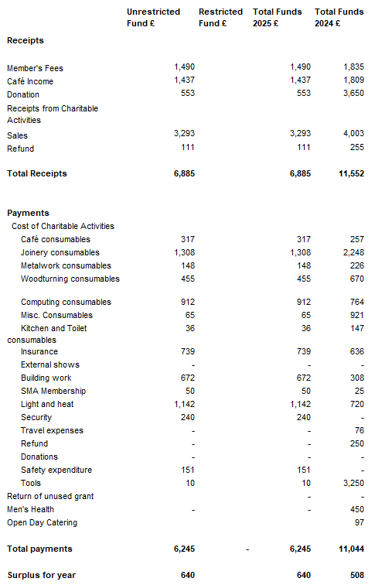
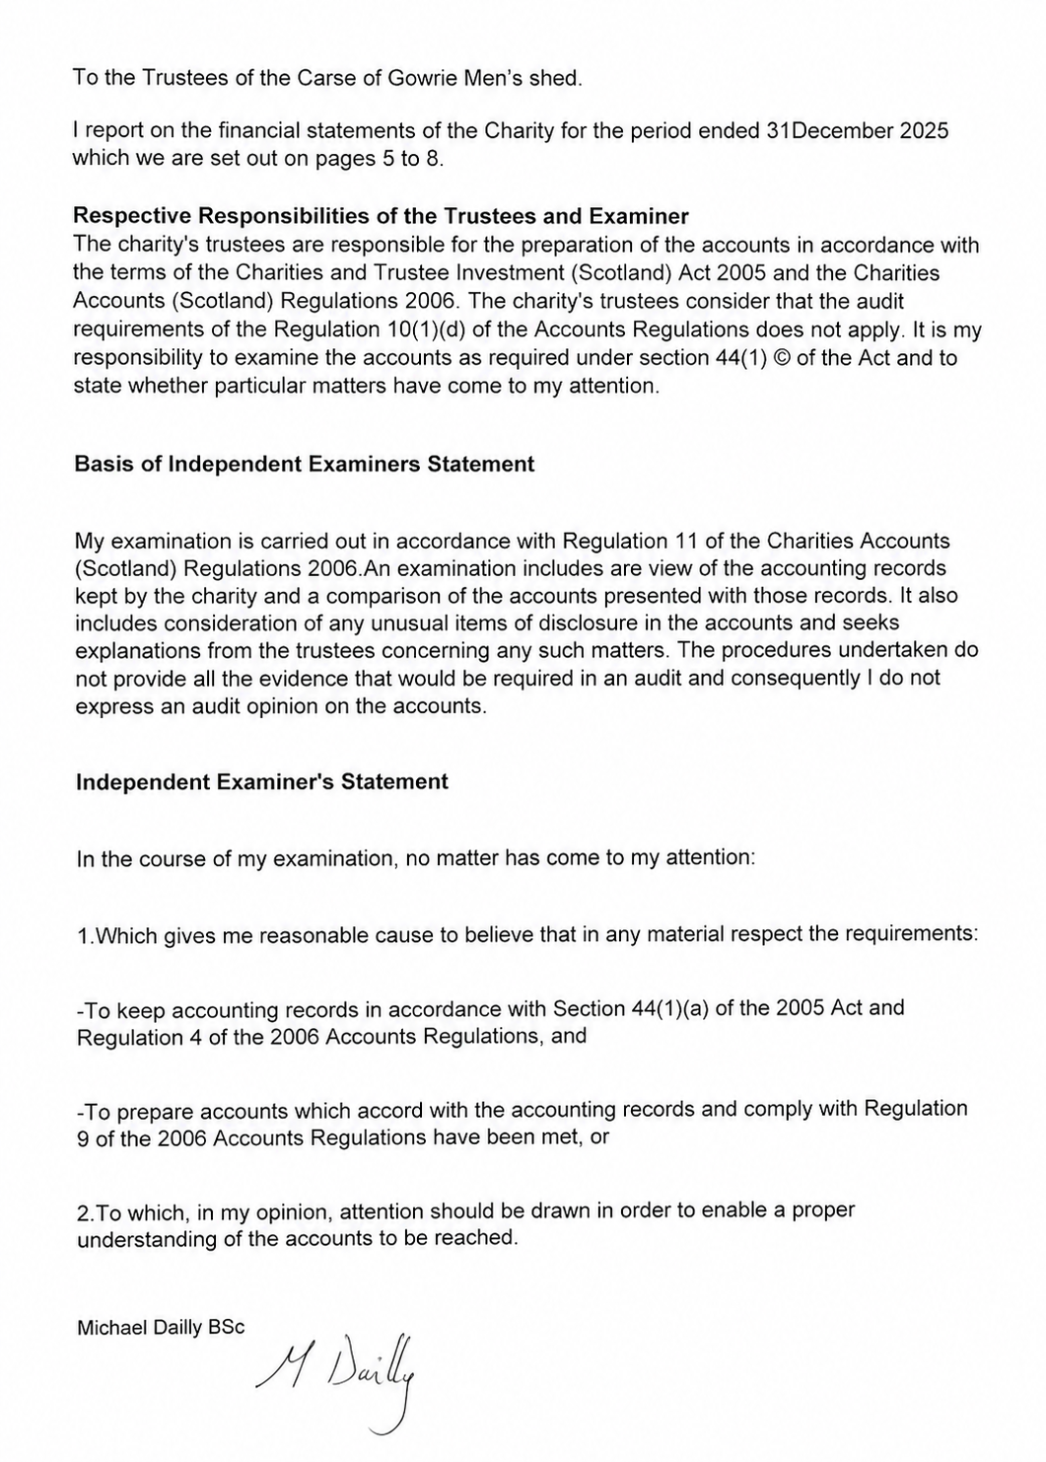
Statement of Balances
as at 31December 2025 |  |  | Total
 | Unrestricted | Restricted | Funds
 | Funds | Funds | 2025
Cash funds
Bank balance | 15019 | - | 15019
Cash | 373 | - | 373
Total | 15393 | - | 15393

Approved by the trustees on 24 July 2026

……… Graeme Mudie ……………………………. Chairman

………William Beckers……………………………. Secretary

