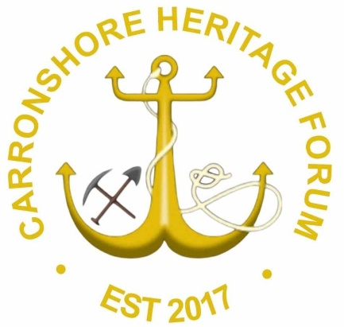
SCO52344
Carronshore Heritage Forum
Preserving the past, engaging the present, inspiring the future.

Carronshore Heritage Forum
Trustees’ Annual Report
Period 1st October 2024 to
30 September 2025.

Charity contact information

Carronshore Heritage Forum
Preserving the past, engaging the present, inspiring the future.

Carronshore Heritage Forum
Scottish Charity Number: SC052344

Address
27 North Main Street, Carronshore, Falkirk.
Postcode FK2 8HW

Email address craig@Carronshoreheritageforum.org
Website N/A
Facebook / Social Media https://www.facebook.com/search/top?q=carronshore%20heritage%20forum

Charity Trustees

TRUSTEES-
- John McLuckie – Chair. Local Businessman.

- Craig Martin – Secretary. Retired, 43 years Railway industry & 20 years Local Elected member of Falkirk Council, including 7 years as Leader.

- Colin Wilson – Treasurer. Retired Quality Assurance Manager.

- Stewart Wright – Health & Safety and Events advisor. Retired, Technical Member of the Institution of Occupational Safety and Health (IOSH), brings a wealth of expertise, holds a Diploma in Health and Safety and several qualifications, including an SVQ in Construction Contracting Operations Management at SCQF Level.

- Gordon Walker – Community Liaison & Events Supports. Works at the local Coachbuilding company, has a wealth of community information and knowledge.

- David Taylor – Fundraising & Events Officer. Ex military and currently working with a well-known Cancer charity.

- Robert Kemp – Veterans Liaison Officer & Community Support. Ex Military retired and worked in the Voluntary sector.
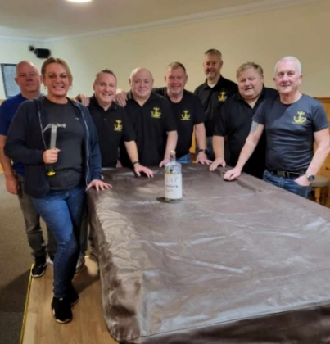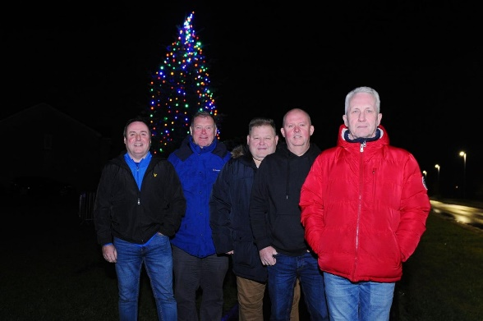

On 23rd March 2025 the Trustee had their first internal ‘development day’. All seven trustees attended and signed the register for accountability. The day was split into two, with the morning being outdoor ‘team building’ exercises to encourage leadership and team building awareness. The second part of the ‘development day’ was office based with presentations on important parts of being a trustee, the list of activities are shown below:-
Team building exercises
Understanding Trustee Responsibilities
Effective Leadership and Decision Making
Strategic Planning and Goal Setting
Fundraising and Resource Management
The outcomes from the development day are laid out below: -
1. Decision-Making Frameworks
Effective decision-making requires structured approaches analysis,
Choosing the right framework depends on complexity, urgency, and available information.
2. Trustees' Responsibilities
Trustees must ensure legal compliance, financial oversight, and strategic direction.
Strong governance and ethical leadership are essential for long-term success.
3. Effective Leadership & Decision-Making
Leadership is about vision, adaptability, and decision-making that aligns with organisational goals.
Decision-making should be strategic, data-driven, and inclusive to foster innovation and accountability.

4. Strategic Planning & Goal Setting
A clear vision, mission, goals provide direction and measure success.
Strategic planning ensures resources are allocated effectively and progress is monitored for continuous improvement.
5. Fundraising & Resource Management
Diverse fundraising strategies ensure financial stability and sustainability.
Effective resource management maximises impact through budgeting, transparency, and accountability.
Final Thought
Success in leadership, planning, and decision-making depends on a proactive approach, adaptability, and continuous learning. By applying these principles, individuals and organisations can drive meaningful impact and long-term success.

Objectives and activities
Carronshore Heritage Forum objectives are:
- the advancement of education
- the advancement of the arts, heritage, culture, or science
- the advancement of citizenship or community development
- The provision of recreational facilities, or the organisation of recreational activities, with the object of improving the conditions of life for the persons for whom the facilities or activities are primarily intended.

to further these purposes Carronshore Heritage Forum Continues to:-
- promote and enhance the History of Carronshore village and the surrounding Bothkennar area by bringing forward visual/cosmetic enhancements to the area.
- educate the residents on the history of the village from an agricultural hub into a thriving Industrial village linked to Carron Ironworks with 4 coal pits. docks for barges and a railway line running through it.
- holding regular community activities inviting the community to attend to bring everyone together.

What we do….
The forum is active in bringing the community together with various community projects, since 2017 we have installed a War memorial in Carronshore, have Christmas festive events within the village catering for all age groups, street lighting decorations, 20/25ft Christmas tree, switch on event with entertainers etc, also have an event with our senior citizens. The 2024/25 ventures/projects included installation of 7 historical information boards, along with accessible seating placed along the River Carron Footpath from Carronshore to the Helix/Kelpies, Holding VE80 & VJ80Day memorials, obtaining equipment & materials that will assist our events in future and during 2024 we published the creation of a 2-year plan (all explained in this report).

We held our yearly remembrance service, in addition, as this was a ‘marked’ year, we held special VE80Day & VJ80Day services, along with a ‘light of peace parade’ in accordance with the national VE80Day commemorations, with assistance of local minister and local primary school pupils, along with a large attendance by veterans and residents...

We work with all age groups, other local voluntary organisations and Local authority, working closely with Local primary and secondary schools encouraging young people to participate in our events.

Our membership is open to all residents of Carronshore, we have 7 trustees, and approximately 20 active members. We meet every 4 weeks for our regular meeting.

We continue to work closely with Falkirk Council Community Learning team on all our proposals to ensure that we not only meet the local authority’s requirements but continue the good working relationship we have.

We have 2 (large income) fundraising events (Prize Bingo & Race night) throughout the year that is well supported by residents towards the on-going costs of our events, such as storage, connections, and all the events expense’s.

The benefits so far continue to be tremendous for the community and local school in that there is a sense of community participation and well-being around the festive time. We continue to enhance the small street decoration so we can include other parts of our village, as exampled within this report.

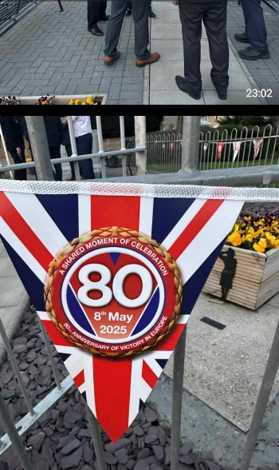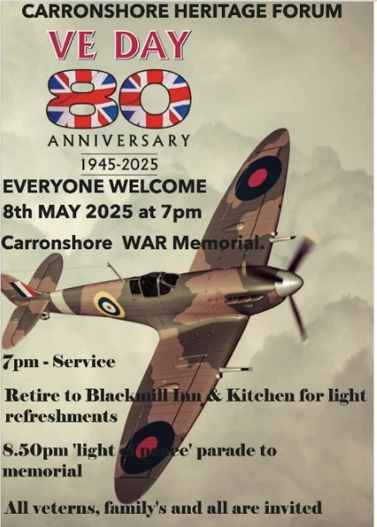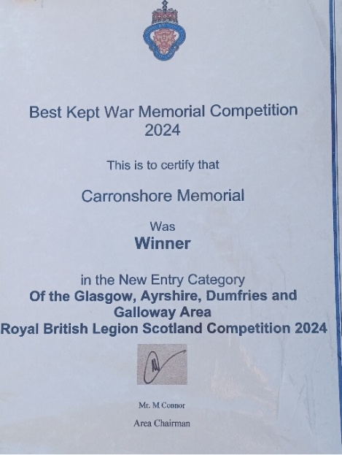

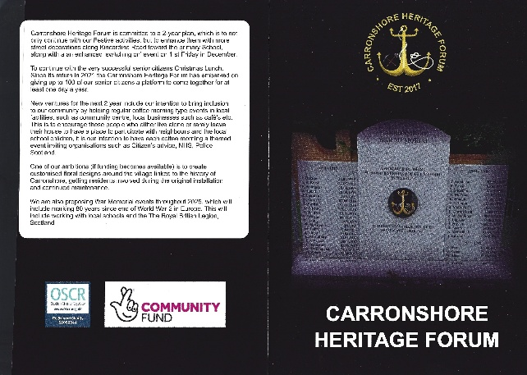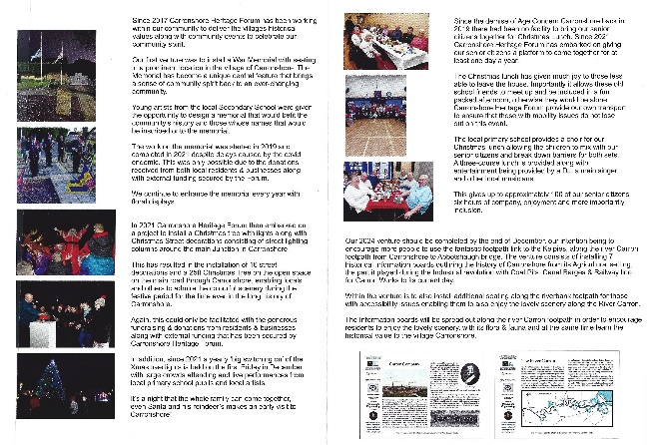

Structure, governance and management
Below is the front page of our governing document.
Our structure is Trustees board & Committee/Volunteers.
Hold monthly meetings of the Trustees Board.
Applied for charitable status in December 2022 and in February 2023 were awarded charitable status from OSCR, we are governed by those rules and regulations laid out by OSCR and submitted our first audited report was submitted in October 2023.
CONSTITUTION
of
CARRONSHORE HERITAGE (GROUP) FORUM

adopted on 8th March 2023
CONTENTS
GENERAL | name, objects, powers, general structure | clauses 1-4
MEMBERS | qualifications, application, subscription, register, withdrawal, expulsion | clauses 5-13
GENERAL MEETINGS (meetings of members) | general, notice, procedure | clauses 14-27
MANAGEMENT COMMITTEE | maximum number, eligibility, election/ retiral/re-election, termination of office, register, office bearers, powers, personal interests | clauses 28-45
MANAGEMENT COMMITTEE MEETINGS | procedure | clauses 46-54
ADMINISTRATION | committees, operation of bank accounts etc., minutes, accounting records and annual accounts, notices | clauses 55-63
MISCELLANEOUS | dissolution, alterations to the constitution, interpretation, initial management committee members | clauses 64-70

Trustee recruitment and appointment
Having a diverse board can help to make our charity more effective. That’s why we believe that we have the right mix of skills and experience to meet our aims and objectives.
Trustees are nominated onto our board, we have seven Trustees, 2 co-opted trustees (vacancies), we continue to strive for suitable nominee’s, especially women & ethnic origin.
Appointments are made at our AGM.
Achievements and performance in 2024/25
The annual Christmas tree switch on is very popular with families, school children, elderly and those with accessibility issues. We always include local primary school who sing carols and arrange suitable entertainment on the night. We estimate crowds are approx. 300-400 on the night on previous years.

Over the next 2 years it is our proposal to increase street lighting decorations, thus becoming more inclusive within Carronshore, we are currently in collaboration with Carronshore Primary school to design a bespoke Christmas theme decoration for the street lamppost outside the primary, however this will be in next year’s Trustees report.

We believe that the events and the decorations that are installed for the festive period enhances not only our community, but further afield in several ways, but here are a few examples:-

- People’s well-being and mental health through the festive
period.
2) Encourage residents to understand the concept of community
partnership.
- To educate through participation social ability within our
community.
- Increase partnership working with our local primary schools,
who we work on many ventures.

- A sense of community awareness, encouraging police, social
health officials to participate.

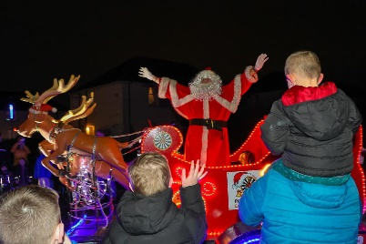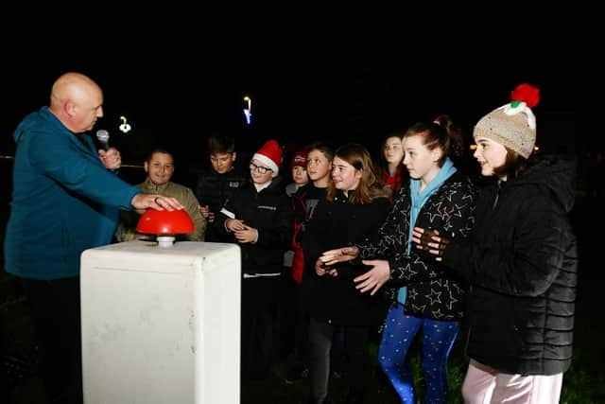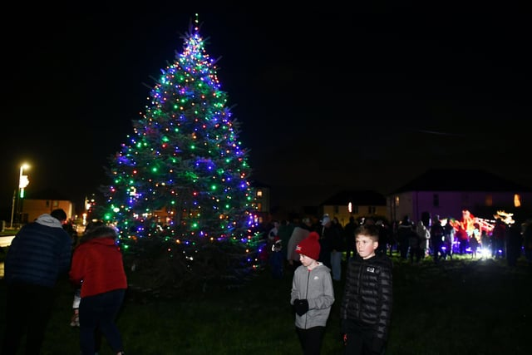

Since the demise of Age Concern Carronshore back in 2019 there had been no facility to bring our senior citizens together for Christmas Lunch. Carronshore Heritage has once again embarked on giving our senior citizens a platform to come together for at least one day a year, indeed our 2-year plan includes a proposal that stems from our success on this matter, hence the reason we are now holding bi-monthly coffee mornings (every 2 months).

Christmas lunch has given much joy to those less able to leave the house, importantly it allows these old school friends to meet up and be included in a fun packed afternoon, otherwise they would be alone. In 2024 we had another successful Christmas lunch with our highest attendance of senior citizens since we started in 2021

Carronshore Heritage Forum provide our own transport to ensure that those with mobility issues do not lose out on this event.

Entertainment included local folk singer, young piper and a main entertainment act, along with Santa from the Larbert Rotary club.

The local primary school provides a choir for our Xmas lunch; this allows the children to mix with our elderly and breaks down barriers for both sets.

A 3 course Lunch is provided with entertainment, including DJ, main singer and other local musicians give 100 of our elderly approx. 6 hours of company, enjoyment and more importantly inclusion.

We believe that the Christmas lunch event enhances our own objectives for inclusion and community well-being in several ways, such as:-

1) Older residents’ well-being and mental health.
2) To educate through participation and understand the concept
of community Partnership of our young and old within our
village.
3) To educate through participation on our social ability within our
community.
- Increase partnership working with our local primary schools,
businesses, other voluntary groups.
- Provide for those with accessibility and health issues, being
Inclusive.
7) Bringing elderly together!

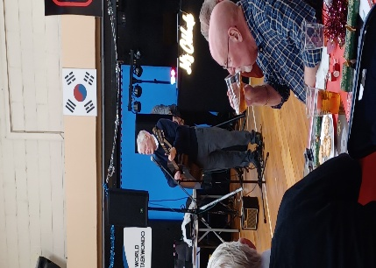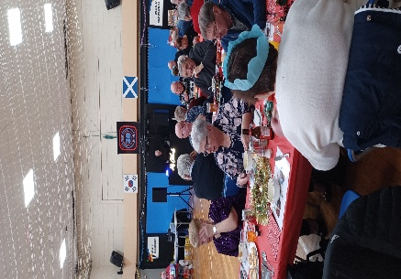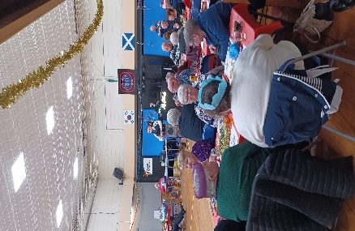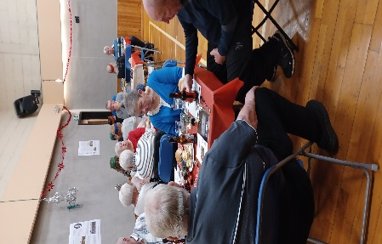

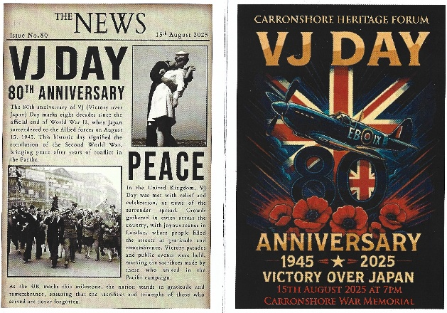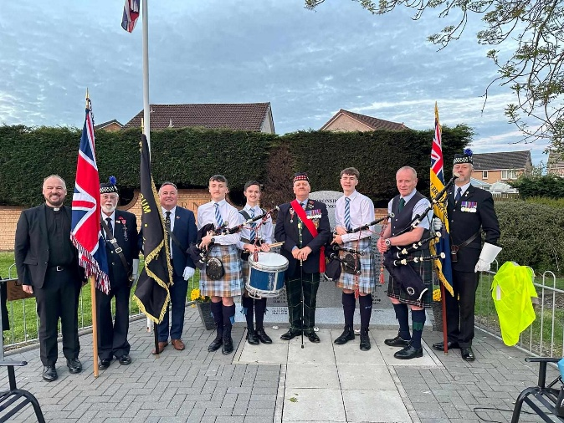
Carronshore Heritage Forum marked the 80th anniversaries of both Victory in Europe Day and Victory over Japan Day with respectful community commemorations designed to honour the sacrifices of the wartime generation and ensure their legacy continues to be remembered within the village.
For VE80 Day, the Forum organised a remembrance service at the Carronshore War Memorial, bringing together residents, veterans’ families, local organisations and young people from the community. The evening included a short act of remembrance, readings reflecting on the end of the war in Europe in 1945, and the laying of wreaths to honour those from Carronshore who served and lost their lives. The event concluded with a symbolic “Light of Peace” parade, where members of the community walked together carrying lanterns and lights, joining with communities across the UK to shine a light for peace and remembrance.
Later in the year, the Forum also marked VJ80 Day, recognising the moment in August 1945 when the Second World War finally came to an end. This commemoration provided an opportunity to reflect on the wider global conflict and remember those who continued to serve in the Far East after victory had been declared in Europe. Through these services, Carronshore Heritage Forum ensured that the sacrifices of the wartime generation were honoured with dignity while also educating younger generations about the importance of remembrance.
Together, these commemorations demonstrated the Forum’s commitment to preserving Carronshore’s history, strengthening community identity, and ensuring that the lessons and sacrifices of the past remain part of the village’s collective memory.

Through this financial year we held 2 local fundraising events, along with donation tubs in various local businesses, this is vital work to ensure that we continue to receive income to allow us not only to continue with our festive events but allows us to enhance them year on year. Switching on of Christmas tree light in December 2024 we had an acclaimed local actor, who was in ‘game of thrones’ Garry Wales to assist us on the evening switching on the Carronshore Christmas Lights.

This year, after being nominated Carronshore War memorial won the category of new entrant for Glasgow, Ayrshire, Dumfries and Galloway area of the Royal British Legion Scotland Competition.

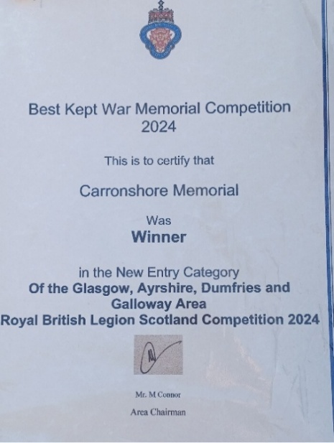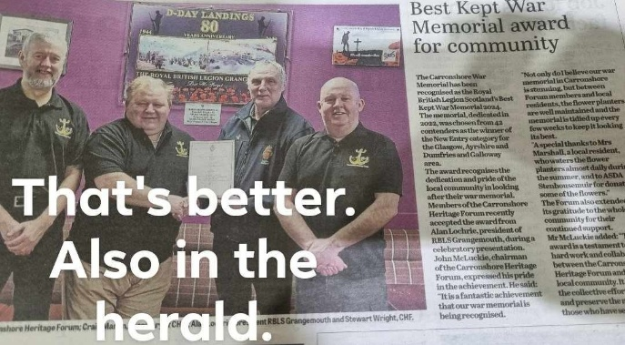

Fundraising

Event Outcome
Airth Highland Games  Prize Bingo in Carronshore Bar  Race Night  Go Fund me page  Round Table donation | Games Stall - Good day, approx. 4500 people in park and our tombola stall was finished by 2pm. Also gave out our new promotional pamphlets. Excellent way to promote the work being undertaken by the Forum, also promotes our village.  One of our large income events, increase in participants than previous year, very good response, Local participation was tremendous on the night! Very successful fundraiser.  Our 2nd large income event. Great response by Local Pub who held the event on our behalf, selling sponsorship and a very good income, Local participation was tremendous on the night! Very successful fundraiser.  source of income.  Excellent amount again. Round Table also supplies Santa and Sleigh on our Christmas ‘switch on’ event. Trustees and volunteers assist the round table with their street collections when Santa is out and about the local streets, on the lead up to Christmas.

During this financial year we held 6 events throughout the year that included something for all family members, with Carronshore Heritage Forums first official opening with our historical information boards, we had well over 100 in total attend our various events this financial year.
Activities
Event Outcome
Official opening of Historical boards & trail.  VD80Day service  VJ80Day Service  Remembrance Sunday  Christmas Tree Lights switch on  Senior Citizens Lunch | Very Good Turnout, great response from those who attended.  Good Service, Minister done well. Very high attendance with musicians adding to the overall event.  Good Service, Minister done well. Very high attendance with musicians adding to the overall event.  Good service, Minister done well. attendance was up on last year and musicians add to the event.  Excellent event with great artists giving up their own time (Gary Wales and Dougie Smith), Carronshore Primary School choir and Larbert round tables Santa and sleigh gave that extra buzz for young children and families, was a great good turn by residents and friends.  Part of own debrief, Trustees and Committee done exceptionally well as table hosts, each table of guest well catered for. Artists done very well, largest attendance of our Senior citizens at the lunch. Food/catering was high quality again.

Venture for 2024/25.
This financial year, and in addition to the above we were awarded approximately £13000 Capital Funding, for our proposal to encourage more people to use the fantastic footpath link to the Kelpies from Carronshore, with our project it now allows additional seating for those with accessibility issues, allowing those people to now enjoy the fabulous wildlife along the River Carron for probably the first time!, along with 7 Historical Information boards outlining the history of Carronshore from its Agricultural setting, the part it played during the Industrial revolution with Coal Pits, Canal Barges and Railway line for Carron Works to the present day. These boards are spread out along the River Carron footpath from Abbotshaughs Bridge to Carronshore with equivalent seating that will allow those with accessibility issues enjoying the lovely scenery along the River Carron, with its vast array of wildlife and at the same time learn the historical value to the village of Carronshore.
Albeit the award came in during last financial year the completed works did not occur until January 2025, this was another large-scale project that was well managed, and feedback has been extremely positive.

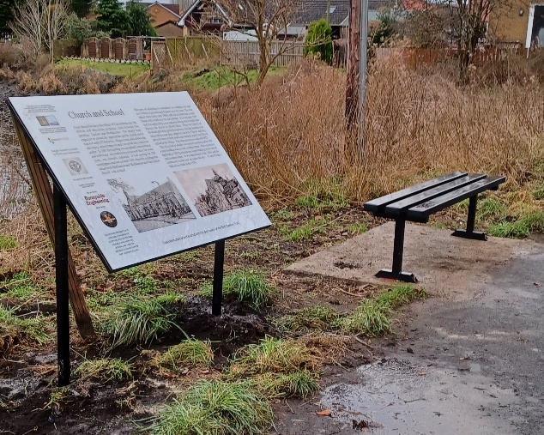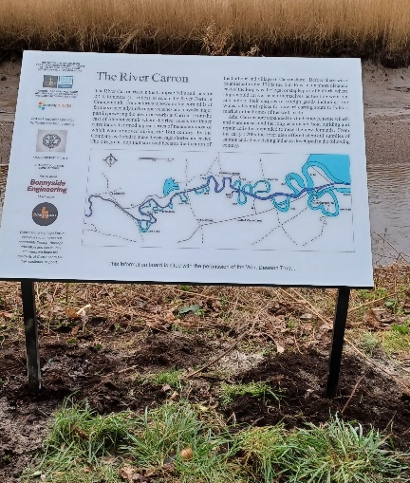
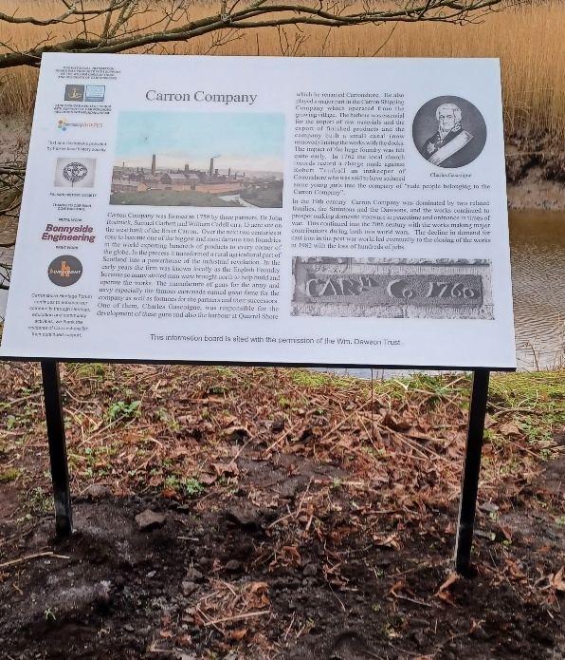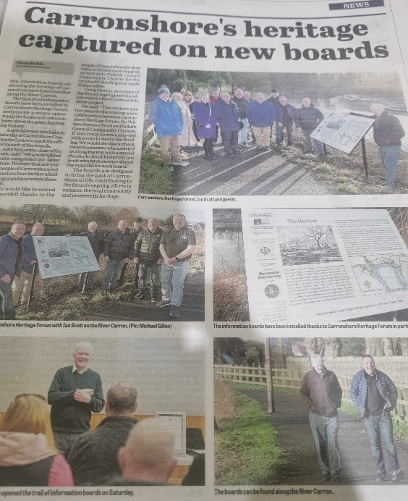
External Funding
2024/25 has been a very successful year for the charity in respect of external funding for project. We received funding from various funders, including the National Lottery, Spf UK, Falkirk community choices, Scotmid to name a few. We are currently working our way through these projects in our 2 year plan.
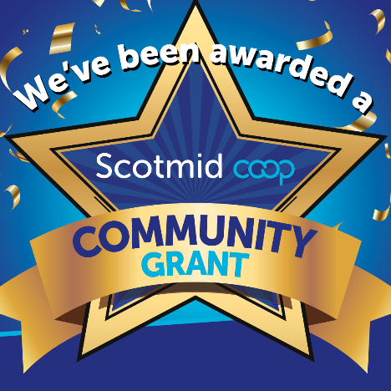




Financial review
Income

Expenses

As the above pie charts explain, even though we spend over £29,206.31 in our local community in 2024-25, our income continues to out-perform our expenses, most of this was due to external national funding, thus allowing us to meet our reserves policy.

Statement of the charity’s policy on reserves
Albeit we do not have a policy on reserves, our treasurer, supported by trustees maintains a ceiling of at least £2,000 (no lower) in our bank account each financial year to ensure that we have sufficient money to embark on a new financial year.

Details of any deficit
Carronshore Heritage Forum has no deficit.

Donated facilities and services
We have donation tubs/tins in various local businesses that get emptied every 4 months, there are always individuals who give donations either at our events or throughout the year, the treasurer records each individual donation on a spreadsheet.
External Funding from various sources is specific to the content of the funding application and those monies are ringfenced for their intended projects; the treasurer records each fund on a spreadsheet and itemises the expense.
We hold 2 major fundraising events each year, prize bingo and Race night, including smaller fundraisers, if invited.

Future plans.
Our 2-year plan for 2025 & 2026.
1.We have applied and been success in obtaining 2-year funding to continue with our Christmas Tree and Street Decorations, we estimate crowds from 500 upwards. So, we propose to put in place in security (road safety measures) and marshalling, with a successful fund application to SPF Uk government grant fund we have bought a stage, sound and lighting PA system etc, to allow our outdoor and indoor events to support the entertainment for these events.
2. Continue the Christmas lunch, it has given much joy to those less able to leave the house, importantly it allows these old school friends to meet up and be included in a fun packed afternoon, otherwise they would be alone.
3. We are aware that with local facilities potentially closing and the threat from the council to close more our new venture over the next 2 years to try and bring inclusion to our community is to hold regular (bimonthly) coffee morning type events in local facilities, such as community centre, local businesses such as café’s etc.

We have successfully implemented the coffee mornings/Lunch events, having completed 3 events with presentation from Senior IT scam group and a presentation on the work Carronshore Heritage are continuing to do, and a presentation from McMillan trust, we estimate to complete 12 individual coffee mornings/lunches December 2025.

This is to encourage those people who either live alone or rarely leave their house to have a place to participate with neighbours and the local school children.

We firmly believe this would assist the mental health and well-being of our community, would be the start of an inclusion event open to all without any requirement to contribute financially.

4. We have upgraded the War memorial, this included working with local schools and the British Legion, we anticipate continuing with events at the memorial and a real time event to show the impact on our community during the World Wars and how our village changed.

5. We have received funding to create customised floral designs around the village linked to the history of the village, this will create several specific community led small gardens in different areas of Carronshore, getting residents involved in original installation and continued maintenance. Council cuts over years have included removal of rose gardens etc, we propose to have various types of flowers beds ( small community Gardens) based on specific historical past, such as a marine (Boat) type of version at Dock Street as that used to be a barge harbour in the 1700 & 1800. A coal wagon version at old Carronshore Pit location etc, with an illustration lectern explaining the historical value of specific locations. This is estimated be done over the 2025/2026 financial year, having received the funding in August 2025, it will take 3 months plus for all materials to arrives, so we anticipate the completed project will be within next year’s report.

6. We are conscious that we don’t produce enough material or properly promote our events, apart from Facebook and local Newspaper, with funding we have been able to produce publications that highlight our events and more importantly educate people on our village life and more importantly protect the surrounding wildlife etc, our community has seen changes through the decades from a small agricultural enclave to a large Industrial village with workers from Carron Company to Coal pits/railway lines/barges etc, then on to the current village life with a sense of community well-being etc.

It is still the charities long term plan to lease a local building from Falkirk Council and create a village hub and event venue, however this will not occur soon.

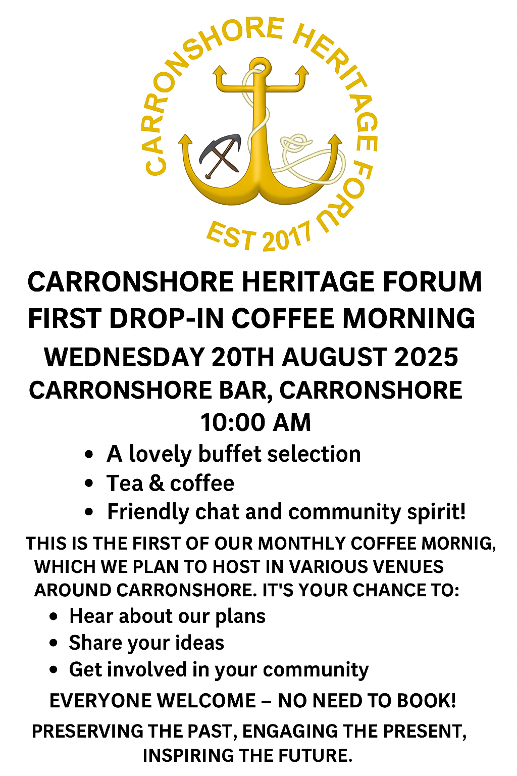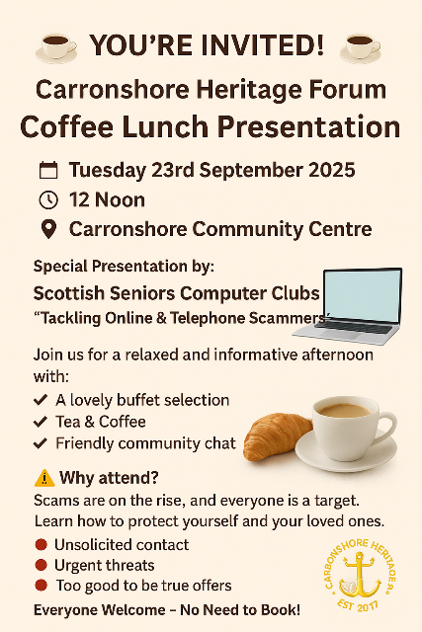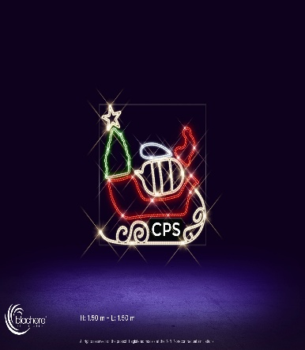

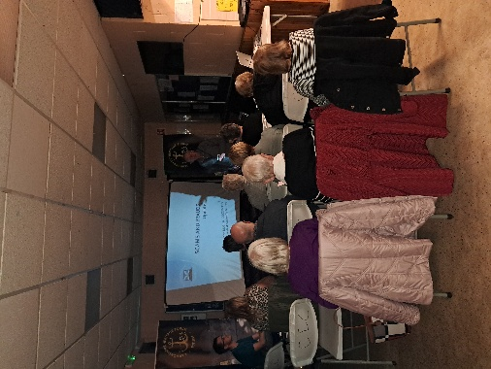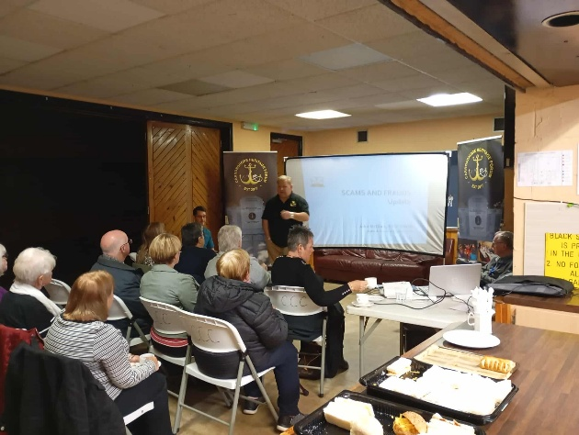
Declaration
Signed on behalf of the charity trustees:
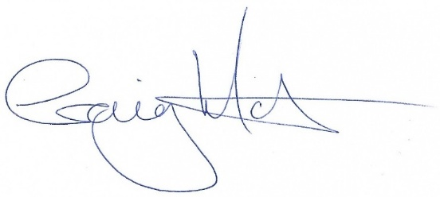
Print name CRAIG MARTIN
Designation SECRETARY
Date 30th September 2025

