BAGS FULL OF LOVE

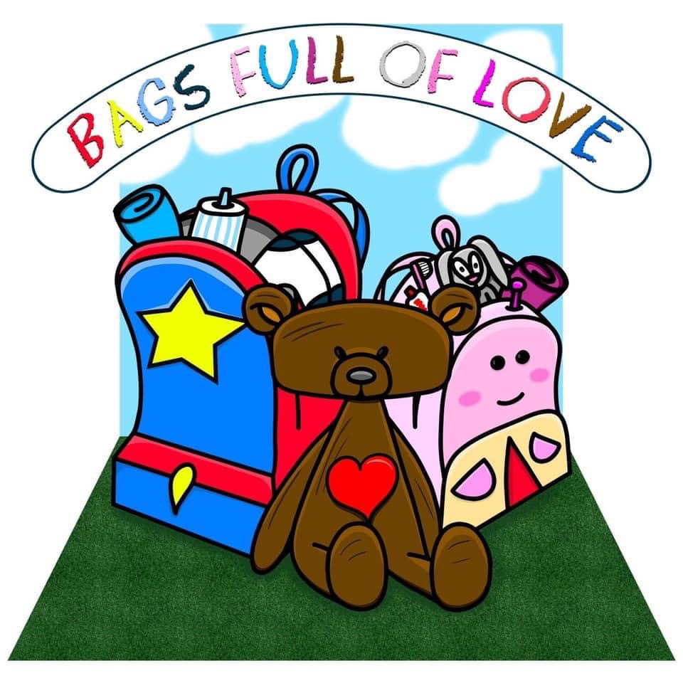

Charity No. SC051957

Annual Report

2025

Reference and Administrative Information

Charity Name: Bags Full of Love
Charity Registration Number: SC051957

Contact Address: Unit 5 Simpson Court

11 South Avenue

Clydebank

G81 2NR

Trustees

The following is a list of the trustees during 2025.

Forename | Surname | Date of Resignation
Fiona | Hennebry
Leigh-Ann | Hennebry
Elizabeth | Stewart
Maureen | Miller
Carolyn | Ralston

Chairperson Fiona Hennebry
Secetary: Elizabeth Stewart
Treasurer: Leigh-Ann Hennebry

Bankers Independent Examiner

The Bank of Scotland
Direct Banking Anne McKellar
PO Box 1000 1 Lewis Gardens
BX2 1LB Old Kilpatrick

Trustees’ Annual Report G60 5EP

Year ended 31 December 2025

Structure, Governance and Management

Governing Document

The charity is administered in accordance with the terms of the Deed of Constitution.

Organisational Structure

The trustees meet regularly throughout the year to ensure the smooth running of the charity

Objectives and Activities

The organisation’s purposes are: -the relief of those in need by reason of age, ill health, disability, financial hardship or other disadvantage by providing support for children entering foster care. A new backpack filled with new comfort and personal care items for children entering foster care. When children are removed from their home most of them will either have the clothes they stand in or a carrier/bin bag of their belongings, we are trying to break this practice. Since many of the children entering the fostering system have been neglected or abused, we will try to give them a sense of self-respect by providing brand new items which they can call their own. And the backpack will be theirs to keep forever.
Trustees’ Annual Report (cont)

Year ended 31 December 2025

Achievements and Performance

Last year 45 bags were distributed to children across West Dunbartonshire. 19 of these bags were given to unaccompanied young people who were placed in care in West Dunbartonshire. We held several events, a summer trip to Five Sisters Zoo and a Christmas party in I-Play which were attended by foster families in West Dunbartonshire and foster families with external agencies whose children are from West Dunbartonshire. We supported Who Cares? Scotland who ran a football tournament during care experience week, We also took 30 children to see the Little Mermaid Panto.
We also donated five translation devices to West Dunbartonshire social work department for use in the three childrens houses and any foster placements where English is not the child’s first language.

Financial Review

Our total income for last year was £8629. This was made by grants and donations over the course of the year.

Expenditure £33610. Several factors contributed to this. Our summer trip cost £1017 and our Christmas party cost £820. We purchased a new van £10194 and general stock for our bags. Each bag costs between £100-£150 depending on the age of the child, we distributed 45 at an average cost of £125 per bag. Our expenditure was a lot higher than our income as we had a multi year grant in 2024.

Year ended 31 December 2025

Statement of Trustees' Responsibilities

The Trustees must prepare financial statements which give sufficient detail to enable an appreciation of the transactions of the charity during the financial year. The trustees are responsible for keeping proper accounting records which, on request, must reflect the financial position of the charity at that time. This must be done to ensure that the financial statements comply with the Charities and Trustee Investment (Scotland) Act 2005, the Charities Accounts (Scotland) Regulations 2006. They are also responsible for safeguarding the assets of the charity and must take reasonable steps for the prevention and/or detection of fraud and other irregularities.

Approved by the Trustees and signed on their behalf,

Fiona Hennebry

Chairperson

Date 26/01/2025
Bags Full of Love

SC051957

Independent Examiner’s Report to the Trustees of Bags Full of Love

Name: Ms Anne McKellar

Address: 1 Lewis Gardens
Old Kilpatrick
G60

Date:

Bags Full of Love
Receipts and Payments Account

Year ended 31 December 2025
 |  |  |  |  |  |  | Unrestricted |  |  |  |  | Restricted
 |  |  |  |  |  |  | Funds |  |  |  |  | Funds |  |  |  | Total
 |  |  |  |  |  |  | 2025 |  |  |  |  | 2025 |  |  |  | 2025
Receipts |  |  |  |  |  |  | £ |  |  |  |  | £ |  |  |  | £
 | Donations |  |  |  |  |  |  |  |  |  |  | 0
 | Activities for Generating Funds |  |  |  |  |  | 4629 |  |  |  |  | 0 |  |  |  | 4629
 | Bank & Deposit interest |  |  |  |  |  | 0 |  |  |  |  | 0 |  |  |  | 0
 | Grants |  |  |  |  |  | 4000 |  |  |  |  | 0 |  |  |  | 4000
Total Receipts |  |  |  |  |  |  | 8629 |  |  |  |  | 0 |  |  |  | 8629
Payments
 | Costs of generating funds |  |  |  |  |  | 216 |  |  |  |  | 0 |  |  |  | 216
 | Charitable activities |  |  |  |  |  |  | 21907 |  |  |  | 11487 |  |  |  | 33394
 | Governance costs |  |  |  |  |  |  | 0 |  |  |  | 0 |  |  |  | 0
Total Payments |  |  |  |  |  |  |  | 22123 |  |  |  | 11487 |  |  |  | 33610

Bags Full of Love
Statement of Balances
At 31 December 2025
 |  |  |  | Unrestricted |  | Restricted |  |  | Total
 |  |  |  | funds |  | funds |  |  | 2025
 |  | Note |  | £ |  | £ |  |  | £
Bank & Deposit Balances
Bank & deposit balances  brought forward |  |  |  | 25661 |  | 20000 |  |  | 45661
Movement in year:
Excess of Payments over Receipts for the year |  |  |  | 22123 |  | 11487 |  |  | 33610
Bank & deposit balances carried forward |  |  |  | 8,629 |  | 5,696 |  |  | 13,779
Assets
Liabilities

The accounts were approved by the Trustees on.

For and on behalf of the Trustees

__________________________________________________ Chairperson

__________________________________________________ Treasurer

 | Movements in Funds
 |  |  |  |  |  |  | At 1 January |  |  |  |  |  |  | 31 Dec
 |  |  |  |  |  |  | 2025 |  | Receipts |  | Payments |  |  | 2025
 |  |  |  |  |  |  | £ |  | £ |  | £ |  |  | £
 | Unrestricted funds
 | General Fund |  |  |  |  |  | 25661 |  | 8629 |  | 22123 |  |  | 12167
 |  |  |  |  |  |  | 25661 |  | 8629 |  | 22123 |  |  | 12167
 | Restricted funds
 | Grants |  |  |  |  |  | 20000 |  | 0 |  | 11487 |  |  | 8513
 |  |  |  |  |  |  | 20000 |  | 0 |  | 11487 |  |  | 8513
 | Total funds |  |  |  |  |  | 45661 |  | 8629 |  | 33610 |  |  | 20680

 |  |  |  | Unrestricted |  | Restricted
 |  |  |  | Funds |  | Funds |  |  | Total
 |  |  |  | 2025 |  | 2025 |  |  | 2025
 |  |  |  | £ |  | £ |  |  | £
3. | Analysis of Donations
 |  | Just giving |  | 2936 |  | 0 |  |  | 2936
 |  | Grants |  | 4000 |  |  |  |  | 4000
 |  | money |  | 1693 |  | 0 |  |  | 1693
 |  |  |  | 8629 |  | 0 |  |  | 8629
4 | Analysis of Payments
 | Costs of generating funds
 |  |  |  | 216 |  | 0 |  |  | 216
 |  |  |  | 216 |  | 0 |  |  | 216
 | Charitable activities
 |  | Unit rental |  |  |  | 8819 |  |  | 8819
 |  | Summer trip |  | 1017 |  | 0 |  |  | 1017
 |  | Christmas party |  | 1220 |  | 0 |  |  | 1220
 |  | Vehicle costs |  | 12447 |  | 0 |  |  | 12447
 |  | Mobile phone/ broadband |  | 709 |  | 0 |  |  | 709
 |  | bag contents |  | 6730 |  | 0 |  |  | 6730
 |  | Electricity |  | 0 |  | 2668 |  |  | 2668
 |  |  |  | 22123 |  | 11487 |  |  | 33610
 | Governance costs
 |  | Independent examiner’s fees |  | 0 |  | 0 |  |  | 0
 | Other payments
 |  | Purchase of assets |  | 0 |  | 0 |  |  | 0
 |  | Purchase of investments |  | 0 |  | 0 |  |  | 0
 |  |  |  | 0 |  | 0 |  |  | 0

