Blackthorn Allotments Association
Trustees’ Annual Report
01 Apr 25 to 31 Mar 26

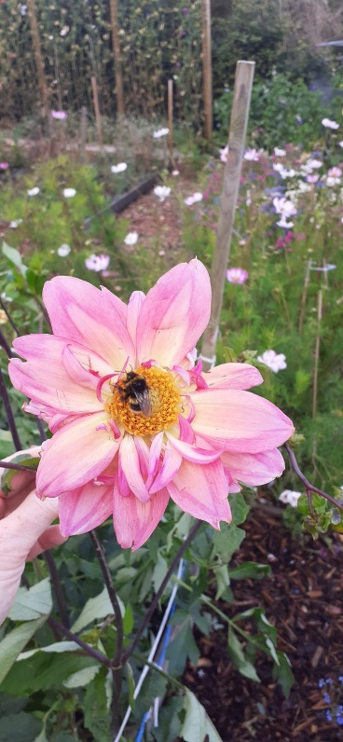

Charity contact information

Blackthorn Allotments Association
Scottish Charity Number: SC044883
Address 83 Holm Farm Road, Inverness
Postcode IV2 6BF

Email address: allotmentsblackthorn@gmail.co.uk
Find us on Facebook at: Blackthorn Allotments, Inverness

Charity Trustees

- Andrew Griffin
- Caroline Fowler
- Moira Prentice
- Iain MacBride

Objectives and activities

Blackthorn Allotments Association was set up to provide allotment plots for lease to residents for the cultivation and growing of vegetables, fruit and flowers.

The charity also aims to:

- Enable people to help improve their physical and mental health through outdoor exercise attributed to horticultural activities and associated social engagement.
- Encourage healthy eating by enabling the growing of fresh vegetables/fruit for the consumption of plot holders and their families.
- Try and reduce the carbon footprint by providing the opportunity to reduce food miles whilst assisting in promoting a healthier environment; for example – composting, rainwater harvesting for irrigation, seed swapping, recycling and upcycling.

The Blackthorn Allotments site has 34 individual plots leased on an annual basis by named members of the local community. There are also 6 large, raised beds for use by those on the waiting list until such time a plot becomes available. We have two communal polytunnels for members wishing to extend the growing season or cultivate more exotic vegetables/fruit. The site has several small, dedicated community plots for use by residents or groups. We also boast two communal orchards and a soft fruit patch – fruit from which is freely available to all. There are a couple of dedicated wildlife areas as well as places to sit and enjoy the beauty and quiet of our location. Our plot occupancy is at 100% and there is a healthy waiting list of people wishing to lease a plot.

Structure, governance and management
Association Constitution
The Blackthorn Allotment Association is governed by an overarching constitution that defines how the association should function and how the allotments site should operate.

Trustee recruitment and appointment
Trustees are all volunteers who are also current Association plotholders. Although managing an allotment is a common theme for us, trustees come from various professional backgrounds and have a range of gardening experience. Trustees are voted in at the Association Annual General Meeting, which is held just before the new financial year. This reporting period, the Chair and Treasurer were re-elected by unanimous vote, but the Secretary role was filled by a new incumbent although they had served in this post previously.
.

Achievements and performance
We believe that being an active plot holder contributes to improved mental health through gardening or being able to spend time away from normal day to day life in a quiet rural environment. This belief is evidenced by the strong social bond our plot holders have with each other and the good spirit that is fostered throughout. Our plot holders have created a friendly and supportive environment where new members are encouraged and made to feel very welcome. In addition, we regularly communicate on a variety of subjects through a WhatsApp social media group. We have been able to hold a few on site social events this year to foster good relations amongst the plot holders.
We have a number of plot holders who regularly offer their time and skills for on site care and maintenance tasks as well as projects that aim to improve the facilities and overall site.
Throughout much of this reporting period, we have maintained 100% plot occupancy. There were a few changes in plot tenancy but due to a healthy waiting list and a severe lack of allotments in Inverness as a city, we were able to quickly fill any plot vacancies.
We do not have access to mains water but the rainwater harvesting and distribution system that we built and operate on site has continued to be used for irrigation purposes, particularly during lengthy dry spells.
Our plot holders continue to produce an amazing variety of fruit, vegetables and flowers both in individual members plots and in the community areas. In addition, we are fortunate that many are willing to help in on-site communal activities such as weeding, pruning, landscaping or repairing and maintaining our buildings and wheelbarrows.
We continue to provide dedicated wildlife areas providing sanctuary and food sources for insects, birds and small mammals. Deer, badgers and hedgehogs have been known to occasionally visit. On site ponds also support frogs, toads and newts.
Again, this year we were able to hold Christmas wreath making workshops which were all very well attended. These workshops are taken by one of our plot holders who has a horticultural background. In addition, donations made at these workshops go to the Highland Hospice in Inverness.
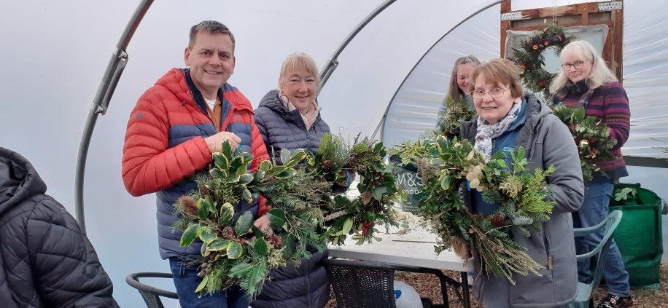

The site is located beside a large housing estate and so we are often visited by members of the local community who are welcome to walk around the site to enjoy the scenes we have to offer or chat with our members.
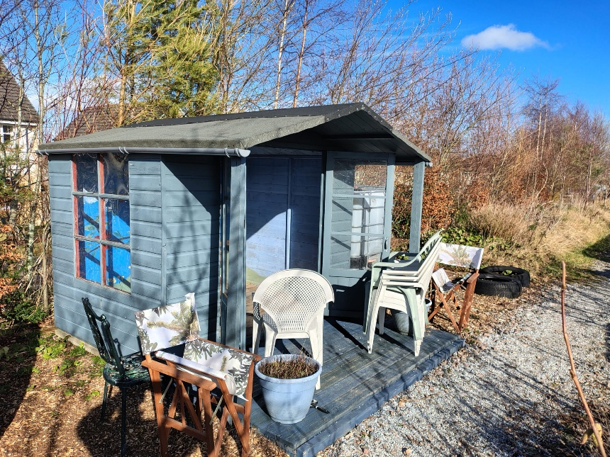

Financial review

Statement of the charity’s policy on reserves
We must retain a minimum of £200 in reserve for our annual rent and a further £250 to cover Public Liability Insurance. However, for financial ‘comfort’, the Committee have agreed that the charity maintains a minimum reserve of £1000.

Details of any deficit
We have had no deficit this year and have maintained a healthy balance.

Donated facilities and services
We receive occasional loads of free wood chip which we use for weed suppression, composting or landscaping. We have also received free chipping of pruned branches from trees in our communal areas from a local landscaping company.

Future plans
In our next reporting period, we hope to expand the rainwater harvesting facility as we recognise the effects of environmental changes from global warming. We are also looking into the change of use for our storage shed into a workshop.

Additional information
The Blackthorn Allotments rely on the Committee to function and to meet the requirements of both our constitution and our landowner. It is only through the kind volunteering that these few offer that we can do this.

Declaration
Signed on behalf of the charity trustees:

AN
Print name

Designation

Date

