Awesome Glasgow Trustees Annual Report

SCIO’s registered name: Awesome Glasgow
Charity number is: SC050756
Registered on: 08 February 2021
Principal contact address is: Glasgow Collective
13-15 East Campbell Street Glasgow
G1 5DT

Names of the charity trustees on date of approval of Trustee’ Annual Report:
Kirstie Dickens
Sarah Campbell
Caitlin Cummings-Duffy
Susan Aitken
Tanya Goyal

Awesome Glasgow uses a constitution as our governing document. Please see appendix 1.

The charity board members are recruited through open recruitment. We ensure that we have a diverse set of skills on the board, and we are inclusive.

Our Charitable purposes as set out in are governing document are as follows:
- the prevention or relief of poverty the advancement of education the advancement of health
the saving of lives
- the advancement of citizenship or community development
the advancement of the arts, heritage, culture or science
the advancement of public participation in sport
the provision of recreational facilities, or the organisation of recreational activities
- the advancement of human rights, conflict resolution or reconciliation the promotion of religious or racial harmony
the promotion of equality and diversity
the advancement of environmental protection or improvement
- the relief of those in need by reasons of age, ill-health, disability, financial hardship or other disadvantage
the advancement of animal welfare
any other purpose that may reasonably be regarded as analogous to any of the preceding purposes.

About us:
We're the Glasgow Chapter of the Awesome Foundation. A fun way of giving £500, no-strings-attached mini-grants to cool projects that will make the world - and Glasgow - more Awesome! Remember: Awesome Glasgow gives just one £500 grant away every two months so you can apply any time. Finalists are invited to a gift night which you need to be able to attend.
There are four criteria:
- The project must be based locally (Glasgow - with a G postcode).
- You need to have a budget - prove you have a plan for how additional funds will be raised.
- It has to benefit the local community.
- Most of all, it has to be Awesome

Website: https://www.awesomefoundation.org/en/chapters/glasgow

Facebook page: https://www.facebook.com/AwesomeGlasgow
Instagram: https://www.instagram.com/awesome_glasgow/
Newsletter: https://us15.campaign-archive.com/?u=e2e88c4d4f97012a7660bd3ef&id=7850c0681d

An overview of our year:

For the period 01/09/24 to 31/08/25 we undertook 7 in person pitch nights.

In total we gave out 8 grants for the period with the grants given out totally £3500. We gave 6 grants of £500 and for one round we split the money across two winners with £250 each.

Here are our 8 winners, what they do and why they needed the Funding:
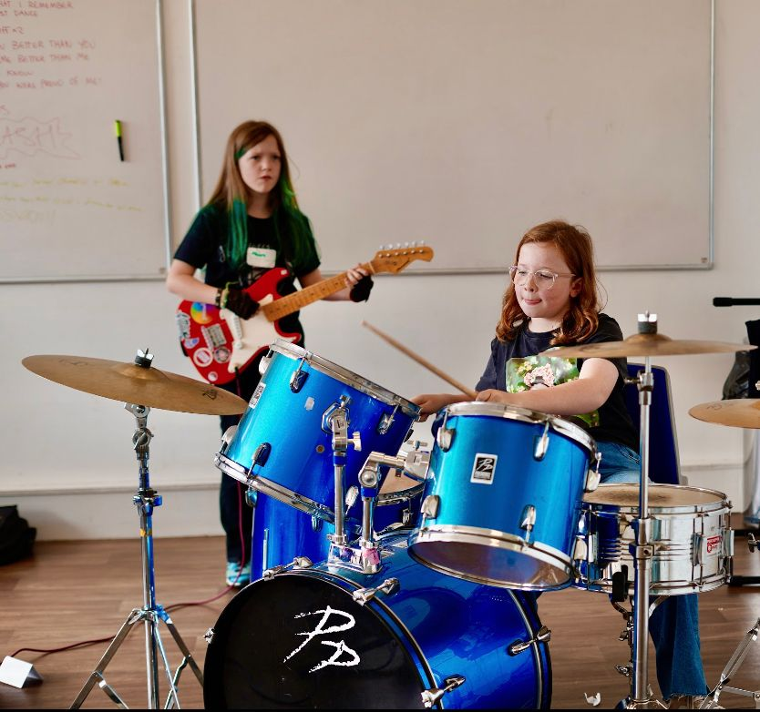
Girls Rock £500

Girls Rock Glasgow is a volunteer-run CIC established in 2015 and officially constituted in 2024. We work to empower young girls, and nonbinary youth through instrument tuition, band formation, songwriting, stagecraft, arts workshops, and empowerment sessions. Our programs aim to enhance musical skills while fostering resilience, mental well-being and identity. By building confident and musical young girls we hope to address gender imbalances and create a more equal music industry and society.
Using instrument tuition, band forming and song-writing alongside stagecraft, arts and empowerment workshops, we work to narrow the gender imbalance for women in the music industry while contributing to overall mental well-being by instilling life skills, resilience, and fostering a strong sense of identity.
From restarting the project in 2024, we have learnt of the lasting impact the project has had. Many parents of ex-participants have been in contact to say how big an impact past summer schools and showcases had on their children. Some of the participants signed up to take part in this years summer school spoke in their application of being a member of the audience for showcases in the past, wishing they were old enough to take part and are now very excited about the project returning now that they have come of age. On top of that nearly half of our volunteer team are returning members of projects from the past, some returning volunteers and some ex-participants now returning to either support the summer school or perform at our fundraising events.
Girls Rock Glasgow stands out for its holistic approach to musicianship. We blend arts, culture, and wellbeing to empower young girls. We aim to continue to build our work so our participants are able to transition from our projects into continuous involvement in music.

Achieve More Scotland - Select Dance Team £500
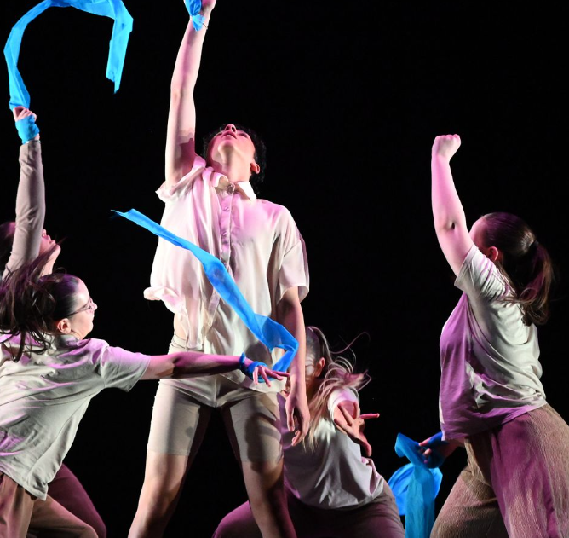
Achieve More! Scotland is a registered SCIO based in Glasgow. We deliver programmes to improve young people’s physical and mental health and well-being, confidence and self-esteem, aspirations, personal responsibility and life chances by engaging them in structured, positive activities that work across communities and are delivered by role models. These activities take place within schools and communities.
Our diversionary activities for young people include sports, physical activity, group work, volunteering, employability and personal development sessions in areas of high social deprivation.
Our Select Dance team consists of talented members who are young people from areas that fall within Scottish Index of Multiple Deprivation 1 & 2 in Glasgow. Generally, these young people are priced out of activities such as dance because of the costs associated with participating.
Each team member auditioned to secure their place and all were very passionate about taking their dance skills to the next level. By joining this team, they meet like-minded young people from the city, make new friends and share their creativity and passion for dance. The group comprises young people aged between 10 and 18 who are very interested in participating in dance. Being part of our Select Dance team will enable them to participate in competitions across the country to showcase their talents and skills. Some participants, who have been part of our programmes for many years, are volunteers with us at Achieve More Scotland. This is a testament to their commitment and our impact on their lives.

Glasgow Baseball Association £500

The Glasgow Baseball Association (GBA) is a Glasgow-based baseball club, currently open to all adults, regardless of age, gender or experience. We are open to any adults interested in playing, learning and supporting baseball. Our coaches have also taken time to help and support emerging baseball clubs in Glasgow, like previous Awesome Glasgow Award Winners the Glasgow Sunflowers. As a club, we are passionate about growing baseball in Scotland, with our next project establishing a youth baseball program for the 2025 season. Currently, there are very limited opportunities for individuals under the age of 16 to try baseball in Glasgow and Scotland as a whole – and no opportunity in the East end of Glasgow, where we play out of Tollcross Park. Over the last two years, we have had over 20 enquiries about a youth program and are looking for your help to develop a safe, inclusive and fun environment for youth aged 8-15 to learn to play baseball. Our main financial objective is to purchase youth safety equipment for this program to keep costs as low as possible for all participants. By providing the necessary equipment for safe participation we would be able to offer this program at as low as £1 per participant. Our goal is to provide a fun safe environment where youth of all backgrounds can learn to love our sport! Your support can make this possible.

The Spirit of Springburn £500
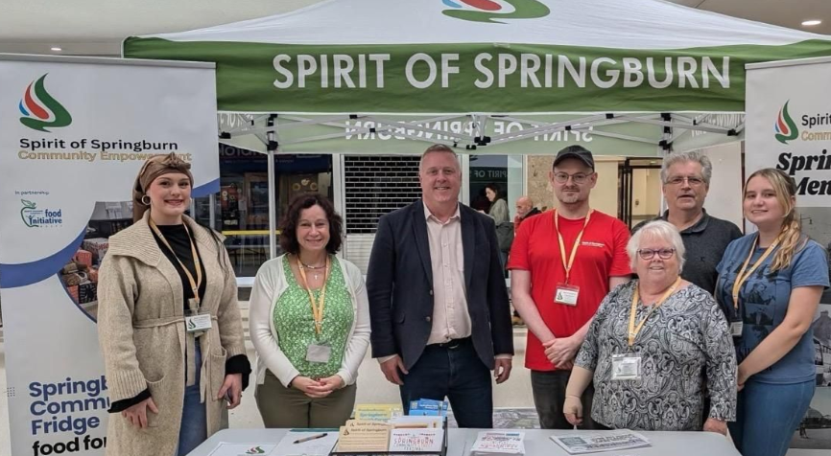

Our project aims to celebrate the rich heritage, resilience, and ongoing revival of Springburn, a historic area in North Glasgow. Once the birthplace of the steam locomotive and the UK’s first motorcar, Springburn has faced significant challenges, including social decline, addiction, and economic neglect. Yet, the community's spirit endures, fueled by efforts to restore its pride and identity. This initiative will engage residents and visitors through an immersive pop-up exhibition at the Springburn Community Hub, showcasing local history with archival photos, interactive videos, books, and artifacts. A dedicated cinema space will screen documentaries, including a feature on the town’s locomotive industry and its multicultural community. The event will highlight Springburn's contributions to Scotland's industrial and cultural heritage while emphasizing the community's resilience and a call for greater investment. Together, we aim to honor Springburn’s past while building a resilient, inclusive future.
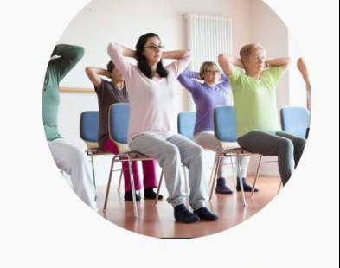
Accessible Chair Yoga and Movement £500
Many people in Glasgow face feelings of isolation linked to their protected characteristics, leading to loneliness and a sense of social disconnection. As inherently social beings, our relationships with others are crucial for our overall well-being and personal development, making such isolation a serious concern for both mental and physical health. Thankfully, there are effective strategies to tackle these issues. One promising method is yoga, which has proven helpful in alleviating anxiety, stress, and depression. It can support those who feel alone by fostering a more positive self-image, which can facilitate healing and enhance the confidence and motivation needed to establish a consistent practice. This uplifting change can also inspire other healthy habits, such as increasing physical activity, making better dietary choices, or even quitting smoking. The prevailing yoga culture, however often reflects the inequalities present in our society, such as systemic racism, lack of accessibility, and excessive gatekeeping. Moreso, many individuals feel unwelcome or unsafe when entering a yoga studio or participating in a class. However, yoga has the potential to be an inclusive, fair, and liberating community practice. By offering a free course in an accessible venue (ramp, smooth floors, etc) or online, the format is inclusive of everyone, no matter their experience or fitness level. It is particularly beneficial for anyone with restricted mobility (individuals dealing with arthritis, osteoporosis, or ongoing pain) as props such as chairs, blocks, blankets, straps will be used to support an individuals needs.
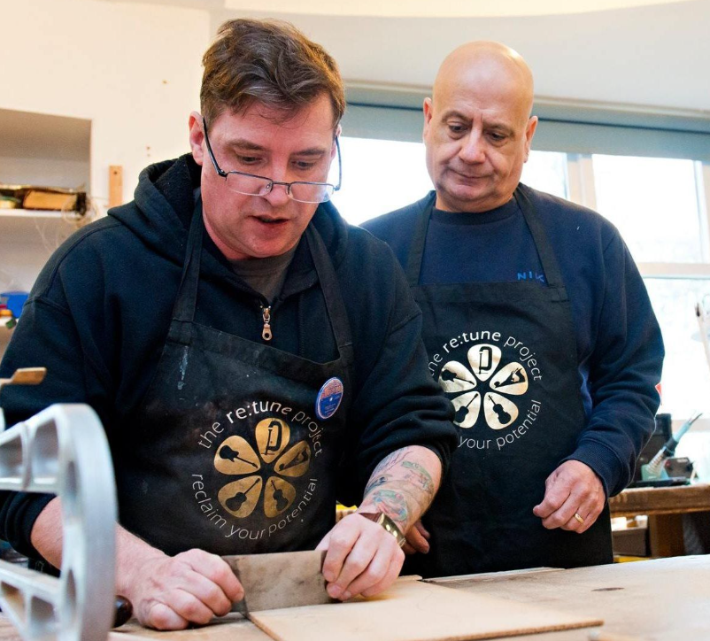
Reclaim your Potential £500
RETUNE operates 5 days a week Monday to Friday, to work with 28 attendees over the year to teach fine woodworking of stringed instrument construction and repair, CNC machine software and use, as well as reclaiming old unused hand tools specific to the workshop environment. RETUNES motto (Reclaim your Potential) is twofold. Reclaiming and reusing wood and tools and reclaiming and reusing the individual’s potential To reclaim and reuse these tools as an example of RETUNES motto (Reclaim your Potential) this engages the personal development plan for each participant done in weekly stages with the learning manual. Our target groups are Veterans/Ex-service personnel, Adult Autistic, Long term DWP and those who identify as severely isolated.We are based in Easterhouse, one of Glasgow’s most deprived communities and the bulk of our current participants are drawn from the local area .We help to address individual issues who suffer isolation that are affected with PTSD and many others, with needs ranging from mental health diagnosis, physical disabilities to family breakdown. we operate 2 specific manuals for attendees, one is the learning manual that takes participants on weekly tasks towards learning skills and constructing their instruments, the other is a personal development manual that each person completes on a monthly basis on areas of their lives and issues, where these have been addressed and what they have identified as benefiting or blocking a move on process. We utilise the ‘Cycle of Change’ model a CBT model, is a talking therapy that can help individuals manage their problems by changing the way they think and behave utilising the creative process, It's most commonly used to treat anxiety and depression, but can be useful for other mental and physical health problems. In the project this serves to boost individual social skills, confidence, direction, decrease isolation, improve a sense of wellbeing, and contribute to greater autonomy and independence,
Glasgow Stags Ice Hockey £250

Because it makes one of Scotland’s most exciting sports accessible to students from all backgrounds — including those from low-income families — and helps build something much bigger.
Ice hockey is a fast, physical, and thrilling sport — but also one of the most expensive to play. Many students are priced out of participation. This grant directly removes that barrier, funding five games and keeping the sport open to all. We play at Braehead Arena — a 5,200-seat professional venue — and we’re building toward a Varsity-style event inspired by Nottingham’s student fixture, but on a bigger scale. With Glasgow’s student population double Nottingham’s, we have the perfect platform to create a major student sporting tradition.

Streetcare Volunteers £250
Their purpose is to assist the “Homeless” and others on the pavement / Shelters who are in need of assistance. This may be visually / verbally / writing asking for help, looking like they need assistance or simply presenting as in need of assistance.

Appendix 1.
CONSTITUTION Of AWESOME GLASGOW
GENERAL
Type of organisation
1 The organisation will, upon registration, be a Scottish Charitable Incorporated Organisation (SCIO).
Scottish principal office
2 The principal office of the organisation will be in Scotland (and must remain in Scotland).
Name
3 The name of the organisation is “Awesome Glasgow”.

Purposes
4 The organisation’s purposes are:
4.1 4.2 4.3 4.4 4.5 4.6 4.7 4.8
4.9 4.10 4.11 4.12 4.13
4.14 4.15
the prevention or relief of poverty the advancement of education the advancement of health
the saving of lives
the advancement of citizenship or community development
the advancement of the arts, heritage, culture or science
the advancement of public participation in sport
the provision of recreational facilities, or the organisation of recreational activities
the advancement of human rights, conflict resolution or reconciliation the promotion of religious or racial harmony
the promotion of equality and diversity
the advancement of environmental protection or improvement
the relief of those in need by reasons of age, ill-health, disability, financial hardship or other disadvantage
the advancement of animal welfare
any other purpose that may reasonably be regarded as analogous to any of the preceding purposes.

Powers
5 The organisation has power to do anything which is calculated to further its purposes or is conducive or incidental to doing so.
6 No part of the income or property of the organisation may be paid or transferred (directly or indirectly) to the Board Members - either in the course of the organisation’s existence or on dissolution - except where this is done in direct furtherance of the organisation’s purposes.
Liability of Board Members
7 The Board Members of the organisation (in their capacity as members - see clause 11) have no liability to pay any sums to help to meet the debts (or other liabilities) of the organisation if it is wound up; accordingly, if the organisation is unable to meet its debts, the Board Members will not be held responsible.
8 The Board Members have certain legal duties under the Charities and Trustee Investment (Scotland) Act 2005; and clause 7 does not exclude (or limit) any personal liabilities they might incur if they are in breach of those duties or in breach of other legal obligations or duties that apply to them personally.
General structure
9 The structure of the organisation consists of the BOARD - who hold regular meetings, and generally control the activities of the organisation; for example, the board is responsible for monitoring and controlling the financial position of the organisation.
10 The board also appoints Board Members to fill vacancies, and the people serving on the board (in their capacity as members of the organisation - see clauses 11 and 13) have power to make changes to the constitution itself.
11 The people serving on the board are referred to in this constitution as Board Members - and they are also the MEMBERS of the organisation for the purposes of the Charities and Trustee Investment (Scotland) Act 2005.
12 Under the provisions of this constitution, no-one can be a member unless they are also a charity trustee of the organisation.
13 The Charities and Trustee Investment (Scotland) Act 2005 requires certain decisions to be taken by the Board Members in their capacity as members of the organisation.
BOARD
Number of Board Members
14 The maximum number of Board Members is [10].
15 The minimum number of Board Members is [3]

Eligibility
16 A person will not be eligible for election or appointment to the board if they are: -
16.1 disqualified from being a charity trustee under the Charities and Trustee Investment (Scotland) Act 2005; or
16.2 an employee of the organisation.
Initial Board Members
17 The individuals who signed the charity trustee declaration forms which accompanied the application for incorporation of the organisation shall be deemed to have been appointed by the members as Board Members with effect from the date of incorporation of the organisation.

Appointment/retiral
18 The board may at any time appoint any person to be a charity trustee - by way of a resolution passed by majority vote at a board meeting.
19 At the conclusion of the first AGM, one of the Board Members shall retire from office; the question of which of them is to retire shall be determined by some random method.
20 At the conclusion of each AGM (other than the first)
20.1 any Board Members appointed during the period since the preceding AGM (but excluding those re-appointed under clause 22 during that period) shall retire from office;
20.2 out of the remaining Board Members, one shall retire from office.
21 The Board Members to retire under paragraph 20.2 shall be those who have been longest in office since they were last appointed or re-appointed; as between persons who were last appointed/re-appointed on the same date, the question of which of them is to retire shall be determined by some random method.
22 A charity trustee who retires from office under clause 19 or 20 at the conclusion of an AGM shall be eligible for re-appointment under clause 18 at the next board meeting.
23 A charity trustee vacating office at the conclusion of an AGM will be deemed to have been re-elected at the board meeting which next follows unless:
23.1 they advise the board that they do not wish to be re-appointed; or
23.2 a resolution for the re-appointment of that charity trustee was put to the board meeting and was not carried.
Termination of office
24 A charity trustee will automatically cease to hold office if: -
24.1 they become disqualified from being a charity trustee under the Charities and Trustee Investment (Scotland) Act 2005;
24.2 they become incapable for medical reasons of carrying out their duties as a charity trustee - but only if that has continued (or is expected to continue) for a period of more than six months;
24.3 they become an employee of the organisation;
24.4 they give the organisation a notice of resignation, signed by them;
24.5 they are absent (without good reason, in the opinion of the board) from more than three consecutive meetings of the board - but only if the board resolves to remove them from office;
24.6 they are removed from office by resolution of the board on the grounds that they are considered to have committed a material breach of the code of conduct for Board Members (as referred to in clause 41);
24.7 they are removed from office by resolution of the board on the grounds that they are considered to have been in serious or persistent breach of their duties under section 66(1) or (2) of the Charities and Trustee Investment (Scotland) Act 2005; or
25 A resolution under paragraph 24.6 or 24.7 shall be valid only if: -
25.1 the Board Member who is the subject of the resolution is given reasonable prior written notice of the grounds upon which the resolution for their removal is to be proposed;
25.2 the Board Member concerned is given the opportunity to address the meeting at which the resolution is proposed, prior to the resolution being put to the vote; and
25.3 at least two thirds (to the nearest round number) of the Board Members then in office vote in favour of the resolution.

Register of Board Members
26 The board must keep a register of Board Members, setting out
26.1 for each current Board Member:
26.1.1 their full name and address;
26.1.2 the date on which they were appointed as a Board Member; and 26.1.3 any office held by them in the organisation;
26.2 for each former Board Member - for at least 6 years from the date on which they ceased to be a Board Member:
26.2.1 the name of the Board Member;
26.2.2 any office held by them in the organisation; and 26.2.3 the date on which they ceased to be a Board Member.
The board must ensure that the register of Board Member is updated within 28 days of any change:
27., 27.1 which arises from a resolution of the board; or
27.2 which is notified to the organisation.
28 If any person requests a copy of the register of Board Members, the board must ensure that a copy is supplied to them within 28 days, providing the request is reasonable; if the request is made by a person who is not a charity trustee of the organisation, the board may provide a copy which has the addresses blanked out - if the SCIO is satisfied that including that information is likely to jeopardise the safety or security of any person or premises.
29 The members of the organisation are identical to its Board Members - and therefore the organisation does not require to keep a separate register of members.

Office -bearers
30 The Board Members must elect (from among themselves) a chair, a treasurer and a secretary.
31 In addition to the office-bearers required under clause 30, the Board Members may elect (from among themselves) further office-bearers if they consider that appropriate.
32 All of the office-bearers will cease to hold office at the conclusion of each AGM, but may then be re-elected under clause 30 or 31.
33 A person elected to any office will automatically cease to hold that office: -
33.1 if they cease to be a charity trustee; or
33.2 if they give to the organisation a notice of resignation from that office, signed by them.

Powers of board
34 Except where this constitution states otherwise, the organisation (and its assets and operations) will be managed by the board; and the board may exercise all the powers of the organisation.
35 A meeting of the board at which a quorum is present may exercise all powers exercisable by the board.
Board Members - general duties
36 Each of the Board Members has a duty, in exercising functions as a Board Member, to act in the interests of the organisation; and, in particular, must:-
36.1 seek, in good faith, to ensure that the organisation acts in a manner which is in accordance with its purposes;
36.2 act with the care and diligence which it is reasonable to expect of a person who is managing the affairs of another person;
36.3 in circumstances giving rise to the possibility of a conflict of interest between the organisation and any other party: -
36.3.1 put the interests of the organisation before that of the other party;
36.3.2 where any other duty prevents them from doing so, disclose the conflicting interest to the organisation and refrain from participating in any deliberation or decision of the other Board Members with regard to the matter in question;
36.4 ensure that the organisation complies with any direction, requirement, notice or duty imposed under or by virtue of the Charities and Trustee Investment (Scotland) Act 2005.
37 In addition to the duties outlined in clause 36, all of the Board Members must take such steps as are reasonably practicable for the purpose of ensuring: -
37.1 that any breach of any of those duties by a Board Member is corrected by the Board Member concerned and not repeated; and
37.2 that any Board Member who has been in serious and persistent breach of those duties is removed as a Board Member.
38 Provided they have declared their interest - and have not voted on the question of whether or not the organisation should enter into the arrangement - a charity trustee will not be debarred from entering into an arrangement with the organisation in which they have a personal interest; and (subject to clause 39 and to the provisions relating to remuneration for services contained in the Charities and Trustee Investment (Scotland) Act 2005) they may retain any personal benefit which arises from that arrangement.
39 No Board Member may serve as an employee (full time or part time) of the organisation; and no Board Member may be given any remuneration by the organisation for carrying out their duties as a Board Member.
40 The Board Members may be paid all travelling and other expenses reasonably incurred by them in connection with carrying out their duties; this may include expenses relating to their attendance at meetings.
Code of conduct for Board Members
41 Each of the Board Members shall comply with the code of conduct (incorporating detailed rules on conflict of interest) prescribed by the board from time to time.
42 The code of conduct referred to in clause 41 shall be supplemental to the provisions relating to the conduct of Board Members contained in this constitution and the duties imposed on Board Members under the Charities and Trustee Investment (Scotland) Act 2005; and all relevant provisions of this constitution shall be interpreted and applied in accordance with the provisions of the code of conduct in force from time to time
DECISION-MAKING BY THE BOARD MEMBERS Notice of board meetings
43 Any Board Member may call a meeting of the board.
44 At least 7 days' notice must be given of each board meeting, unless (in the opinion of the person calling the meeting) there is a degree of urgency which makes that inappropriate.
Procedure at board meetings
45 No valid decisions can be taken at a board meeting unless a quorum is present; the quorum for board meetings is 3 Board Members.
46 If at any time the number of Board Members in office falls below the number stated as the quorum in clause 45, the remaining Board Member(s) will have power to fill the vacancies or call a members' meeting - but will not be able to take any other valid decisions.
47 The chair of the organisation should act as chairperson of each board meeting.
48 If the chair of the organisation is not present within 15 minutes after the time at which the meeting was due to start (or is not willing to act as chairperson), the Board Members present at the meeting must elect (from among themselves) the person who will act as chairperson of that meeting.
49 Every charity trustee has one vote, which must be given personally.
50 All decisions at board meetings will be made by majority vote.
51 If there is an equal number of votes for and against any resolution, the chairperson of the meeting will be entitled to a second (casting) vote.
52 The board may, at its discretion, allow any person to attend and speak at a board meeting notwithstanding that they are not a Board Member - but on the basis that they must not participate in decision-making.
53 A Board Member must not vote at a board meeting (or at a meeting of a sub-committee) on any resolution which relates to a matter in which they have a personal interest or duty which conflicts (or may conflict) with the interests of the organisation; they must withdraw from the meeting while an item of that nature is being dealt with.
54 For the purposes of clause 53: -
54.1 an interest held by an individual who is “connected” with the Board Member under section 68(2) of the Charities and Trustee Investment (Scotland) Act 2005 (husband/wife, partner, child, parent, brother/sister etc) shall be deemed to be held by that Board Member;
54.2 a Board Member will be deemed to have a personal interest in relation to a particular matter if a body in relation to which they are an employee, director, member of the management committee, officer or elected representative has an interest in that matter.
Minutes
55 The board must ensure that proper minutes are kept in relation to all board meetings and meetings of sub-committees.
56 The minutes to be kept under clause 55 must include the names of those present; and (so far as possible) should be signed by the chairperson of the meeting.
57 [The board shall (subject to clause 58) make available copies of the minutes referred to in clause 55 to any member of the public requesting them.]
58 [The board may exclude from any copy minutes made available to a member of the public under clause 57 any material which the board considers ought properly to be kept confidential - on the grounds that allowing access to such material could cause significant prejudice to the interests of the organisation or on the basis that the material contains reference to employee or other matters which it would be inappropriate to divulge.]
DECISION-MAKING BY THE BOARD MEMBERS - IN THEIR CAPACITY AS MEMBERS
59 For certain purposes of the Charities and Trustee Investment (Scotland) Act 2005, the Board Member make decisions in their capacity as members of the organisation, rather than as a board; the provisions of clauses 60 to 80 relate to those situations.
Annual general meetings
60 The board must convene a meeting of the Board Members - in their capacity as members of the organisation - in each calendar year; that meeting will be called an annual general meeting or "AGM".
61 The gap between one AGM and the next must not be longer than 15 months.
62 Notwithstanding clause 60, an AGM does not need to be held during the calendar year in which the organisation is formed; but the first AGM must still be held within 15 months of the date on which the organisation is formed.
63 The business of each AGM must include:-
63.1 a report by the chair on the activities of the organisation; and
63.2 consideration of the future strategy for the organisation, including a review of key risks and opportunities.
64 The board may convene any other meeting of the Board Members - in their capacity as members of the organisation - at any time.
Notice of members’ meetings
65 At least 14 clear days’ notice must be given of any AGM or any other members' meeting.
66 The notice calling a members' meeting must specify in general terms what business is to be dealt with at the meeting; and, in the case of a resolution to alter the constitution, must set out the exact terms of the proposed alteration(s).
67 The reference to “clear days” in clause 65 shall be taken to mean that, in calculating the period of notice,
67.1 the day after the notices are posted (or sent by e-mail) should be excluded; and
67.2 the day of the meeting itself should also be excluded.
68 Notice of every members' meeting must be given to all the Board Members; but the accidental omission to give notice to one or more Board Members will not invalidate the proceedings at the meeting.
69 Any notice of a members’ meeting which requires to be given to a Board Member - in their capacity as a member of the organisation - under this constitution must be: -
69.1 sent by post to the Board Member, at the address last notified by them to the organisation; or
69.2 sent by e-mail to the Board Member, at the e-mail address last notified by them to the organisation.
Procedure at members’ meetings
70 The provisions of clauses 45, 47 and 48 (quorum and chairperson) shall apply in relation to all meetings of the Board Members in their capacity as members of the organisation.
Voting at members’ meetings
71 Every Board Member shall have one vote in their capacity as a member, which must be given personally.
72 All decisions at members' meetings will be made by majority vote - with the exception of the types of resolution listed in clause 73.
73 The following resolutions will be valid only if passed by not less than two thirds of those voting on the resolution at a members’ meeting (or if passed by way of a written resolution under clause 77):
73.1 a resolution amending the constitution;
73.2 a resolution approving the amalgamation of the organisation with another SCIO (or approving the constitution of the new SCIO to be constituted as the successor pursuant to that amalgamation);
73.3 a resolution to the effect that all of the organisation’s property, rights and liabilities should be transferred to another SCIO (or agreeing to the transfer from another SCIO of all of its property, rights and liabilities);
73.4 a resolution for the winding up or dissolution of the organisation.
74 If there is an equal number of votes for and against any resolution, the chairperson of the meeting will be entitled to a second (casting) vote.
75 A resolution put to the vote at a members' meeting will be decided on a show of hands - unless the chairperson (or at least two other members present at the meeting) ask for a secret ballot.
76 The chairperson will decide how any secret ballot is to be conducted, and they will declare the result of the ballot at the meeting.
Written resolutions
77 A resolution agreed to in writing (or by e-mail) by all the Board Members, in their capacity as members of the organisation, will be as valid as if it had been passed at a members’ meeting; the date of the resolution will be taken to be the date on which the last Board Member agreed to it.

Minutes
78 The board must ensure that proper minutes are kept in relation to all members' meetings.
79 Minutes of members' meetings must include the names of those present; and (so far as possible) should be signed by the chairperson of the meeting.
80 [The board shall make available copies of the minutes referred to in clause 78 to any member of the public requesting them; but on the basis that the board may exclude confidential material to the extent permitted under clause 58.]
ADMINISTRATION
Delegation to sub-committees
81 The board may delegate any of their powers to sub-committees; a sub-committee must include at least one Board Member, but other members of a sub-committee need not be Board Members.
82 The board may also delegate to the chair of the organisation (or the holder of any other post) such of their powers as they may consider appropriate.
83 When delegating powers under clause 81 or 82, the board must set out appropriate conditions (which must include an obligation to report regularly to the board).
84 Any delegation of powers under clause 81 or 82 may be revoked or altered by the board at any time.
85 The rules of procedure for each sub-committee, and the provisions relating to membership of each sub-committee, shall be set by the board.
Operation of accounts
86 Subject to clause 87, the signatures of two out of three signatories appointed by the board will be required in relation to all operations (other than the lodging of funds) on the bank and building society accounts held by the organisation; at least one out of the two signatures must be the signature of a Board Member.
87 Where the organisation uses electronic facilities for the operation of any bank or building society account, the authorisations required for operations on that account must be consistent with the approach reflected in clause 86.
Accounting records and annual accounts
88 The board must ensure that proper accounting records are kept, in accordance with all applicable statutory requirements.
89 The board must prepare annual accounts, complying with all relevant statutory requirements; if an audit is required under any statutory provisions (or if the board consider that an audit would be appropriate for some other reason), the board should ensure that an audit of the accounts is carried out by a qualified auditor.
MISCELLANEOUS
Winding-up
90 If the organisation is to be wound up or dissolved, the winding-up or dissolution process will be carried out in accordance with the procedures set out under the Charities and Trustee Investment (Scotland) Act 2005.
91 Any surplus assets available to the organisation immediately preceding its winding up or dissolution must be used for purposes which are the same as - or which closely resemble - the purposes of the organisation as set out in this constitution.
Alterations to the constitution
92 This constitution may (subject to clause 93) be altered by resolution of the Board Members - in their capacity as members of the organisation - passed at a members’ meeting (subject to achieving the two thirds majority referred to in clause 73) or by way of a written resolution of the Board Members in their capacity as members.
93 The Charities and Trustee Investment (Scotland) Act 2005 prohibits taking certain steps (eg change of name, an alteration to the purposes, amalgamation, winding-up) without the consent of the Office of the Scottish Charity Regulator (OSCR).
Interpretation
94 References in this constitution to the Charities and Trustee Investment (Scotland) Act 2005 should be taken to include: -
94.1 any statutory provision which adds to, modifies or replaces that Act; and
94.2 any statutory instrument issued in pursuance of that Act or in pursuance of any statutory provision falling under paragraph 94.1 above.
95 In this constitution: -
95.1 “charity” means a body which is either a “Scottish charity” within the meaning of section 13 of the Charities and Trustee Investment (Scotland) Act 2005 or a “charity” within the meaning of section 1 of the
Charities Act 2011, providing (in either case) that its objects are limited to charitable purposes;
95.2 “charitable purpose” means a charitable purpose under section 7 of the Charities and Trustee Investment (Scotland) Act 2005 which is also regarded as a charitable purpose in relation to the application of the Taxes Acts.

