Annual Report & Financial Statements For the period to 31st May 2025

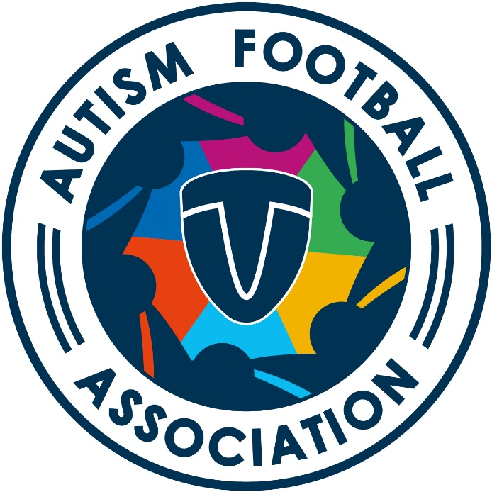

Reference and Administrative Information Charity Name
THE AUTISM FOOTBALL ASSOCIATION

Charity Number
SC047640
14 Frankfield Crescent, Dalgety Bay KY11 9LW

Current Trustees

Ann Brown Chair
Lorraine Angus Secretary
Tim Davidson Trustee
Gillian Pyper Trustee
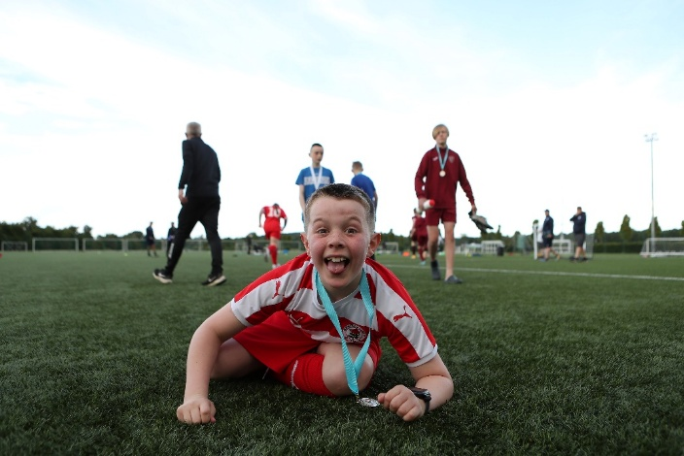
Ryan Wong Trustee

Contents
Page

Trustee Annual Report 4

Objects and Charitable activities 5

Achievements and performance 6

Financial Review 7

Trustees’ Annual Report
For the period ended June 2025

The Trustees have pleasure in presenting their annual report together with the financial statements of The Autism Football Association for the period from incorporation as a SCIO.
Structure, Governance and Management including organisational set-up Appointment of Trustees
The Autism Football Association, which normally meets bi-monthly, are the SCIO’s Trustees. In its inception on 26th June 2017, the organization was registered as Team United before a change of name in September 2023 to The Autism Football Association. The reason for this change was the merger of Team United with Hibernian Community Foundation in September 2023.

Trustees are elected at the Annual General Meeting (“AGM”) which is held in the summer of each year. The SCIO aims to have a minimum of four Trustee representatives with two parent representatives. Representative from people with a Neurodivergent condition is also welcomed. We currently have two Trustees who are neurodivergent.

The Board also agreed to the establishment of a Youth panel in 2022 to bring forward a youth-led approach to our work. Funding from Young Start, a programme of the National Lottery, allowed the organization to establish this forum and develop a new scheme called Team leaders. Since then, the organization received continuation funding to extend our work to those 16 to 24 years through our Social Community League which is also funded by The National Lottery Young Start Fund.

The organization currently works on a volunteer led basis. The Trustees do not employ staff but operate by establishing volunteer led sub groups. Such as the league committee who take responsibility for developing, and delivering the league and cup competitions.

The organization pay coaching staff on a sessional basis to ensure consistency for young people. The Chair of the organization works on a voluntary basis. The organization operates an Affiliation scheme with each partnership club paying an annual fee to enable them to participation in league and cup competitions.. Parental contributions are gathered monthly to support weekly participation for young people which in turns helps pay support and coaching staff.
Objectives and Activities

Charitable Purposes
To advance public participation in football by people in Scotland living with a disability, with a view to:

- Provide a range of sporting opportunities with targeted support to young people with disabilities

- The promotion of social inclusion among disabled young people and their parents who are socially excluded from society or parts of society as a result of them having a disability

- Provides an awards programme that encourages and enables disabled people to participate more effectively within the wider community

- Provide training and support

- Increasing or coordinating opportunities for people with disabilities to engage with service providers to enable these providers to adapt services to better meet their needs

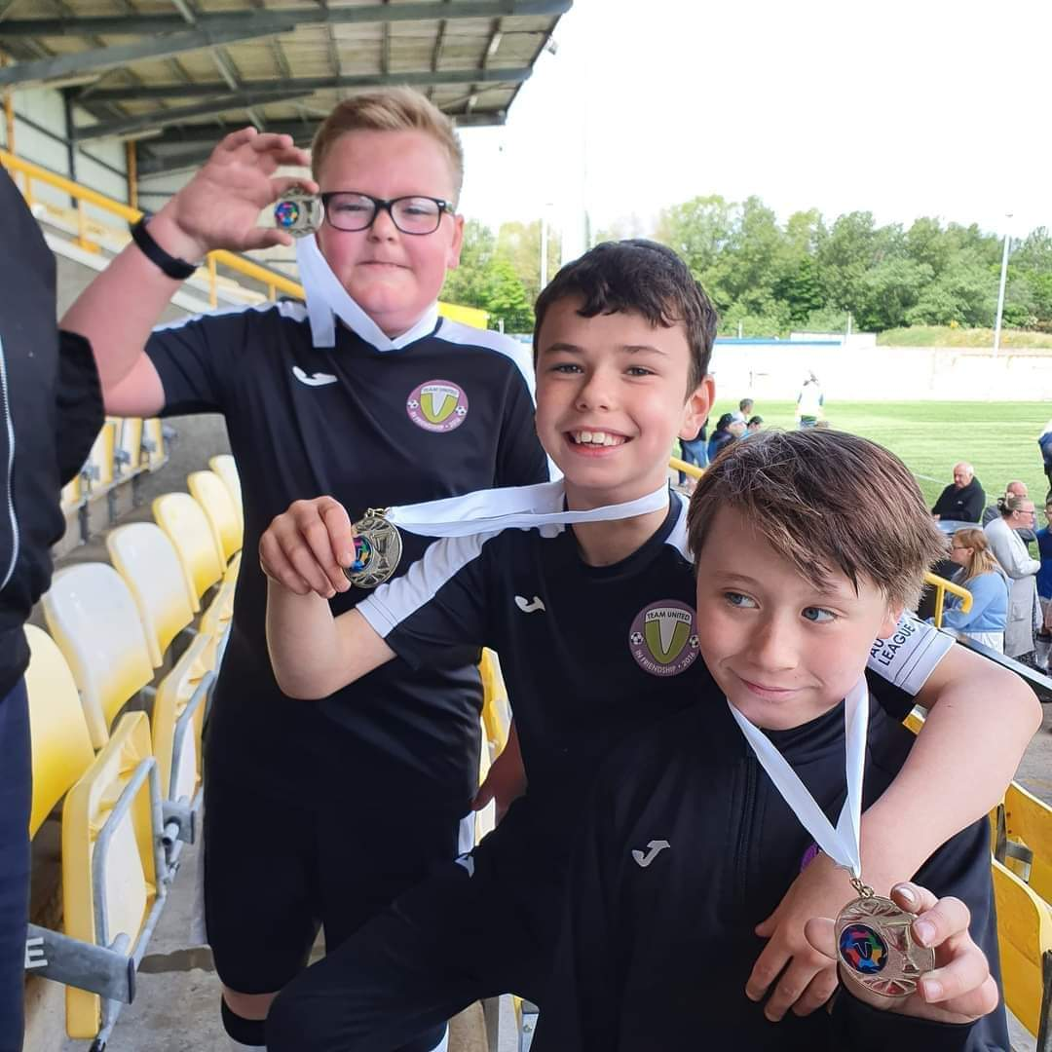

Activities

The organization focuses on supporting young people with Autism and other Neurodiverse conditions aged 10-16 years. In January 2024, the organization was fortunate to run a pilot project in order to gain funding to support recreational football for 16 to 24 year olds.

We offer a range of sports opportunities, mostly football, and we adapt the sessions to meet the need of the child. Over the past 12 months, we have changed our focus on supporting young people with Autism & Neurodiverse conditions. This is in keeping with the trend and diagnostics currently in place.

Our sessions are structured and consistent and all staff have knowledge and experience of working with young people with Autism.

The Autism Football Association is affiliated to The Scottish FA through Scottish Para Football. The organisation also manages and run the Autism League. We partner with local grassroots clubs who go on to develop autism teams with our support. Clubs become affiliated to the organization which enables them to register players through our digital platform and participate in sessions, competitions and activities. Young people automatically become members of the organization and are able to take part in the many activities, social clubs and projects we operate.

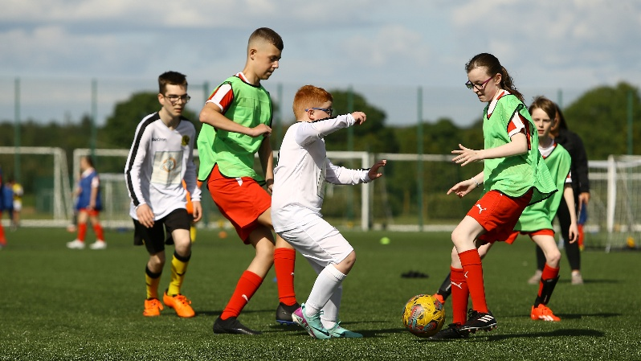
Performance

The organization's name was changed following the transfer of its main program through a partnership with the Hibernian Community Foundation
This allowed The Autism Football Association to focus its activities and further its work in operating a competition framework. The transfer of the Team United programme took place in September 2023 with £117k of restricted funding transferred to support the ongoing project work that has been raised and restricted to Team United activities.
The Autism Football Association retained £40,000 of funding to enable them to progress the work of the association which was previously not possible due to a cross over of responsibilities. Becoming a governing body (A football Association) meant that a separation of activities was required for both entities to grow.
The growth of the organization continues with a close working relationship with Hibernian Community Foundation who through their Team United programme increasing participation at a local level with grassroots clubs and therefore leaving the Autism Football Association to grow the game.

With the inclusion of Neurodiversity in our work, it has been necessary to develop a new strapline and aim which is :

The Neurodiverse Football charity

With the change of name and focus of the organization following on from our partnership with Hibernian Community Foundation, The Autism Football Association now operates effectively with a strong volunteer led basis.

The Autism Football Association has aspirations to increase the awareness of Neurodiversity in Football, grow the game at both a local, national and international level.

Financial Review
Prior to the partnership with Hibernian Community Foundation and the transfer of our Team United programme, the balance of funds was £117,687 - £39,916 (unrestricted) restricted £78,470.
The Autism Football Association retained £40,000 of unrestricted funds to further its work with the
balance carried of restricted funds to Team United programmes, who would be managed by Hibernian Community Foundation. All funders and stakeholders were informed of the change and supported the transfer of funds to complete the work in which funding support was provided.
There was little activity during the period 2023 – 2024 as the Autism Football Association were only running the leagues of which parental contributions and small amount of grants covered the costs.
One member of staff remained on a self-employed basis to manage the Autism Football Association and left in June 2024 when talks with Hibernian Community Foundation to de-merge in Juily 2025 .
Reserves Policy The Trustees have made a commitment to review their Reserve policy. With no staffing commitments and low expenditure, the Trustees feel assured in their current reserves position.
Plans for the Future
The organisation continues to receive an annual grant from Scottish Para Football towards the delivery of the league meetings and cup competitions. This funding along with small grants has enabled the continuation of the charity. Team United (now under Hibernian Community Foundation) continue to promote and work in partnership with The Autism FA
The Chair continues to be the main fundraiser and the Board are thankful for the effort and success that her experience has brought to the Charity.
The organization recognizes the need for a strategic review and is considering plans for the growth into other para football disciplines in order to grow the youth game in Scotland. The Autism FA is currently the only organization operating in this space with many other disciplines talking to us about the adoption of our business model. We recognize the financial advantage in this area and will continue discussions with national and local organisations to explore further.

7
Approved by the Trustees and signed on their behalf.
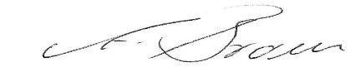
Ann Brown, Chair, May 2025

