Arran Dogs SCIO

Scottish Charity No – SC053020

Annual Report and Financial Statements

For the year ended 31 December 2025

Index

- Trustees’ Annual Report: pages 2-7

- Statement of Receipts and Payments: page 8

- Statement of Balances: page 8

- Notes to the Financial Statements: pages 9-11

- Independent Scrutineer’s Report: page 12

1

Trustees’ Annual Report

The trustees have pleasure in presenting their report together with the financial statements for the year ended 31 December 2025.

Reference and Administrative Information

Charity name

Arran Dogs

Charity no

SC053020

Principal Address

18 Alma Park, Brodick, Isle of Arran. KA27 8AT

Trustees who served during the year

Debbie Merritt Chair

Lesley Elliott Secretary

Steve Merritt Treasurer Appointed 4 April 2025

Veronica Michaluk-Ballota

Claire Gratton Appointed 18 August 2025

Patricia Templeton Resigned 20 March 2025

Julie Graham Resigned 11 August 2025

Trustees’ Annual Report (Continued)

Structure, Governance and Management

Constitution

The charity was recognised as a Scottish Charity on 20th December 2023 and is registered as a single tier SCIO, and as such the trustees are the members of the charity.

Appointment of trustees

The management committee, which normally meets online each month, are the charity’s trustees.
Trustees are elected at the annual general meeting which is held in March.
There must be a minimum of three trustees.

Trustees’ Annual Report (Continued)

Objectives and Activities

Charitable purposes

The organisation’s purposes are:

- To promote positive, kind and effective training methods for dogs by educating the public in such matters thereby preventing cruelty and suffering to dogs by using outdated training techniques.

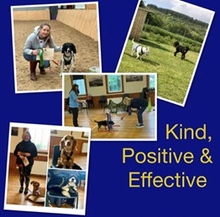

- To educate dog owners as to their legal responsibilities including control of their dog, to prevent dog attacks on people and other animals, and their dogs’ welfare requirements.


Trustees’ Annual Report (Continued)

- To provide dog training at a price that is accessible to all, discounting if necessary, to prevent dogs from being surrendered to rehoming charities.



- To advance the health of those who are mobility impaired by providing training in an accessible space so that they can exercise with their dog safely.
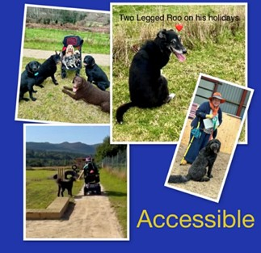

Trustees’ Annual Report (Continued)

Activities

The charity provides a secure, bookable dog field where owners can exercise or train their dogs without intrusion from other dogs or people.
The field is available at no charge, but donations are welcome.

The charity also provides dog training, mainly in classes. This can be for general dog training or working towards the Kennel Club Good Citizen Awards.

Achievements and performance

The secure dog field for the use of the public to train and exercise their dogs has now been open for a full calendar year. Before the first anniversary of it opening we had the accessible path and the enrichment equipment installed to enhance the visitor experience.

The field is achieving good occupancy, of which 50% is by Arran residents, 25% by visitors, and 25% for dog training and maintenance.
The dog training classes continued to be popular, with several dogs achieving bronze, silver, and gold awards in the Kennel Club Good Citizen Awards Scheme.
We have continued our awareness campaign regarding cannabis poisoning in dogs. In 2024 our local vet dealt with 5 cases in a 9 week period, in 2025 they can only recall dealing with 2 cases the entire year.

We have introduced an Equipment Library whereby owners can donate unused items to prevent them going to landfill and these items can either be purchased for a donation or borrowed and returned for cleaning and re-use.

Financial Review

Our main source of funding this year was from donations. The main outgoing was the installation of an accessible footpath and fixed agility equipment.
The upkeep of the field is covered by donations from dog owners who use the field.

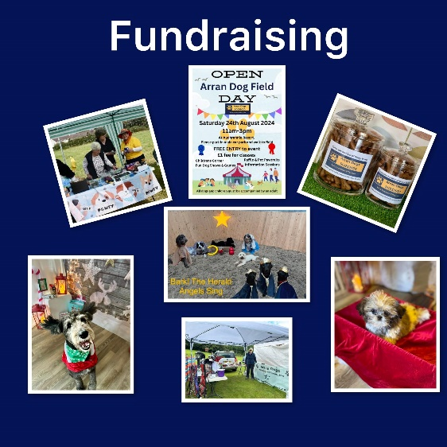

Trustees’ Annual Report (Continued)

Reserves policy

The Trustees’ policy is to retain at least 3 months’ worth of normal running costs in order to meet commitments and to cover any unexpected expenditure.

Plans for the future period

Next year we intend continue fundraising with the objective of providing either accessible parking adjacent to the field or an accessible path from the closest car park.

D A Merritt 18 June 2026
Debbie Merritt (chair) Date

Independent Examiner’s Report on the Accounts

Respective responsibilities of trustees and examiner

The charity’s trustees are responsible for the preparation of the accounts in accordance with the terms of the Charities and Trustee Investment (Scotland) 2005 Act and the Charities Accounts (Scotland) Regulations 2006. The charity trustees consider that the audit requirement of Regulation 10(1) (d) of the Accounts Regulations does not apply. It is my responsibility to examine the accounts as required under section 44(1) (c) of the Act and to state whether particular matters have come to my attention.

Basis of independent examiner’s statement

My examination is carried out in accordance with Regulation 11 of the Charities Accounts (Scotland) Regulations 2006. An examination includes a review of the accounting records kept by the charity and a comparison of the accounts presented with those records. It also includes consideration of any unusual items or disclosures in the accounts and seeks explanations from the trustees concerning any such matters. The procedures undertaken do not provide all the evidence that would be required in an audit and, consequently, I do not express an audit opinion on the accounts.

Independent examiner’s statement

In the course of my examination, no matter has come to my attention

1. which gives me reasonable cause to believe that in any material respect the requirements:
• to keep accounting records in accordance with section 44(1) (a) of the 2005 Act and Regulation 4 of the 2006 Accounts Regulations, and
• to prepare accounts which accord with the accounting records and comply with Regulation 9 of the 2006 Accounts Regulations

have not been met, or

- to which, in my opinion, attention should be drawn in order to enable a proper understanding of the accounts to be reached.

Signed Kaye Johnstone

Kaye Johnstone (Receipts & Payments)

Date. 18 June 2026

