KILLEARN MALAWI GROUP

Annual Report & Financial Statements For the year ended
16th April 2026





CONTENTS
Trustees’ Annual Report ...................................................................................................................... | 3 – 9
Independent Examiner’s Report .......................................................................................................... | 10
Statement of Receipts & Payments ..................................................................................................... | 11
Statement of Balances......................................................................................................................... | 12
Notes to the Financial Statements....................................................................................................... | 13-14

The trustees are pleased to present their report and financial statements together with the independent examiner’s report for the year ended 16th April 2025.

REFERENCE AND ADMINISTRATIVE DETAILS

Charity Name Killearn Malawi Group

Charity Number SC043555

Principal Address 43 Allan Road Killearn Glasgow

G63 9QF

Website Address www.killearnmalawigroup.org.uk

Current Trustees Ken Allen Shona Kelday Sue Beck Jenifer Barrett Jennifer Wilks
Doreen Snadden
Gayle Porter Judith Robertson
Other Trustees who served during the year

John Shaw resigned 13 September 2025
Hilary McGregor resigned 13 September 2025

Independent Examiner Ian Brooke
IBSM Ltd
Forrest Hill Cottage
Broughton
By Biggar
ML12 6QH

STRUCTURE GOVERNANCE AND MANAGEMENT

Governing Document
Killearn Malawi Group is an Unincorporated Association which was registered with the Office of the Scottish Regulator (OSCR) on 13th November 2012. It is governed by its constitution which was reviewed and updated in March 2017 and June 2024.

Appointment of Trustees
Trustees are elected at the AGM by the members. The management committee may co-opt other trustees at any time.
At each annual general meeting, all of the members of the management committee retire and are eligible for re- election. The constitution allows for a maximum of nine trustees.

Organisational Structure
The organisation is run entirely by volunteers, The Killearn Malawi Group management committee is chaired by an elected chairperson and meets about five times a year. A sub-group of trustees and interested friends organise fund-raising activities.

Risk Assessment
The principle sources of income is through fund-raising. Income is also generated through savings interest on the capital. The main expenditure is projects which have been assessed, approved and assured from existing funds. The Killearn Malawi Group maintains a level of reserve.

OBJECTS & ACTIVITIES
Killearn Malawi Group works to help the prevention and/or relief of poverty, the advancement of health and the advancement of education.
Killearn Malawi Group has maintained links to both the north and south of Malawi through its differing projects: sending out of clothing, tools, equipment and books for dispatch and dissemination in Mzuzu; fundraising activities to raise money and awareness of the needs in Malawi; supporting various projects in Malawi which have originated there.

ACHIEVEMENTS & PERFORMANCE
The past 12 months have enabled the Killearn Malawi Group to raise funds for future projects and to support our communities in Malawi as they recover from the various adverse weather conditions experienced during the year. We have maintained good contact with our partners in Nkhande through Dr Kondwani Chidziwisano.
We have been able to send clothing, sewing machines and craft supplies to Malawi through the Bananabox Trust, delivered to Mzuzu, to support self-sustaining industries at Hilltop in Mzuzu. We have also sent knitted baby clothes for the maternity hospital at Ekwandeni, and books and other items for Kileni Nursery. This work is currently on hold while the Bananabox Trust reorganises following the death of their Chairperson in 2025, which means we are currently unable to send items to Malawi through them.
We continued to support Chrissy’s Meals, helping widows to become more self-sufficient and providing food and supplements to fortify maize for a healthier diet, as well as supporting some orphans through school fees. As a result of our Chairperson’s visit in 2024 we have been able to maintain better contact with Chrissy and her daughter, Rachel, in their remote village.
We continued to support Nkhande CDSS by providing scholarships for eleven students across all four year groups. We were able to do this for the first term of the academic year; however, secondary education is now free to all students, so we are exploring other ways to support those most in need. We also continue to support the use of computers in the school. The school has to sign up to a five-year maintenance scheme, which we will support. This will be a game changer for the school, promoting inclusivity and enabling students to study computing for the first time.
We continue to move forward with plans to build a girls’ hostel at Nkhande CDSS. Over the year, foundations have been laid using bricks manufactured by the villagers, making this a genuine community effort.
We continue to be members of the Scotland Malawi Partnership (SMP), a national civil society network that co-ordinates, supports and represents the people-to-people links between our two nations. The SMP represents a community of 109,000 people with active links to Malawi.
The SMP launched its 20th anniversary year with a photographic exhibition showcasing projects delivered by member groups. The exhibition was held in Killearn before moving on to other venues.
The Annual Gathering, incorporating the business of an Annual General Meeting, was held on 13 September and was attended in person by the committee and seven Friends of the Killearn Malawi Group. Dr Kondwani Chidziwisano, was able to join us via video link and update everyone on the projects in Nkhande.

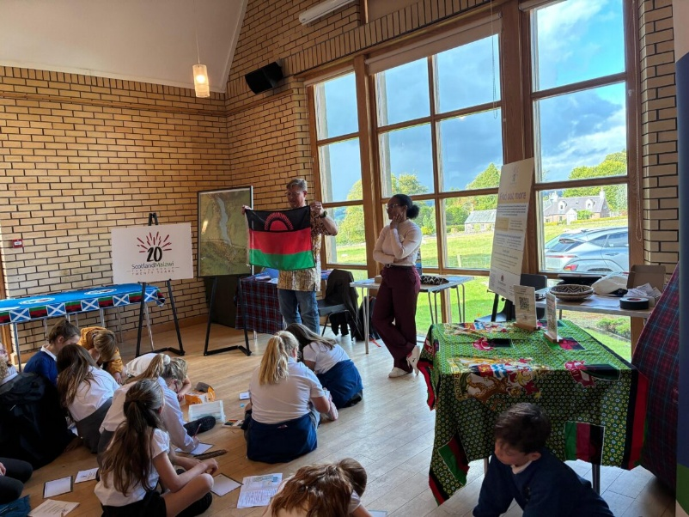
A group of Primary School children attending the Scotland Malawi Partnership 20th anniversary Photographic Exhibition

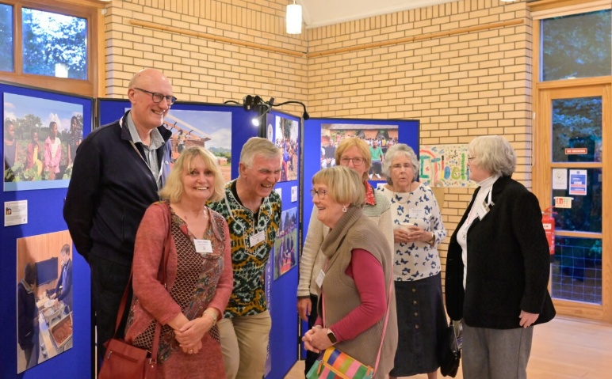

Committee at the Scotland Malawi Partnership 20th anniversary Photographic Exhibition

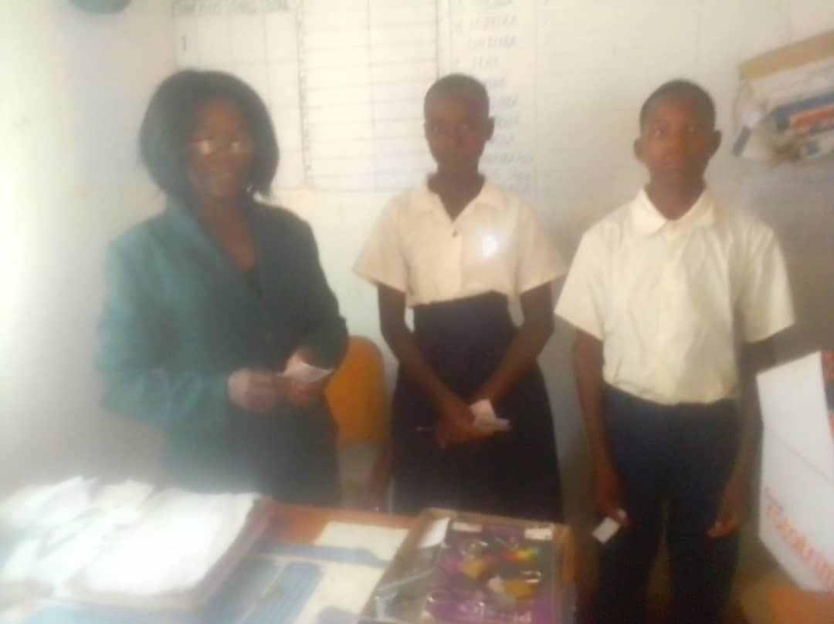

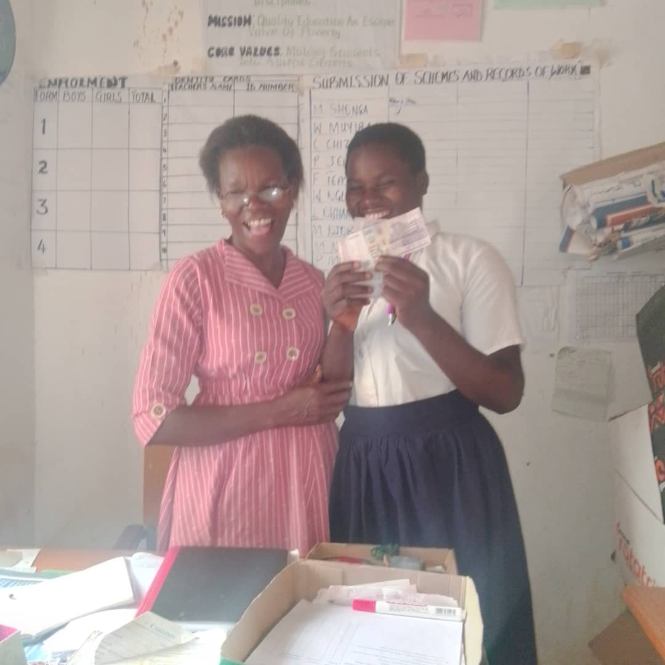

Recipients of the scholarship grants that Killearn Malawi Group supported.

Nkhande Girls dorm progression during the year.

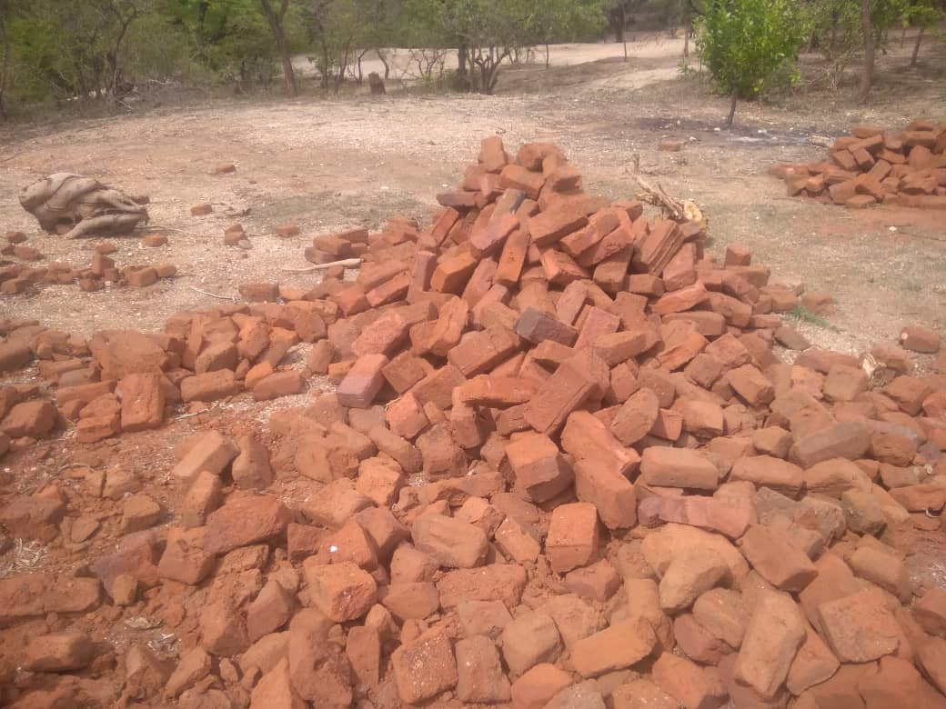

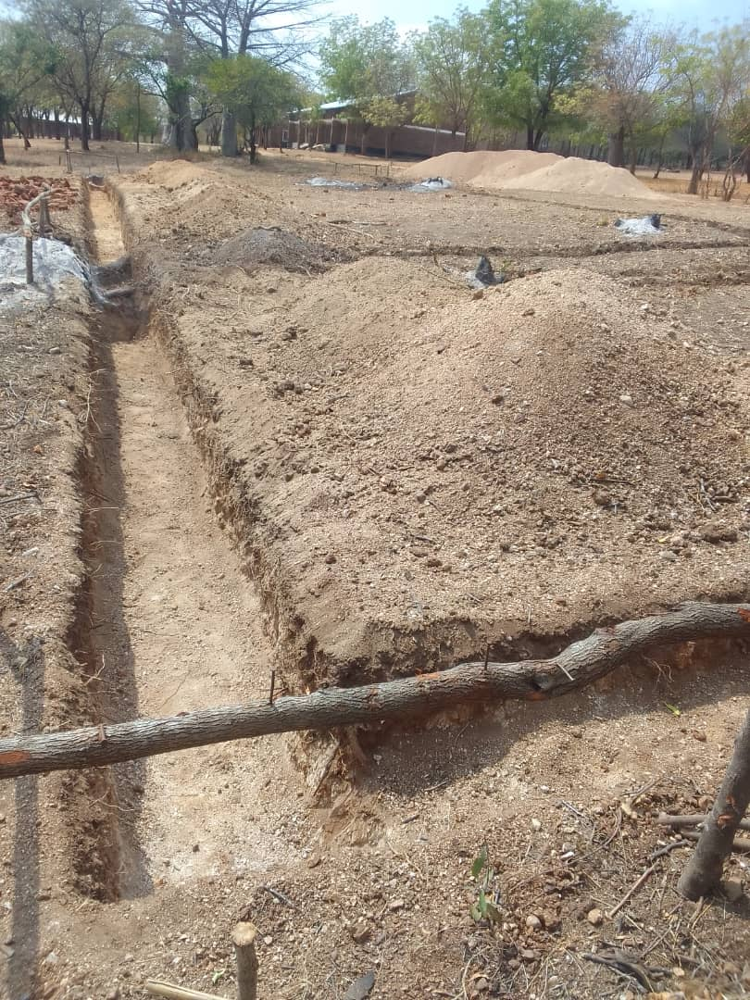
Bricks made by the local community

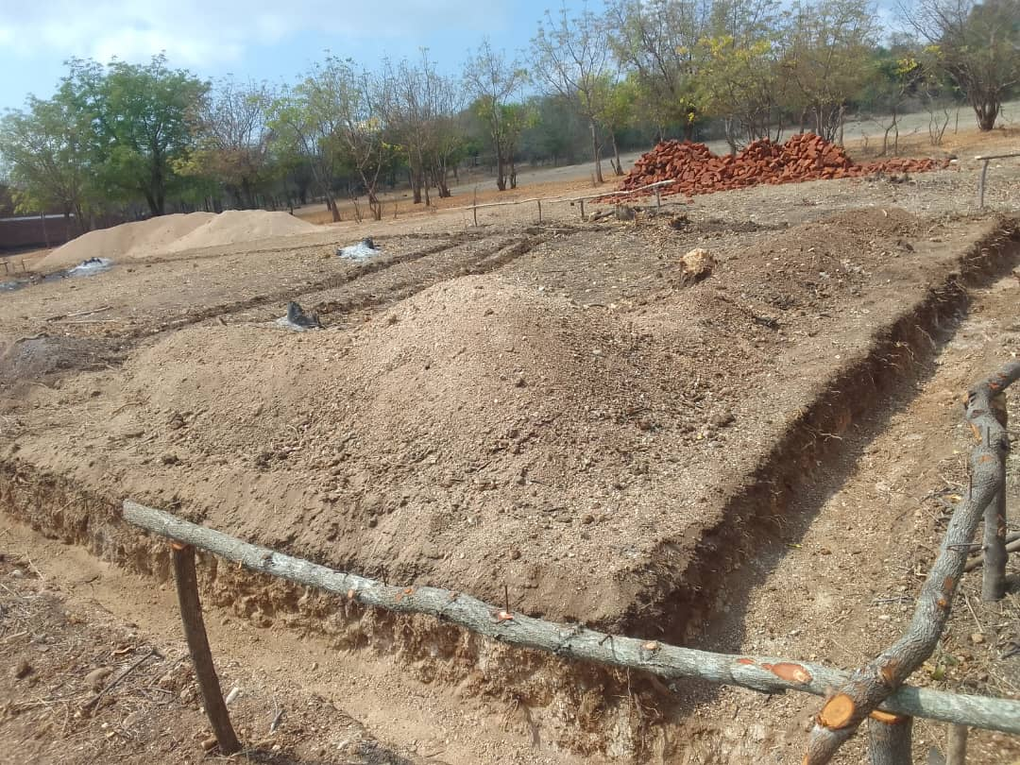
Foundations in the making

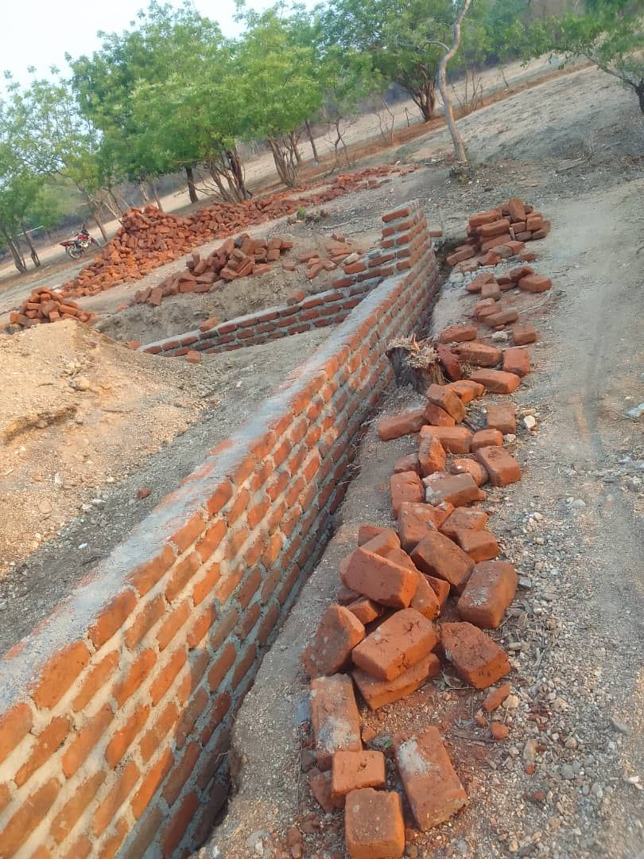
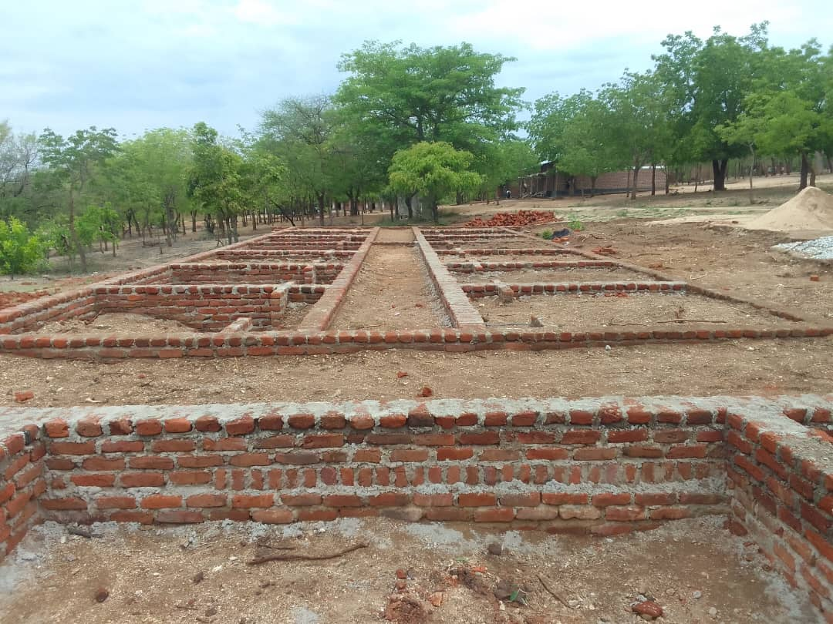

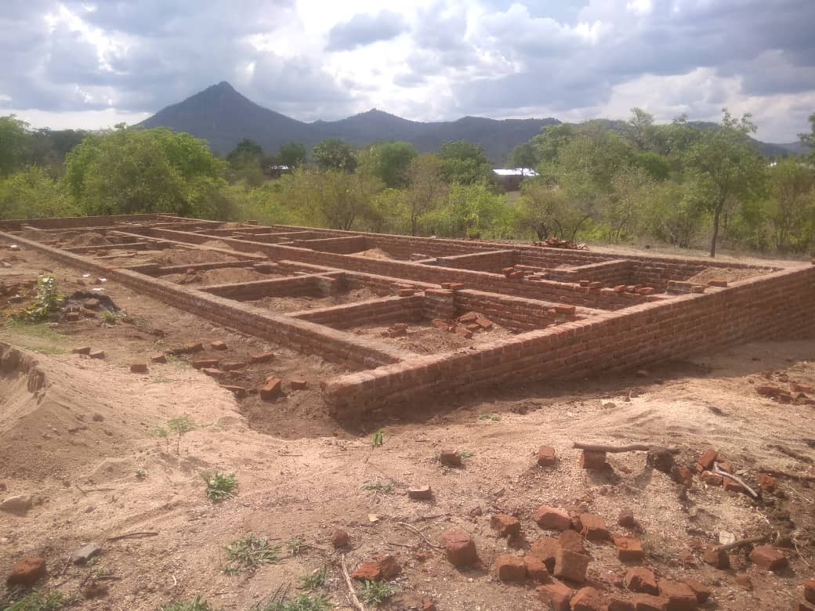

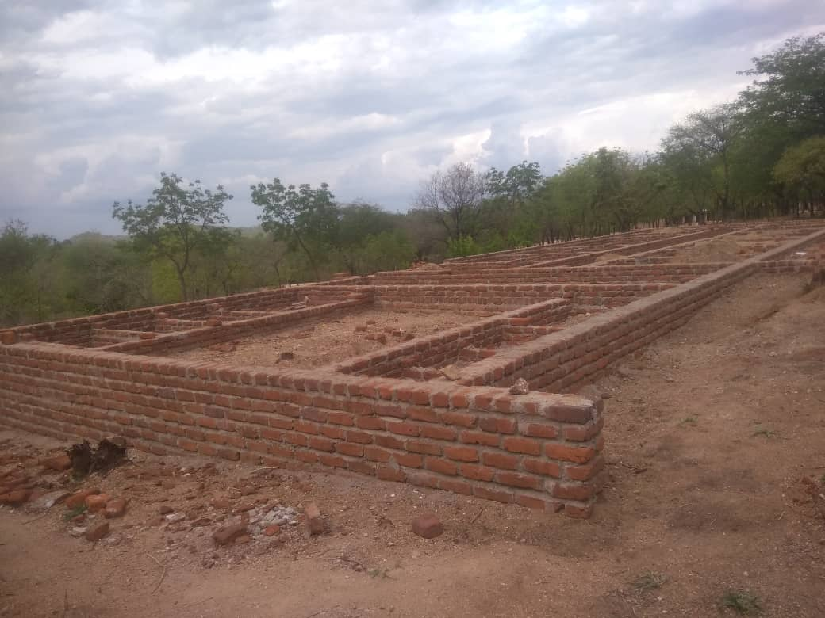

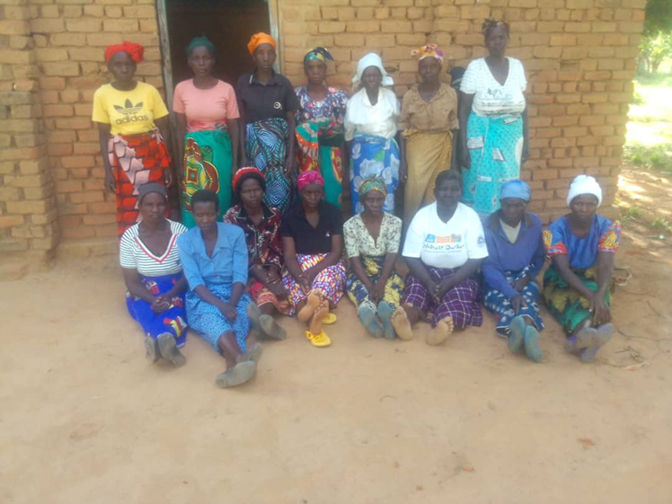

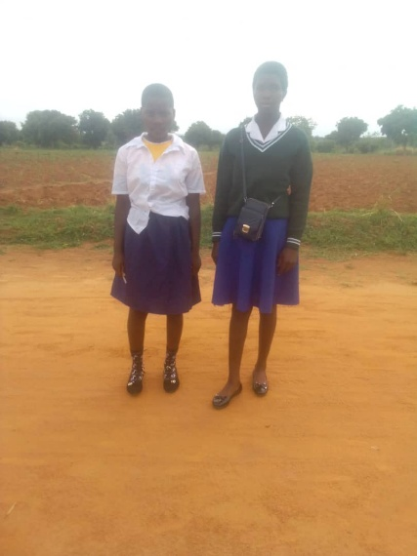
Recipients of money sent for Chrissy’s meals

Pupils who have been supported at the school in Embangweni

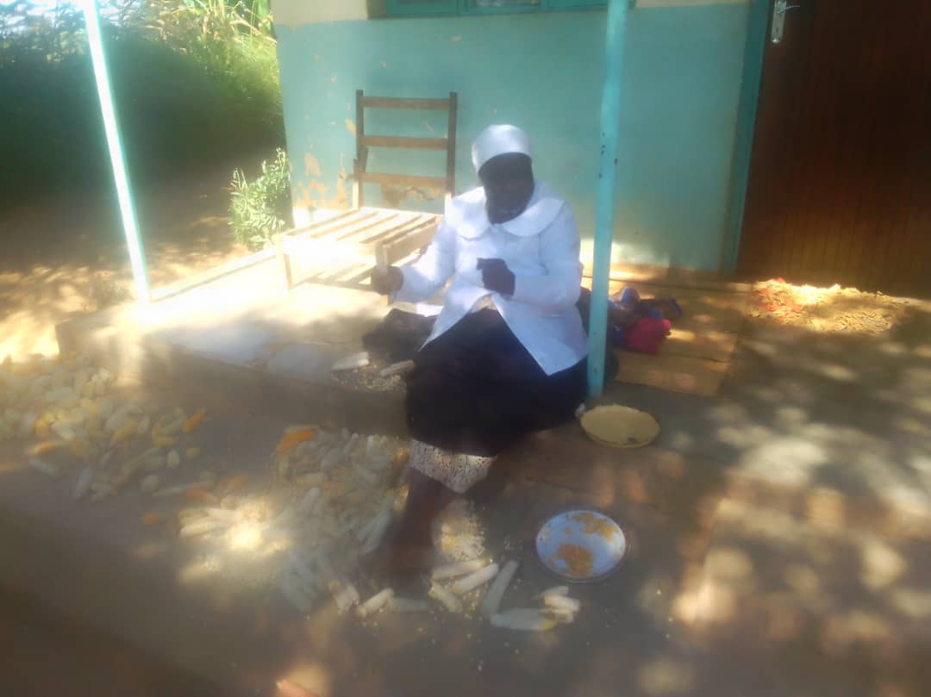

Chrissy

Main areas of our work

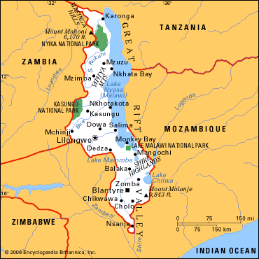
Chrissy’s meals, Embangweni
Nsanje area where we have built the science and library block. We are actively moving forward to build a girls hostel to enable girls the opportunity to attend school in a safe and secure way.
Mzuzu, in the north were the Bananabox container deliveries from the group are sent.

FINANCIAL REVIEW

Overview
Income during the year was £7,161 (2025: £10,703) raised through donations, fund-raising and interest. Expenditure in this year was £4,262 (2025: £4,322) and was used to continue to support our projects, towards the cost of raising funds and admin such as website and bank charges. There was a total surplus within the year of £2,899.
Restricted Funds
Monies raised specifically for the Girls’ Hostel project at Nkhande Community School during 2025-6 of £3,024 giving £9,559 at year end.

Fund Raising
Our fundraising activities during the year included a ceilidh in November which was well attended and after costs raised a total of £ 1,233 and the annual jumble sale in February which raised £2,587 after costs.
We are continuing with fundraising and sourcing grant applications to fund our next major project, a girls’ hostel at Nkhande CDSS.
We also took advantage at the events to provide participants with information on what we have been doing and our future and ongoing projects.

Donated Facilities & Services
Items donated by individuals and sent to Mzuzu though the Banana Box Trust are not valued in the accounts as it is not practical to do so and the cost of valuing the goods outweighs the benefits. Services such as such as use of computers in preparing for meetings other than the Annual Gathering are services given to the charity.

Reserves Policy
Reserves at the end of the year are £18,838 (2025: £15,902) The trustees have agreed in general to keep a minimum reserves of £1,000 at the year end to cover operational costs (e.g governance and support costs) for at least six months. The rest of the funds will be utilised to continue to support the present and future projects within Malawi.
Investment Policy
To maximise the income on bank interest the trustees have funds that are not for immediate use within an interest bearing account with the Virgin Bank.

FUTURE PLANS
The trustees continue to contribute to the building of a girls’ hostel at Nkhande Community School. They will continue to support the projects both in sending items out to Mzuzu and continuing projects in Nsanje.

APPROVAL
This report was approved by the trustees on 5 June 2026 and signed on their behalf by:

Kenneth Allen
Trustee

Independent Examiner's Report to the Trustees of Killearn Malawi Group
I report on the accounts of the charity for the year ended 16th April 2026, which are set out on pages 1 to 14.

Respective responsibilities of Trustees and Examiner
The charity’s trustees are responsible for the preparation of the accounts in accordance with the terms of the Charities and Trustee Investment (Scotland) Act 2005 ("the 2005 Act") and the Charities Accounts (Scotland) Regulations 2006 (as amended) ("the 2006 Regulations"). The trustees consider that the audit requirement of Regulation (10)(1)(d) of the 2006 Regulations does not apply.
It is my responsibility to examine the accounts under section (44)(1)(c) of the 2005 Act and to state whether particular matters have come to my attention.

Basis of Independent Examiner's Statement
My examination is carried out in accordance with Regulation 11 of the 2006 Regulations. An examination includes a review of the accounting records kept by the charity and a comparison of the accounts presented with those records. It also includes consideration of any unusual items or disclosures in the accounts, and seeks explanations from the trustees concerning any such matters. The procedures undertaken do not provide all the evidence that would be required in an audit, and consequently I do not express an audit opinion on the view given by the accounts.

Independent Examiner's Statement
In connection with my examination, no matter came to my attention:-
- which gives me reasonable cause to believe that in any material respect, the requirements
  - to keep accounting records in accordance with section 44(1)(a) of the 2005 Act and Regulation 4 of the 2006 Regulations, and
  - to prepare accounts which accord with the accounting records and comply with Regulation 9 of the 2006 Regulations
have not been met, or
- to which, in my opinion, attention should be drawn in order to enable a proper understanding of the accounts to be reached.

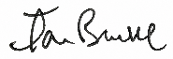
21 June 2026

Ian Brooke
IBSM Ltd
Forrest Hill Cottage
Broughton
By Biggar
ML12 6QH

 | Notes | Unrestricted Funds | Restricted Funds | Total 2026 | Total 2025
Receipts |  | £ | £ | £ | £
Donations |  | 631 | 500 | 1131 | 1213
Fund Raising |  | 2635 | 2274 | 4909 | 9339
Receipts from Other Charitable |  | 394 | 250 | 644 | 0
Income from Investments |  | 477 | 0 | 477 | 151
 |  | 4137 | 3024 | 7161 | 10703
Payments
Grants and Donations | 5 | 1035 | 2020 | 3055 | 1585
Cost of fundraising | 6 | 48 | 1041 | 1089 | 2254
Charitable activities (Admin) |  | 118 | 0 | 118 | 408
Governance Costs |  |  |  | 0
Independent examination |  | 0 | 0 | 0 | 50
AGM |  | 0 | 0 | 0 | 25
 |  | 1201 | 3061 | 4262 | 4322
Net movement in funds |  | 2936 | (37) | 2899 | 6381
Transfer between funds |  | 0 | 0 | 0 | 0
Surplus/ (Deficit) for year |  | 2936 | (37) | 2899 | 6381

The Notes on pages 13-14 form an integral part of these accounts.

 |  | Unrestricted Funds | Restricted Funds | Total 2026 | Total 2025
Funds Reconciliation |  | £ | £ | £ | £
Balance as at 17 April 2025 |  | 15902 | 9596 | 25498 | 19117
Surplus/ (Deficit) for year |  | 2936 | -37 | 2899 | 6381
Balance as at 16 April 2026 |  | 18838 | 9559 | 28397 | 25498
Bank & Cash Balances
Cash at Bank of Scotland |  | 0 | 0 | 0 | 3633
Cash at Virgin Money Current Account |  | 2056 | 4000 | 6056 | 0
Cash at Virgin Money Savings account |  | 0 | 0 | 0 | 21865
Cash at VM 30 day account |  | 16783 | 5559 | 22342 | 0
 |  | 18839 | 9559 | 28398 | 25498
Other Assets
Sum Up Machine |  |  |  |  | 166
 |  |  |  |  | 166
Liabilities
IE Expenses |  | 100 |  | 100 | 0

The Notes on pages 13-14 form an integral part of these accounts.
These accounts were approved by the trustees on 5 June 2026 and signed on their behalf by:

Doreen Snadden Kenneth Allen

Trustee Trustee

Basis of Preparation
These accounts have been prepared on the receipts & payments basis in accordance with:
  - The Charities and Trustee Investment (Scotland) Act 2005
  - The Charities Accounts (Scotland) Regulations 2006 (as amended)
There have been no changes to the basis of preparation or to the previous year’s accounts.

Fund Accounting
  - Unrestricted funds are those that can be expended at the discretion of the trustees in the furtherance of the objects of the charity.
  - Restricted funds are those that can only be expended on the girls‘ dormitory in Nkhande Community School.

Taxation
  - The charity is not liable to corporation tax or capital gains tax on its charitable activities.
  - The charity is not registered for VAT, thus all costs are shown inclusive of VAT charged.

Transactions with trustees and related parties
  - No remuneration was paid to trustees or any persons connected with them during the year (2025:
£Nil).
  - No expenses were reimbursed to the trustees during the year (2025: £Nil).

Grants and Donations distributed
 | Unrestricted Funds | Restricted Funds | Total 2026 | Total 2025
 | £ | £ | £ | £
Chrissy's Meals | 500 |  | 500 | 250
Banana Box | 0 | 0 | 0 | 500
Nkhande School | 535 | 2020 | 2555 | 835
 | 1035 | 2020 | 3055 | 1585

Cost of Fundraising

 | Unrestricted Funds | Restricted Funds | Total 2026 | Total 2025
 | £ | £ | £ | £
Ladies Night |  |  | 0 | 2229
Ceilidh |  | 1041 | 1041 | 0
Jumble Sale | 48 |  | 48 | 25
 | 48 | 1041 | 1089 | 2254

- Movement in Funds
 | As at 16/04/2025 | Receipts | Payments | Transfers | As at 16/04/2025
Unrestricted Funds | £ | £ | £ | £ | £
General Fund | 15902 | 4137 | (1201) |  | 18838
Restricted Funds
Nkhande Girls Hostel | 9596 | 3024 | (3061) |  | 9309
Total Funds | 25498 | 7161 | (4262) | 0 | 28397

- Purpose of Funds
The funds are for use to fund projects in Malawi as agreed and minuted by the trustees of the Killearn Malawi Group.
General Fund Unrestricted funds that can be expended at the discretion of the Charity Trustees in furtherance of the objects of the charity.
Nkhande Girls Hostel Fund Monies raised specifically for the Girls’ Dormitory project at Nkhande Community School

