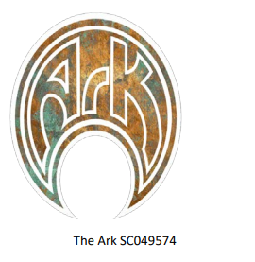
REGISTERED ADDRESS THE ARK CHARITY
The Ark
Games Club
C/O Jewel Miner's Club
56 Duddingston Park South
Edinburgh
EH15 3LJ

CHARITY NUMBER SCO49574
Trustees:
Kenny Kirkpatrick
Tyler George Hewitt
Gabor kovaics

The organization is established for charitable purposes only. The provision of recreational facilities or the organisation of recreational activities, with the object of improving the conditions of life for the persons for whom the facilities or activities are primarily intended

CHARITABLE ACTIVITIES CARRIED OUT THROUGH YEAR
Through the year of May 2024 to April 2025 The Ark did not operate as normal due as we are still confirming arangements oround our new location at the jewels miners club.
As such no income came in and no expenditure went out.
The accounts were zero.
The Ark has located a new premises and intends to move in at the start of 2025 to relaunch its work.

