DRAFT ANNUAL REPORT DR4A
May 2026

It has been a relatively quiet year for DR4A but never the less the ambition and drive to support grass roots rugby within Aberdeen / shire still remains.

The charity took part in the annual “Celebrate Aberdeen” parade on 23rd August along Union Street. It was amazing to be part of such a large street parade involving charities and voluntary organisations from all over Aberdeen and the surrounding areas. There were plenty of smiling faces and one bonus was we got to keep the banner which will come in handy for future events! Rebecca was particularly delighted to meet Angus the Bull! We also got to try out our new charity T-shirts designed by our very own talented Ali Robertson.

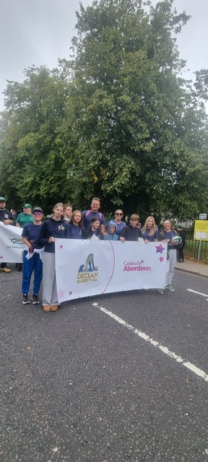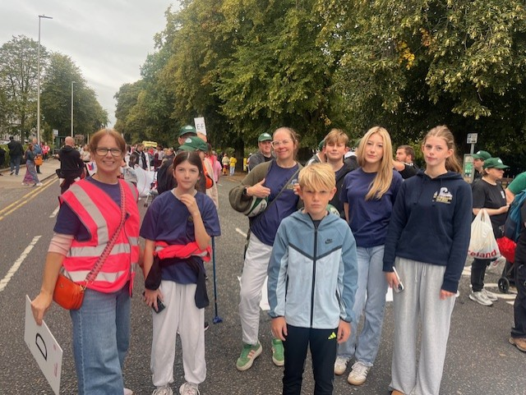

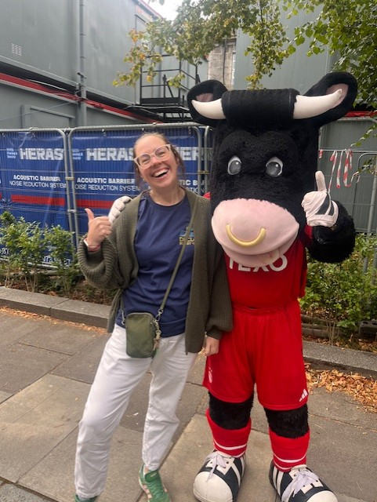
FUNDRAISING ACTIVITIES
On 27th April, a very good friend of the charity Jonny Whitfield managed to raise a whopping £2702 by completing the Manchester marathon in memory of Declan. He completed it in 6 hours and 15 minutes which is amazing given it was Jonnies first ever marathon. Here are some photos with his medal.

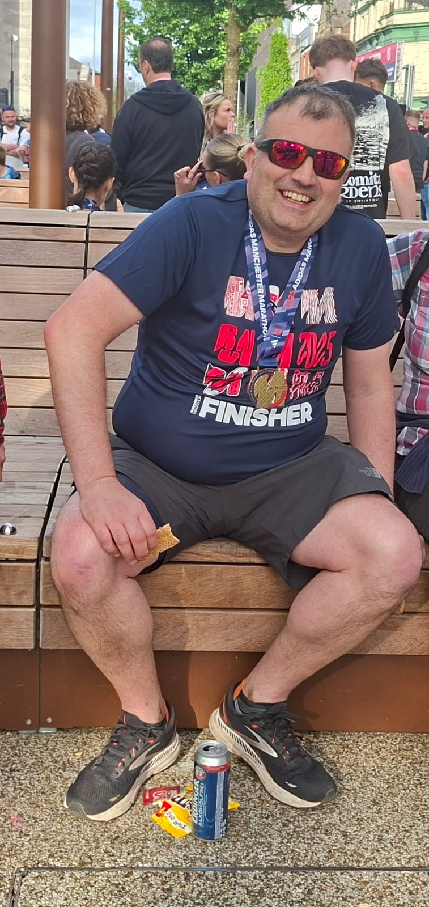

The Charity has continued to receive regular donations from the charitable trust of The Denton’s Law firm for which we are truly grateful to Laura Morrison for organising. Another very good friend of the family and charity

It would have been Declan’s 50th birthday in October 2025 and a number of personal donations were made by friends in family to honour Declan and his legacy. DR4A are truly grateful for all the generosity.

CURRENT PROGRAMMES AND COMMITMENTS
The charity has committed to funding the Northfield Academy rugby school for the academic year 2026-2027. They are hoping to secure long term funding / sponsorship but to fill this gap in funding and to prevent the highly successful programme from folding, DR4A has stepped in to help the amazing work of Paul Harrow and his colleagues.

Representatives from the charity including Claire Harnett and Rebecca Shannan will attend an open evening / sponsorship event at ARFC on Friday 29th May 2026 where some of the great work of the rugby academy will be showcased. This will include case studies and statistics on attendance and behaviour for the children attending the programme. The outcomes have all been extremely positive and Paul with the help of DR$A and potential new sponsors are hoping to roll out this programme to other secondary schools within Aberdeen city.

