39 Inglefield Street, Govanhill, Glasgow G42 7AY
Tel: 0141-424-1797
A
N
N
U
A
L

R
E
P
O
R
T

2
0
2
5
/
2
0
2
6

Larkfield Community Centre

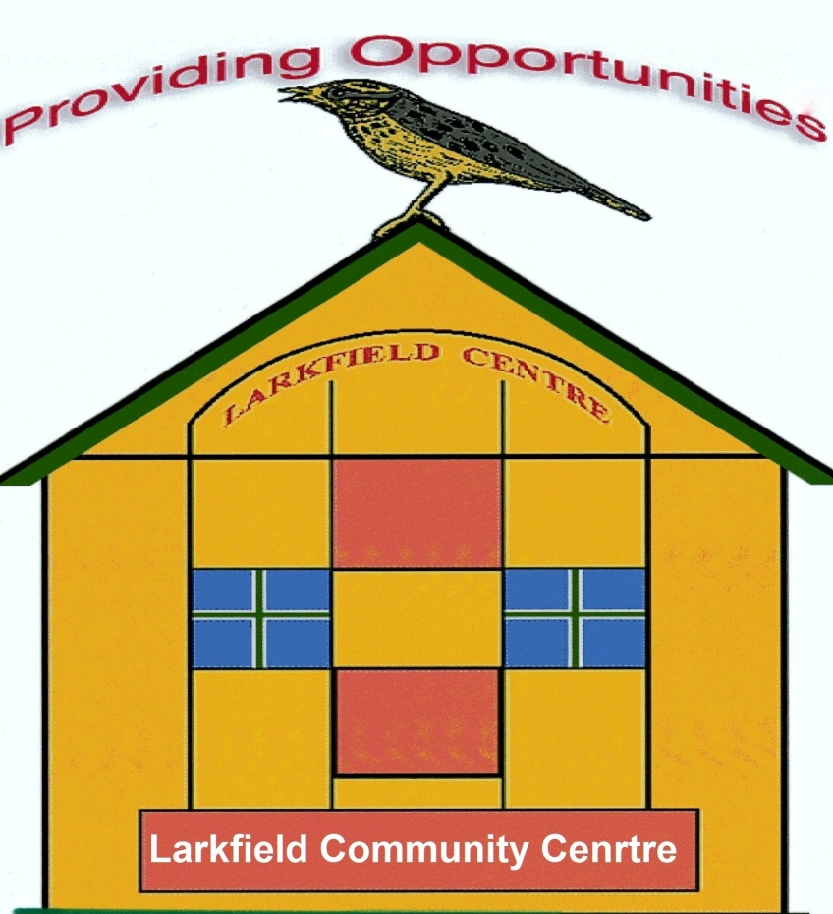



Funded by the following:

Glasgow City Council Glasgow Communities Fund

The Weir Charitable Trust

The Robertson Trust

The National Lottery

The Andrew Mary Elizabeth Little Charitable Trust




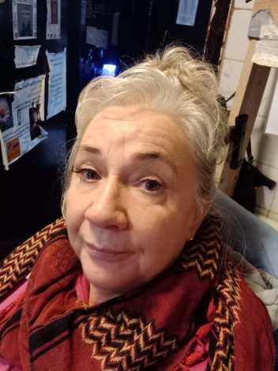
Chairperson Report

Over the last year we had 1,865 people come through the doors of the Larkfield Community Centre to attend classes, groups, Events and services.

Our centre groups, Digital Photography, Keep Fit Class, Singing For Fun Group and also the Art Group continue to run weekly at the centre with the art group attracting new members and losing some old members, though their numbers remain the same. Sadly our Woman’s Group stopped this year as the Tutor we managed to get to take the group after the previous Tutor retired secured a full time job, so sadly the group came to an end.

Our regular lets still meet at the centre here are a few examples, Active Life Club, Grooves in the Dark, Language Class for children/young people, Positive Action in Housing, Social Security Scotland, Merge Welfare Group and Glasgow Chess League to name a few.

We also began a partnership last year with The Govanhill Community Development Trust (GCDT) providing a weekly Job Club to assist local people into the workplace, which has been successful but due to staff illness at GCDT sadly it’s on hold for the time being.

We continue to provide classes, groups and services that meet the needs of the local community, promoting health and wellbeing, opportunities to learn about Digital Photography, Art etc.

Our partnership with Hollybrook Academy continues to thrive and the Taste Buddies which serves up nutritional and healthy hot food to the local community free of charge is something we are proud to be part of. We are also proud of the students who cook the food and deliver it to the community that they learn in and it’s been very rewarding to see the community enjoy their time at the centre and also to see the student blossom makes it all worthwhile.

Sadly we have had a member of staff off on long-term sick and miss their contribution to help deliver the much needed services that we provide and we
wish them well and hope to see them back doing the job they were a natural at.

This year we held just the one Christmas Event due to not having enough staff to manage our full Christmas Events Programme but the one event went really well as we combined the Santa’s Grotto with the Christmas Lights Switch-on, Everyone had a great time and just seeing the community smile at Christmas time made it all
Chairperson Report Continued

worthwhile, as it was a free event which was good for local families as many would not have disposable income to take their children into the City Centre to attend a Christmas Event.

I’d like to take this opportunity to thank the following:

Glasgow City Council’s Glasgow Communities Fund

The National Lottery Community Fund Scotland

The Robertson Trust

The Weir Charitable Trust

The Andrew & Mary Elizabeth Little Charitable Trust

Thank you all for supporting us over the last year as without your financial support we would have had to close the doors on the centre which has served the local community for over 3 decades.

I’d also like to take this opportunity to thank fellow Board Members for taking the time to oversee the running of the centre as without your input there would be no centre.


Best Regards

Marion Nisbet
Chairperson of the Larkfield Community Centre Board of Trustees


Centre Groups
Digital Photograph
The Digital Photography Group continues to meet at the centre on a Tuesday morning 10am-12noon. They are always looking for new members to come along an join them, so if you are interested please pop along on a Tuesday morning.


Singing For Fun
The Singing For Fun group meets on a Wednesday afternoon 1pm-3pm and is led by the fantastic Suzie G, who is very enthusiastic and gets the group singing from start to finish and in-between have a cuppa and a biscuit too. So if you like to sing for fun, you don’t need to have a great singing voice just have a love for singing pop along as a warm welcome awaits you.

Women’s Keep Fit Class
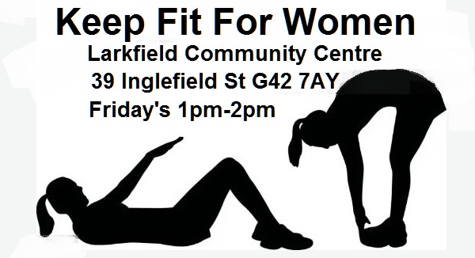
The Keep Fit Class for Women continues to
meet on a Friday 1pm-2pm and it’s free. So if
you want to get fit for summer then come along
and join the group and I’m sure the Tutor Sylvia
will help you on your way to getting fit.

Women’s Group
The women’s group was providing a space for women to meet up and learn about hand massage, nails and beauty but due to the retirement of the original Tutor we had and then the new Tutor we managed to employ for a while secure full time employment and we found it difficult to get someone else and there was no option sadly but to let the group close.

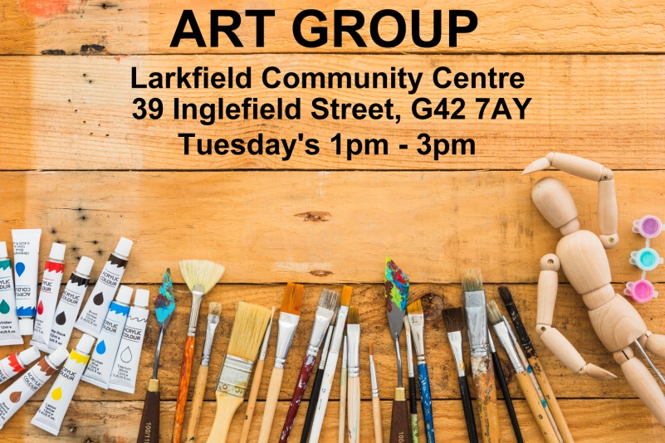
Art Group
The Art Group continues to meet on a Tuesday 1pm-3pm and is happy for new people with an interest in are to come along and join them. They are very welcoming and will share their art skills with each other so it would help improve your artistic skills if you came along and joined them.
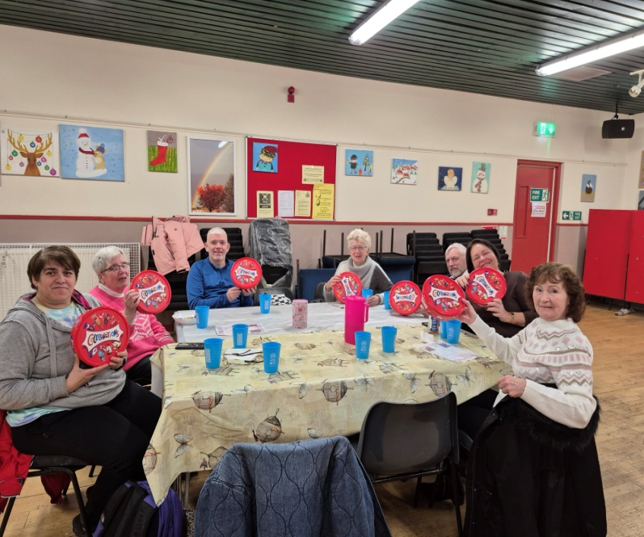
Taste Buddies
Taste Buddies meet on the first two Thursdays of each month at the Centre from 10am-12noon. The fabulous students from Hollybrook Academy make delicious food at the school and bring it over to the centre to serve up to the community that they learn in.
Taste Buddies Continued
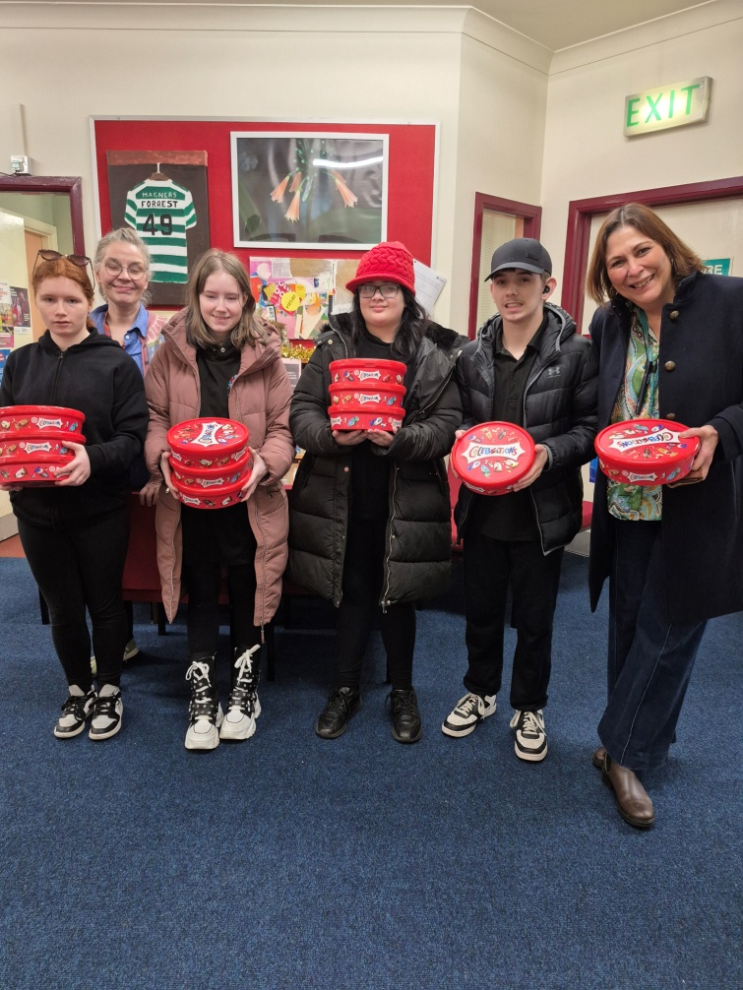
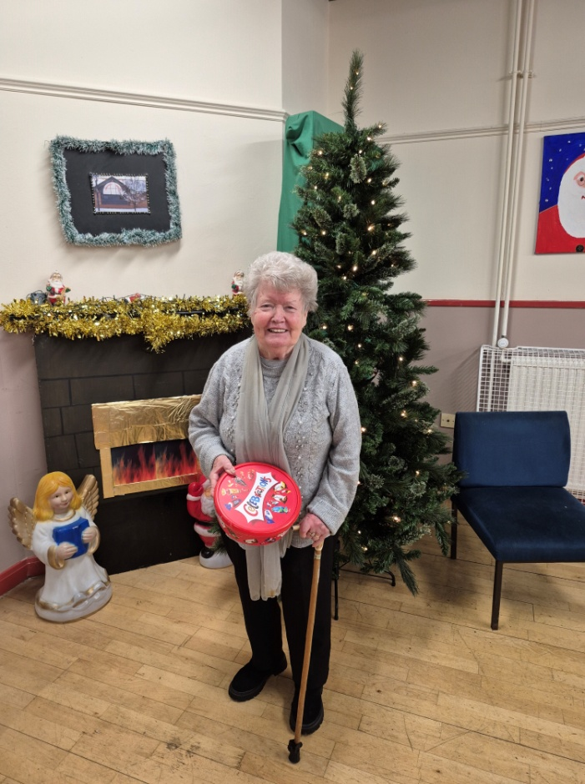
The group enables the students to meet the community and gives them the opportunity to learn skills that may enable them in the future to gain employment in the Hospitality industry when they leave school as being part of the group builds their confidence in meeting new people on a regular basis. It is so heart-warming to see the student’s blossom, gain in confidence and it makes the group worthwhile having.
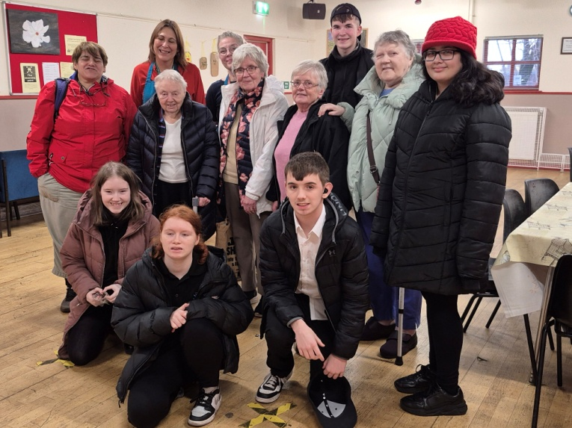
The members of the community just love popping in for some good wholesome food and chatting with the students and also others in the community they live in.

Job Club

The Job Club which was in partnership with the Govanhill Community Development Trust (GCDT) took a bit of time to getting a regular footfall and once it managed to establish itself with people coming through the doors looking for support into the employment market by getting support with CVs, opportunities for volunteering and also courses to improve their skill set. Sadly they had a staff member who went off sick and due to this they took the decision that it wasn’t safe for one member of staff to take the Job Club and it has been out on hold for the time being. This is sad as it had just built itself up into being active for members of the community and hopefully they are able to resume the service in the coming months.


Language Class
The Language Class continues to meet at the Centre (Monday – Thursday at 4.30pm-6.30pm) .
The group enables children and young people to learn Arabic enabling them to read the Koran and keeping their family cultural background.


Positive Action in Housing
Positive Action provides much needed support to the Romanian part of our community who are marginalised. The support enables them to have equal access to services which can assist with various issues such as housing, Residency etc.
Audit

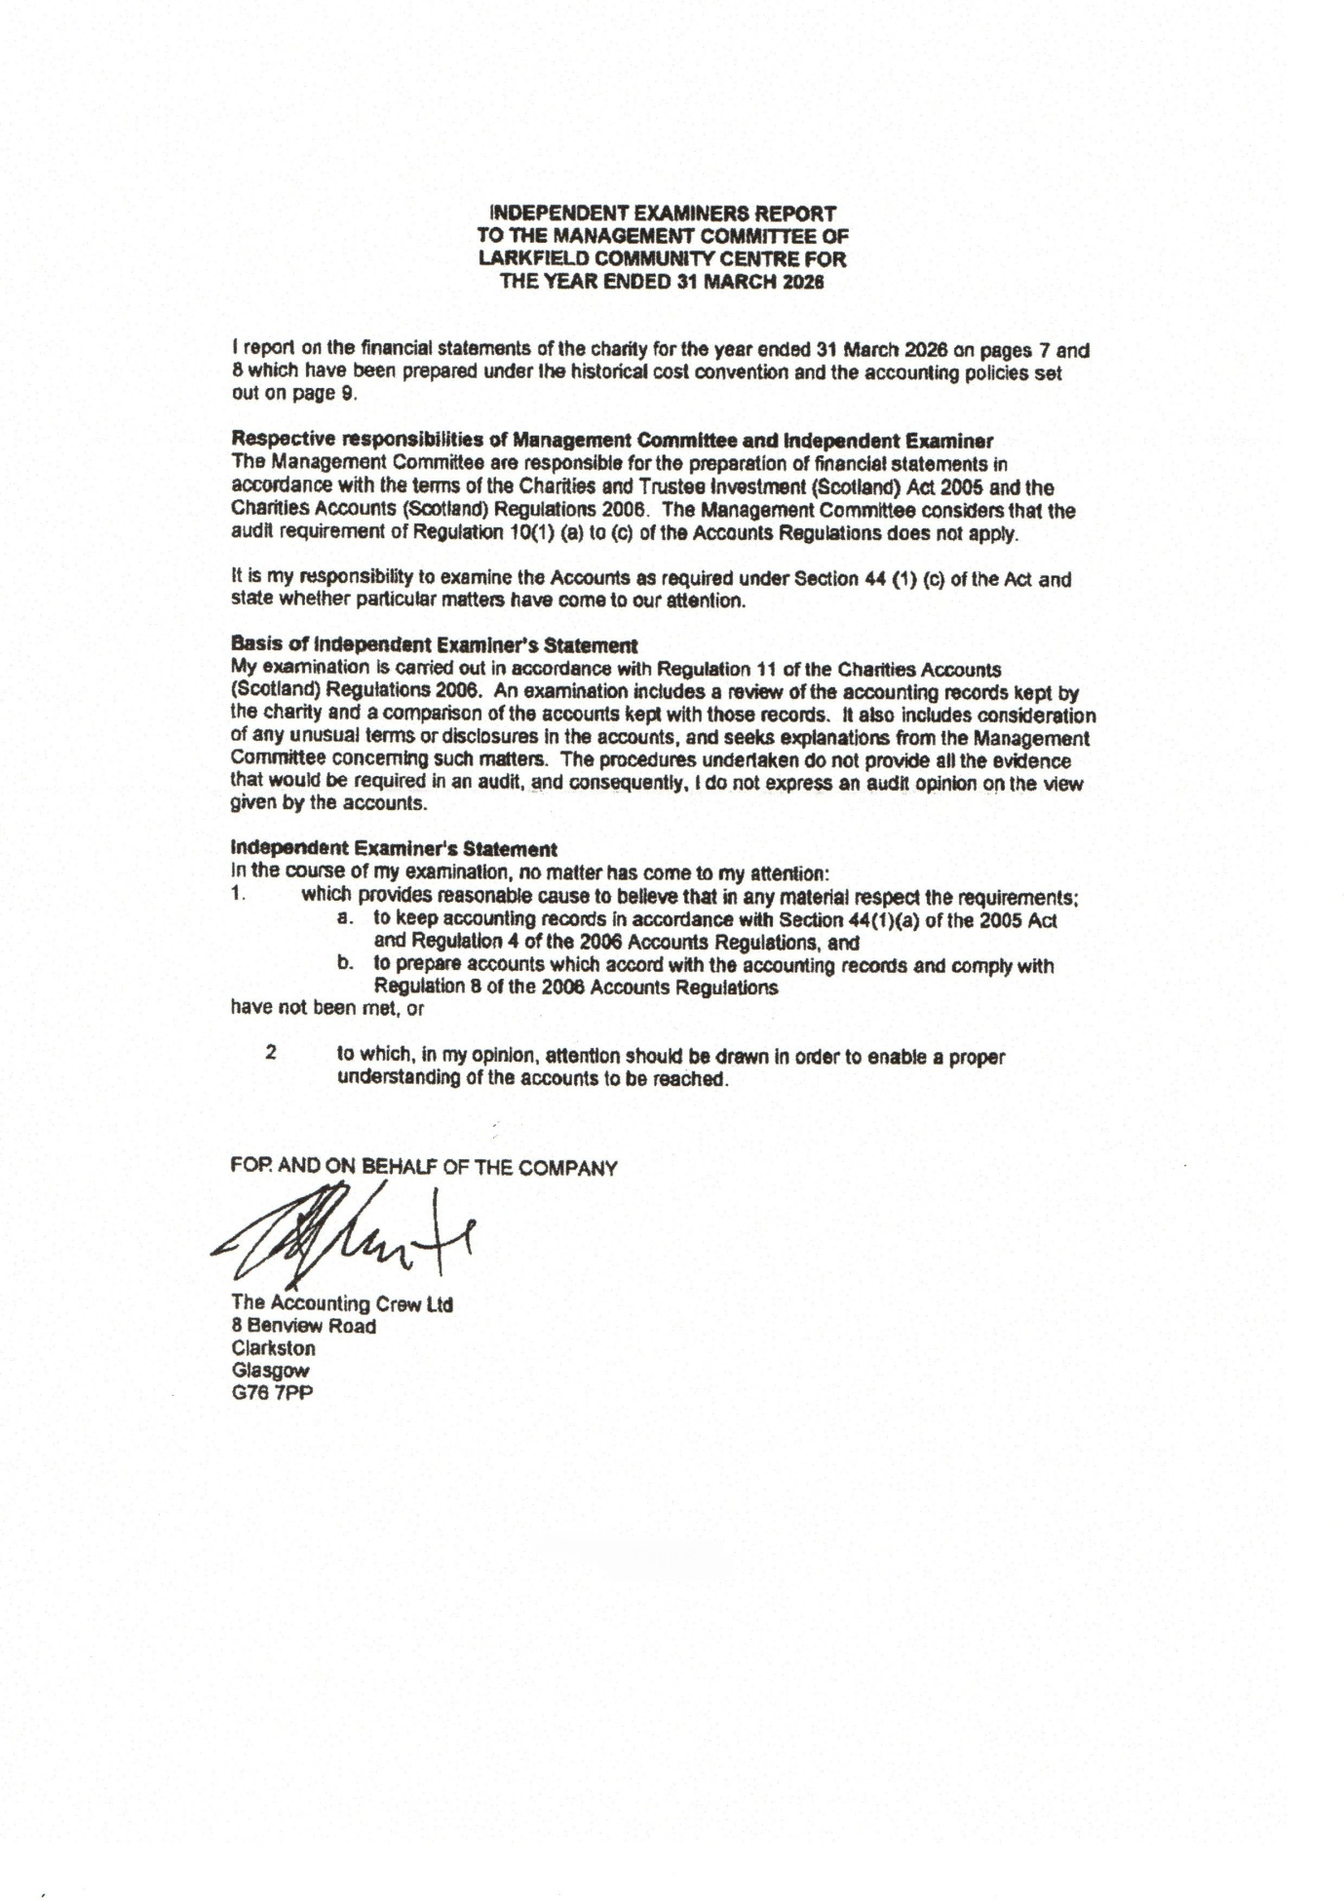

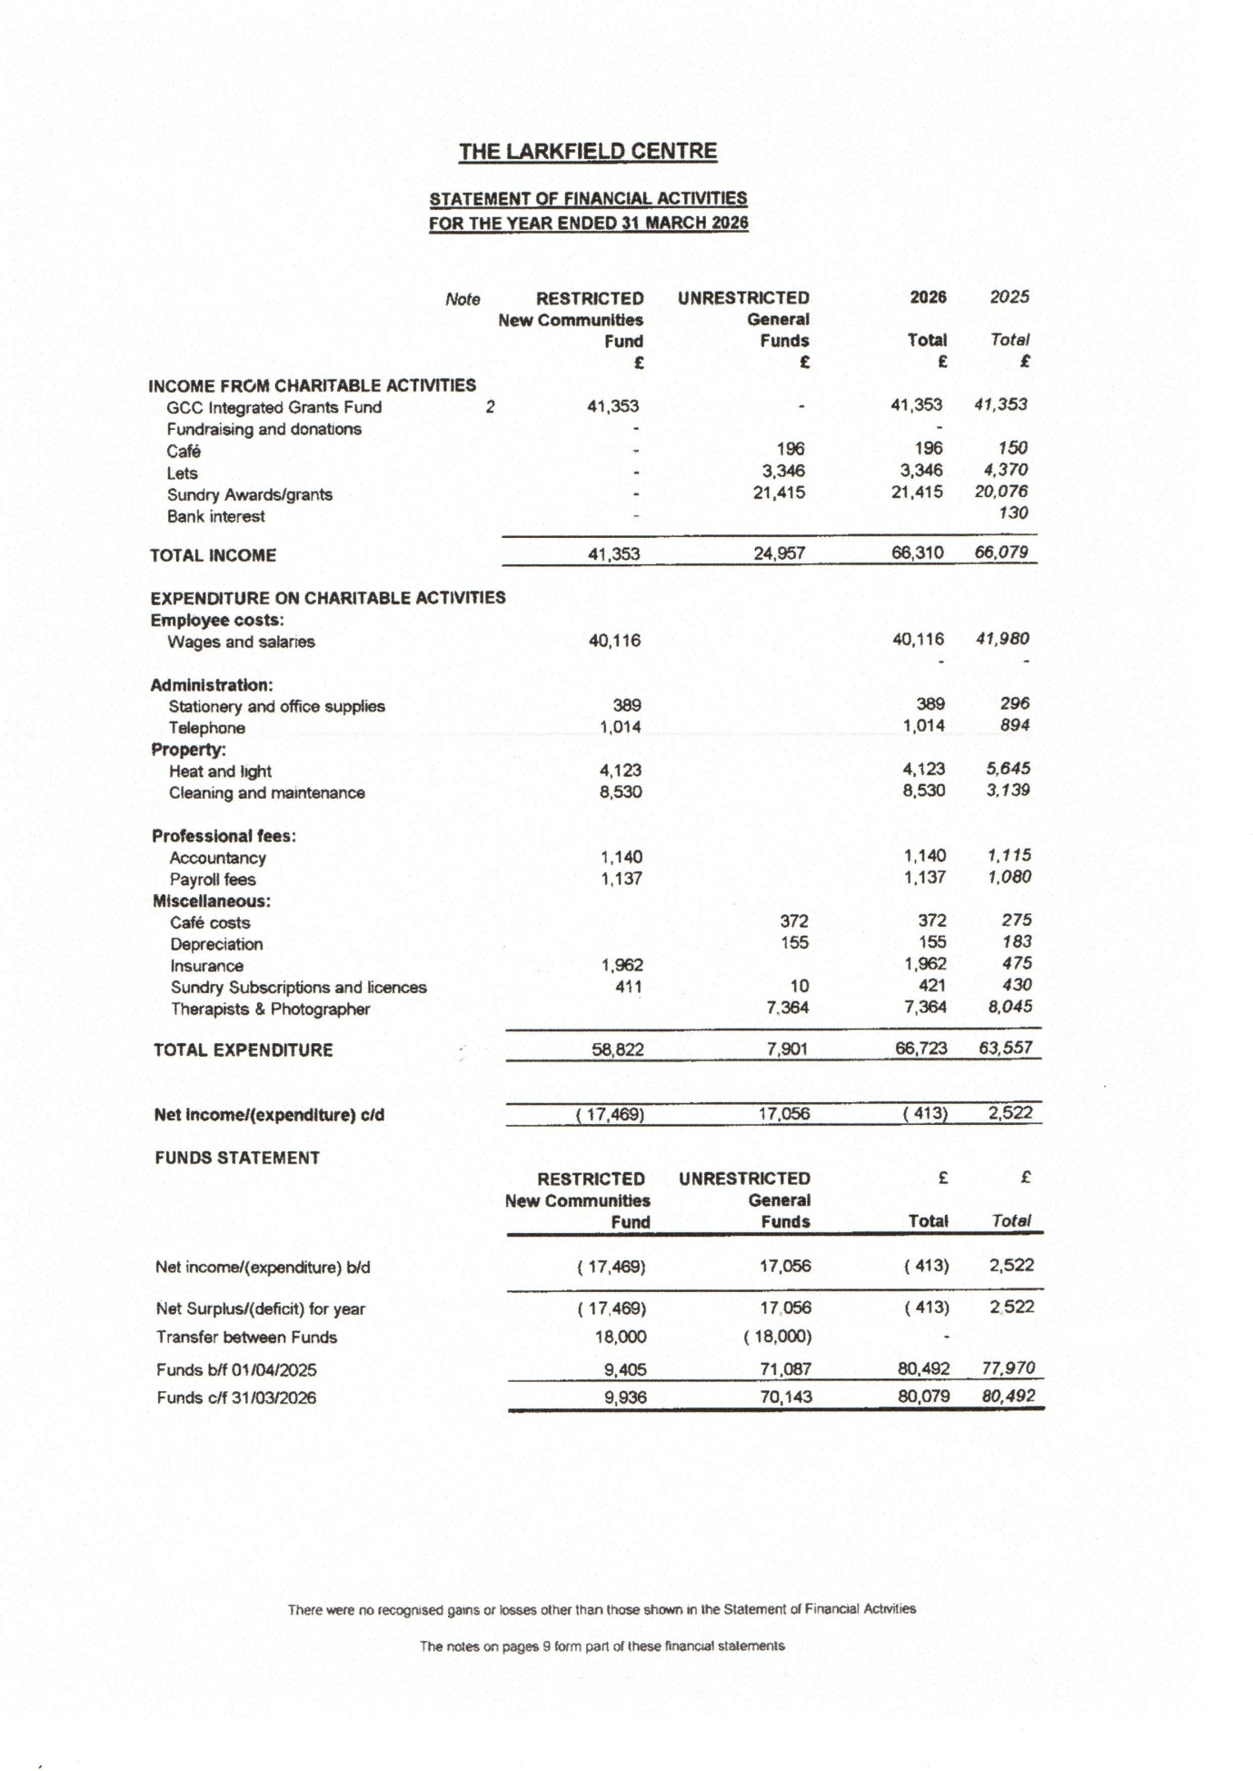

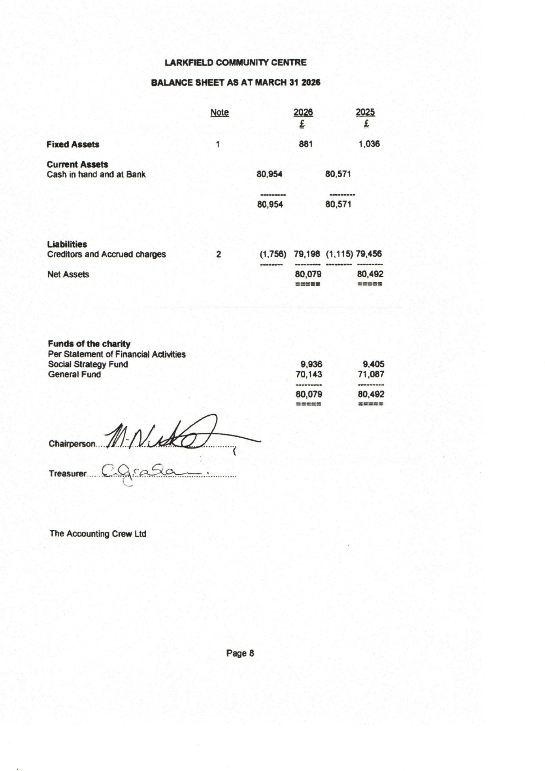


Grooves in the Dark
Groves in the Dark continue to meet at the centre on a Wednesday evening. It has grown in numbers over the last year and many say it helps them exercise without knowing they are doing it. The group members always go home with smiles as they have enjoyed it so much.

Richmond Fellowship
The Richmond Fellowship continue to meet at the centre once per month providing various things for the local residents that they support for e.g. Arts/Crafts and Karaoke. They also hold seasonal events for Easter, Halloween and also Christmas. The residents seem to love the events too, which makes them worth holding.

Carrgomm
Carrgomm continue to meet at the centre on a weekly basis providing various things for the local residents that they support for e.g. Arts/Crafts, games, bingo. Those they support seem to love the group and its activities and always leave with smiles.

Youth Club
The youth club started off the year with us then sadly it stopped for internal reasons. But they have been in contact with us recently to see if they could re-start it and we are waiting on them confirming if the times we had available were of use to them.
Glasgow Chess League

The Glasgow Chess League continues to meet bi-monthly at the centre as the accommodation meets the needs of their League members. They have been accessing the centre for several years mow and we look forward to continue to help them deliver for Glasgow in the coming year.

Glasgow Deaf Athletic Football Club
The Glasgow Deaf Athletic Football continued to access the centre for their Annual General Meetings, and on occasions they will hold a club meeting as the centre is in a good location for their membership.
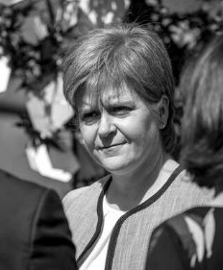
Local Elected Members
Local MSP Nicola Sturgeon held her monthly surgery on the 2nd Friday of each Month from 11am – 12noon at the centre and as she has since left her post as our local MSP we would like to wish her well in the future.

Local MP John Grady continues to hold his monthly surgery at the centre from 10am – 12noon. Please remember to book an appointment on 0141-737-1115 as they will let you know the date and the day for the surgery.
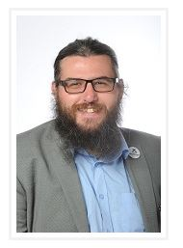
Local Elected Members Continued

Local Glasgow City Councillor Alexander Belic also
continues to hold his monthly surgery on the 4th Friday
of each month 9.30am-11am.
Telephone No: 0141-287-4610

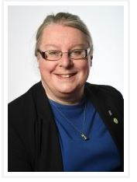

Local Glasgow City Councillor Elaine Gallagher
Telephone No: 0141-287-4466



Local Glasgow City Councillor Mhairi Hunter
Telephone No: 0141-287-7034


Local Glasgow City Councillor Soryia Siddique
Telephone Number: 0141-287-5625
Christmas Events
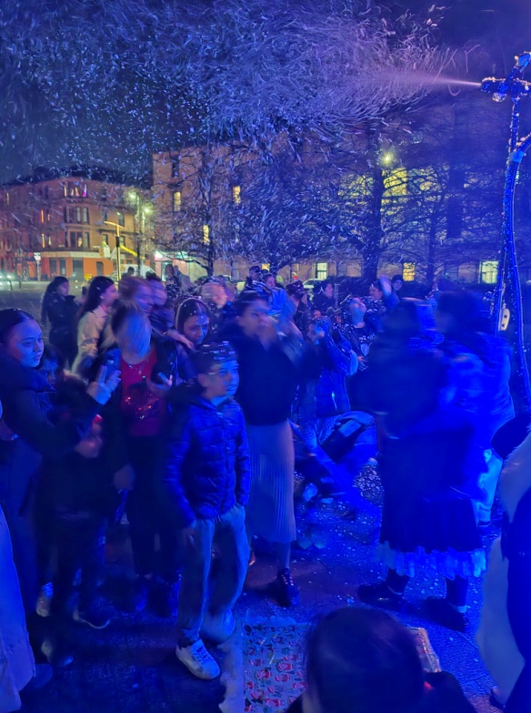
Christmas Lights Switch-On
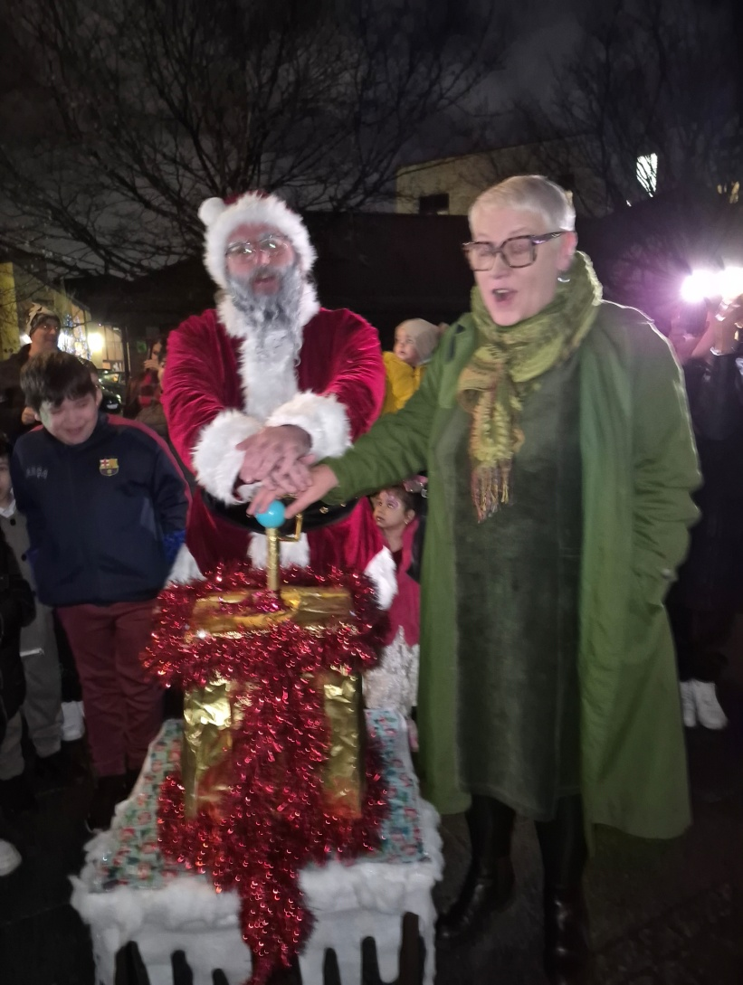
Due to the centre being short staffed due to ill health they decided to combine the Christmas Lights Switch-on and also the Santa’s Grotto into the one event. Which went really well and everyone enjoyed themselves and it was really lovely to see the smiles on the children’s faces but also of the adults too. The event was free and the children were given a selection box from Santa. A great night was had by all. Below are some pictures of the Event.



Christmas Events Continued
Christmas Lights Switch-on Continued
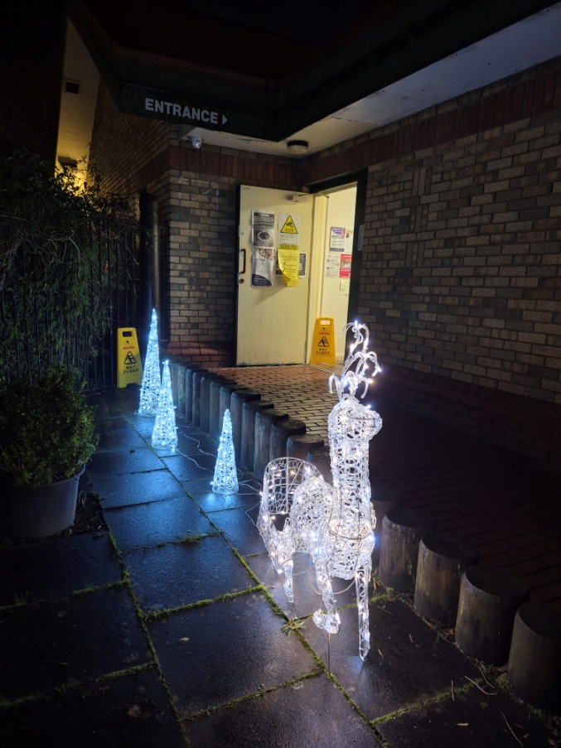
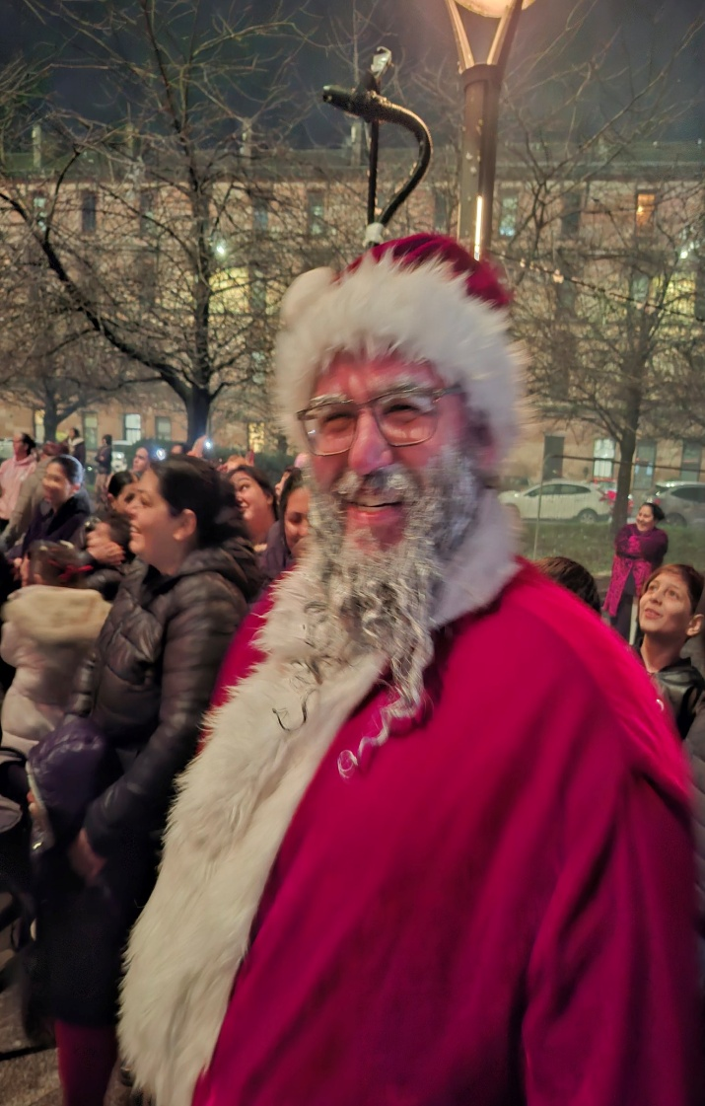

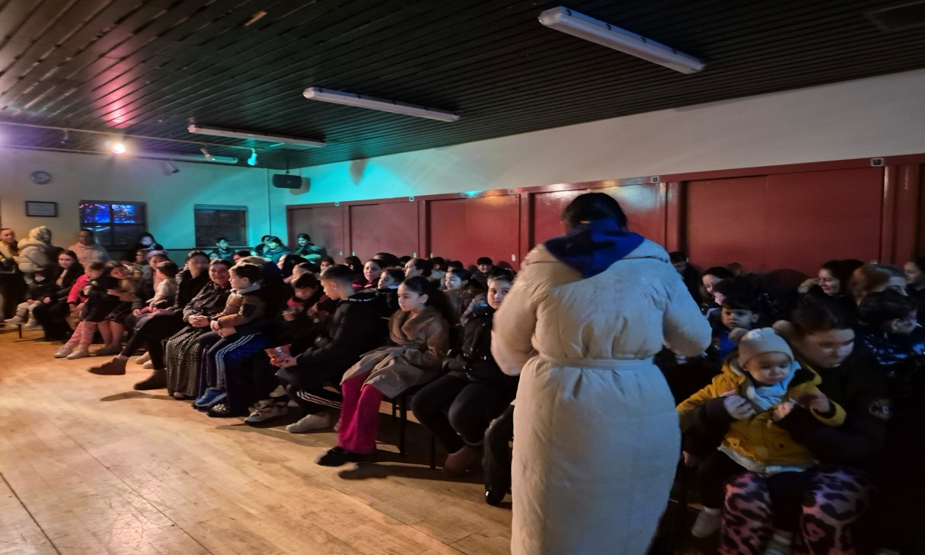

Christmas Events Continued
Christmas Lights Switch-on Continued
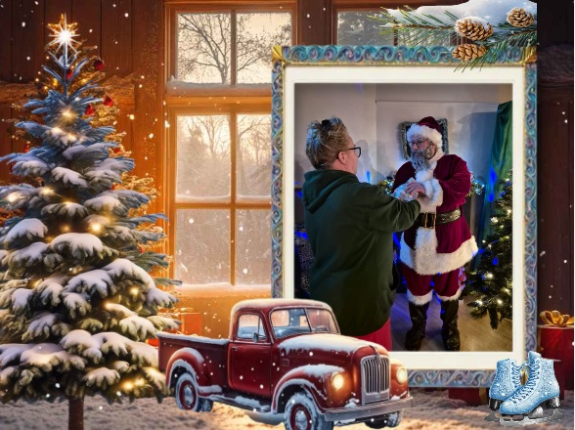



Audit



Glasgow City Council
Glasgow Communities Fund


The Weir Charitable Trust


The Robertson Trust

The National Lottery Community Fund Scotland

The Andrew and Mary Little Charitable Trust

