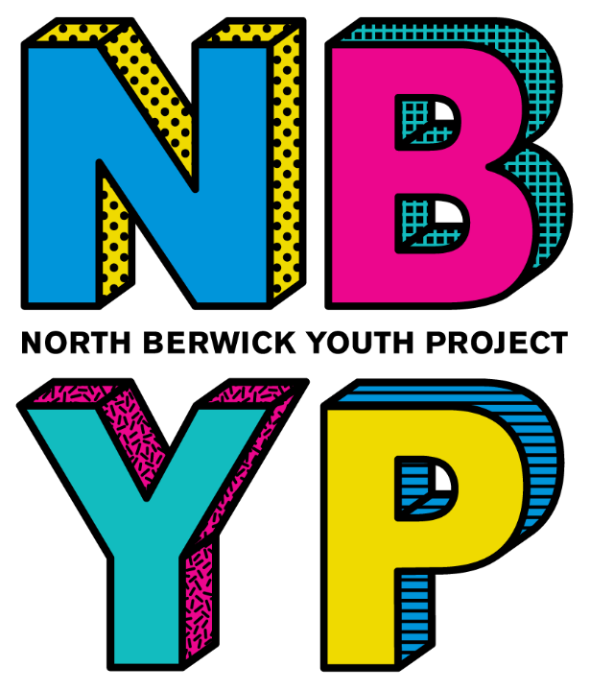

Annual Report
2024 – 2025





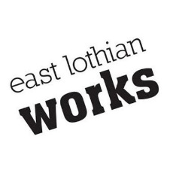
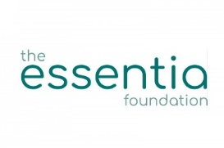

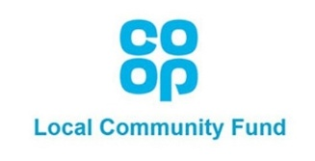


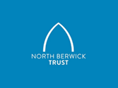




HIGHLIGHTS

  - We continued respite residentials and days as part of the Better Breaks programme
  - 16 families accessed the bursary scheme (Funded by the North Berwick Coastal Area Partnership) and Cash For Kids fund to support financial difficulties in paying for holiday provision
  - Holiday Hunger Fund (East Lothian Council) allowed us to provide free lunches across all holiday activities
  - Worked with 18 young people on employability programmes
  - 1 Youth Worker gained their Professional Development Awards in Youth Work
  - Co-delivered Raising Teens with Confidence course to 9 parents/guardians

IMPACT
The following statistics help us to measure the impact of the work that we do and to create an overview of all work done and the amount of young people engaging.
Including Cool, Calm and Connected, Transition work and other ad hoc school work we worked with 361 young people, 60 more than the previous year.
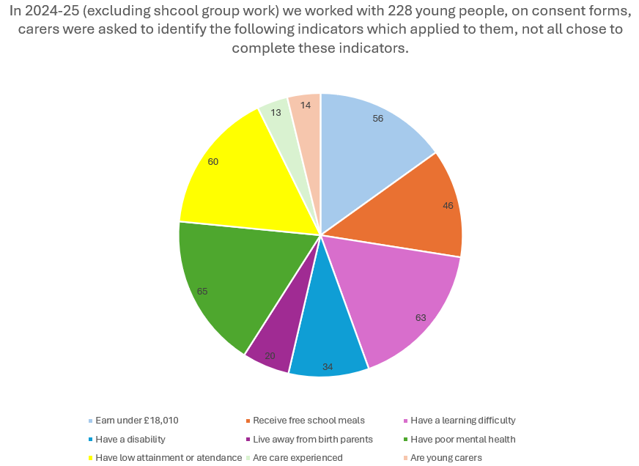
56% are from low income households​, 46% receive free school meals​, 63% have a learning disability​, 34% have a disability​, 20% live away from birth parents​, 65% have poor mental health, 60% have low attainment or attendance​, 13% are care experienced​ and 14% are young carers.

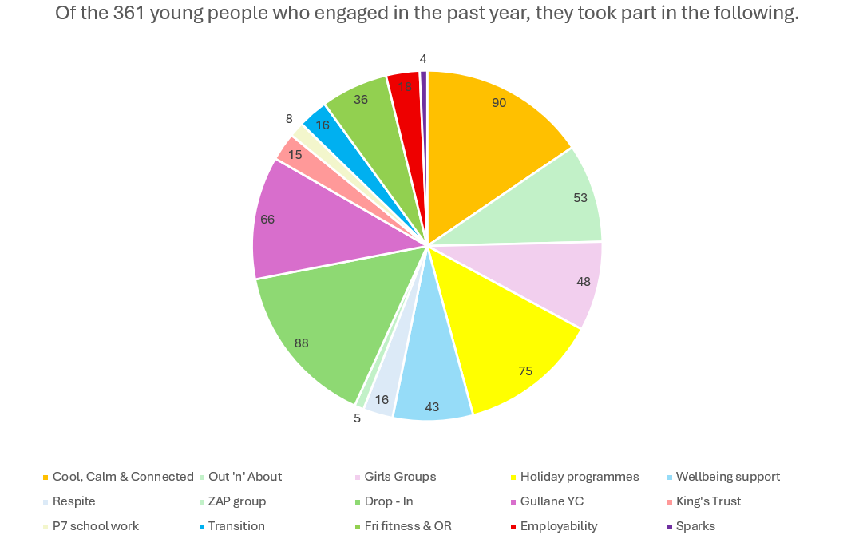
Cool, Calm and Connected – 90, Out’n’About – 53, Girls Groups – 48, Holiday Programmes – 75, Wellbeing support – 43, Respite support – 16, ZAP group – 5, Drop-In – 88, Gullane – 66, Kings Trust – 15, P7 school work – 8, Transition work – 16, Fitness and Outreach – 36, Employability -18 and Sparks group – 4.

PARTNERSHIP WORK
NORTH BERWICK HIGH SCHOOL
Cool, Calm and Connected
This year, we successfully delivered Cool, Calm and Connected to three S1 classes. A total of 90 young people completed the course. At the end of the programme, all young people were asked to provide feedback, helping us evaluate the impact of the sessions and identify areas for improvement.
“I've enjoyed learning about who I can go to when I am feeling down and learning more about empathy.”
“I really like that the activities were interactive and were focused on mental health and how our teenage brains work. You guys were really kind and positive, there is nothing to improve! Thank you for teaching me”
- Young people, S1

Feedback also highlighted how much young people value meeting youth workers and the role of youth workers in delivering these sessions, underlining the importance of trusted relationships in supporting young people's mental health.
‘Cool, Calm and Connected was a great addition for the S1 PSE programme. The staff who delivered the sessions were fantastic and really went out of their way to get to know the individual pupils in the class. The subject content was appropriate, relevant and used a variety of learning tasks, meaning that the pupils were engaged and on task throughout. The S1s responded well to the subject matter and left with lessons around how to view their own thinking and what factors can lead to their reactions in situations. A valuable resource that was well received by North Berwick Pupils.’ – Liam Porteous, NBHS Guidance

Transition
This year we supported sixteen P7 pupils with their transition to NBHS. The young people were identified as benefitting from this additional support by their primary teachers. Youth workers supported High School staff in this additional transition support. The Specialist Youth Worker also organised additional visits for a young person that they had been working with for a year.
The transition supports aim to give young people the opportunity to feel more accustomed to High School surroundings, share their worries and thoughts around moving into secondary school, reducing stress and enabling them a smoother transition and less worrisome first few weeks in their new environments.
“My son has been meeting with Mikey on a weekly basis for the entire school year and has built up a trusted relationship with him. We were really worried about our son making the transition from P7 to High School and it was such a relief when Mikey helped set up a couple of extra visits out with school hours. Mikey and North Berwick Youth Project have helped so much with their continued and valued support to help with my son’s transition to High School and we don’t know what we would have done without them.” – Parent

Kings Trust Achieve Award
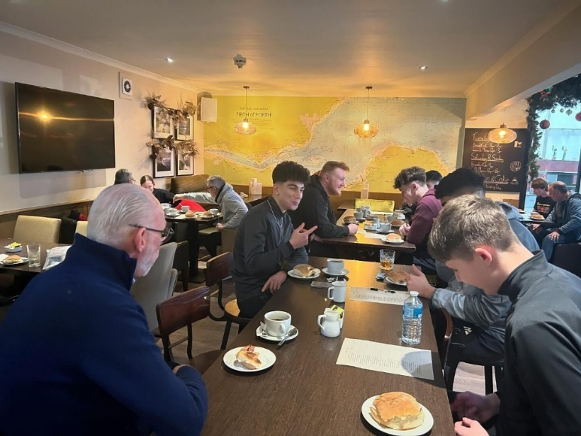
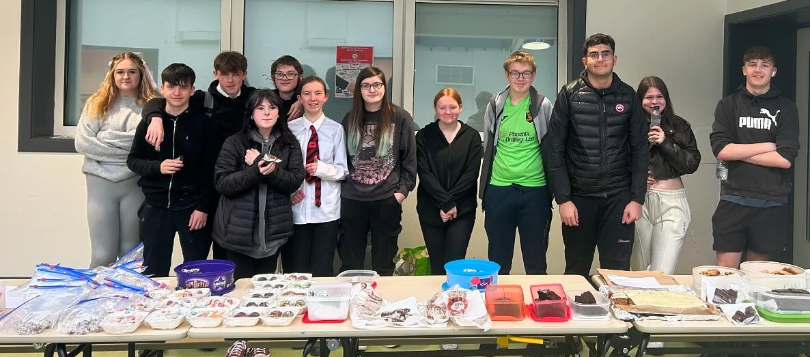
This year we delivered the King’s Trust Achieve Award (previously known as Princes Trust Achieve) to a group of 15 senior students, delivered across four periods each week. The course continues as part of the curriculum and would not be possible without our support as the school do not have capacity to deliver it solely. The students successfully completed units in Community Impact, Physical Activity and Enterprise gaining SCQF accredited awards.
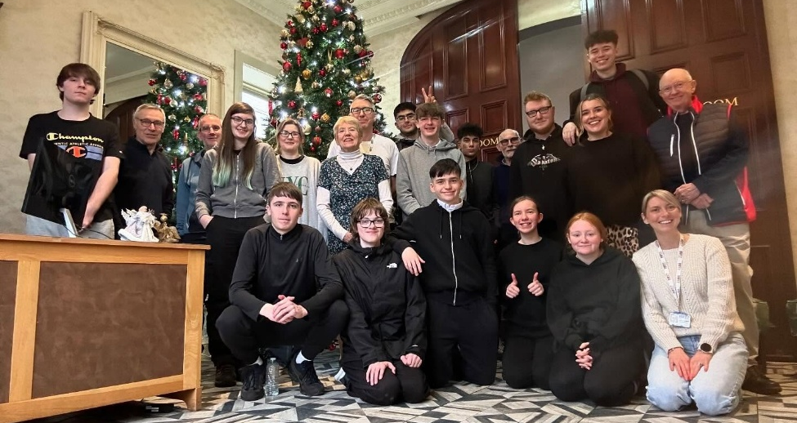
As part of the Enterprise unit, the class planned and hosted a bake sale in the school canteen during break time. They took full responsibility for marketing the event, preparing the home baking, and running the stall. The event was a great success and raised £229. The group chose to use the money they raised to give back to their community. For their Community Impact unit they organised a bacon roll and coffee morning at the Nether Abbey Hotel, inviting people from their community including elderly community members, teachers, and family members, who they felt would benefit from social connection and a welcoming community space. The event was a huge success, with attendees providing very positive feedback. A huge thank you to the Nether Abbey for all their kindness and support as they gave the bacon rolls and coffee’s for free, meaning we can organise yet another community event with the funds raised at the bake sale.
As part of their Physical Activity unit, the young people chose to research and plan a trip to RYZE trampoline park. In the lead up to the trip, they learned about the importance of staying active and how physical activity supports both physical and mental wellbeing. The trip was a great success. All the young people had a brilliant time, putting their learning into action in a fun and engaging way.
“NBYP project are a valuable partner for the school in their delivery of the King's Trust. They provide regular, structured, supportive and responsive learning for a wide variety of young people with many experiencing barriers to their learning and challenges socially. The group this year engaged fantastically with the sessions, gaining confidence in themselves and in their place in the community. Learners have just received their certificates upon completing the award and all showed great sense of pride of achievement.” - James Mumford, Equity Principal Teacher, NBHS

“Princes Trust was good because it was a different style of learning. It wasn’t just your average sit in a class and do work. You could have a good time whilst doing your work and it really helped me with making stronger relationships with people I wouldn't normally meet.” - Young person, aged 16.

“I really enjoyed Princes Trust because it taught me new social skills and other types of skills. These have helped me to get into college and build my CV” - Young person, aged 16.

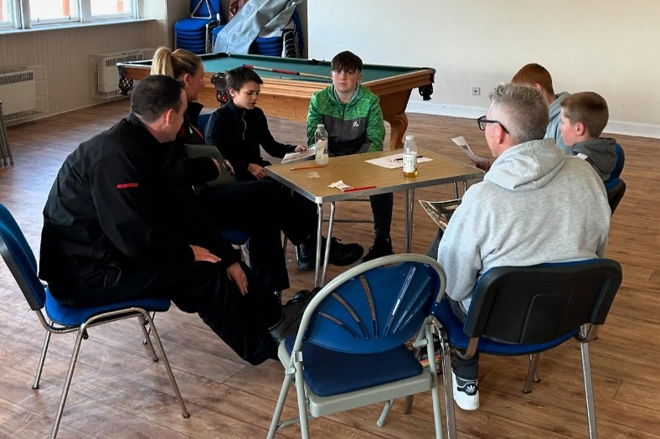
Sparks Group
It was identified that a targeted group was needed for young people engaging in risky and anti-social behaviours. We worked with NBHS to identify young people who would benefit. 4 young people engaged.
The Specialist Youth Worker developed a programme of activities including climbing with Venturing Out, sessions with the Fire and Rescue Service, MYPAS, Police, health and wellbeing sessions, knife crime and antisocial behaviour. The Specialist Youth worker also supported one young person through their Gym Induction at the local sports centre and supported them for a further six weeks at the gym. The sessions allowed the young people an insight into how anti-social behaviours can impact services, and their community and engaged in positive risk taking to encourage them to participate in new and challenging activities which allowed them to channel their energy into positive activities and as a result, behaviours, choices and engagement all improved.
The young people took a lot from their sessions with the different organisations they worked with, learning how negative choices can have a major impact on their lives. They engaged in each session, asking pertinent questions and gained valuable insights into developing as a young person and how the decisions they make can play a vital role in the community.
“There is no doubt that there has been a positive impact on the work NBYP has accomplished with the Sparks Group during session 24/25. The creative mix of support and activities offered challenged and enthused the group. The result meant that the group were engaged and thoroughly enjoyed their time during the sessions.
The young people have maintained or indeed increased their attendance in school, some of the young people are also on target to attain at a level appropriate during this academic year due to them realising how important their learning is and how it can shape their future. Our young people are also aware and informed as to how to make good positive choices in school and the community.
The power of community links cannot be underestimated in supporting our young people as they navigate the teenage years in terms of keeping themself safe and in doing so achieving success, which in turn supports their self-esteem and confidence.” - Patricia Shepherd, Principal Teacher – Pupil Support

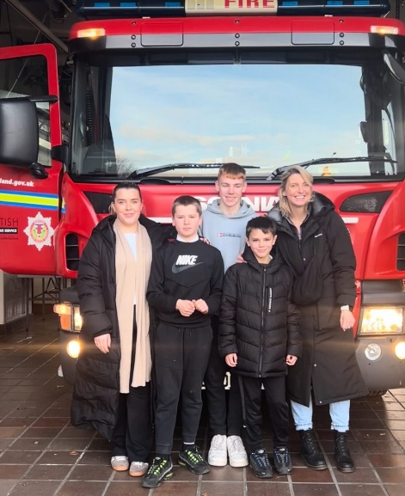
CLUSTER PRIMARY SCHOOL WORK
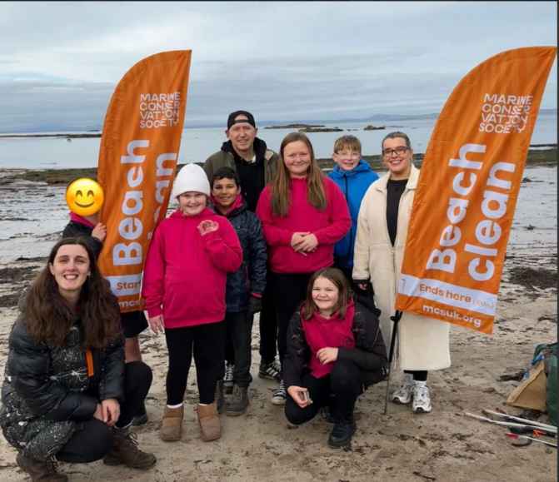
Pictured : P7 Out’n’About school group. The group worked with the Marine Conservation Society to complete a local beach clean.
P7 Out’n’About Group
Over the course of 10 weeks, youth workers engaged a group of 8 Primary 7 pupils in outdoor activities. Chosen by their teachers, the young people took part in sessions that included den building, scavenger hunts, and several sessions with the Scottish Seabird centre where they explored rock pools, the beach and used binoculars to spot animals. They also participated in a beach clean with the Marine Conservation Society and enjoyed a creative pebble painting session for the Remembrance display outside Abbey Church in North Berwick by the Bass Rock Community group. These experiences provided opportunities for the young people to connect with their local community and natural environment, while also developing new skills. They were able to strengthen their teamwork, built confidence, and form positive peer relationships in an outdoor setting. To celebrate their achievements, the group enjoyed a festive trip to Archerfield Walled Garden, where they enjoyed a hot chocolate and cake before going for a walk around the Fairy Trail.
“The work of the Youth Project was invaluable to our P7 cohort during the 2024-2025 school session. At the start of the year the teachers identified pupils who were struggling with self-confidence and social skills. On a weekly basis the Youth Project provided an opportunity for small groups to work on fun activities that developed their skills, which improving their integration and attention in their new classes.” – Clare Brodie, Law Primary

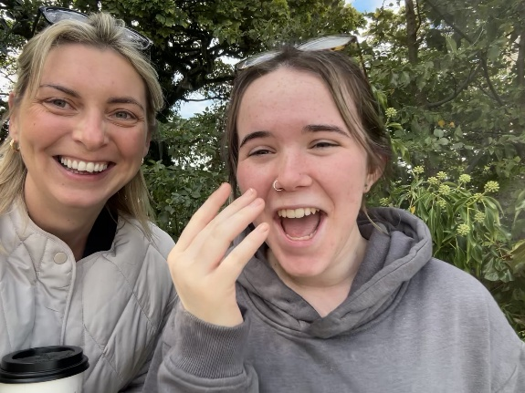
WELLBEING SUPPORTS
Our 1:1 and small group wellbeing work continues to be a huge success. This year 43 young people have engaged in wellbeing groups and/or 1:1 wellbeing support. Young people from North Berwick High School, Law, Dirleton, Gullane and Aberlady Primary schools all engaged. Young people are supported with issues affecting them and work towards SMART goals to help improve their mental health and wellbeing, in group work young people explore and learn tools to increase their resilience and coping skills which they practice and are able to implement in their daily lives, improving their understanding of their own mental health and wellbeing and how to increase it.
Referrals are welcomed from all schools in the cluster and all young people referred gain the opportunity to engage with a youth worker. A small percentage of referrals are re-referred if the early intervention support is not deemed as appropriate. We also accept referrals from other professionals, family and other trusted adults.

“I have been going on walks with Beth from the NBYP for about 2 years now, and after every walk I feel like a weight has been lifted off my shoulders. Not only is Beth someone I can talk to and trust with anything, she has been a friend when I haven’t had any. I enjoy being able to talk to her about anything and have a laugh taking stressful things off my mind” - Young person, aged 17

“The 1 to 1 and group support offered by Lauren and her team at NBYP is quite simply invaluable. So many of our most vulnerable young people rely heavily on the kindness, support, structure, and accountability that they offer through their programmes.
The Youth Project is so much more than just sanctuary….they inspire young people to do more and be more. They provide consistency, develop resilience and role model responsibility. Lauren and her team continue to work closely with us at school and are an integral part of what we offer and how we support our young people”.
- Euan Orr, Guidance Teacher

"Before the meetings with Mikey our young person had been struggling to leave the house at all and had no social contact with anyone else. Mikey managed to build up a good rapport with him and take him outdoors for walks. Mikey has engaged him and gently challenged him. This has increased our young person's confidence and self-esteem and has enabled him to try leaving the house on his own and talk to others. There is still a long way to go, but thanks to NBYP and Mikey we've seen a significant improvement, and we are really grateful for the input we've had."
- Parent

EMPLOYABILITY SUPPORT
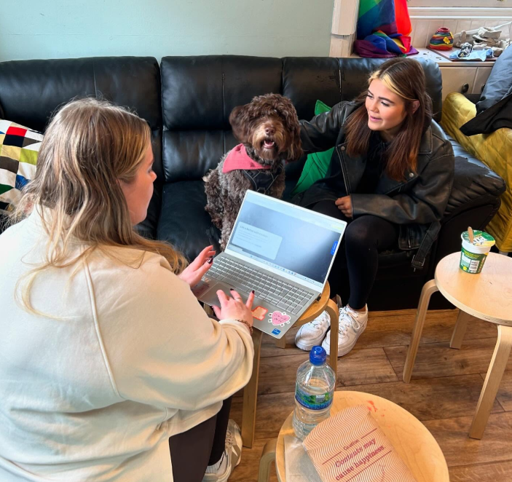
Funding from East Lothian Works enabled us to deliver several groups (lasting 10 weeks and 7 weeks) as well as 1:1 support for young people, all designed to remove barriers, build skills, and support them in progressing toward positive destinations such as employment, further education, or training. Emma, from Skills Development Scotland, joined the group to co-deliver sessions to explore young people’s next steps, options and how to work to reach their goals.
These tailored sessions provided support to help young people prepare for their next steps, and included:
- Building confidence and self-awareness
- Developing teamwork and communication skills
- Exploring interview techniques
- Creating a CV and cover letter
- Learning how to job search effectively
- Identifying the right next step – e.g. employment, further support, or college
- Support with completing college applications
- Gaining a better understanding of the workplace environment
In total, 18 young people engaged in employability support. Four have been supported into full, or part time employment, three have been supported into work experience. All have benefitted from group and / or 1:1 support.
“It was really good for me to get help from NBYP to think about what I was doing with myself after school, I'm not the most confident but feel like the employability group has helped me to build that and to know what I need to focus on”
- Young person, 16

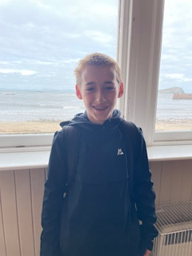
CASE STUDY
This young person has been receiving support from NBYP for the past three years. He was first referred as it was recognised as a positive addition to his school day which he can at times find incredibly challenging to navigate finding traditional classroom environments hard to manage as well as keeping his emotions in check would be hugely beneficial. The young person was first offered the opportunity of one-to-one wellbeing walks during the school day as well as attending Drop-In sessions and Boys Group, where he feels a real sense of belonging.
He also attended our holiday programmes which he really enjoyed and took a lot from. In all these sessions the young person worked closely with youth workers, especially the Specialist Youth Worker, building a trusted relationship working together on resilience, leadership and the importance of making positive decisions. He also attended our Mental health and wellbeing group, as well as getting involved with the Picnic In The Park event working with a local pizza business to create and sell pizzas at the event to raise money for North Berwick Youth Project.
This young person is a valued member of NBYP and Boys Group in particular, and has gone from strength to strength cementing friendships, which he had found tricky to maintain in the past, whilst also helping and guiding younger members of the group when needed. He is a caring, funny and confident young person who thrives when given opportunity to engage in varied and challenging activities and will continue being a valued young person at NBYP with supports continuing this year.

“M has been an active member of NBYP for three years now and it’s been a delight to see his confidence come on in leaps and bounds since then.
He has had a tricky start in life, which has contributed to him finding peer relations particularly hard. He has been a target for significant bullying in his school life and the combination of this has seriously affected his mental health, and in turn, his enjoyment of school, and what should be the most fun and easy years of his life.
His first experience with the youth project was on the recommendation from a boy in his class, to come to boys group. He returned to me happy and hopeful, after a healthy run around the woods, and team building activities with, at the time, one of his nemesis from school. Some clever one on one trust games and a zero tolerance for any bullying, meant a painful daily school situation for M became, what can now be called, a friendship. An excellent start to his journey with the Youth project.
He has enjoyed countless adventures, all at a very reasonable cost, with the activities put on during holidays. He excitedly looks forward to the programme going live.
He has cemented friendships that may have ordinarily been harder to navigate within the school environment and had support with ones that are trickier to deal with. Where once he would have avoided going somewhere where there may be some tricky social nuances, he happily attends the hope rooms, knowing that if things become too much, that he can look to the adults to help.
The structure, but also the space that allows them the freedom to be themselves, in an environment where the youth workers are experienced and gifted in providing a supportive and empathetic ear, has been life changing for M in lots of ways.
He is extremely open about his feelings and is more than capable of expressing himself, but when he has had difficult times, he has sought out someone from the team at the youth project, to share his troubles with. This speaks volumes.
His one on one walks, that were arranged with the school, were a lifeline for M when he started secondary. It was a very difficult transition and I know he highly valued that time both with his worker, and now with the group setting. It breaks up, what is a very long and challenging day within school, and provides excellent emotional support, that he is more than happy to tap into.
He has been able to have many adventures with his peers, where he can feel safe and understand that if there is any sign of bullying, he will be supported. Alongside that, the clear boundaries and confidence of the adults in charge, create a safe space that he can flourish in.
He has been given responsibility in multiple situations where the trust he has built with the workers, has allowed him to take pride in himself and his capabilities.
And he has fun! Lots of outside, inside, laughter, memories and fun!! Both M and I are extremely grateful for the support and opportunity to be able to access the youth project. It has been a huge part in supporting and shaping who he is growing into and it is a fabulous resource run by some beautiful people.
Thank you. L”- Parent

“Youth project has been very helpful for me to have fun with my friends outside of school. Youth project helps with team building friendships and much more, I would highly recommend youth project to any child. Beth, Lauren and Mikey make you feel very welcome and care for you.” - Young person

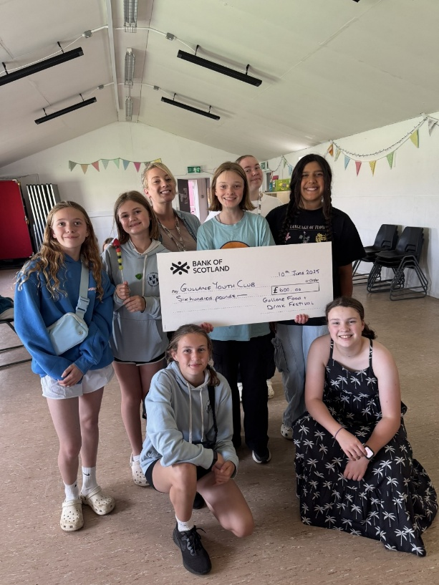
Gullane Youth Club
Gullane Youth Club (GYC) has been running for four years now and has grown significantly in a short space of time. We were fortunate to be able to respond to a need identified in the Gullane community for a dedicated youth space. Thanks to the support of local volunteers and the Gullane Village Association, the youth club was successfully launched and continues to thrive.
At the start of this year, we split our weekly sessions into two groups, one for P7s and another for young people in high school. On average, 35 young people attend weekly and over the course of the year 66 young people have engaged.
Each session is packed with a range of fun and engaging activities including arts and crafts, cooking, movie nights, and a GYC favourite - karaoke!
In June 2025 GYC received a generous donation of £600 from the Gullane Food and Drink Festival. This funding supported and continues to support a series of youth-led cooking sessions, where the young people planned and prepared a variety of dishes. They had so much fun getting creative in the kitchen and trying out new recipes. Some of the highlights included themed cooking sessions and plans are underway to continue the cookery throughout next year.

“I enjoy GYC because it is fun to go to if you can’t hang out with friends. I also love going to meet the staff and chat to them because they are lovely! I hope it keeps on going since most of the activities are excellent as well!!”
- Young person, aged 13
“GYC has been a fun and worthwhile experience, I’m so glad we have something like that in our community. I can’t wait to go back” – Young person, aged 12

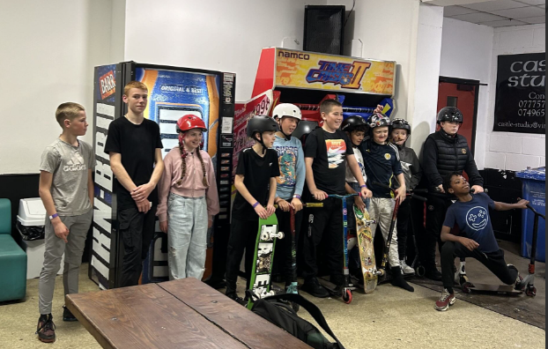
Holiday Programmes
This year, we delivered holiday programmes during October, February, Easter, and Summer, offering a wide range of activities for young people across the North Berwick Coastal area.
In total, we offered 444 spaces with 75 young people taking part. 16 bursary applications were submitted, ensuring that cost was not a barrier for young people to participate. Funding from Cash for Kids enabled us to offer 6 spaces on every day of the summer programme and funding from Holiday Hunger (East Lothian Council) allowed us to provide lunches at every session.
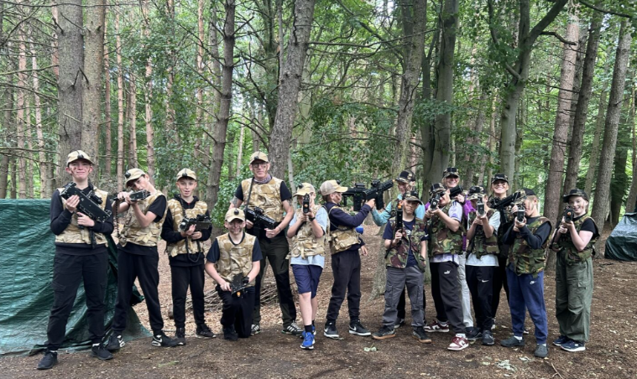
Young people took part in a variety of engaging, age-appropriate activities that supported different abilities and interests. These programmes play a vital role in helping young people stay connected, active, and supported during the school holidays, many young people may be at risk of isolation or disengagement during these times.
Young people shared that the holiday programmes helped build their confidence ahead of transitioning to High school, especially by giving them the chance to meet older pupils and form new friendships. The holiday programmes also offer valuable respite for young carers and families supporting children with additional needs.

Over the year, holiday highlights have included, Skateboarding at Unit 23, Blair Drummond Safari Park, Beach days with BBQs and slip 'n' slides , Shopping trips into Edinburgh, Edinburgh Dungeons, Arts & Crafts and Baking days at the Youth Project, Cinema trips, Laser tag at Edinburgh Combat Challenge, Rock climbing at Ratho and so much more!
“Thank you for giving me the opportunity to take part in the activities during the summer holidays. I had loads of fun and got out more and got out of my comfort zone. If it weren’t for you guys I would have just stayed inside and not done much. This summer holidays was the best summer ever. Thank you very much” - Young person, aged 16
“I really enjoyed being with different groups on each trip. The youth workers are good fun but also caring” - Young person, aged 12
“It helped financially and made my daughter very happy. She did things she ordinarily wouldn't have. I definitely see a difference in her confidence and is more open to trying new things. She also gained access to new people and was able to enjoy new friendships. Having the holiday broken up by planned activities helped us all in different ways.” - Parent
“It was good to give him a gentle push to go do something out of the house and interact with new friends” – Parent

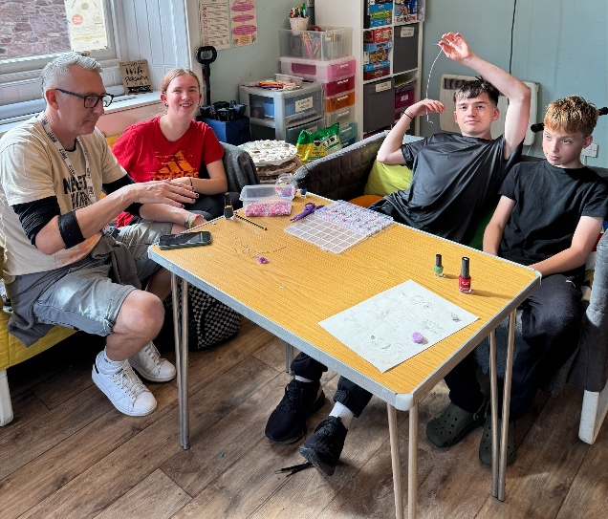
Drop-In
Our Friday Drop-In is the most popular group we run, with an average of 22 young people attending each week. After a busy school week, young people enjoy coming down to the youth project to relax with friends, take part in activities like baking, pool, football, and volleyball, and engage with youth workers in a welcoming and informal setting. On warmer days, we’ve made the most of the good weather by heading up to the lodge or down to the beach for games and BBQs, the young people have really enjoyed getting outside. Drop-In is a vital part of our service, offering youth workers the chance to connect with a wide range of young people they might not normally engage with through other groups. This setting allows us to build new relationships, identify emerging needs, and offer targeted support outside of the Drop-In itself.
“I enjoy drop in because it’s a fun place to meet new people and I feel like there is always an opportunity to have new experiences!!” - Young person, 15

“I love Friday Drop-in because it’s a great place to make friends and it’s such a great hang out spot. I would recommend lots of people to go there. Thank you for the amazing year I’ve had going to drop-in!” - Young person, aged 13

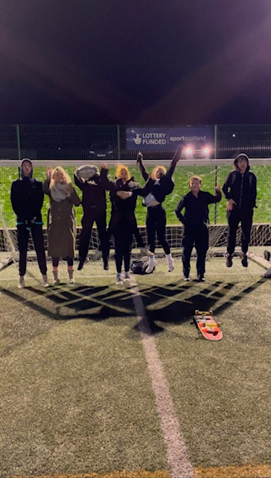
Friday Night Sports Outreach
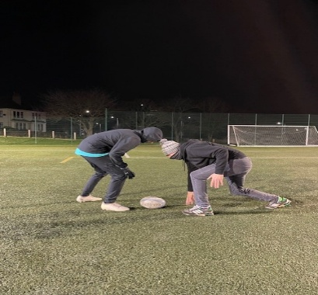
Outreach runs from 7-9pm each Friday evening. It was identified that free sports sessions would be a good way to engage with young people in the local area. These sessions started in December 2024 with between 14 and 26 young people attending weekly sessions such as Basketball, Football, Touch Rugby (where a young person led the session) Rounders, Badminton and Short Tennis. We work to use these sessions as a pathway for young people to continue into a club setting, although this is not the sole purpose, many young people have benefitted from building relationships with staff who have encouraged and supported them into the other weekly activities and holiday programmes. The youth workers work with young people to further develop and identify need. One young person was supported by the Specialist Youth Worker and NBFC to get involved in twice weekly training sessions and weekend matches, which the young person said they wouldn't have otherwise done.

In June 2025 North Berwick Coastal Area Partnership granted funding to continue running free Friday night sports sessions for our young people for the next year.

Our Specialist Youth Worker attends regular Sports Hub meetings to strengthen links with local sports clubs and the opportunities they can provide for young people.

“Friday Night Sports was good cause it got me out the house, meeting new people and kept me fit. It was good seeing the young ones from the community getting together and getting along” - Young volunteer, aged 16

ZAP Group
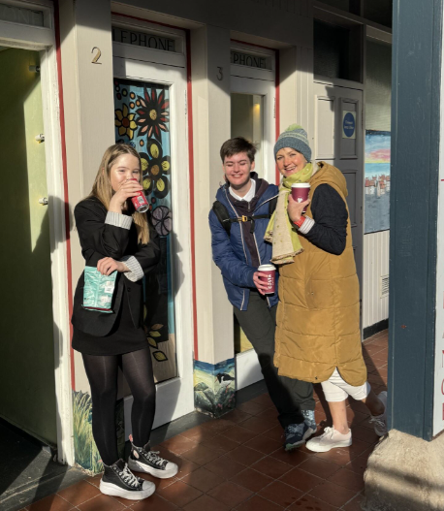
Pictured : Some very proud ZAP members and Youth Worker standing very proud by their Window Wanderland display.
Our weekly Additional Support Needs group, ZAP, continues to run every Thursday after school during term time. The group currently has five members, aged between 11 and 16. At the start of each term, the young people are encouraged to share their ideas and choose the activities they’d like to take part in, this allows the group to be youth led and gives the young people a sense of belonging and responsibility. This term, the group has enjoyed a variety of activities including clay projects, pumpkin carving at Halloween, trips to Costa and Alandas for ice cream, manhunt in the lodge, sandcastle competitions, and much more! A highlight was when Julie from Rock and Bird joined ZAP for a creative session to design a Window Wanderland display. The final piece was proudly displayed on the High Street in the High Street Kiosk/ex telephone boxes. One session, the group took a walk to see the final piece, they were all so happy to see their work displayed in the community. The group has also enjoyed exciting outings to RYZE trampoline park and East Links Family Park.
“ZAP is fun because we get to choose what we do. If we don’t like an activity we don’t need to do it. I have liked going on the trips this year, especially RYZE because I had never been before!”. - Young person, aged 14

“Thursday’s are my sons favourite day. I believe going to the ZAP group is one of the supports that helps him through his school days, which can be challenging for him.” - Parent

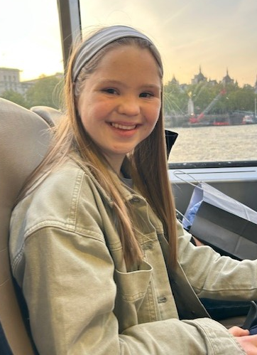
CASE STUDY
A 16 year old young person has been attending ZAP since January 2023, after hearing about the group through the Pupil Support Base at North Berwick High School. Although she initially felt a little nervous about joining a new group, she quickly settled in and began to thrive.
She is a fun, caring and bubbly young person with a passion for singing, karaoke, dancing, and musicals. Her vibrant personality has been a wonderful addition to the group, there is never a dull moment when she’s around! She has formed strong, positive relationships with both her peers and the youth workers. When a younger S1 member joined the group, she immediately welcomed him and showed a caring, supportive side. Her kindness helped him feel at ease and demonstrated empathy and also leadership.
ZAP has given her a real sense of belonging and connection to her community. It has supported her in building new relationships with peers and youth workers, growing in social confidence, and pushing herself to try new things in a safe, supportive environment.

“My daughter has gained so much from attending ZAP, it has truly made a difference in her life. It’s given her a safe, supportive environment where she can be herself, build confidence, and make genuine friendships.
The staff at ZAP are incredible — patient, caring, and truly understanding of each young person’s needs. Their dedication and warmth have helped my daughter feel valued and accepted, and it’s been amazing to see her happiness and sense of belonging flourish.” - Parent

“ZAP is the best place I ever went and l love it there.” - Young Person

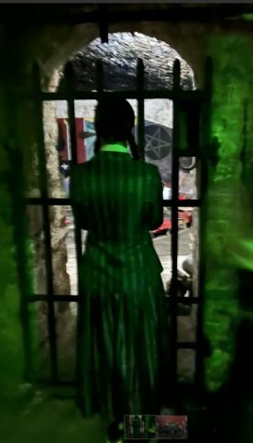
HALLOWEEN - Trip to Edinburgh Vaults and Graveyard Tour
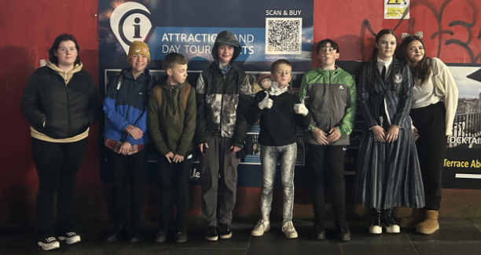
Staff identified that young people would benefit from engaging in an activity on Halloween. Some of the young people may have otherwise been isolated, engaged in anti-social behaviours or some benefitted from just being able to spend time with friends. We arranged a trip to the Edinburgh underground Vaults and Greyfriars Graveyard with the Auld Reekie tours. 8 young people enjoyed a fright night all round and it was enjoyed by everyone.
“W had the absolute best time this eve, he told us so much about it with was lovely because I normally get the teen 'yeah fine’. Thank you so much for taking your time to show our young people an amazing Halloween ❤️❤️
feel free to share, he genuinely had so much to report " -Parent
“Thanks so much for bringing us. I am having the best night ever!” - Young person, 15
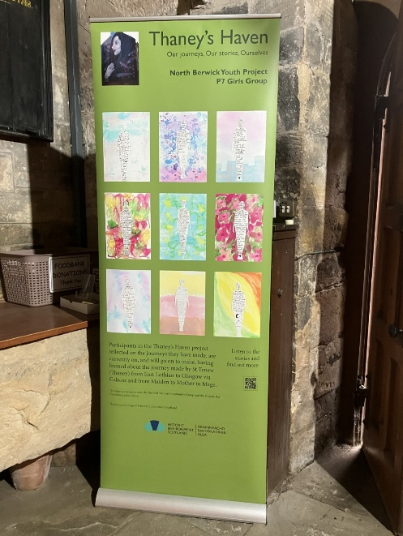
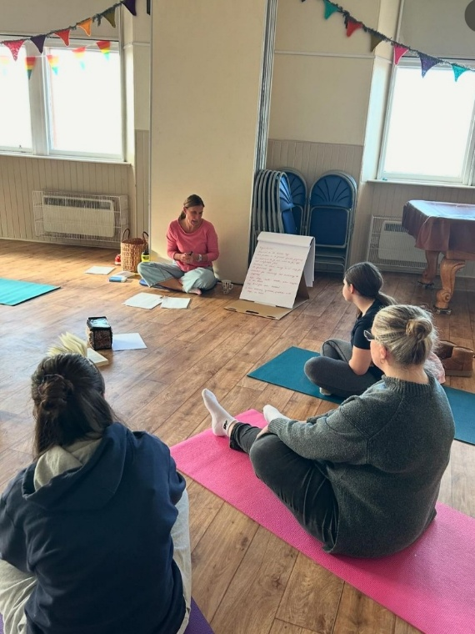
GIRLS GROUP
This year, due to the group being so popular, we split the Girls Group into three age based groups, one for Primary 7’s one for high school girls and one for more senior girls. On average, 17 girls attended the P7 sessions, 14 attended the high school group and 5 engaged with the senior group weekly. Sessions ran every Wednesday during term time and were youth-led, with the girls deciding what activities they’d like to take part in. Including, baking, various arts & crafts, cooking, karaoke, games, hair and beauty and issue based sessions.
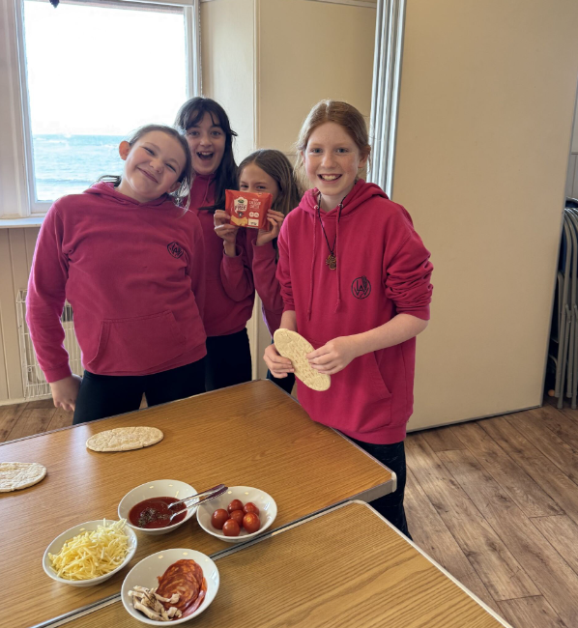
We worked with several partners to offer a wide range of engaging and informative sessions for the young people.
- Kamila from Harmonia Support delivered workshops for both groups with a focus on the female body and menstruation.
- Melanie from Sorellina led a creative jewellery-making workshop.
- MYPAS joined the high school group for two sessions around drugs and alcohol awareness.
- The P7 group took part in a creative project with the Learning & Inclusion Team at Historic Environment Scotland and Fife-based writer Rebecca Sharp. This was part of the Maiden, Mother, Mage performance project, inspired by the story of Thaney, a historic princess from the Lothians who was exiled and later helped found the city of Glasgow. The girls took part in creative writing workshops, producing poems, artwork, and recordings, which were featured in the final performance exhibition.
- We also worked with NB Connected Communities during their Demystifying Death Week, where the girls created a collage that was displayed as part of the event. This allowed them to think about death and grief and their own experiences.
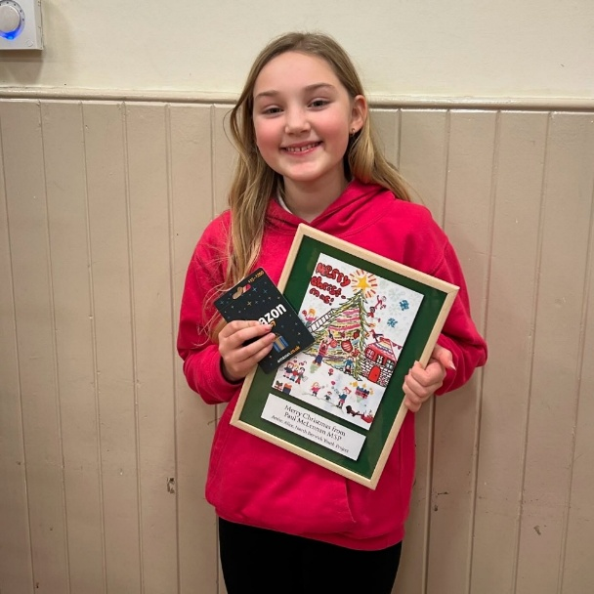
Another highlight this year included one of our P7 girls winning the Christmas Card competition run by MSP Paul McLennan. Her design was chosen to be sent to his contacts over the festive period and a Christmas meal out at the Puffin.
“The new P7 girls group is excellent. It gives the girls a great environment to learn and play in a safe environment with girls there own age. The activities are well organised and the girls love them. The staff are all great and the kids love them.” – P7 Parent
“I wanted to drop a quick message of appreciation for all the activities you put on at NBYP. This is a vital part of our local youth community and there’s clearly a lot of care, thought and effort going into making it a place our girls want to go to. It’s a safe and welcoming space where my girls know they can meet their friends and have fun. Long may you continue and thank you again” - P7 Parent

Senior Girls Catch-up's
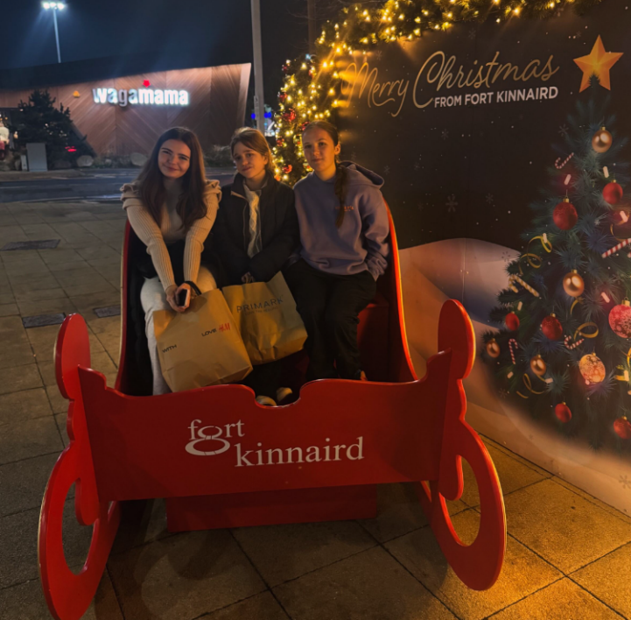
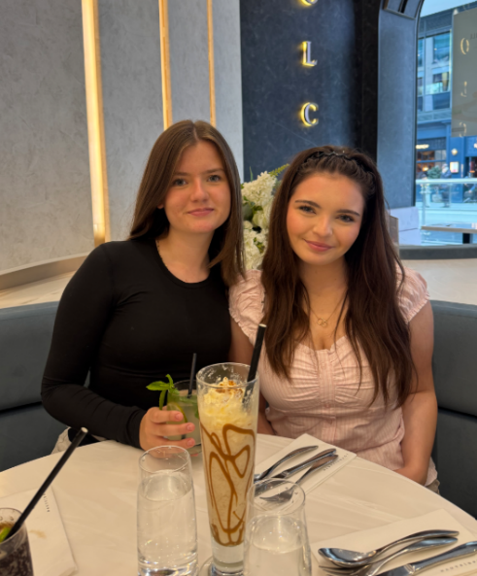
Over the year, five girls from our Senior Girls Group have regularly come together to catch up with each other, connect with youth workers and enjoy a supportive, relaxed space. The group aims to meet once a month, and the girls have taken part in a wide variety of activities including a jewellery making workshop with Melanie from Sorellina, a female health and menstruation workshop with Kamila from Harmonia Support, a trip to the cinema at Halloween, a shopping trip at Christmas and various lunches and dinners as well as sessions based at youth project. These sessions allow the girls a chance to maintain meaningful peer relationships and access support from youth workers.

“Senior Girls Group has helped me through lots. I get to go outside and talk to people I wouldn’t normally talk to. I like the group because I feel safe there and happy” - Young person, aged 15.
“I love girls group because at the group I feel safe, seen and supported. It’s a place where I can be myself, meet new people and talk to the amazing youth workers.” - Young person, aged 16.

BETTER BREAKS RESIDENTIALS
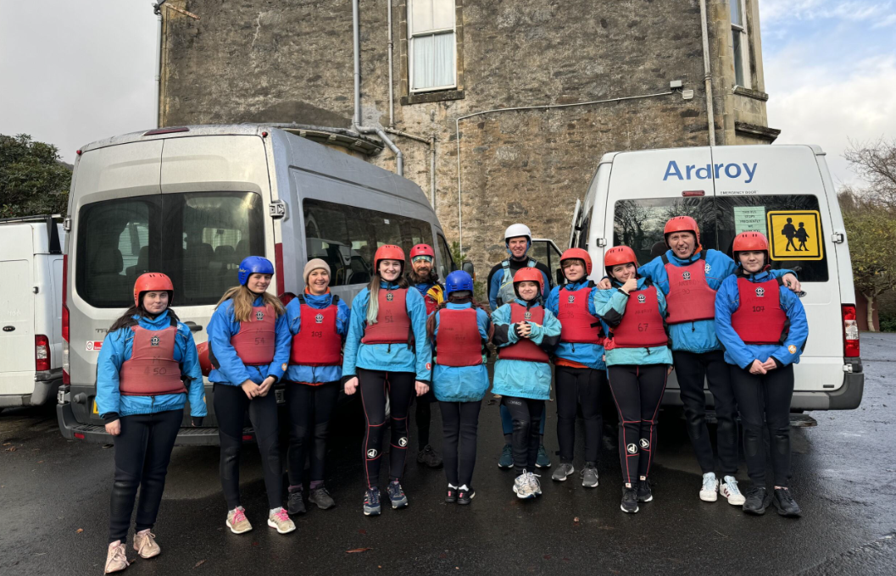
In March 2024 and again in March 25 we received funding from Better Breaks, Sort Breaks fund, enabling us to deliver four 2 night outdoor activity residentials and once monthly activities for young people aged 11–20 with additional support needs and disabilities. These residentials and outings offered young people valuable time away from home to build independence, while also providing their families and carers with much needed respite. The residentials were held at Ardroy Outdoor Education Centre in Lochgoilhead, with eight young people attending each trip. The four residentials took place in November, March, during the Easter holidays in April and July. Young participants were identified by working with local partners including North Berwick High School, local primary schools, and social work, as well as through our own mainstream and ASN services at NB Youth Project. These residentials and monthly activities provided young people with opportunities to develop confidence, try new things, and build friendships in a safe and supportive environment. 16 families have benefitted from the project to date.

“Whilst our daughter was away, we could spend some time alone, enjoy a break, whilst knowing that she was safe and happy.” - Parent

“My son appreciated time spent with friends, doing activities he wouldn't normally get to do and in an inspirational setting.” – Parent

CASE STUDY
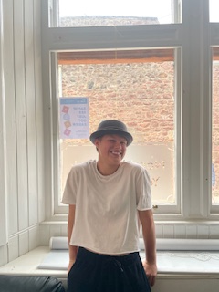
This young person has been attending the Youth Project for 3 years. They were first introduced after moving to the area and attending became a regular part of their weekly activities.

Being part of the Youth Project has helped them integrate quickly into the community and with peers. Engaging with the activities has allowed them to build friendships and maintain them, increase confidence and try so many new things. They enjoy all the Project has to offer, attending our village club, Girls Group, weekly drop-in's, residentials and has been a fantastic and motivated help at fundraisers and community events.

This young person has also worked closely with youth workers 1:1 and in small groups to help improve their wellbeing and learn tools and coping strategies to help them navigate their teenage years. They have built positive relationships with our youth workers and mentioned them when asked by another professional ‘who is in your trusted circle of people?’. This is testament to how they feel safe and able to be open and access support from the service.

“I like that you can just talk to the youth workers. Though I don’t think of them as youth workers or teachers. They just listen and take care of you. They are always understanding and supportive and never judge you.” - Young person

“S has gained so much from being part of NBYP. The youth workers have been a force of strength and have quickly helped S feel accepted and at home in the group. She’s had so much to deal with in her life and they have helped her make sense of some things, building on her strength and confidence. Seeing her go off happily on trips has been a joy and we are 100% confident that she is in safe hands in every way.” - Parent

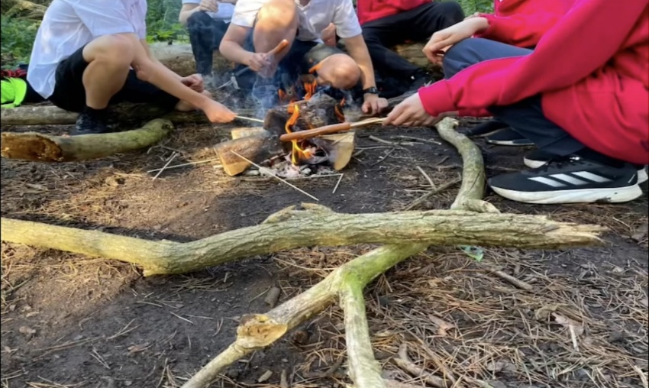
OUT’N’ABOUT PROJECT / BOYS GROUPS
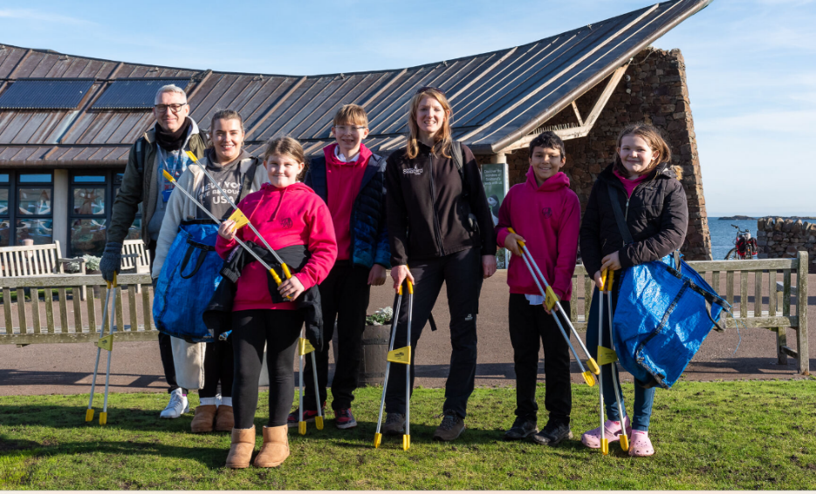
The Out’n’About project came to an end in June and over the three years gave young people opportunity to engage in activities in the outdoors. The project aimed to support young people to develop confidence, improve wellbeing, connect with their local community and develop key skills for life by exploring and connecting with the outdoors and the local environment. 53 young people engaged with the project over the year. Three outdoor groups ran – a P7/S1 Boys Group, Senior Boys Group, a P7 school group (featured earlier in the report) weekly sports and Sparks Group. Some highlights this year included forest and beach scavenger hunts, fishing, learning about safely cooking outdoors on an open fire, beach cleans and the opportunity to discover and learn about the importance of our ecosystem and how to protect it.
North Berwick Youth Project as a whole have now embedded outdoor learning and activities across our offering. We will continue to utilise the equipment we now have, as well as loaning it to other groups. Staff and volunteers have new skills and learning which they will embed into their delivery of youth work.
Young people have a greater sense of the importance of caring for our environments and have learned skills and knowledge that they can share across the community. Some young people have gained new hobbies such as beekeeping and young people are all more engaged in their communities and community groups.
We have observed and recognised the positive impact that being in the outdoors, and in nature has for the young people that we work with – increasing mental health and wellbeing, learning about and reflecting on risk taking behaviours and young people who have found new passions, skills and desires, building team work skills and increasing confidence and communication. Young people feel a part of something, and loneliness and isolation has reduced as a result.

Through the partnerships that we have with partners and schools we were able to identify and engage some of the most disengaged, challenging and hard to reach young people and have been able to embed informal learning as part of their school timetables. This has been an incredible step with huge impacts on those young people, their achievements and attainment.

‘Camping! I had the best time, I liked making the dinner on the fire and getting to camp out with friends that I wouldn't have been allowed to do at home’ - Young person, 12

‘J was really isolated, and I was very worried about him spending all of his time in his room, playing out friendships with people he only knows from online. I was concerned that he was avoiding in person social situations and had no real friends. I heard about the Youth Project from another mum and knew as soon as I had a look on the social media that my son would love it. It was a massive help that he was able to meet with Mikey before starting groups, and without his support I'm not sure he would have gone at all. We haven't looked back since, he looks forward to the group every week and spends extra time in the outdoors with the friends that he has made, he has taken up skateboarding and never complains now when we go out for a walk as a family, telling us all the things he has learned from the group along the way. Thank you NBYP you have been incredible.’ - Parent

SPECIALIST YOUTH WORKER - funded by East Lothian Council and Friends of the Edington

This is the third year of having a Specialist Youth Worker in a role which was funded by East Lothian council and Friends of the Edington as a result of the adverse impact that covid has had on young people as well as the need to increase supports for young people especially around mental health. The SYW’s main role is to work in partnership with the North Berwick Coastal Ward schools to support young people with their learning and development through targeted 1:1 support and group work. The four main outcomes of this role are engagement, prevention, transition and wellbeing.

In November 2024 the SYW featured in the ELC communications as part of National Youth Work Week. You can read more about that here ; https://www.eastlothian.gov.uk/news/article/14382/meet_mikey

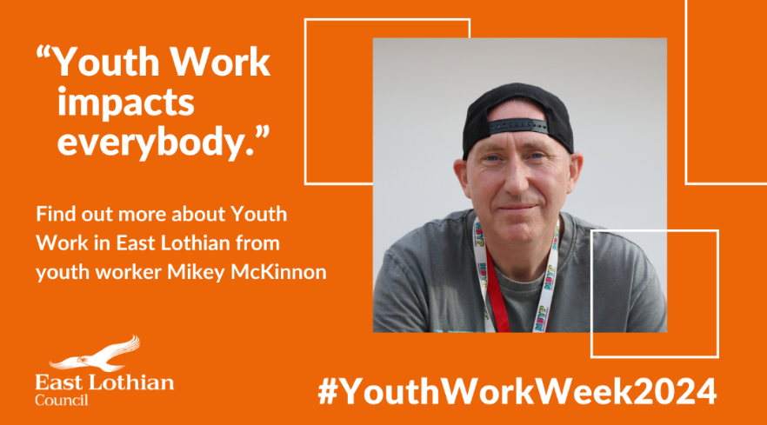
The SYW has continued to engage with the cluster primary schools to implement early intervention and supports as well as working in partnership with NBHS. Partnership work with the schools has included the development of our ‘Sparks’ group which took referrals from NBHS for young people who were identified as being at risk of engaging in anti-social and risk-taking behaviors and / or were disengaged from education. The delivery of Cool, Calm and Connected to 90 S1’s, Kings Trust Achieve to 15 pupils, 1:1 well-being supports to 12 young people, and resilience and transition groups to 24 pupils. As well as the partnership with schools, over the year, our SYW has worked with 39 boys at Boys Group, 4 young people on our Sparks group, 88 at Drop-in's, led a group of 10 young people on the school week long residential, 16 on respite residentials and groups, and co-delivered Raising Teens with confidence to 9 parents/guardians.
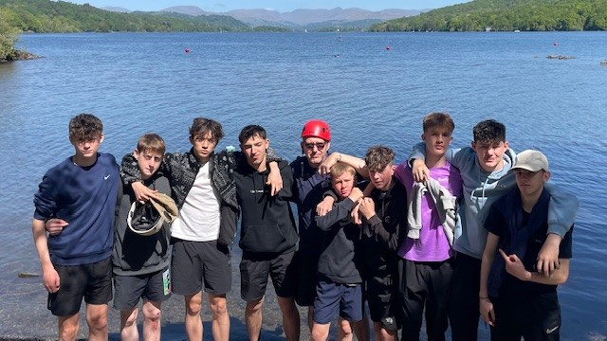
The Specialist Youth Worker was asked by NBHS if he would attend their third year residential in May to support a young person who would benefit from additional support from a youth worker he had built a relationship with. Having worked together one to one and in group settings for over a year the SYW was the best fit for this young persons needs. This relationship helped the young person get the best out of their residential, helped them make good choices and work within a group. It also gave the SYW an opportunity to meet and create relationships with other S3 pupils he would not normally work with.
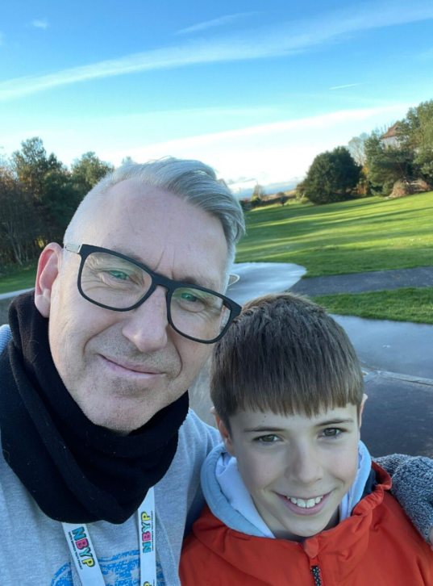

Alice Clubb, Deputy Headteacher at NBHS said: "Having Mikey with us on our residential was a brilliant addition to the staff team. He got involved with everything- and I think he enjoyed the activities almost as much as the young people did! Mikey came into his own during the “down time” where the young people were in and out of their rooms, or having free play outside. Mikey would watch the young people and give a gentle nudge when he could see individuals struggling to get involved , or when he pre-empted potential falling out or disagreements.
Mikey has got to know a wider variety of the NB young people from being on this year group trip, and has raised the profile of NBYP work just by being there. We are very lucky to have the partnership working… and so lucky that Mikey takes everything in his stride!”

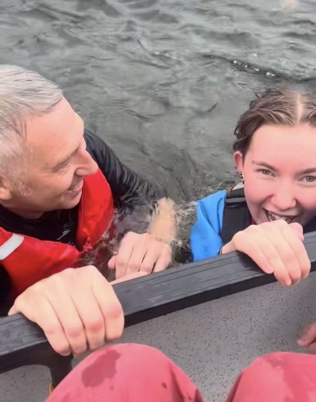
Parents and Young people who engage in 1:1 work and other groups at NBYP with the Specialist youth worker, were asked how the SYW has supported them and they said the following: -

“When we were at Ardroy, Mikey gave me the confidence to go out of the canoe into the water when I really didn’t want to, he went into the water and showed me that it wasn’t scary, and I even learnt how to float. When we went gorge walking there was a rope you could swing from and I was really scared but Mikey told me it was ok and I was safe, and when we were at a part in gorge walking we got to jump off a cliff into water, I was so scared but Mikey said he would go first and help me swim back just so I was sure it was safe. If it wasn’t for Mikey I wouldn’t have been confident enough to do any of the jumps and swimming at residential. Mikey is awesome and always helps. If there is something you want to talk about Mikey would always listen and offer advice, he is funny and is brave and makes going to youth project a fun, safe and happy place.” - Young person, age 15.

“Mikey is a really kind and supporting youth worker and he makes me feel really welcome at the Youth Project. I really enjoy Boys Group because we do so many amazing things I would never get to do.”
- Young person, age 15.

“I love going to Boys Group and Mikey always organises cool stuff like going to a proper restaurant, with the head chef showing us how it all runs! We got to make Haggis and Chilli Burgers and then we all sat down and ate them together!” – Young person, age 14.

“When school suggested Mikey came to have a weekly wellbeing walk with our son, we were really chuffed as he loves being outside and finds 1:1 situation more comfortable than a group setting.” - Parent

“Our son benefits from ‘brain breaks’ in class and so having this opportunity to get outside and walk and chat or have a kick about on the pitch with Mikey was really helpful for him. He looked forward to the Mikey walk days every week and they built a good connection. Mikey’s contact with the High School has also really helped our son with his transition to High School and to better understand what to expect when he moves there. It’s been a real find for our family and we’re looking forward to our son having the chance to join the boy’s group on a weekly basis after the holidays.” - Parent

“My walks with Mikey were very fun and I found out what you do in High School. Sometimes we played football and sometimes we had walks and chats. I also met Mikey’s dog Molly who is so nice.” – Young person, age 11

“I love going to Youth Project when Mikey is there cause he’s the best youth worker, sorry Lauren and Beth! He makes me laugh and always asks me how I’m doing. I feel safe when he’s there.”
- Young person age 14.

A parent who attended the Raising Teens with Confidence course said

“I found the course absolutely fascinating. Each session has been really useful particularly learning about the teenage brain’ They said they are now ‘Being more understanding. Teenage brains need extra time and understanding so I’m being easier on my teenager”

Overall, 98% of young people who have worked 1:1 with the SYW, reported an increase in their overall wellbeing, including feeling more respected, responsible, included and safe.
C-CARD
Through our C-Card service, young people are able to access free condoms and sexual health advice and information from our C-Card trained staff. Staff training takes place regularly to ensure that staff have the most up to date knowledge to share with young people to keep them safe.

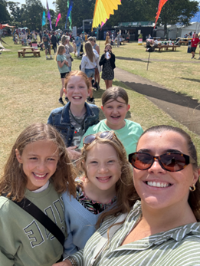
FRINGE BY THE SEA 2025
Each year we work closely with the organisers of FBTS to ensure that there are youth opportunities built into the programme. This year we supported them to engage our young people in their arts for this years theme ‘Timeless Treasures’. We took 26 young people along to events, and attended their community eventsNorth Berwick Trust fund 100 tickets yearly. This allowed us to take 3 groups of 12 young people along to Brainiac Remixed, Ezra Collective and Flawless Dance Troupe and 27 tickets were distributed to families and young people and their families attended various shows such as Air, Hot Dub, Mass Karaoke, AIR and RSNO Orchestra.
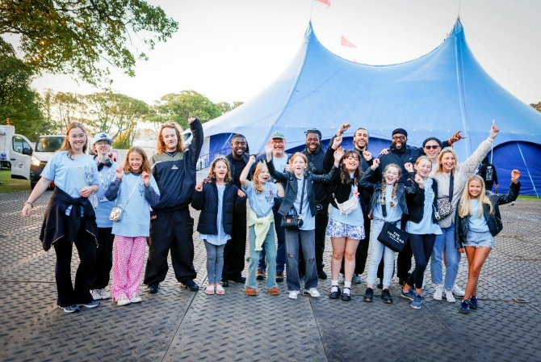
This year was made even more memorable when our young people were invited backstage to meet Ezra Collective, a collective of incredibly talented musicians who were formed with youth work at the heart and are brilliant advocates for youth work. They even gave us a big shout out to a crowd of thousands (although forgot the North in North Berwick) and mentioned the importance of youth work, and youth supports. The sentiment in these words were powerful! - see the video here ; https://youtube.com/shorts/xLwAo0g51II?si=N6OwfsAgS3zNEOUs
PARTNERSHIP WORKING
North Berwick High School
The partnership with North Berwick High School is fundamental to the work of the Youth Project. Youth workers work closely with teachers, support workers and the Guidance team to take referrals for young people, create plans for the young people we are working with and to identify need for small group work which we deliver in school time.

Through GIRFEC staged assessments meetings, the Youth Project is now seen as part of the solution. – getting it right for every child, NBYP also attend the Child Planning Locality Framework meetings, individual Child Planning meetings, HUB meetings, and Guidance meetings regularly.

We delivered Princes / King’s Trust Achieve awards to 15 senior students.
16 Young people were supported with their transition.
Cool, Calm and Connected was delivered to 90 young people.
We ran a group for young people who are disengaged from education.
We spoke to staff at an in-service staff day about the work of the Youth Project and the importance of youth work in education.

NBHS Careers Fair
2 staff represented NB Youth Project at the NBHS Careers Fair, organised by Developing the Young Workforce (DYW). The event brought together a wide range of organisations to give pupils insight into various career pathways and employment opportunities across multiple sectors. NBYP’s focus was to promote youth work as a meaningful and rewarding career, highlighting the key skills and qualities that make a good youth worker. It was a valuable opportunity to engage with young people, raise awareness of the youth work and inspire young people to consider the role as a potential career path.

Your Resilience
2 staff completed the training. 3 youth workers and 1 your resilience worker delivered the course to Princes Trust students. Youth workers and the your resilience worker met once a week on zoom to discuss delivery of the sessions. Workshops included making decisions, learning about resilience, anxiety and managing mental health.

ASH Scotland workshops
Young people engaged in a focus group which asked young people for the input around their views on nicotine products and the impact that the current marketing has on young people.

ELC Youth Vision
3 youth workers were a part of working groups and attended cafe workshops which allowed youth workers to dicuss the Youth Vision and helped to shape the vision for the coming years. Youth workers also engaged with young people to collect input and feedback around the vision to ensure that the vision was formed with young people’s needs at the heart.

North Berwick Rotary Club
The Project Manager often visits the Rotary Club to update them on the work of the Youth Project and has close links with their Youth Lead Rotarian who is kept informed. Discussions allow a good understanding of the work at the Youth project and identify areas where Rotarians can support the work.

STAFF AND VOLUNTEERS
The Project is led by a full time Project Manager, responsible for the strategic direction of the project, finance and fundraising and also manages the youth work team with the full-time Lead Youth worker with youth work aspects of the project and a full time Specialist Youth Worker. The Project also employs 3 sessional staff and is heavily reliant on volunteers.

Some of the young people go on to be volunteers and several of its sessional staff started as volunteers. The Project Manager started as a young person. This year we introduced a new role ‘Junior youth worker’ this role is allowing a young person to earn a wage whilst accessing training and experience in youth work.

The Youth Project has a very supportive Board, which includes the High School Deputy-Head, an ex High School teacher, an ex-School Counsellor and people with a real commitment to young people and the community.
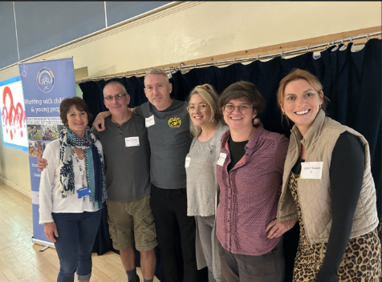
STAFF TRAINING
The staff and volunteers had access to training courses throughout the year. We strongly support our staff and volunteer team to continue their personal development.

Pictured: Staff at ‘The Gathering’ in September 2024, delivered by East Lothian Council

EMBEDDED IN THE COMMUNITY
We are passionate about working in our community to build relationships which benefit the young people, our organisation and those in the wider community. In the past year through our various projects and opportunities we have continued to embed into the North Berwick Coastal Community which has benefitted all. Below are some examples of how we are engaging with the wider community, schools and groups.

COMMUNITY ENGAGEMENT
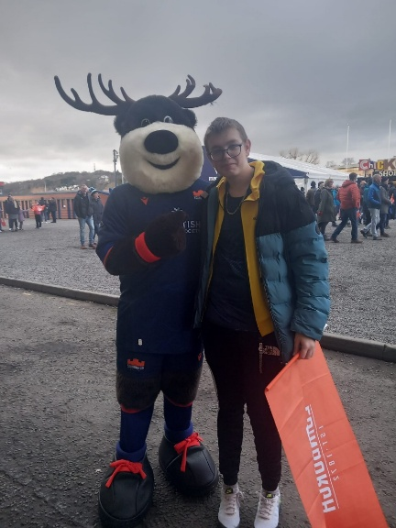
Remembrance Day
The P7 Out’n’About group painted remembrance pebbles they collected from the beach and painted them, which were then included in the display outside the Abbey Church in North Berwick, organised by the Bass Rock Community Group.

Scottish Open
With thanks to the Scottish Government, we were able to offer 10 free tickets to the Genesis Scottish Open in July.

Scottish Rugby
Thanks to Scottish Rugby and LAYC we were able to offer families free tickets for the 1872 Cup Edinburgh Ruby vs Glasgow Warriors game in December.

“Thank you so much for the rugby tickets for today. Me and [my son] had a great time at the game. I really appreciate it and I got to spend a bit of 1 on 1 time with him which is rare these days. Thanks so much again” - Parent
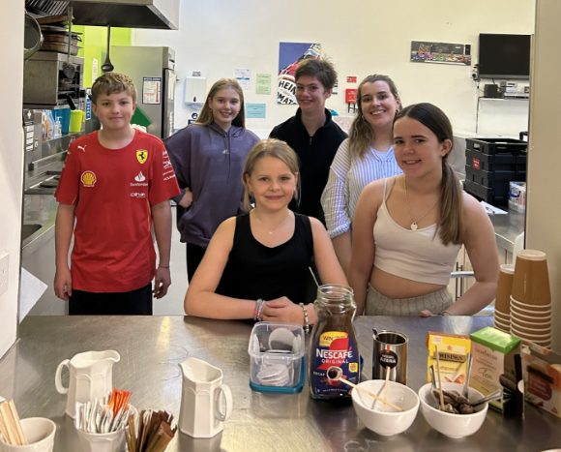
North Berwick Community development Company
A group of young people served teas and coffees at the North Berwick Community Development Company’s public meeting. This was an excellent opportunity for them to develop a range of skills including confidence, responsibility and communication.

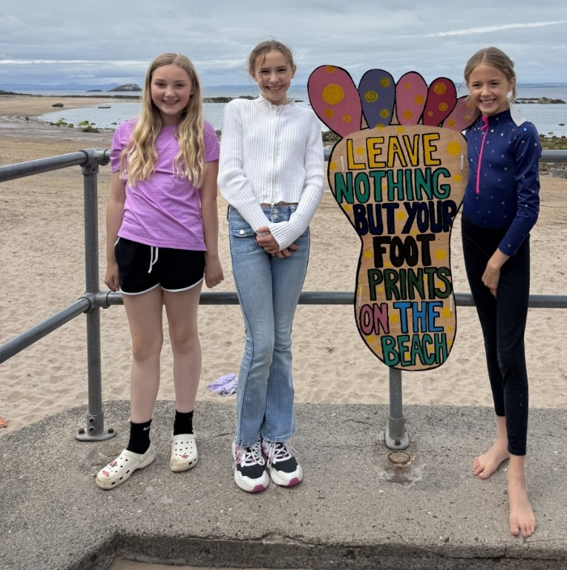

Community Council
North Berwick Community Council invited young people from NBYP to paint the new footprint signs, which have been placed at various locations around the seafront. Young people from several groups, including ZAP, the Well-being groups and Friday Drop-in, enjoyed getting creative with the designs for these colourful, new signs.

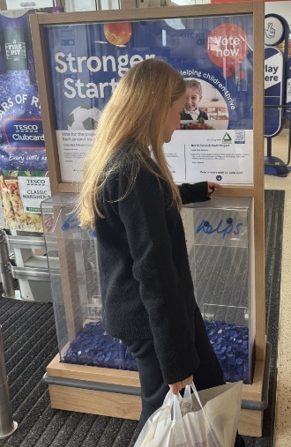
Bag’s for Help
In spring 2025 NBYP were included in the Tesco Stronger Starts vote in store, with the goal of raising funds for youth club sessions. We were incredibly grateful to be awarded a generous donation of £1,000, which will go towards supporting our activities.

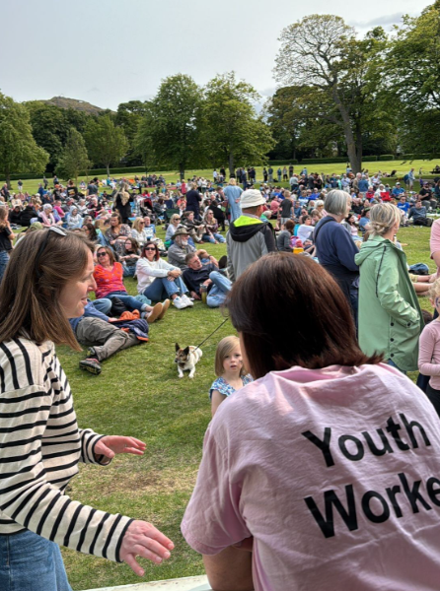
Picnic in the Park
NBYP were invited by the picnic in the Park organisers to sell teas and coffees and home baking for the 2nd year. We also worked with Jamie from ‘Jamie’s Backyard Slice’ to train young people to make pizza’s to sell on the day. (more about this in fundraising). Young people gained new skills and confidence.
Police
We meet with the School Police officer which is paramount to supporting and identifying young people. Where appropriate we share information with Police and Wardens.

CHILD PLANNING - our youth workers are often invited to be a part if the child planning process and we are seen as part of the solution for many young people.

NBCDC – Our manager is a Director of the NB Community Development Company. Young people served tea’s and coffee’s at their Public meeting.
CPLFT – Our manager and Specialist Youth Worker attend the Child Planning Locality Framework meetings.
NBC&YN – Our manager attends the Children and Youth Network meetings where she is also a Vice Chair.
CHURCH YOUTH WORK - We have a great relationship with the Church Youth worker which has been invaluable, especially to ensure that young people are getting appropriate supports from their trusted adults.
SPORTS HUB - When appropriate our Specialist Youth Worker attends Sports Hub meetings which has afforded us and the young people incredible opportunities with the many sporting clubs in NB including the Tennis Club, Table Tennis Club, Rowing Club and Rugby Club
NOLB HUB MEETINGS– We attend HUB meetings to identify young people in need of support
PSG MEETINGS – Our Specialist youth worker attends weekly school guidance meetings and is seen as part of the solution when looking at supports for young people identified at NBHS
SUSTAINING CHOICES – Engaging in the action for the NBCC
BASS ROCK COMMUNITY GROUP - we are thankful to the community group for always engaging us in project and fundraisers which we have also benefited from. Our young people enjoyed taking part in the Window Wanderland project where they did art work for the kiosks on the High Street
FRIENDS OF THE EDINGTON – We are incredibly thankful to the Friends of the Edington who support us immensely in the Mental health and wellbeing work that we do.
NB COMMUNITY CENTRE COMMITTEE – We are grateful to the committee for allowing us to hold intergenerational meals, discos and other larger group work in the centre.
NBCAP – Our manager attends Area Partnership meetings and NBYP have been supported by the Area Partnership members through receiving funding.
ROTARY – we continue to work closely with the Rotarians who are a constant and welcome supporters of NBYP
EAST LOTHIAN RANGERS - working with our Out’n’About project
LOCAL PLACE PLAN – Our manager worked on the early stages of the Local Place Plan, ensuring that young peoples voices were included in the plan.
FAMILIES TOGETHER – We have a close relationship with the area families together worker who attends the youth project drop-in's weekly and has supported young people on holiday programmes and trips.
The SPACE Dunbar – supporting the Board of Directors to explore issues that young people face and to engage young people with consultations.
NBCC – we engaged with the North Berwick Community Council throughout the year and opened the Cafe in the Lodge serving home baking and drinks at their Picnic in the Park event, painting beach signs.
PICNIC IN THE PARK EVENT - Young people catered for the Picnic in the Park event and fundraised by selling homebaking and serving Pizza prepared as part if an initiative with Jamie’s backyard Slice.
ELYC – 3 young people benefitted from access to a free week long course to learn to sail, gaining accreditation with East Lothian Yacht Club, NBYP helped to identify young people that would benefit most.
PARK RUN UK - Young people enjoyed getting involved in the Park Run at Archerfield Estate
SCOTTISH SEABIRD CENTRE – Workshops, visits and boat trips in the summer
COASTAL COMMUNITIES MUSEUM – visits and engagements in their exhibitions
SCOTTISH BADGER ASSOCIATION – Workshops and sessions
Scottish Centre for SOCIAL RESEARCH– focus group – Vaping and E-Cigarette marketing
MYPAS - Workshops and sessions
VENTURING OUT – Outdoor activities for Out’n’About and holidays programmes
MARINE CONSERVATION SOCIETY - Workshops and sessions
HONEYBEE SANCTUARY - workshops
SURFSKATE - Sessions
Iorienteering and EAST LOTHIAN ORIENTEERING CLUB - Workshops and sessions
SHAPED NATURE - Session
LAND ART AND EUROPEAN LAND ART FESTIVAL - workshop session and day to the festival
Fringe By the Sea FESTIVAL – we work closely with the organisers to develop and consider youth activities for the festival as well as distributing free tickets to young people and the families and enfafing young people in their yearly themed arts.

FUNDRAISING
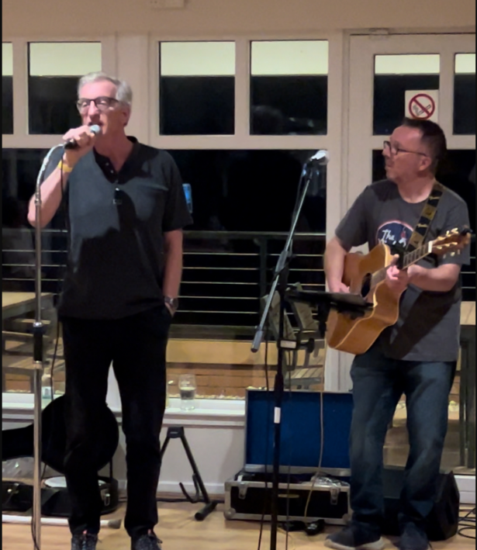
Pictured : Our star fundraiser of the year – Alex Galloway (left) with good friend and musician Keith Logan (Right).
The work that Alex and friends put in have had a huge impact on our young people and the services they are able to access to support them with their mental health, removing barriers to supports which we are incredibly grateful for.
Jamming for Good
Raising £1637 Jamming for Good was a music event which was held at the Glen Golf Club and was organised in memory of Jonny Galloway, by his brother Alex Galloway and friend Keith Logan along with his band Midnight Jam and friends – Biphonix, Auld Hat and Stuart Smith all of whom donated their time for the cause. The event was a sell out and raised awareness of Mental Health and Suicide.
Alex Galloway Golf Round
Raising £1,300 Alex Galloway undertook a round of golf, a challenge for him being partially sighted and having suffered a stroke. Alex is passionate about raising funds to support the mental health supports that we provide, and the funds raised from this event and Jamming for good allowed us to expand on the services that we can offer to young people in the North Berwick Coastal Ward, specifically to create a fund which has and will continue to support young people to access private counselling sessions where other supports have not been suitable.

Picnic in the Park
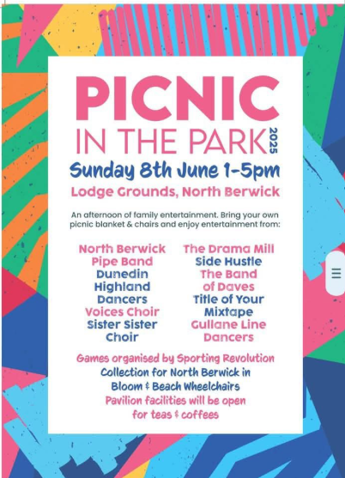

This year we were invited back to the pavilion to sell home baking and hot drinks. We were also approached by Jamie’s backyard slice, a stone baked pizza co who worked with our young people to learn how to make and bake pizza’s and to come up with a menu for the event. Jamie, the owner donated half of all pizza sales on the day. We are very grateful to Jamie and the event organisers who allowed us to fundraise at the event, raising a very successful £1,275 from home baking, pizzas, glitter body art and donations.
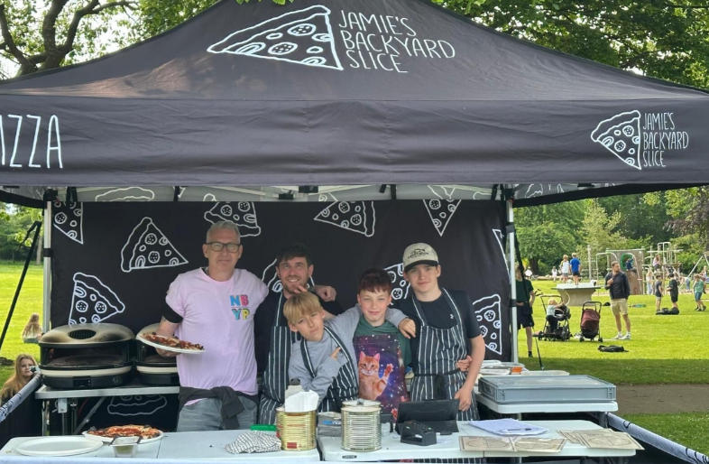

East Lothian Triathlon
We were invited back this year to serve tea’s and coffees and home baking at the event. We are grateful to the organisers and athletes who supported us on the day to raise £249.

Flaskit Christmas Sales donation
Local company Flaskit donated 50% of all of their Christmas sales of their woodland bottles raising £200.
Huffin Puffin’s
The local Huffin Puffins hosted a quiz night at the Glen Golf Club and raised a fantastic £200, the donation was used to buy sports equipment. Thank you Huffin Puffins!

FUNDING
The Youth Project would like to thank the following funders, who gave grants during the year. Without them none of this would be possible.

East Lothian Council – Service Level Agreement, Specialist Youth Worker, Holiday Hunger, employability
North Berwick Coastal Area Partnership – Friday Fitness
Gullane Food & Drink festival – Gullane Youth Club
North Berwick Trust – Lead Youth Worker, full time position
Better Breaks – Respite residentials and day breaks
Young Start – Out'n’About Project
Co-op Community fund – Drop-In and Gullane Youth Club
Children In Need – ZAP group
Cash For Kids – Easter and summer programmes
Essentia Foundation
Friends of the Edington

