
Annual Report

2024/25

INDEX

Chairperson Report Page 3

Meet the Team Page 4

Youth Groups Page 5 & 6

Family Support Groups Page 7

IMPACT Courses Page 8

Adult Support Groups Page 9 & 10

NeuroMINDS Page 11

Research Page 12


Raising Awareness & Awards Page 13

Funding Page 14

Future Plans Page 15

Chairperson Report

During the 2024/25 reporting period, the Board of Trustees met on four formal occasions to fulfil its governance responsibilities. In addition to these scheduled meetings, trustees maintained regular communication and received ongoing updates from our Chief Executive Officer, Alison Zerouk, ensuring effective oversight of the charity's activities and strategic direction.
As you read through this report, you will see the significant positive impact our services continue to have on children, young people, adults and families affected by ADHD across Dundee and Angus. The achievements highlighted throughout the year reflect the dedication of our staff, volunteers and trustees, and the continued demand for accessible, high-quality support within our communities.
Like many charities, our ability to deliver these vital services is entirely dependent on securing external funding. The continued generosity and support of our funders enables us to provide meaningful support, information and advocacy to those affected by ADHD. Without this financial investment, many of our services simply would not be possible.
On behalf of the Board of Trustees, I would like to extend our sincere thanks to all of our funders for their continued confidence in our work and for investing in the people and communities we serve.
Finally, I would like to express my heartfelt thanks to Alison Zerouk, our Chief Executive Officer, and the entire staff team for their professionalism, commitment and compassion throughout the year. Their hard work, determination and dedication continue to make a lasting difference to the lives of those who rely on our services
Georgia Cruickshank

Georgia Cruickshank
Chairperson
Dundee and Angus ADHD Support Group

Meet the Team

CEO

Alison Zerouk

Office Staff
Steve Rossbourgh, Wilson Ngotho

Family Team

Abigail Perkins, Kirsty Iniglis, Ann Davidson, Claire Paul

Youth Group Staff
Shannon Kennedy, Steve Scott, Alison Page, Jay Talbert,
Cameron Adam, Rachel Simpson, Paula Thomson,
Darryl McComish, Leah Waddel

Volunteers
Hannah Smith, Cameron Adam, Ezra Cheung,
Hannah MacCrimmon, Jazmine Bennett, Taylor Scott

Trustees
Georgia Cruickshank, Angela Smith, Shona Bryce,
Sandra Mitchell, Phillipa Montador

Youth Groups


Activity weeks throughout the year Showcase the Street (tech hub), The Disc (outdoor football), Arts & Crafts and a partnership with Ryze (trampoline park) alongside various other activities.
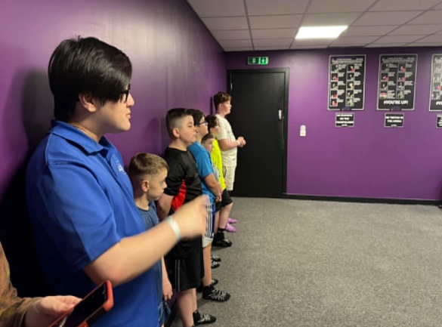

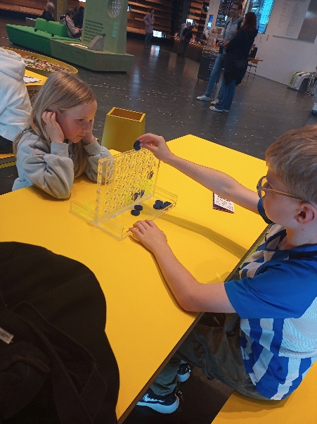



The youth group has provided children with a wide range of engaging and enjoyable activities throughout the year, helping them to build confidence, develop new skills and form positive friendships. Children have taken part in creative arts and crafts
sessions, climbing activities, ten-pin bowling, and a variety of outdoor pursuits that encouraged teamwork, communication and physical activity. The activity weeks were particularly popular, giving children the opportunity to try new experiences, have fun and create lasting memories. These activities have not only supported their social and emotional wellbeing but have also helped them grow in confidence and develop a stronger sense of belonging within the group.
The youth groups run over 4 nights a week in Dundee and 2 nights a week in Angus..

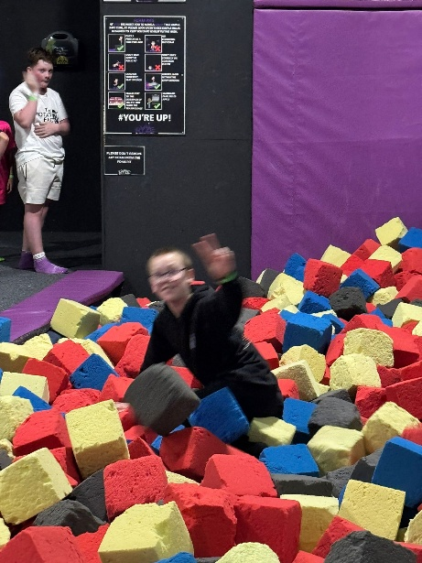
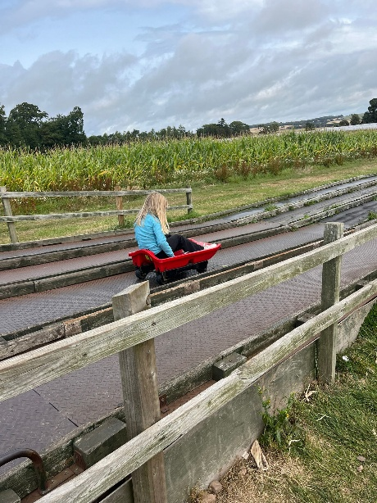



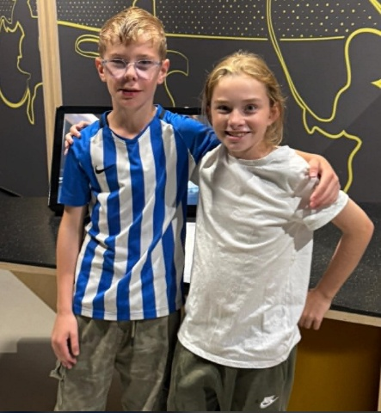

Family Support Groups
Our Family Support Service runs during the last week of every month. Following feedback from parents and carers, we learned that daytime sessions would be more accessible and better suited to their needs. As a result, we adjusted the group times to run during the day.
The Angus support group takes place on the last Tuesday of each month, while the Dundee support group is held on the last Thursday of each month. Both groups continue to be well attended, demonstrating the importance of providing families with opportunities to connect with others who share similar experiences, access information, and receive emotional support.
Alongside facilitating these support groups, our Family Support Team provides a wide range of services to children, young people, and their families. This includes attending Team Around the Child meetings and multi-agency meetings to ensure families are represented and supported throughout decision-making processes. The team also offers one-to-one support to parents and carers, advocacy, practical guidance on accessing local services and benefits, signposting to specialist support, and assistance with education, health, and social care matters.
The Family Support Team works closely with schools, healthcare professionals, and partner organisations to help families navigate challenges, build confidence, and develop strategies that promote positive outcomes for their children. The team also provides emotional support, helps families prepare for key transitions, facilitates peer connections, and ensures that families have access to relevant information, training opportunities, and community resources.
Through this holistic approach, the Family Support Team aims to reduce isolation, strengthen family resilience, and empower parents and carers to advocate effectively for their child's needs.

IMPACT Courses

Our IMPACT courses continue to be well received and have provided valuable support to families. Through ongoing evaluation and feedback, we have identified an opportunity to further strengthen the programme's effectiveness.
Previously, the course was delivered simultaneously to both parents/carers and children. Moving forward, we will adopt a revised model that focuses initially on working directly with parents and carers throughout the six-week programme. This approach will provide parents and carers with dedicated time to develop their knowledge, skills, and confidence in supporting their child's needs within the home environment.
Following completion of the six-week programme, the Family Support Team will provide tailored one-to-one support for the child or young person. This will allow practitioners to build on the strategies introduced during the course, address individual needs, and reinforce positive outcomes for the whole family.
We anticipate that this revised approach will strengthen parental capacity, promote consistency between home and support interventions, and enable more personalised support for children and young people. Ultimately, this will help improve family resilience, increase confidence, and support better long-term outcomes for the families we work with.

Adult ADHD Support Group

Following our first meeting in Angus on Tuesday 3rd October 2023, the adult support group has continued to provide a welcoming, safe and supportive environment for local adults. Attendance remained steady throughout the year, with members benefiting from regular opportunities to connect with others who share similar experiences.
The group has helped reduce feelings of isolation, encouraged peer support, and provided a space where individuals can openly share challenges, successes and coping strategies. Feedback from attendees has been very positive, with many highlighting the value of meeting others who understand their journey.
As the group has developed, we have seen increased confidence, stronger social connections and a growing sense of community among members. We look forward to building on this success and continuing to support adults across Angus in the coming year.
Our meeting in Dundee is on the first Thursday of each month at our premises at Manhattan works. Again these groups are well attended with the average numbers are around 20 people.
At both meetings we deliver a topic at the start of the session then after tea break the adults have time to chat and discuss any issues they might be facing.
Our meetings are attended by undiagnosed/diagnosed ADHD adults

Zest Partnership/Adults
The Dundee and Angus ADHD Support Group worked in partnership with Zest Café in St Andrews to deliver information, guidance and support to adults affected by ADHD. This six-month pilot project provided a welcoming and accessible space where individuals could learn more about ADHD, share experiences and access peer support.
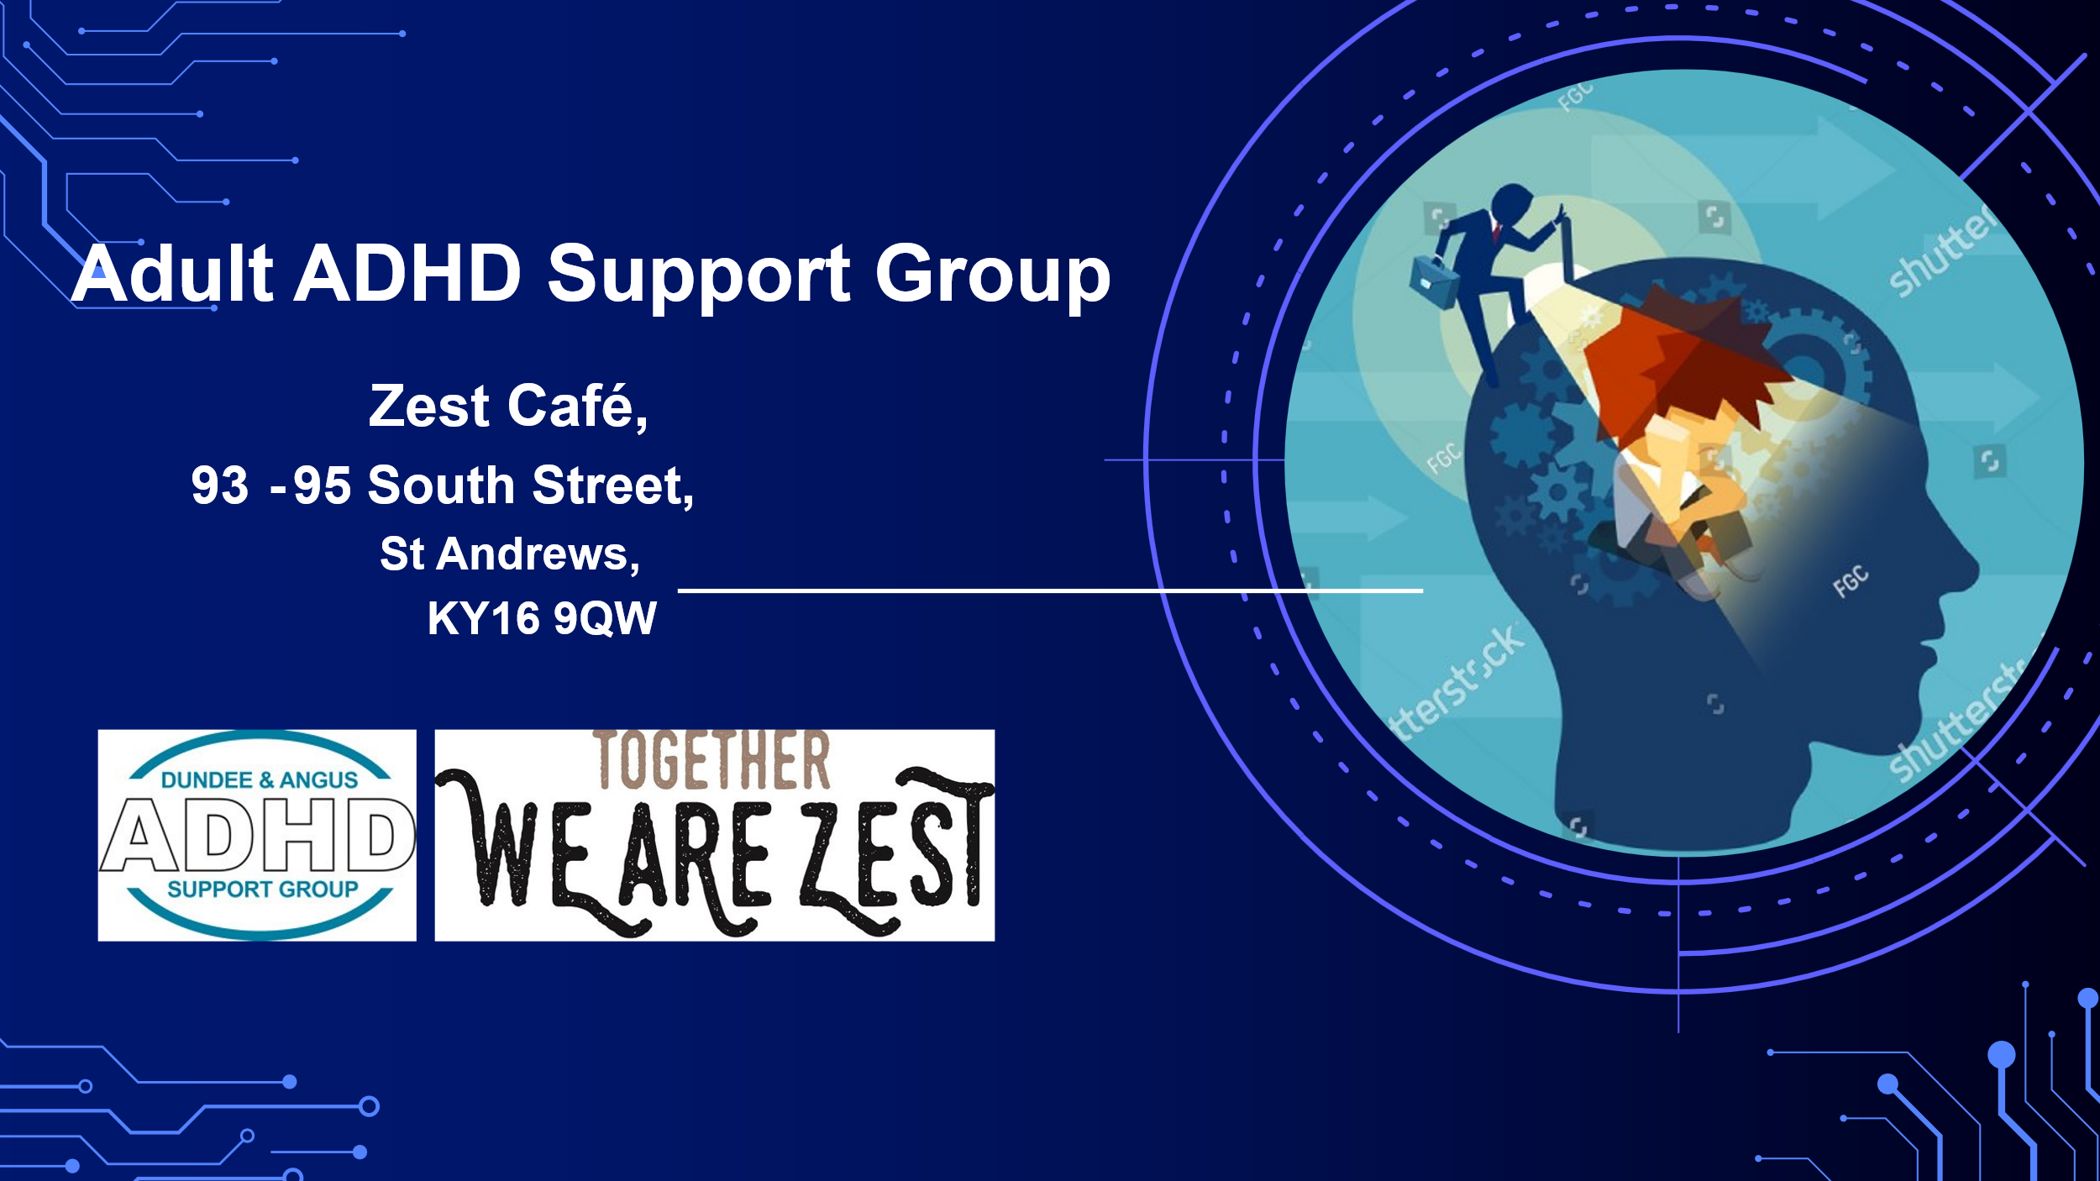
The feedback received throughout the pilot was extremely positive, with participants reporting that they valued the opportunity to connect with others, gain a better understanding of ADHD and access practical information in an informal setting. The success of the project demonstrated the importance of community-based support and highlighted the benefits of partnership working in reaching and supporting local adults.

Café Sessions Dundee/Adult


We hold a monthly adult ADHD support sessions in Cake & Dice Dundee.
The group runs monthly, this is a drop in session and this is open to diagnosed/undiagnosed adults.
This has been a successful part of our services with adults who do not like big meetings and face sensory issues around venues etc, the adults in attendance at the café prefer to attend small group setting.

Neuro-MINDS Pilot/Adults
In partnership with Autism Initiatives, we delivered a four-week “Understanding ADHD and Autism” workshop programme across four localities in Angus, alongside a weekly online session. These workshops provided adults with valuable information about ADHD and autism, helping participants to better understand their experiences, challenges and strengths. A weekly café in each location was well attended also.
The programme has proven particularly beneficial for adults who are awaiting an ADHD diagnosis, offering support, practical strategies and opportunities to connect with others in similar circumstances. Feedback from participants was very positive, with many reporting increased understanding, reduced feelings of isolation and greater confidence in managing day-to-day challenges while waiting for assessment and diagnosis.
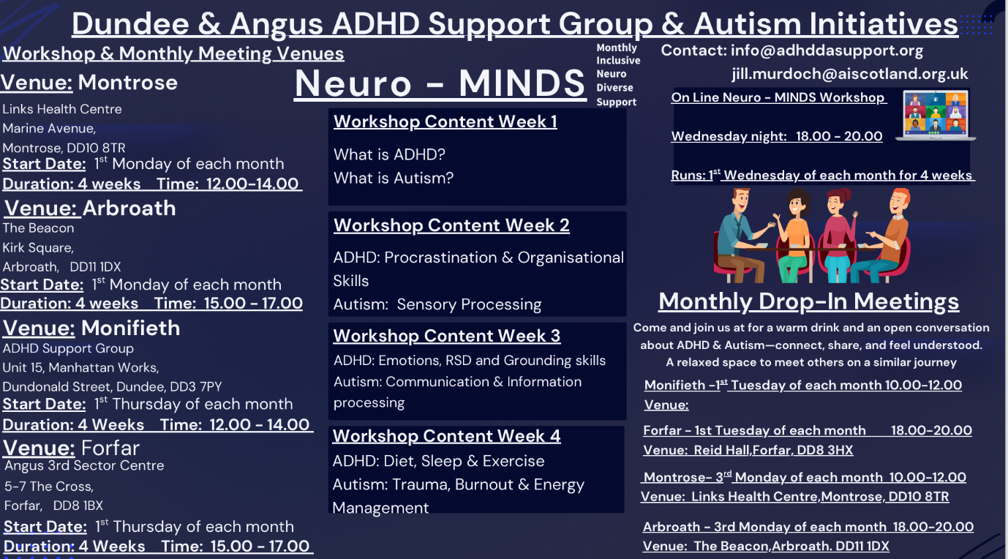
Funding for two years will be available next year.
Research/Students
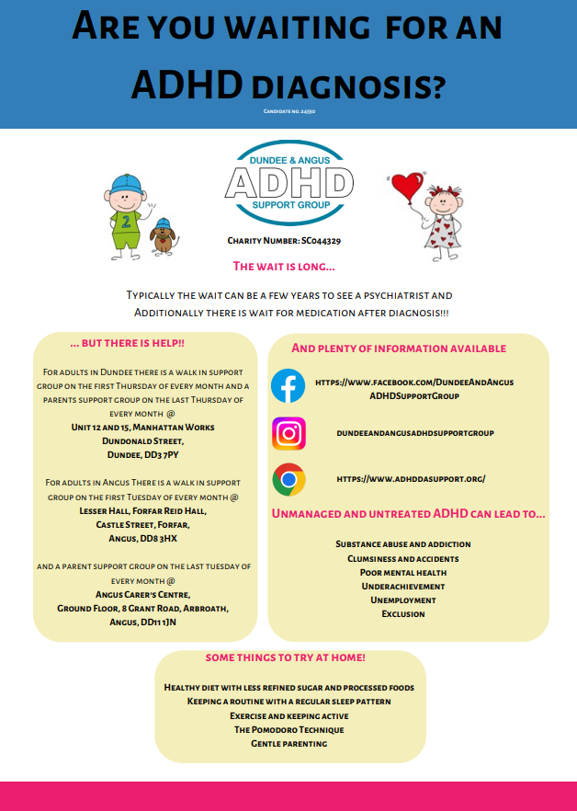
Cameron Prempeh, Edward Marsh-Smith and Gabrielle Maberly
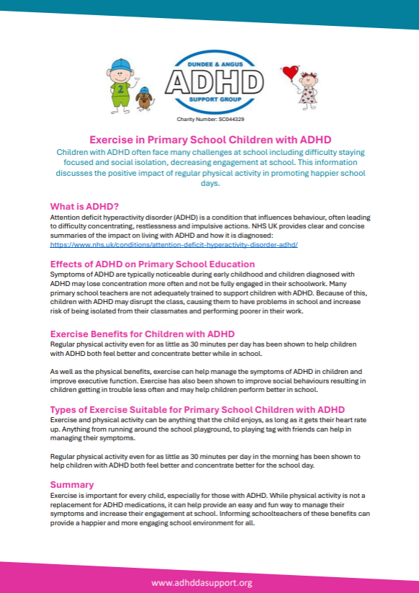

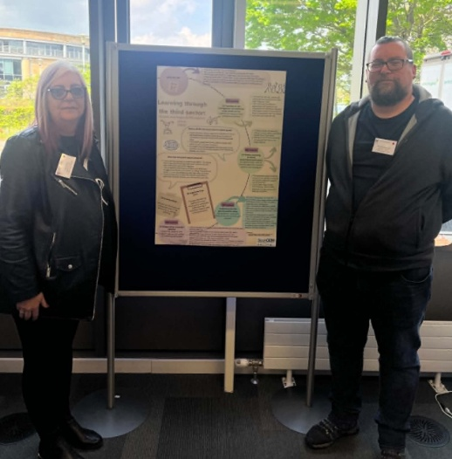
Cameron and Edward, who are students at St Andrews University, St Andrews volunteered their time and expertise to develop the attached information leaflets for both adults and children.
Gabrielle, a student at Abertay University, Dundee, contributed to the development of information leaflets aimed at adults who have ADHD, whether they have received a formal diagnosis or are exploring the possibility that they may have ADHD.
Their contributions have helped create accessible, informative resources that support individuals and families in understanding ADHD and accessing appropriate support.
Raising Awareness
Throughout the year, Steve, our Administration Manager, actively promoted our organisation by visiting numerous stores and community locations across Dundee and Angus. By engaging directly with businesses, staff, and members of the public, he helped raise awareness of our services, increase community understanding of ADHD, and ensure that more individuals and families were aware of the support available to them.
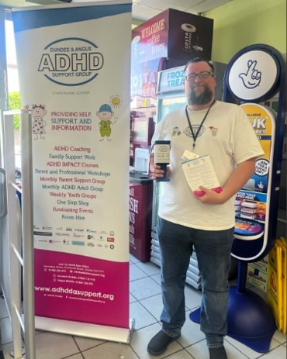
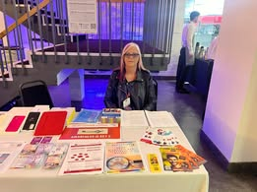

Steve at Scot Mid, Dundee
Alison attending the UKAAN Conference in London on behalf of ADHD Europe

DSEN Awards
The Dundee and Angus ADHD Support Group was proud to be awarded Social Enterprise of the Year, recognising the organisation’s outstanding contribution to the community and its commitment to supporting individuals and families affected by ADHD. This achievement reflects the dedication, hard work and passion of our staff, volunteers and supporters, who have worked tirelessly to develop and deliver high-quality services across Dundee and Angus.
Receiving this award is a testament to the positive impact the organisation has made within local communities, building strong partnerships, increasing awareness of ADHD and providing much-needed support to those who need it most. We are honoured to receive this recognition and remain committed to continuing our work and expanding our reach in the years ahead.


Christmas Bingo

We held our Christmas Bingo at the

beginning of December where we

raised over £400.

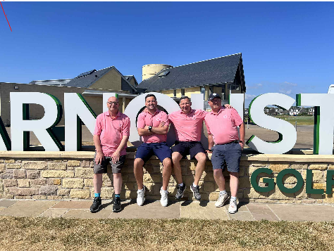
Donations Received
December 2024: Unite Tradesmen
December 2024: Dundee Rotary Club
December 2024: Super Snacks, Perth Road
May 2025: DD Competitions
May 2025: Jim, Shaun, Jamie & Brian photographed at Carnoustie Golf Course

Funding Received
A4A – Angus Dundee Voluntary Action Soutar Trust
Youth Link Scotland Better Breaks Northwood Trust
R S McDonald Help for Kids Tesco
Angus Rural Fund Postcode Lottery Co-op
Agnes Hunter Fund Voluntary Action – Angus Scotmid
Tayside Health Board Big Lottery – Dundee Just Giving

Future Plans

- Monitor Youth Group
- Provide access to an ADHD café
- Provide weekends away for families and Dalguise for the children
- Work in partnership with Autism Initiatives for NeuroMINDS
- Additional member of staff with knowledge and expertise on Autism
- On going support for children, families and adults
- IMPACT courses
- ADHD Coaching

