Andarroch Trust

Trustee’s Annual Report and Accounts for the year ended 31 December 2025

Scottish Charity No: SC032270

Trustees

Bruce W Clark
Sarah F Clark
Eleanor Shena Clark

Contact Address
4 Orchard Road
Hampton, Middlesex
TW12 2JJ

Governing Document
The trust is governed by the Trust Deed recognised by the Inland Revenue on 17 October 2001, under Section 505 Income and Corporation Taxes Act 1988.

Recruitment and appointment of Trustees
Appointment and removal of Trustees is approved by unanimous agreement of the existing trustees and removal of any trustee by the unanimous agreement of the others.

Charitable Purposes
The purposes, as recorded in the Trust Deed include:
- The financial support of Christian organisations, activities, churches or missionary organisations or individuals carrying out Christian work.
- For the benefit of charitable institutions as the trustees in their discretion may select.

Activities and achievements
Over 2025 the trust made monthly payments to the following causes and organisations:
- OMF International - Church based work in Japan
- Teddington Baptist Church, UK
- A church based local charity working with the homeless in Kingston, UK.
- Richmond Food Bank
- Missionary Aviation Fellowship

Further gifts totalling £4,700 were made in the year for humanitarian and medical work in Afghanistan, Pakistan and Nepal.

Trustee remuneration and expenses
No remuneration or expenses were uplifted through the year.

Reserves
At the end of the year unrestricted funds increased to £117,929. When considered alongside the investments held within the trust, this is considered sufficient to continue with the activities of the trust.

Approved by the Trustees and signed on their behalf

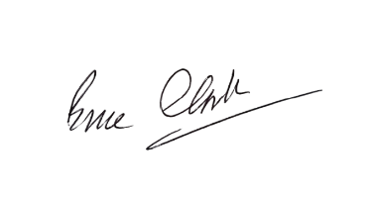

Bruce Clark

Note 1: Transactions with trustees and connected persons.

During the year, the charity received donations of £2,900 from one of its trustees, Mr. Bruce Clark. This donation is considered a related party transaction as defined by the Charities Statement of Recommended Practice (SORP). The donations were made without any conditions attached.

