 ADOPTION AND FOSTERING GROUP ANGUS

TRUSTEES' ANNUAL REPORT AND FINANCIAL STATEMENTS
for the year period
31st October 2024 to 30th October 2025
Scottish Charity Number: SC034175

Janet Robertson BAcc
Independent Examiner
2 The Fiddlers
Monikie
Angus
DD5 3QU

 ADOPTION AND FOSTERING GROUP ANGUS
Committed to Care
Scottish Charity Number: SC034175

Charity Address
Adoption and Fostering Group Angus
Dunlea, The Smithy
St Vigeans,
Arbroath
Angus
DD11 4RA
afgascotland@gmail.com


Trustees Annual Report
For the year ended 30th October 2025

The Charity Trustees present their report together with the financial statements and the Independent Examiners Report for the year ended 30th October 2025.

Reference and Administrative Information

The Charity's name is Adoption and Fostering Group Angus (otherwise known as AFGA)
The Charity Trustees are: -
Chairperson Mrs Jill Hamilton
Vice Chairperson Mrs Polly Milne
Secretary Mrs Dorothy Archer
Treasurer Mrs Kate Marshall
Management Committee Ms Kerry Roberts

Other during the period Mr William Hardy (30/10/2025)

Structure, Governance and Management

Adoption and Fostering Group Angus are an unincorporated organisation to which the purpose is set out in our constitution. The club is registered as a charity in Scotland. Trustees are recruited at the Annual General Meeting. The office Bearers are elected at the Annual General Meeting. The Trustees will have the power to co-opt throughout the year for a period to meet special need. The Charity has no paid staff and all tasks are carried out by volunteers.

Trustees Annual Report
For the year ended 30th October 2025

Objectives and Activities
Our charitable purpose is to provide support to Children who are Fostered or Adopted. Also support to the families who are involved in Adoption and Fostering. Support is provided on a one to one basis and organisation of educational and social events for these Foster children and families. The charity will continue in its efforts by applying for funding via grants and holding fundraising events. The income will then be spent on support and social events for the Fostered and Adopted Children and families. These are Vulnerable children who were unlikely to achieve or maintain a reasonable health or development before coming into care. They had little opportunity to achieve or participate in activities. Through trying new experiences and activities the children will learn new physical and social skills. They will gain the development of motor skills and stimulation of mental ability. Our activities help the foster child’s need of being treated equal to other children be address.

Achievements

Our activities this year were An Enchanted Forest visit for one family, A children’s party in Carnoustie with the Animal man and the children were given McDonalds Meals, Adult night out to an Edinburgh Theatre, Driving lessons, Horse Riding lessons, East Neuk Paddle Boarding, a day at Brechin Castle Centre , a ride on the Dinosaur Steam Train in Brechin, Aqua Splash Park, a trip to Lunan Bay beach for a BBQ , Funparx, Arbroath Football Ground Tour, Arbroath Football Trust gave us 4 season tickets, Teen Ranch, Holiday to Flamingoland with 13 caravans booked and a trip to London.
We have been doing many Fundraisers this year. Bingo evenings in Forfar, we held a Psychic Night in Forfar, Tesco Blue tokens, Tombola stall in Warddkyes School, Peter Thomson Farm Blue Berries picking, we have attended a few Car Boot sales, We are collecting ink cartridges to send to Recycle 4 Charity, The Sweet shop in Carnoustie gave us sweets for the children, Greggs donation, Asda gave us Easter Eggs for the children, Morrison, Asda and Tesco gave us Raffle Prizes, Other shops gave us raffle or bingo prizes and we have been give Sim cards for Phones.
We applied and received Funds from Carnoustie Charity Shop, The Rotary, Ground Works Tesco Blue Tokens, Network Rail, Scotmid Co-op, Aberbrothock Skea Trust, Co-op Community Fund, YHS Explorer Fund, Hugh F Foundation, Carnoustie Golf Link Trust and Cash for Kids. THANK You.
Fostering network came to talk to us, we started to have our meetings online for any member who could not physical attend, we also had evening meetings, A New Law came into force and all our committee had to add our charity to their PVG and we registered with Volunteer Scotland. Norman a member of our group told us about starting the group and why it was necessary.

Words from some Children
It was a wonderful opportunity to be with my friends and have fun trying new activities. Nice to support each other. Nice to have the freedom to spend time with friends. I feel I benefited as this time made me feel included, allowed me to engage in fun activities. Lots of laughter and fun had but I am very tired. Matthew

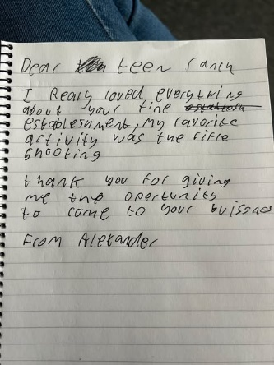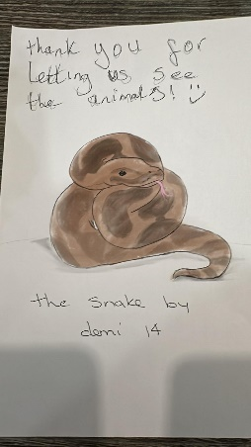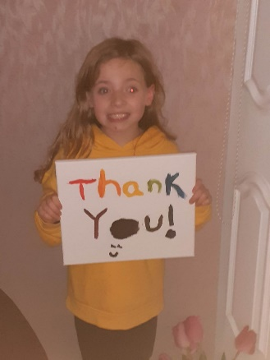

Future Plans
To continue being influential in changing the lives of young people and children in the care system, through group participation activities, which give the children and young people the opportunity to develop their Emotional, Social and Physical well-being. To provide opportunities for the children to connect with each other and build trusted relationships.

Trustees Remuneration and Expenses
There has been no remuneration to Charity Trustees during the period.

Financial Review
The results for the period are set out in the attached accounts. The results show a slight deficit of £1,061 for the year leaving unrestricted reserves of £16,396. The activities will be provided under the same objectives.
The trustee's reserves policy is to use any reserves to further the objects of the organisation. There are no funds required for reserves, as trips are booked in receipt of funds received. The trustees are responsible for the strategic direction and planning of the charity.

Approved by the trustees on and signed
on their behalf by:

Mrs D Archer  Secretary
Date of Signing 28/04/2026

