Commentary on the Trustees’ Annual Report and Accounts:
Any Dog’il Do Rescue

This report is for a dog rescue charity which operates in the South East of Scotland. It is incorporated as a SCIO.
The charity has income below £250,000 and as such is eligible to prepare its accounts on a Receipts and Payments Basis. The governing document does not require the charity to prepare fully accrued accounts and neither does it require an audit.
It was incorporated as an SCIO in October 2013 and the accounts incorporate the period from 1st April 2025 to 31st March 2026

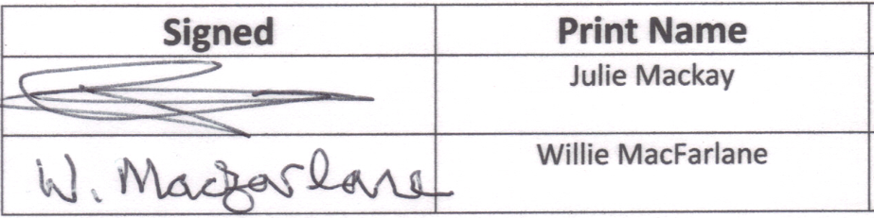 | Date
 | 15/04/26
 | 15/04/26

ANY DOG’IL DO RESCUE

SCOTTISH CHARITY NO: SC044302

ANNUAL REPORT AND FINANCIAL STATEMENTS
1 April 2025 to 31st March 2026

Trustees’ Annual Report
For the year ended 31 March 2026
The trustees have pleasure in presenting their report together with the financial statements for the period from 1 April 2025 to 31 March 2026.

Reference and Administrative Information
Charity name
Any Dog’il Do Rescue

Charity no
SC044302

Address
2 Cuffabouts, Carriden, Bo'ness EH51 9LP

Current Trustees
Lynn Patrick Chair
Julie Mackay Treasurer
Willie McFarlane
Paul Convoy
Suzanne Burt
Stewart Duffy
Structure, Governance and Management
Constitution
The Charity is a Scottish Charitable Incorporated Organisation (a SCIO). It was registered in its current legal form on 01 October 2013. The charity was previously an unincorporated association but changed its legal form to a SCIO. It has a single tier structure and as such the trustees are the members of the charity.

Appointment of trustees
The Committee, which normally meets every quarter, are the charity’s trustees and its key co-ordinators. Trustees are elected at the annual general meeting which is held in Edinburgh. There must be a minimum of three and a maximum of eight trustees.
We ended this financial year with the same six trustees that we ended last year with.

Objectives and Activities
Charitable purposes
To provide rescue, rehabilitation, fostering and rehoming services for abandoned dogs from the UK.
Activities
The charity provides rescued dogs with a safe environment through temporary kennelling, transport, assessment, fostering, training and rehoming.
Rigorous home checks are carried out by our trained co-ordinators to ensure any potential owner’s circumstances are suitable for our dogs before adoption. All our dogs are neutered, vaccinated and microchipped prior to adoption. Owners must sign an adoption contract which mandates that if the dog ever had to be rehomed it would be returned to our care.
The rescue runs 24 hours a day, 7 days per week.

Achievements and Performance
We have rehomed 32 dogs in the financial year 2025/2026. Which is 12 more than we rehomed in the previous year. Demand for rehoming abandoned dogs continues to increase, however, due to limited foster homes and private kennel spaces we are restricted on the numbers we are able to help.
ADDR is an entirely volunteer managed rescue and 100% of funds raised this year were targeted directly back into supporting the dogs in our care or to help us raise more funds. We did need to spend more money on fundraising assets to ensure that more money can be raised into the future.
We have again increased our co-ordinator numbers this year and they continue to specialise in activities such as rehoming, kennel support, social media and fundraising.
We started the year with 18 dogs and are closing the year with 23 dogs in our care, five of which are long term foster dogs.
Four of the dogs who came into us this year had been adopted previously but needed to be returned for a variety of reasons.
All of Pennies Puppies have now been neutered and all associated costs have been paid.

Financial Review
I am pleased to report that we have again shown an increase in our funds, after last years’ deficit. This is even more surprising since our vet bills were nearly 50% up on last years’ figures.
Our fundraisers had another amazing year but we also benefited from larger one-off donations from two sources. The family of a late dog lover donated in excess of £10,000 and a local Rescue decided to close and very kindly agreed to donate their outstanding funds to ADDR which came to nearly £13,000 – in return we have agreed to offer Rescue Back-up for any dogs they had previously rehomed.
We continue to use the skills of a good behaviourist to help some of our more challenging dogs.
We continue to use a more expensive kennels in Fife for one of our dogs as they are not welcome at our regular kennels due to behaviour issues. However, our kennel costs are still down by nearly £6,000.
We were able to pledge nearly £1,500 for dogs in pounds across the UK when we were not able to take them ourselves, helping to save more dogs.
Our savings account has accrued over £138 of interest. Thankfully we have not had to dip into our savings account funds which is our reserve for emergencies.

Reserves policy
The trustees’ policy is to retain an account balance of approximately £3,000 per month for three month’s worth of normal running costs. The trustees believe that this is an acceptable range based on current costs but will continue to monitor the situation.
Targeted donation and fundraising campaigns also ensures sufficient income is available to cover any unexpected expenditure (emergency vet treatment, etc).

Plans for future period
We will continue to rescue a variety of dogs from owner surrenders and whose time is up in high kill shelters; to offer them a chance of a new future.
We continue to recruit new emergency foster carers in order to keep our kennels fees down as much as possible.
As previously stated we intend to support our rescue partners financially in the coming year.

