
4th Fife Cardenden Scout Group
Trustees’ Annual Report
April 1st 2025 to March 31st 2026

Charity contact information

4th Fife Cardenden Scout Group
Scottish Charity Number: SC044791
Address – Easter Bowhill Farm
Cardenden
Fife
Postcode - KY5 OHB

Telephone number- 07748349808
Email address- Cardendenscouts@gmail.com
Facebook – 4th Fife Cardenden Scout Group

Charity Trustees

- Brodie Wallace
- Richard Cook
- Rosemary Wallace
- Leigh Grainger
- Emma Gilmour
- Lynn Jenks ( joined June 2025)
- Sheena Gilbert ( resigned June 2025)
- Pete Borthwick ( resigned June 2025)
- Graham Gilbert ( resigned September 2025)

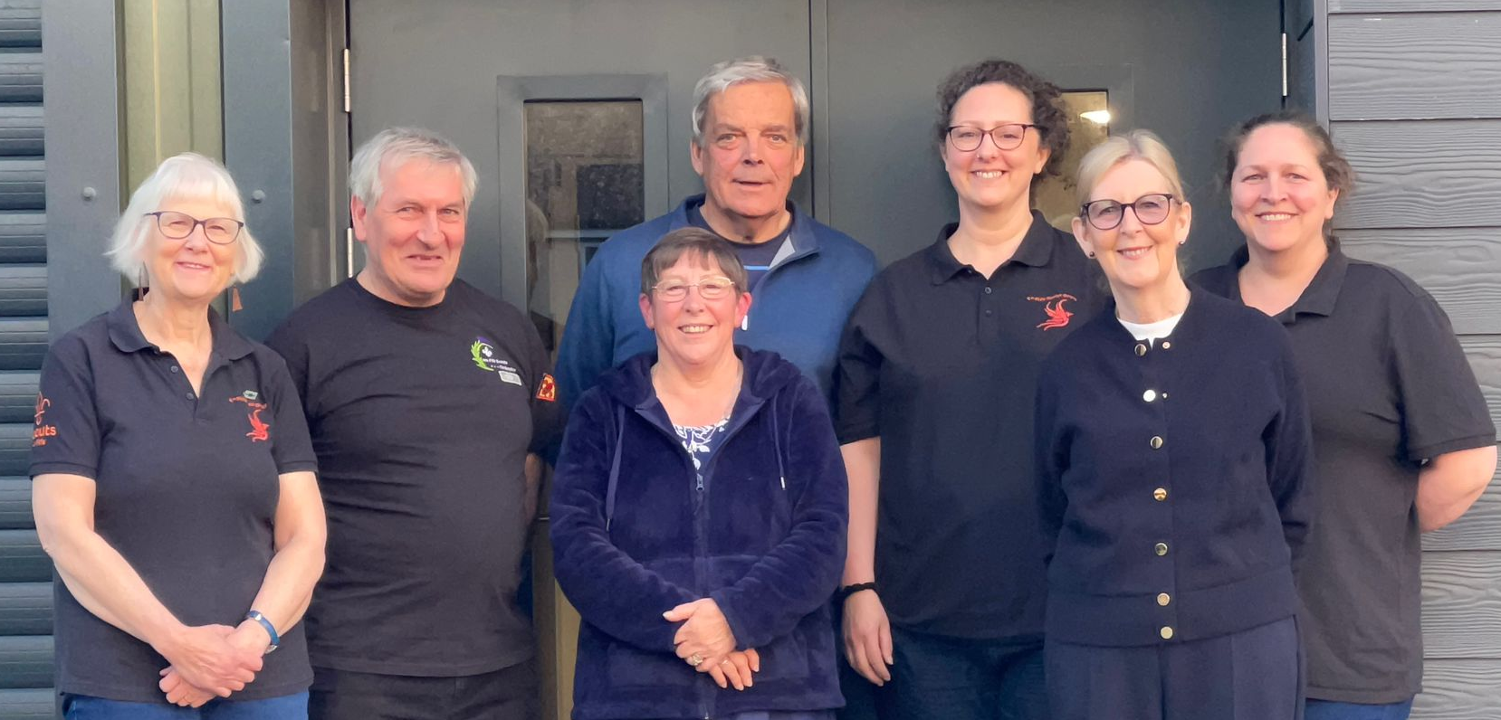

Pictured L-R : Rosemary Wallace, Brodie Wallace, Marie Gaffney (Group Lead Volunteer), Richard Cook, Emma Gilmour, Lynn Jenks and Leigh Grainger.
Objectives and activities
The Scout group is constituted in terms of the rules of the Scout Association which is a charitable body incorporated by Royal Charter.
The purpose of the Scout Association is to promote the development of young people in achieving their full physical, intellectual, social and spiritual potentials , as individuals, as responsible citizens and as members of their local, national and international communities. The method of achieving the aim of the Association is by providing an enjoyable and attractive scheme of progressive training based on the scout promise and law and guided by adult leadership.
Achievements and performance
Activities and Achievements 1st April 2025 to 31st March 2026.
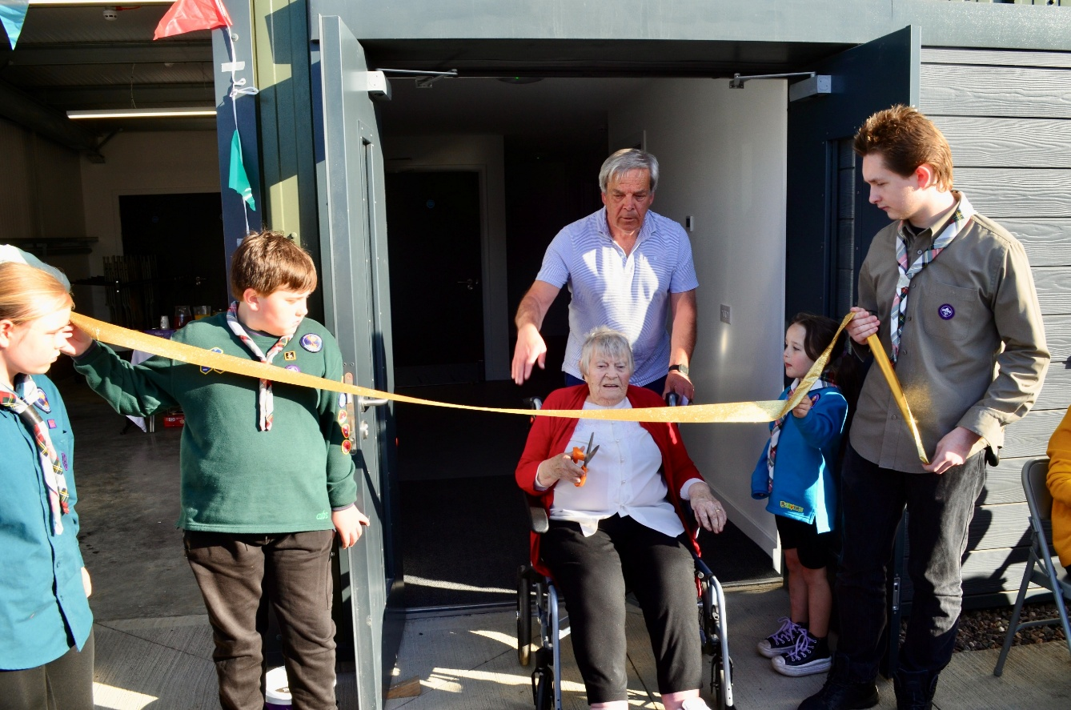
The main achievement for the group this year was the official opening of our new hall on May 28th the result of 6 years of fundraising after the devastating fire in February 2019 destroyed our old hall. The group was 100 years old in 2024 so it was most appropriate that a local 101 year old officially opened the hall.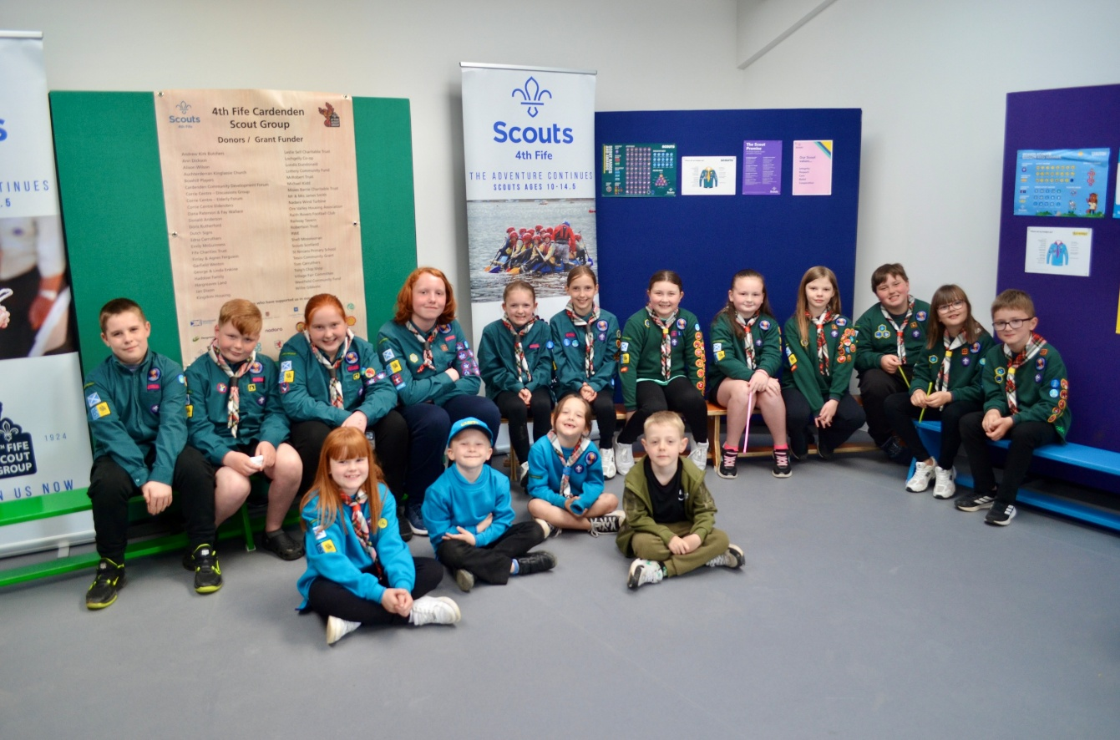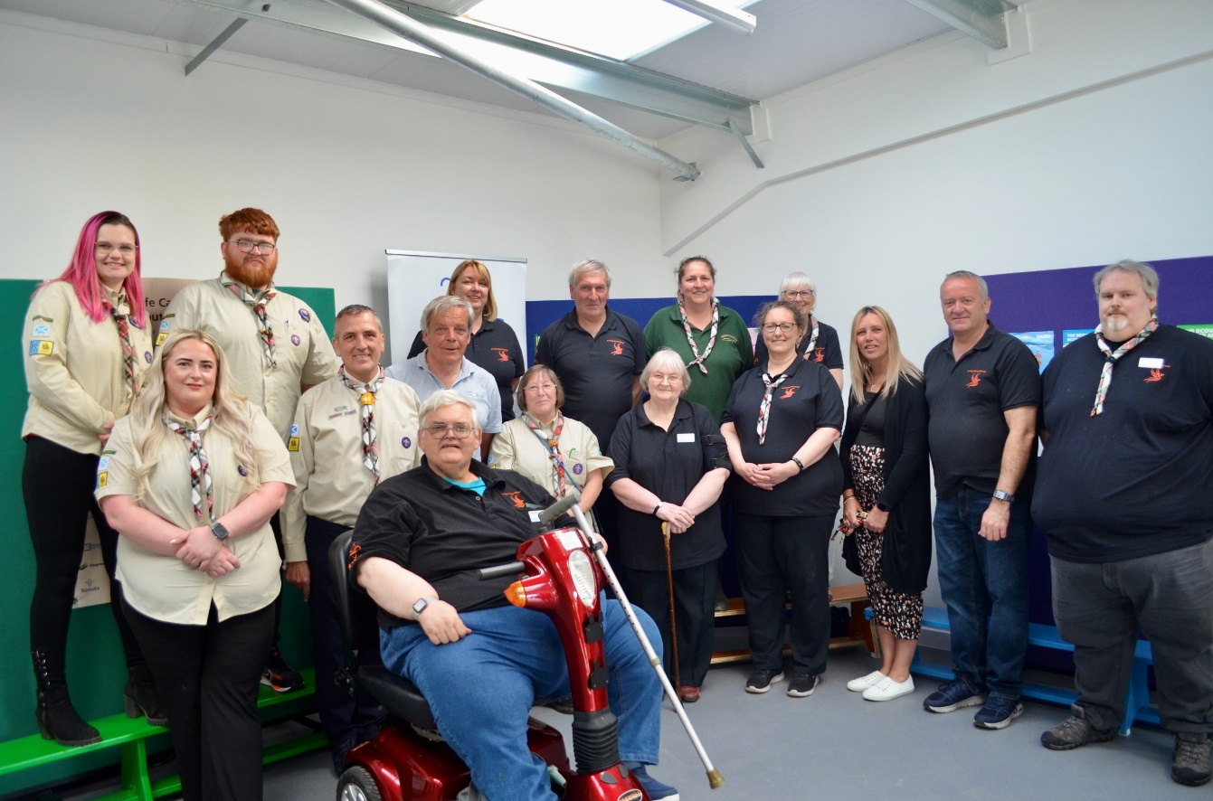

Additionally we have recruited new volunteer leaders who have organised new activities and camps for all our young people. Numbers continue to grow and waiting lists are in place .
LOTS OF ACTIVITIES AND ADVENTURES
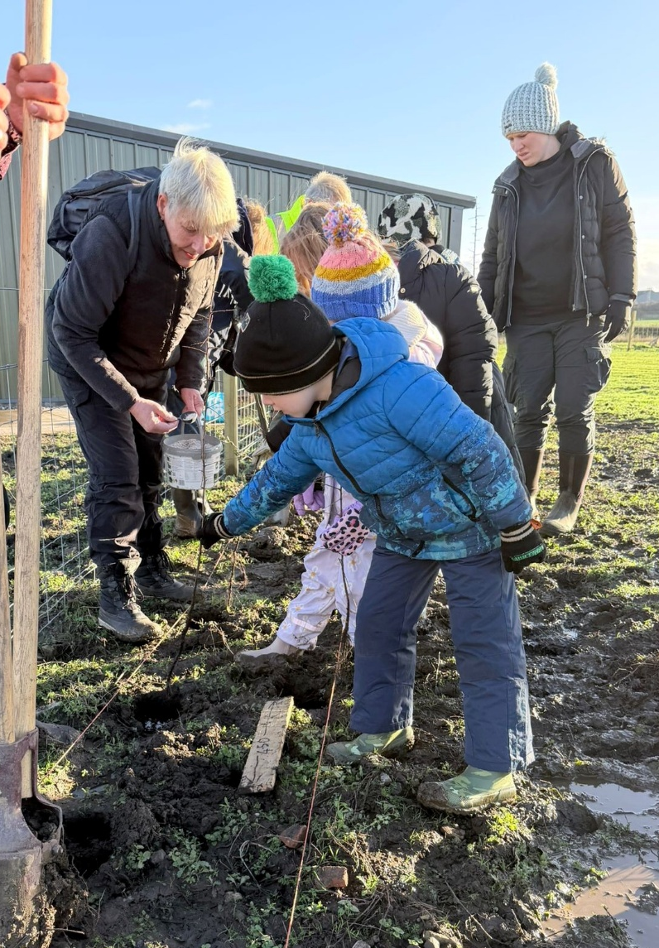
Hedge planting was an intergenerational event.

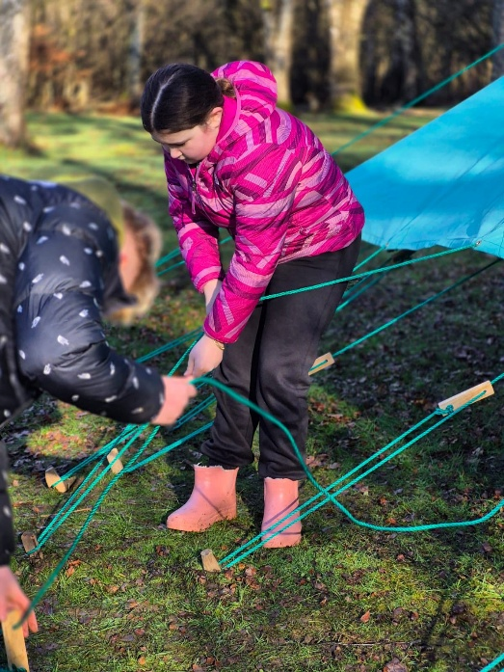
Camps
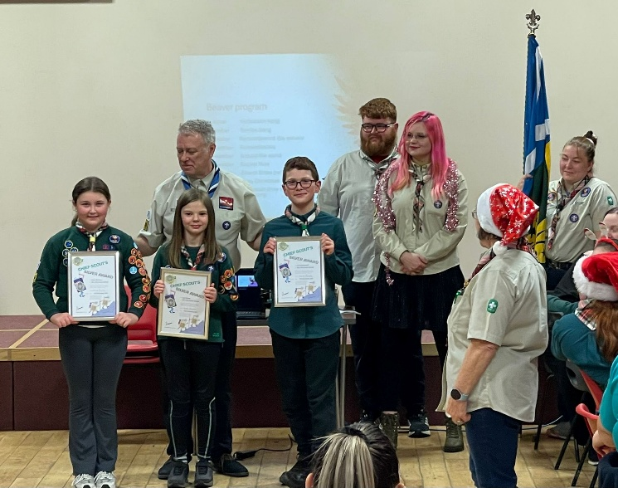
Lots of Chief Scout Awards

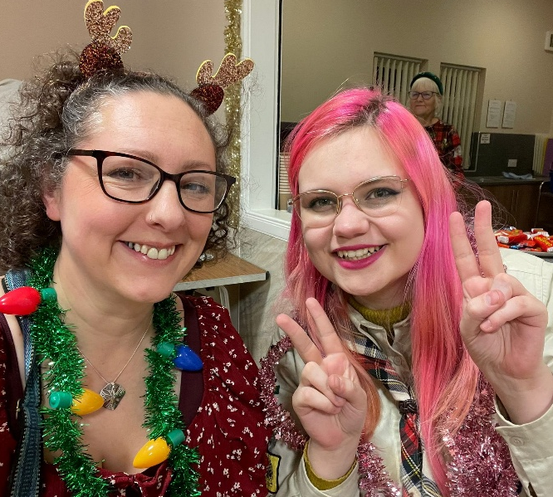
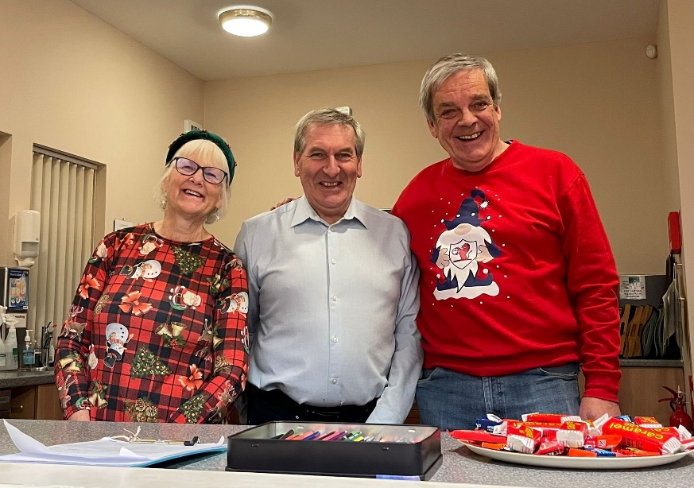
Putting the ‘fun’ into fundraising.

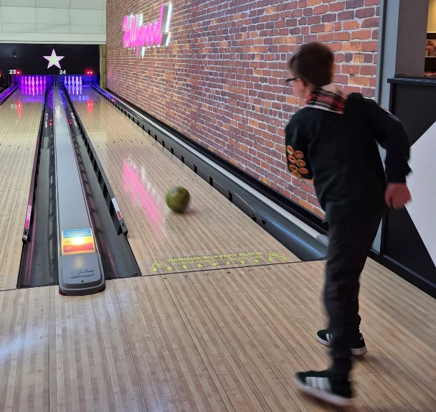
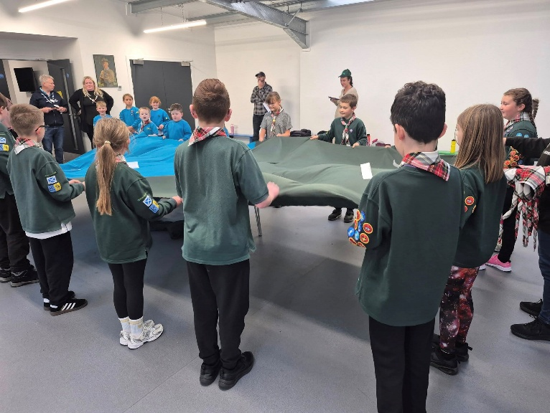 ‘Swimming up’ in our new hall
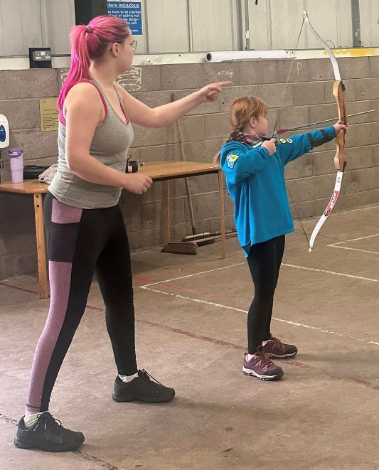
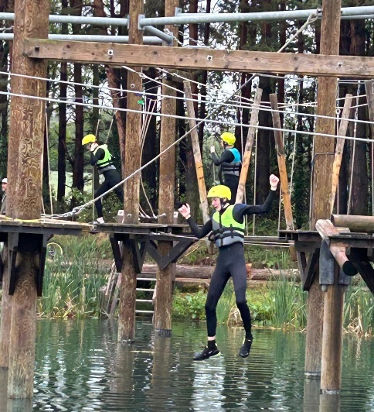
Bowling

Archery sessions

Waterpark adventures
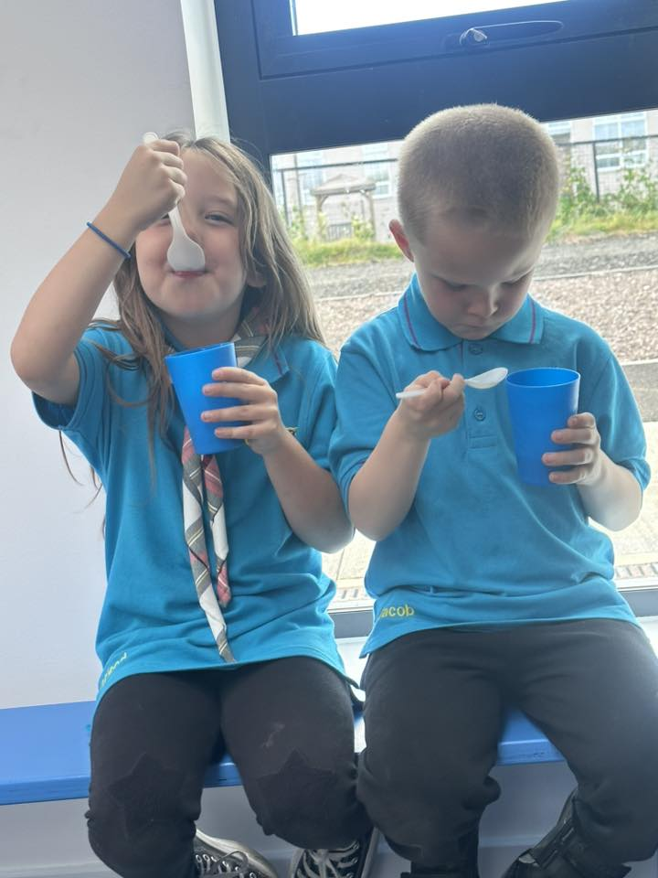
Making delicious ice-cream!
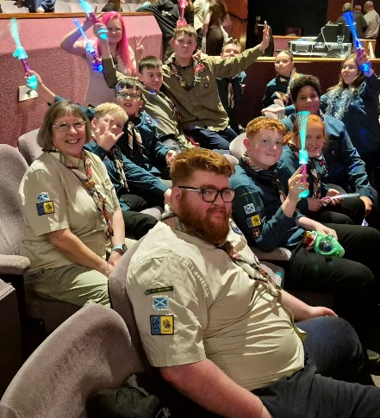
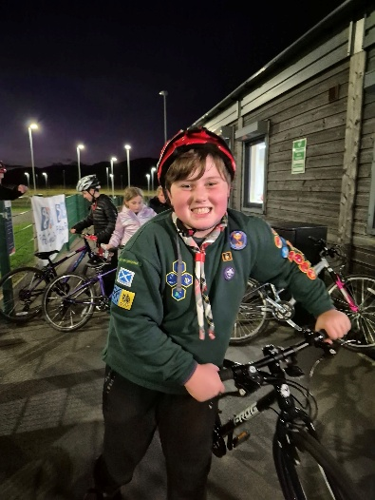
Cycle skills. Theatre trip.
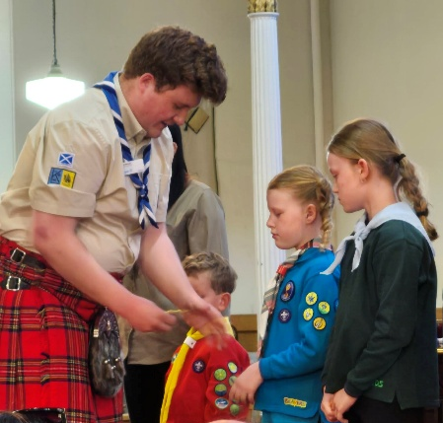
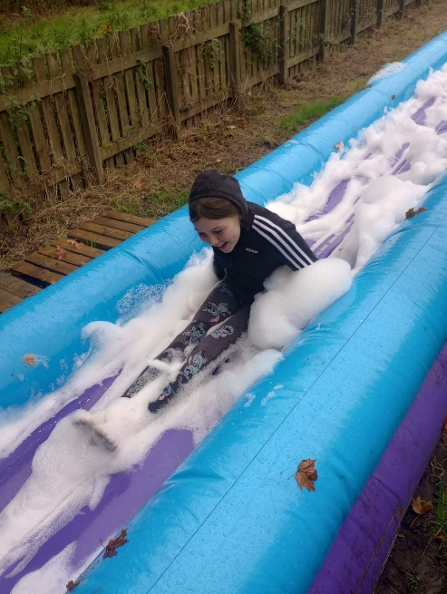

Badges on St Georges Day

Foamy fun at camp

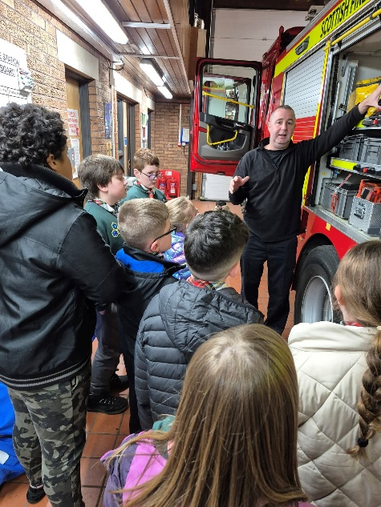

Fire station visit.

