Formerly known as Age Concern West Kilbride
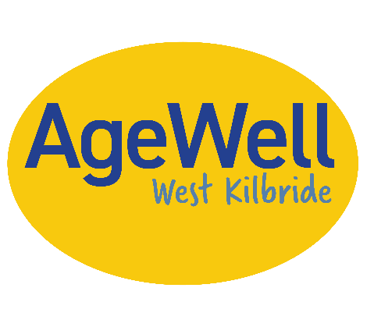
TRUSTEES ANNUAL REPORT AND ACCOUNTS
FOR THE YEAR ENDED 31 MARCH 2026
SCOTTISH CHARITY SC001342

CONTENTS PAGE

Organisational Information 3
Trustees report 4

FINANCIAL STATEMENTS
Receipts and Payments Account 1
Statement of Balances 2
Independent Examiner’s Report 3

TRUSTEES Kay Hall
Anne Paton
Sheila Plimbley
Barbara Sharp
Nicol Armstrong
Isobel Reid

ADDRESS c/o 10 Castleview
West Kilbride
Ayrshire
KA23 9HD

BANKERS Royal Bank of Scotland
Irvine (E) Branch
69 High Street
Irvine KA12 0AL

CHARITY NO. SC001342

REPORT OF THE COMMITTEE
The Committee has pleasure in submitting its Report for the year ending 31 March 2026 which complies with current statutory requirements and with the charity’s constitution.
STRUCTURE, GOVERNANCE AND MANAGEMENT
The Association’s original Constitution was adopted on the 5 September 1978 and was updated and registered with OSCR in October 2023. This includes our change of name.
The Association is unincorporated and is registered as a charity in Scotland under number SC001342.
The policy and general management of the Association is directed by a committee (hereinafter called “the committee”). Members are elected to the Committee at the Annual General Meeting and hold office for one year. All members are eligible for reappointment.
Membership is open to any interested party.
The Committee elects the honorary officers of the Association who are the Chair, Secretary and Treasurer. The Chair, or if unavailable, Secretary presides at all meetings of the Committee or of the Association.
New committee members will be provided with information and links to brief them on their legal obligations under charity law, the content of the constitution, decision making processes and recent financial performance of the charity.
OBJECTIVES AND ACTIVITIES
The objects of the charity are to promote the welfare of older people in any manner which is deemed by law to be charitable within Scotland.
Activities in furtherance of these objects are:
- To promote the welfare of older members of our community and cooperate with other groups in order to do so.
- To consult with our community and consider their views and ideas regarding our priorities.
- To identify and advertise activities which would promote and support the quality of life of older people.
- To organise services and events for the benefit of older people in our community.
- To liaise with North Ayrshire Council, Age Scotland and other agencies in order to access support and advice for our work.

ACHIEVEMENTS AND PERFORMANCE
The previous year’s AGM was held on 2nd June 2025.
Over the following year Kay Hall remained as Chair, Barbara Sharp as Secretary and Nicol Armstrong as Treasurer. Anne Paton remained as the coordinator for the hospital transport service and Sheila Plimbley managed the Yuletide Lunch and promoted other activities.
CHAIR’S REPORT – Kay Hall
Since this new committee group was established in 2022 each of us have settled into areas of responsibility and an annual pattern of events and services have been planned and managed and are detailed in the following reports. We work together closely and offer support to those who take leading roles.

We have contributed to North Ayrshire’s and North Coast’s Older People’s Forum where we have shared ideas, suggestions and resources. We are well known to the Officers of the Council and value their support and interest.

SECRETARY’S REPORT – Barbara Sharp
Following the success of our resource booklet for older residents, ‘Age Well West Kilbride’ (2024), we updated the publication this year. The update was produced by our Trustees and the printing of 250 copies funded by the local West Kilbride Lottery.

Once again, the publication focuses on activities and sources of support most likely to be of interest to older people. Information has been updated and new resources added. A brief description, contact details, online links and QR codes (as available) are given for each categorised entry. All contributors to the previous version of the resource were invited to submit changes and new contributors invited to prepare a short script.
On completion of writing and printing the 2026 update, all contributors were provided with an interactive digital version of the booklet. Supplies of the booklet were distributed to the local GP surgery, the Village Hall, Local Library and Village Larder.
Local professionals have warmly welcomed the resource:
‘These resources are really valuable for my work within mental health. Helping people to stay engaged and connected within their community can be a key part of my therapeutic work with people. And often finding appropriate activities for those in older age groups can be limited. As a busy clinician working across all of Ayrshire and Arran it can also be hard to keep up to date with what is going on in different areas and resources such as these help with staying up to date and they are good accessible resources that can be shared with people I work with’. Dr Nikki Miller, Principal Clinical Psychologist 2025.
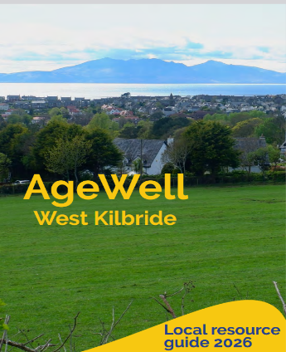
Social media posts promoted the availability of the resource and where people could pick up a copy and/or access a digital version.
Link to the digital version of the resource is here -
https://drive.google.com/file/d/1rD0IDfn-PvG1G6PNONXPfoTLb33El1IA/view?usp=sharing
Older people attending social groups in the West Kilbride Village Hall, Community Centre and Parish Church assisted in the promotion and the local Co-op supported with supplies of tea and coffee.

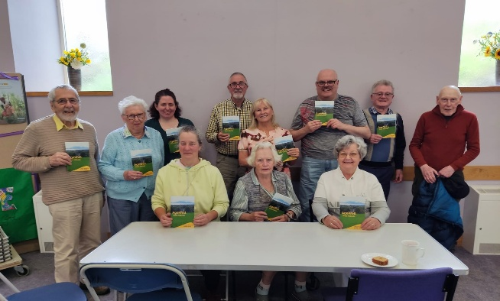
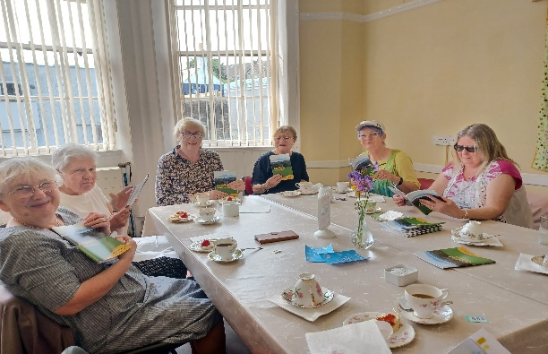
CHRISTMAS MEAL – Sheila Plimbley

Funding to support the cost of providing a Christmas Meal to 200 people was provided from North Ayrshire Council to the sum of £2,623. Christmas Lunch at the Seamill Hydro
The Christmas Lunch is held at the beginning of December annually in Seamill Hydro. It is a two course meal consisting of a main course and dessert followed by tea or coffee. Tickets at a subsidised cost of £10 each, go on sale in November at different venues around the village. They are greatly sought after and sold only to people who live in KA23 area and are mostly over 70 years old. They are sold on a first come first served basis. We provide transport for people with mobility problems.
In 2025 we again catered for 200 people and had a wonderful afternoon meeting up with friends who they can’t see regularly. We also have a free raffle with prizes mostly donated by the local Boys Brigade Company. We appreciate the collaboration with Community Roots who provided free places at the lunch for Village Larder customers
Summary of 24/25 year of Hospital Transport - Ann Paton
In Dec 2025 the West Kilbride Community Trust granted £2000 to support the recruitment and training of volunteer drivers, contribute towards their expenses and meet the new requirements associated with Protection of Vulnerable Adults legislation.
Age Well West Kilbride recognises the problem of travelling to hospital appointments in Ayrshire
and beyond while dependent on public transport - an appointment at Ayr hospital, for example,
can involve a journey of 5.5 hours - and therefore provides a hospital transport service for older
people who cannot access the Ambulance Patient Transport to attend their NHS appointments.
This services operates in conjunction with the local GP surgery in West Kilbride and is dependent
upon volunteer drivers using their own cars and giving their time.
In the last year the volunteer drivers have provided transport for 160 appointments to the
following hospitals
Crosshouse
Ayr
Ayrshire Central
Brooksby
Golden Jubilee
Gartnavel
East Ayrshire Community Hospital
There have been several visits to dental practices in the Three Towns and Irvine, this is reflective
of the fact that there is no longer a dental practice in West Kilbride. This has been a commitment of over 480 volunteer hours with a total mileage covered of 6,725.
Overall the requests for our service have increased by 50% from last year and we are very
indebted to the volunteers who provide this greatly valued service.

GARDENING REPORT – Kay Hall
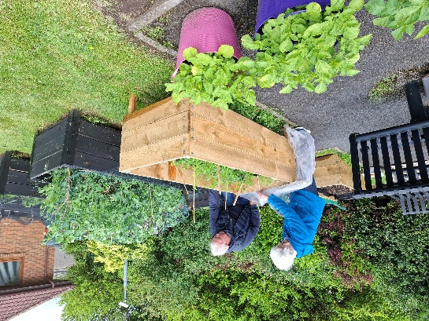
We have been well funded by the Coop Community Fund and during 2025 received £2,375.90 to spend on projects.

We have continued to support Headrigg Gardens most recently providing them with a strimmer to ensure the area around the raised beds may be kept tidy.

We have continued to support Burnside place and welcomed volunteers from the Environmental Group to carry out some heavy digging, branch cutting and weeding. The area is a delight.
Earlier this year we cleared a derelict area at Coldstream ready for the older residents to be able to plant there. We are hoping this may stir up some local interest and will revisit the site in the new year.
A newly retired group have been set up to manage the War Memorial Garden as the original gardener was finding the work rather overwhelming. This has proved to be very successful and new plants have been sourced and new friendships have been made.

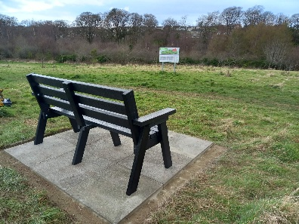
A bench was requested by older dog walkers to be placed in the Orchard as a half way resting place with a lovely view. The Civic Society and Environmental Group paid for the Labour to carry out this work and Age Well bought the bench.

TRUSTEES RENUMERATION AND EXPENSES
No trustees received renumeration during the year. Reimbursement of expenditure is allowed under the constitution and mainly applies to our volunteer drivers.
FUTURE PLANS
Working with local community groups and local agencies we will raise awareness about activities and the sort of help and support which are already available locally.
We will continue to promote further activities to encourage social contact and personal interests. We remain committed to providing the hospital transport service.
We will continue to seek ways to promote engagement with residents at Headrigg Gardens. We have started to extend this support to other sheltered premises in our town.
We will strengthen our relationships with other groups and attend North Ayrshire forums which seek to improve the quality of life for our older community members.
ACCOUNTS AND FINANCIAL REVIEW
The Treasurer’s Report is attached - see pages 1-3
Total Income for 2025 ~ 26 financial year = £ 9893.56

Total Expenditure for 2025 ~ 2026 was = £ 9091.08
The Association is greatly indebted to the volunteers who gave their time and effort freely during the year.
Signed on behalf of the committee
KAY HALL
DATE: 28th July 2026

