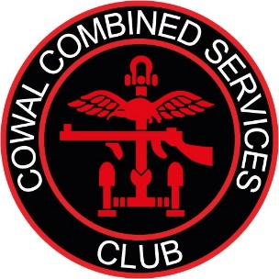

COWAL COMBINED SERVICES CLUB

MINUTES OF ANNUAL GENERAL MEETING – 22 May 2026
AT 1900hrs
BLAIRMORE VILLAGE HALL, BLAIRMORE, BY DUNOON

Present
Andrew Armstrong, AA; Iain Collinson, IC; George Darroch, GD; Henry Henderson, HH; Pauline Horton, PJH; Pam Horton, PAH; Alistair McLaren, AM; Rick Murry, RM; Linda Murry, LM; and Chris North, CN.

Apologies
David & Marion Achard, Lenny Davis, Jeffrey Douglas, Ken Lawns, Jo & Pete McDill, Allan Moore, Mike Osinski, and Gerry Pursley.

1. Chair’s Report
GD welcomed all as he opened the meeting at 1901hrs. In PM’s absence, PJH took the minutes. The minutes of the previous AGM were adopted as a true record and were proposed by CN, seconded by LM, with no objections or comments.

Year in Review
In 2025, we grew stronger as a group. While some members moved on and others joined us, it remains important that we continue to promote the value of membership and the support we provide within the community.

Planned Visits
The visits we hoped to arrange remain beyond our budget, but they have not been ruled out. We have reviewed costs and identified ways to make future trips more affordable. For example, rail travel with a railcard would be cheaper than hiring a coach, although accommodation costs for longer visits would stay much the same.

Welfare Support
The welfare team had a quiet year, handling two straightforward cases. In both, the necessary information was gathered, and the matters were referred to larger agencies and national charities. We also received two referrals from outside the membership, but after initial contact both individuals decided they did not need our support. One case remains under discreet review.

Activities and Events
During the year, members and the wider public took part in a variety of activities, including:
- social events such as film and games nights.
- a small but dedicated group of regular gym members
- planning for future visits and social events

Film Nights
Film nights remained popular, with screenings focused on Navy, Army and Air Force themes. Greyhound was probably the most popular, while Reach for the Sky had members slipping into 1940s accents and phrases.
Two members again provided ice cream, while others brought snacks, which were much appreciated. However, changes to the Argyll & Sutherland Highlanders Association’s staffing payment policy, along with their increased use of the venue on Friday and Saturday evenings, have reduced our access.

Dunoon Veterans Breakfast Club
The Dunoon Veterans Breakfast Club (DVBC), a subsidiary of CCSC, continues to meet on the first Sunday of each month. Because of winter closures at Hunter’s Quay Holiday Village, we returned to the Argyll Hotel in Dunoon, and this became a permanent arrangement during the year. Attendance still varies because of other commitments, but numbers are rising steadily. It remains a valuable chance for members to catch up.

Remembrance Weekend
Remembrance weekend was again a great success. We supported the Dunoon Remembrance Parade on Sunday despite the weather and also had a small presence at Dunoon Grammar School’s Friday services. There was an excellent turnout at the war memorial on the 11th at 1100hrs, where Garelochhead Service Trust joined us and provided soup and sandwiches at the Argyll Hotel.

Christmas Party and Games Night
Our Christmas party and games night took place in December, with the team organising an excellent range of activities. Competition was strong throughout. Indoor curling, though improvised, quickly became one of the evening’s highlights, with Alan proving especially skilled. Jenga was a close second, while the hula hoop games tested hand-eye coordination.

Looking Ahead

Overall, we are moving forward with momentum and intend to build on that progress in the year ahead. Thank you for your continued support.

2. Treasurers report
- As a matter of record all current Trustees are on the Banks mandate. As such they can independently review the account on-line.
- For transparency it should be recorded that the treasurer is also the treasurer for the Cowal fiddle workshop and Blairmore Hall trust.
- PJH gave an overview of the financial situation of the ‘Reporting Year’ (same as calendar year). She explained that we continue to operate without a deficit.
- Opening balance £5440 plus £1976 (years income) minus £1856 (years expenditure) results in £120 income. Cash in Bank equals £5560.
- RM proposed that her statement was an accurate reflection of the accounts, this motion was seconded by CN and subsequently carried.
- During the year, we benefited from donated facilities and services. The Argyll Hotel allowed us to use its restaurant for the DVBC free of charge, and we hope this support will continue in future years. When we have used the Argyll & Sutherland Highlanders’ Association Club in Union Street, Dunoon, they have also not charged us for venue use, power or staff, although this is beginning to change and a small charge to cover staffing costs has been introduced. We also received professional support from Betty Adams, a former HMRC inspector, who reviewed our accounts before submission to OSCR at no cost. This likely saved the charity around £300–£500 during the financial year.

3. Election of Trustees
PJH stated that in accordance with our constitution all the Trustees, except herself, would now resign.
PJH said that she had 6 names put forward for 7 trustee positions; she explained that she was required to ask for any nominations for that 7th position from the floor. None were forthcoming.
CN proposed PM as a trustee; seconded by PAH and carried by vote.
LM proposed GD as a trustee; seconded by IC and carried by vote.
PAH proposed CN as a trustee; seconded by RM and carried by vote.
CN proposed RM as a trustee; seconded by KL and carried by vote.
LM proposed KL as a trustee; seconded by CN and carried by vote.
At this stage PJH resigned as a trustee and GD took control of the AGM.
GD proposed PJH as a trustee; seconded by CN and carried by vote.
That concluded the election/re-election process of Charity Trustees.
Please note that votes are for Trustee positions only – officer posts are decided amongst the Board of Trustees
4. Chair’s Closing Remarks
GD thanked everyone for attending and ensuring the meeting was quorate. AM asked that the membership’s thanks be recorded for those serving as trustees in what can often feel like a thankless role. GD also invited everyone to stay after the AGM to discuss proposed social activities and visits for the year ahead.
5. AOCB
PJH proposed further discussion on whether the loss of the social events calendar is affecting camaraderie within CCSC. The main issue remains finding a suitable venue with good availability, parking, enough space, and easy access to refreshments. One option would be to rotate events between Blairmore Hall, Sandbank Hall and Innellan Village Hall, using in-house games such as indoor curling, Jenga and Connect 4.

6. Close
There being no further business, PJH, thanked all again and closed the meeting at 19.29 hrs

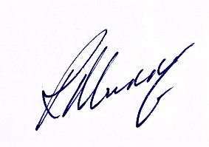
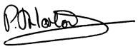

Chris North Pauline Horton Rick Murry
Member Treasurer Member

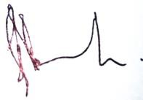
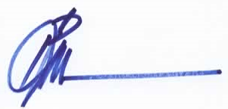
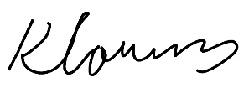

Ken Lawns Peter McDill George Darroch
Member Secretary Chair

