Mauchline Burns Bairns Under 5’s Group
Trustees Report
Year End 31st March 2025

Name and Address
Mauchline Burns Bairns Under 5’s Group
c/o The Centre Stane, 2 The Cross, Mauchline, KA5 5DA

Governing Document
Mauchline Burns Bairns Under 5’s Group is a Scottish Registered Charity (Charity Number SC028797) and a Company Limited by Guarantee Not Having a Share Capital (Scottish Registered Company Number SC354423). It is governed in accordance with the Memorandum and Articles of Association of Mauchline Burns Bairns Under 5’s Group.
Charitable Purposes
The organisations objects are:
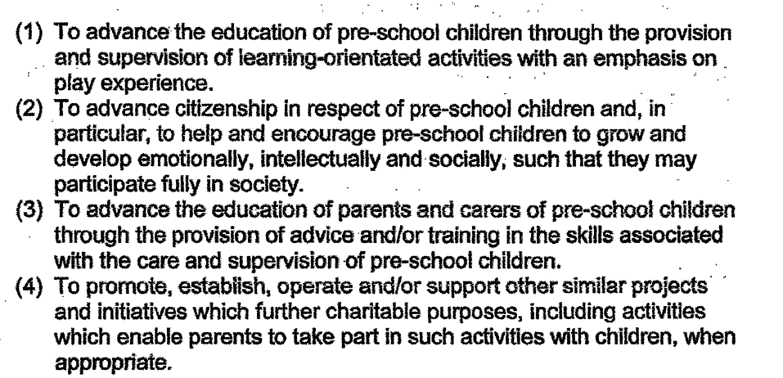

Trustees:
Chairperson: Kirsty Mair
Treasurer: Claire Ritchie
Secretary: Claire Duff
Other Trustees: Laura McEwen
: Gloud Ritchie

Trustee Recruitment and Appointment:
Trustees hold regular meetings throughout the year and generally control and supervise the activities of the company. Any members of Mauchline Burns Bairns Under 5’s group (parents and gradians of children regularly attending the service) are eligible to be appointed as trustees. Employees of the company shall not be eligible for membership; a person who becomes an employee of the company after admission to membership shall automatically cease to be a member. Trustees are elected at the Annual General Meeting.
Achievements and Performance:
Throughout the year, Mauchline Burns Bairns Under 5’s Groups have continued to deliver high-quality services for pre-school children and their parents/carers within the local community, in line with our charitable aims.
During April and May, the children explored the life cycles of plants and animals, using The Very Hungry Caterpillar as a key learning stimulus. This was enhanced through hands-on experiences, including planting seeds outdoors to give real-life context to their learning. The children also demonstrated creativity and imagination through junk modelling activities, where they designed and created their own farm animals and insects. During this period, two new members of staff were successfully recruited to help address staffing shortages and strengthen the team.
In June, we welcomed a visit from the Care Inspectorate, which recognised significant improvements across the service. Burns Bairns was awarded grades of “Good” (4) in both How good is our setting? and How good is our staff team?, reflecting the hard work and dedication of the team. The children also enjoyed our annual summer trip to Dumfries House on 13th June. The day included time in the play park, a fun and active sports day, and opportunities to explore the STEM area.
Learning continued in June with a focus on babies and caring roles. Through imaginative play in the home corner, children developed an understanding of how to care for babies and keep them safe and healthy. We were also delighted to welcome a photographer, who captured a range of special moments. Pre-school children took part in a transition visit to Mauchline Primary School, helping to prepare them for the next stage of their learning journey. This was followed by a graduation ceremony, which provided a warm and memorable send-off, filled with celebration, laughter, and a few emotional goodbyes.
Trustees successfully negotiated with Mauchline Community Association to secure continued use of the Centre Stane for the forthcoming academic year, maintaining the same cost as the previous year and ensuring stability for the service.
In August, we were pleased to welcome back returning children for their second year, alongside new children and families beginning their journey with Burns Bairns.
September marked a significant and exciting milestone, as Burns Bairns purchased a plot of land in Mauchline with planning permission for a purpose-built nursery. This development represents a major step forward for the organisation, and we look forward to progressing these plans.
In October, the children enjoyed a fun-filled Halloween celebration, dressing up in costumes and taking part in a variety of themed games and activities.
December was a busy and joyful month, with a range of festive experiences including a Christmas lunch, a visit to Mauchline Primary School’s nativity, a pantomime trip, and our Christmas party, which featured a special visit from Santa.
Our Bump, Baby and Child Group has continued to grow in both attendance and impact, offering valuable support, social opportunities, and engaging activities for parents and young children.
At the end of March, trustees met with a business adviser, with support from East Ayrshire Council, to explore the next steps in progressing plans for the new nursery building and to help move this exciting project forward.

Financial Review:
The accounts this year are attached as part of this report. Fully accrued accounts along with the statement of balances for the year end March 2024 disclose a total balance of £156,763.35 (previous year £184,182.64). The accounts have been independently examined by Allison Walker, Mint Accounting.
During this financial year we have had a reduction in income of £13,961.79 and a significant increase in professional fees due to staffing issues and the purchase of a fixed asset, resulting in an overall deficit of £27,419.29. Trustees are actively pursuing means to increase our income and are working to develop a business plan to increase the revenue we generate over the coming years, so we are not as dependent on funding from East Ayrshire Council. To achieve this, we have purchased a site with planning permission (fixed asset) to build our own nursery building allowing us to generate greater income and make Burns Bairns more sustainable.
Reserves Policy:
The charity trustees have considered the reserves required and have taken into account their current and future liabilities. It is the Trustees’ policy to hold reserves equivalent to 4 months operating costs of Mauchline Burns Bairns Under 5s group. A separate restricted fund in also held to cover the cost of any staff redundancies.

This report has been approved by Mauchline Burns Bairns Under 5’s Group Trustees.
Signed on behalf of the Trustees.
Kirsty Mair
(Chairperson)

