APPENDIX 1

OSCr | Trustees’ Annual Report for the period
OSCr |  | Period start date |  |  |  | Period end date
OSCr |  | Day | Month | Year |  | Day | Month | Year
OSCr | From | 1 | 1 | 2025 | To | 31 | 12 | 2025
Office of the Scottish Charity Regulator

Reference and administration details

Charity name |  | Urban Uprising
Other names charity is known by
Registered charity number |  | SC044205
Charity’s principal address |  | 22 East Claremont Street, Edinburgh
 |  |  | Postcode EH7 4JP

Names of the charity trustees on date of approval of Trustees’ Annual Report

 | Trustee name | Office (if any) | Dates acted if  not for whole year | Name of person  (or body) entitled to  appoint trustee (if any)
1 | Stuart Green | Chairman
2 | Sarah Hayden | Secretary
3 | Julia Jackson | Treasurer
4 | Robert Sutton
5 | Thomas Ray
6 | James McMeekin
7 | Emma Caldwell
8 | Andrew Patrick
9 | Thomas Davey
10
11
12
13
14
15
16
17
18
19
20

1
APPENDIX 1

Reference and administration details

Names of all other charity trustees during the period, if any, (for example, those who resigned part way through the financial period)

Name | Dates acted if not for whole year

Structure, governance and management

Type of governing document | Scottish Charitable Incorporated Organisation. We were formally registered on 15th Aug 2013.
Trustee recruitment and appointment | Appointment and removal is in accordance with the Charities Constitution which requires Trustee appointments to be approved by unanimous agreement of the existing trustees at the next Board Meeting.

Objectives and activities

Charitable purposes | At Urban Uprising, we help give disadvantaged young people the opportunity to transform their futures.  Urban Uprising’s vision is a society where all young people feel engaged and empowered to create a positive future for themselves. In partnership with climbing centres and committed volunteer role models, we are here to support young people to address and overcome the individual root causes of the problem and become their own agents of change.
Summary of the main activities  in relation to these objects | Our unique climbing programme gives 8-18 year-olds who face various challenges in life the chance to develop their physical, social and personal strengths with the support and encouragement of highly trained positive coaches. There are barriers – both individual and societal – that prevent some young people from accessing and consistently engaging with new experiences. Urban Uprising’s vision is a society where all young people feel engaged and empowered to create a positive future for themselves. In partnership with climbing centres and committed volunteer role models, we support young people to address and overcome the individual root causes of the problem and become their own agents of change.  Urban Uprising operates programmes in Glasgow, Edinburgh, Aberdeen, Cambridge, and Bristol often working with young people from the most deprived areas.  These local areas have been identified through our own community mapping, consultation and government data for multiple deprivation indicators. This way we know we are operating where the need is greatest. We collaborate with local youth organisations and schools who know the communities well and are able to identify the young people who are most in need.  PROGRAMMES  Our programme centres on personal development and life skills. Through our sessions, young people can discover a sense of be- longing to a new and different community with many positive role models. We tailor the programme slightly for each group to suit their age, maturity and other specific needs. We also consider any particular areas of focus our partner organisations have been working on with the young people to date.  Through a 10-week structured indoor ‘Climb’ programme young people are taught how to climb safely and responsibly. Each weekly session is 1.5 hours long, and - where resources and instructors are available - participants are invited to take part in a day of outdoor climbing at the end of the programme.  Following the 10-week Climb Programme, groups can attend ‘Repeat’ programmes. This allows participants to continue improving their climbing skills and build on the positive relationships they have developed with our volunteers and instructors. This allows us to deepen our impact significantly for the young people who choose to keep going.  The young people are guided through the accredited National Indoor Climbing Award Scheme (NICAS). This gives them a focus for the physical and technical aspects of climbing, as well as a component of safety and managing risk which helps a lot with building confidence.  IMPACT  Our programme has 3 main outcomes for the disadvantaged young people.  Increased confidence to try new things  Increased resilience to deal with failure  Increased participation in physical activity  Rock climbing can be daunting, and breaking through that barrier to try it for the first time, or to try new and harder climbs, is a real confidence builder. The nature of climbing is that you are failing more than you are succeeding, and the experience of not being able to get past a certain point - or falling off the wall entirely - is an important part of it. Building resilience to deal with this failure and understanding that failing is a learning opportunity (and nothing to be afraid of) is very empowering for the young peo- ple. Showing up, taking part and being physically active is not only good for physical health, it is also a great boost for mental health.

2

APPENDIX 1

Achievements and performance

Summary of the main achievements of the charity during the financial period | Key achievements in 2025:  - Worked with 194 young people across 18 groups.  - Ran 153 indoor sessions and 11 outdoor sessions including a residential.  - 89% of participants showed increased confidence.  - 86% showed improved resilience to failure.  - 88% increased participation in physical activity.  - Delivered first programme at Bloc10 Aberdeen  - Successful residential with Edinburgh Young Carers.  - New partnerships with The Perse Sports Centre in Cambridge, Redpoint in Bristol, The Climbing Hangar in Edinburgh  - Trained 30 volunteers in FUNdas / Climbing Wall Instructor / Bouldering Wall Instructor  - Treasurer Julia was finalist for Trustee of Year (SCVO)  - Recruited a Corporate Partnerships Manager and new corporate partners.  - Urban Uprising featured on BBC News.  - Best fundraising year yet with £152,844 raised through community, grant and corporate fundraising.  A full breakdown of this can be found in our 2025 Annual Report here.  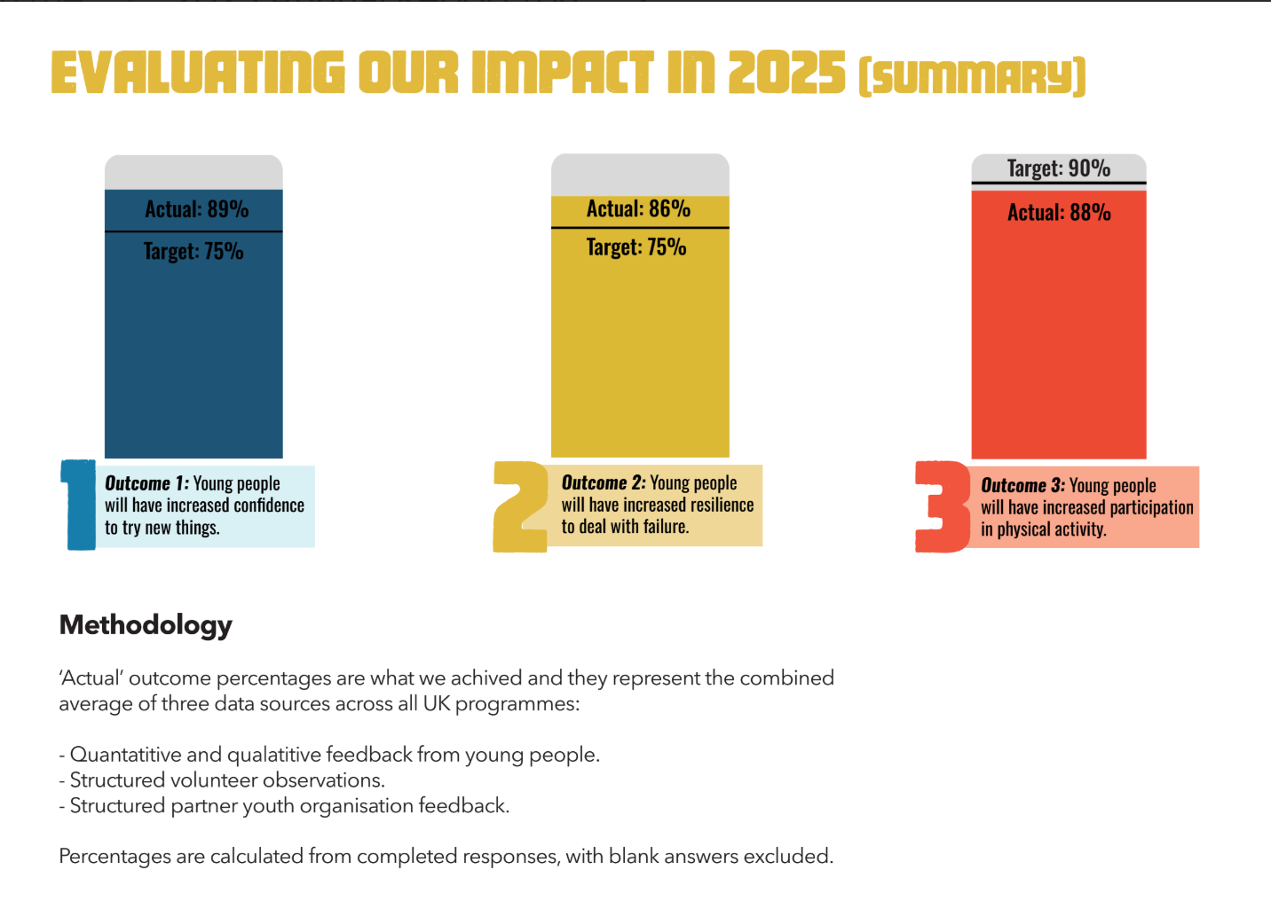  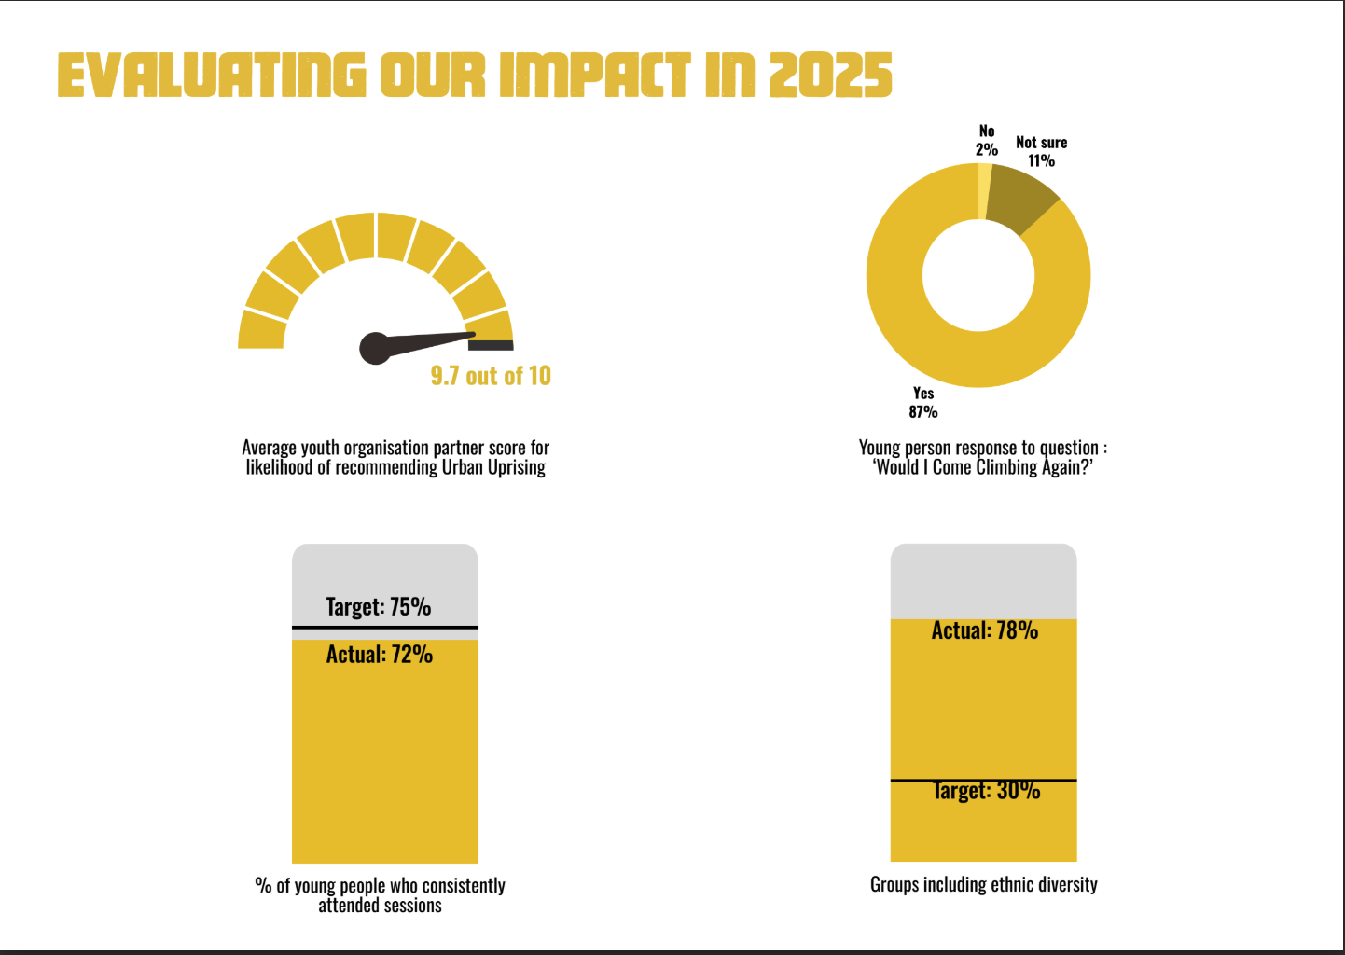  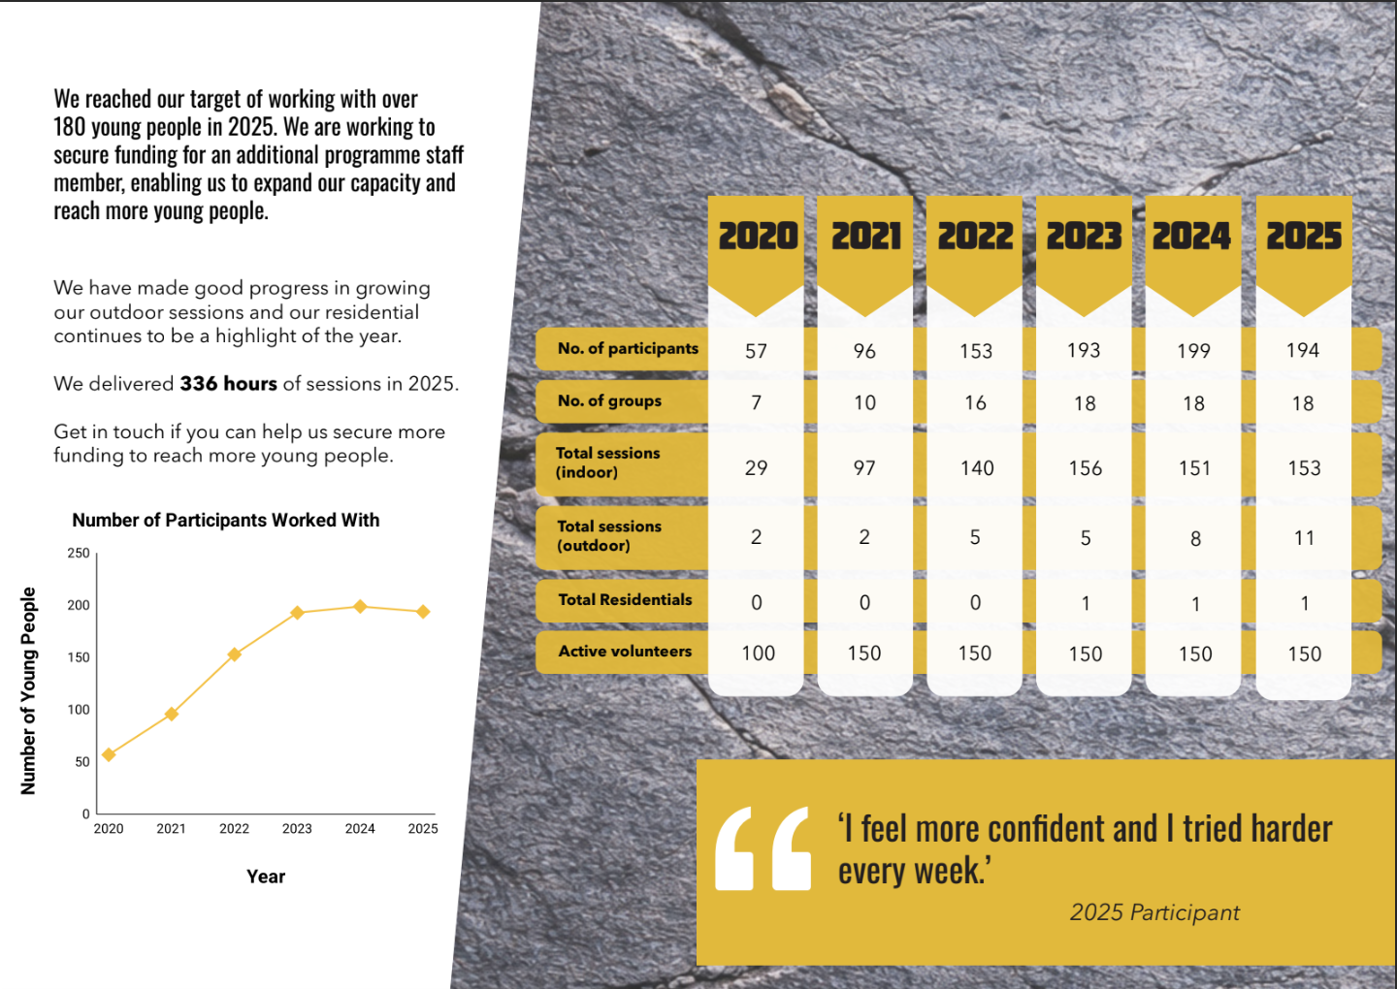

Financial review

Brief statement of the charity’s policy on reserves | The trustees’ policy is to maintain unrestricted funds at a level that provides enough operating costs to ensure continuity of service. Previously this was for 6 months but in order to support our 2026 underfunded projects, we have reduced the time period to 5 months. The figure for this contingency reserve for the financial year January to December 2026 is £44,500. In addition, the earmarked reserve for programmes not yet grant funded for 2026 has been increased to £63,000. A Project Expansion Reserve of £20,000 has also been maintained.

Details of any deficit
Donated facilities and services (if any) | All of our partners keep costs as low as possible to enable us to work with as many young people as possible.  We have been donated climbing shoes for our outdoor sessions.  Skilled volunteers donate their time and expertise to work on technical projects with us.

3

APPENDIX 1

Other optional information

Declaration

The trustees declare that they have approved the trustees’ report above.

Signed on behalf of the charity’s trustees

Signature(s) | 
Full name(s) | stuart green
Position (e.g. Chair) | Chair
Date | 20 May 2025

4

