Town Break SCIO
Annual Report & Financial Statements
Year Ended 31 December 2025

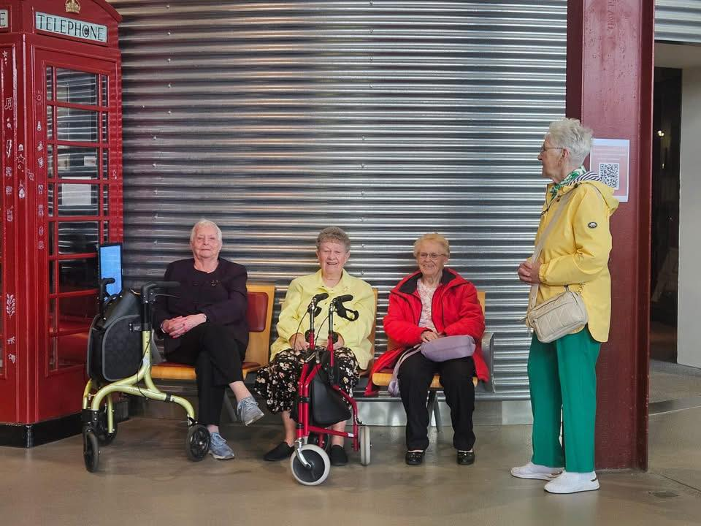

“Town Break Dementia Support reminds us that life with dementia
can still be full of connection, laughter and friendship.”

Unpaid carer supported by Town Break Dementia Support

Contents
- Reference and Administrative Details 3
- Chair of Trustees’ Statement 4
- Chief Executive Officer’s Statement 5
- Key Highlights 2025 6
- Our Work in 2025 7
- Our Mission, Purpose, Vision, and Values 8
- Our Story 9
- Our Services 10
- 2025 Objectives and Achievements 11
- Our Impact in 2025 14
- Voices from the Community 17
- Case Study: Supporting someone living with dementia 19
- Case Study: Supporting an Unpaid Carer 20
- Case Study: The Role of Volunteers 21
- Our People: People Living with Dementia and Unpaid Carers 22
- Our People: Volunteers 22
- Our People: Staff 23
- Fundraising and Community Support 24
- In Remembrance 24
- Structure, Governance and Management 25
- Financial Review 26
- Reserves Policy and Going Concern 26
- Risk Statement 27
- Future Plans 28
- Post Balance Sheet Events 29
- Independent Examiner’s Report 30
- Statement of Financial Activities 31
- Statement of Financial Position 32
- Statement of Cash Flows 33
- Notes to the Accounts 34
- Our Thanks 48

Reference and Administrative Details

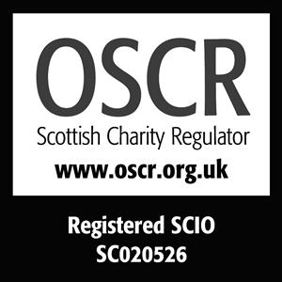
Registered Charity Name: Town Break SCIO
Registered Charity No: SC020526

Registered Office: 1 Springkerse Road
Stirling
FK7 7SN

Legal Status: Town Break is a Scottish Charitable Incorporated Organisation (SCIO) regulated by the Office of the Scottish Charity Regulator (OSCR). As a SCIO, the charity has legal personality and operates in accordance with its Constitution.

Founder: Rosas Mitchell

Website Address: www.townbreak.org

Patron: Gina McKie, Events Host and Radio Presenter

Board of Trustees: P Cassidy Chair of the Board
D Carson Treasurer
J Oswald Trustee
D Newell Trustee
G Young Trustee
J Young Trustee
F Burke Trustee (Appointed 2025)

Management Team: H Duncan Chief Executive Officer
D Keane Operations Manager
F Clark Finance Manager

Staff Team: L Rushforth Community Fundraiser
E Duncan Referral & Admin Coordinator
L McMillan Administrative Coordinator
J Palmer Services Coordinator
A Goodman Services Coordinator
C Inglis Services Coordinator
L Milne Services Coordinator
K Inglis Services Coordinator
B Colbecki Services Coordinator

Independent Examiner: Arm in Arm Accounting
Alloa Business Centre
FK10 3SA

Bankers: Bank of Scotland
Stirling
FK8 2EJ

Chair of Trustees’ Statement
It is my pleasure to present this year’s report on behalf of the Board of Trustees of Town Break Dementia Support Services.
Since its establishment in 1992, Town Break has grown from a small, locally led initiative into a well-established organisation supporting people living with dementia and their unpaid carers across the Forth Valley. While the organisation has developed over time, our purpose remains clear: to provide welcoming, community-based support that enables people to live well with dementia.
Dementia continues to present significant challenges for individuals and families. It can affect memory, confidence and independence, and often leads to isolation for both the person living with dementia and those who care for them. In this context, accessible and compassionate community support is essential.
Town Break plays an important role in meeting this need. Through our groups, activities and personalised support, we provide opportunities for connection, companionship and meaningful engagement. These services support individuals to remain active within their communities while offering unpaid carers valuable time and reassurance.
During the past year, the organisation has continued to respond to growing demand by strengthening and developing its services. This progress reflects the commitment of our staff team, the dedication of our volunteers and the continued support of our partners and funders.
There have been changes within the organisation over the year. We extend our thanks to colleagues who have moved on or retired for their valuable contribution, and we have welcomed new team members and trustees who strengthen the organisation as we look ahead.
I would like to acknowledge the leadership of Helen Duncan, our Chief Officer, whose commitment continues to guide the organisation. She is supported by our Operations Manager and a skilled and dedicated team, ensuring that services are delivered consistently and to a high standard across Forth Valley.
Our volunteers remain central to Town Break. Their time, compassion and commitment make a meaningful difference to the people who attend our services. We are also grateful to the organisations, donors and partners whose support enables us to sustain and develop our work.
The Board continues to provide strategic oversight, ensuring the organisation remains focused on its charitable purpose and long-term sustainability. I am pleased to report that Town Break remains financially stable, supported by careful management and a clear focus on resilience.
Looking ahead, our priority is to consolidate and strengthen our foundations. Demand for dementia support continues to grow, and we remain committed to delivering services that are accessible, responsive and sustainable.
I would like to thank everyone who contributes to Town Break. Together, we ensure that people living with dementia and their unpaid carers feel supported, valued and connected within their communities.
Paul Cassidy
Paul Cassidy
Chair of the Board of Trustees

Chief Executive Officer’s Statement

This past year has not been defined by bold headlines or the launch of new services. It has been quieter than that, and in many ways, more important. Our focus has been on strengthening what we already do well, deepening our relationships, and reinforcing the foundations that allow Town Break to support people living with dementia and those who care for them.

There is a simple truth at the heart of our work: what we do at Town Break works. Week in, week out, across our groups and communities, we see the difference it makes. We see it in the familiarity of a warm welcome, in the trust that builds over time, and in the sense of belonging that grows when people feel understood. This year, we have invested in that consistency, ensuring our services remain reliable, responsive, and rooted in the needs of those who attend.

We also faced a significant challenge with the withdrawal of Falkirk HSCP funding. It was a considerable setback. We chose not to be despondent but to respond with determination, seeking new funding opportunities, strengthening partnerships, and adapting our services in Falkirk so that support could continue. This required flexibility, careful decisions, and a clear focus on what matters most. As a result, we have maintained the same level of support in Falkirk, ensuring continuity for those who rely on us.

Alongside this, we have continued to strengthen partnerships and community links. These relationships extend our reach, deepen our understanding, and ensure that dementia support remains visible and valued. Dementia awareness remains central to this work. Greater understanding reduces stigma and builds more compassionate communities where people feel recognised and included.

None of this happens in isolation. It is shaped by the commitment and belief of many people.

My sincere thanks go to our Trustees for their governance and guidance, to our staff for their professionalism and care, and to our volunteers whose generosity creates the welcoming spaces our groups are known for. To the carers and people living with dementia who attend each week, thank you for trusting us and for being at the heart of everything we do.

And lastly, in this work, we meet people at different points in their journey. We build relationships, we share moments, and, inevitably, we say goodbye. Those we lose leave a lasting impression. They shape who we are, and they remain part of Town Break in ways that stay with us, always.

Helen Duncan
Helen Duncan
Chief Executive Officer (CEO)

Key Highlights 2025

Supporting people to live well with dementia remains at the heart of Town Break Dementia Support Services. During 2025, we strengthened our services and continued supporting people across Forth Valley affected by dementia.

Our work is shaped by the experiences of those who access our services. By listening and learning, we ensure our support remains welcoming, meaningful and responsive. The progress outlined in this report reflects the dedication of our staff, volunteers, partners and supporters, as we continue to build communities where people feel connected, valued and supported.

402 new referrals
A 1% increase, reflecting both the rising need for dementia support across Forth Valley and the trust families place in Town Break.

Expanded community-based support
Delivered a wide range of social groups across Stirling, Clackmannanshire and Falkirk, alongside new initiatives such as Toastie Thursdays, creating additional opportunities for connection and peer support.

Strengthened personalised support through Town Break at Home
Developed flexible, one-to-one support, enabling individuals to receive tailored support within their own homes and local communities.

Improved access to services
Introduced a new online referral system and launched a new website and information materials, making it easier for individuals, families and professionals to access support.

Supported unpaid carers
Delivered information events, including a Dementia Information Day, and provided opportunities for carers to access guidance, reassurance and peer support.

Invested in our people
Supported staff and volunteers through training, engagement and development opportunities, ensuring high-quality and consistent service delivery.

Strengthened partnerships and community connections
Worked collaboratively with local organisations, community groups and national partners to extend reach and improve support across Forth Valley.

Raised over £32,000 through fundraising and donations
Reflecting strong community support and directly enabling the continuation and development of our services.

Maintained financial stability
Income exceeded £379,000, supporting the sustainability and growth of Town Break services.

Our Work in 2025

Supporting people across Forth Valley to live well with dementia remains at the heart of Town Break Dementia Support Services.

During 2025, we continued to respond to the growing demand for dementia support by strengthening our services and developing new opportunities for connection. Across our groups, activities and personalised support, we focused on creating welcoming spaces where people feel understood, valued and able to remain active within their communities.

Our services provide more than structured support. They offer opportunities for friendship, conversation and shared experiences that help people maintain confidence and a sense of belonging. Alongside this, we recognise the vital role of unpaid carers and aim to provide reassurance, support and meaningful opportunities for respite.

Throughout the year, we expanded access to our services, strengthened existing groups and introduced new ways for people to engage with Town Break. This included developing community-based activities, improving referral pathways and continuing to build partnerships across the region.

None of this would be possible without the people who support our work. Our staff, volunteers, partners and supporters all play a central role in delivering our services and ensuring that individuals and families receive consistent, compassionate support.

The impact of our work is reflected in the everyday experiences of the people who attend: friendships formed, confidence regained and families supported.

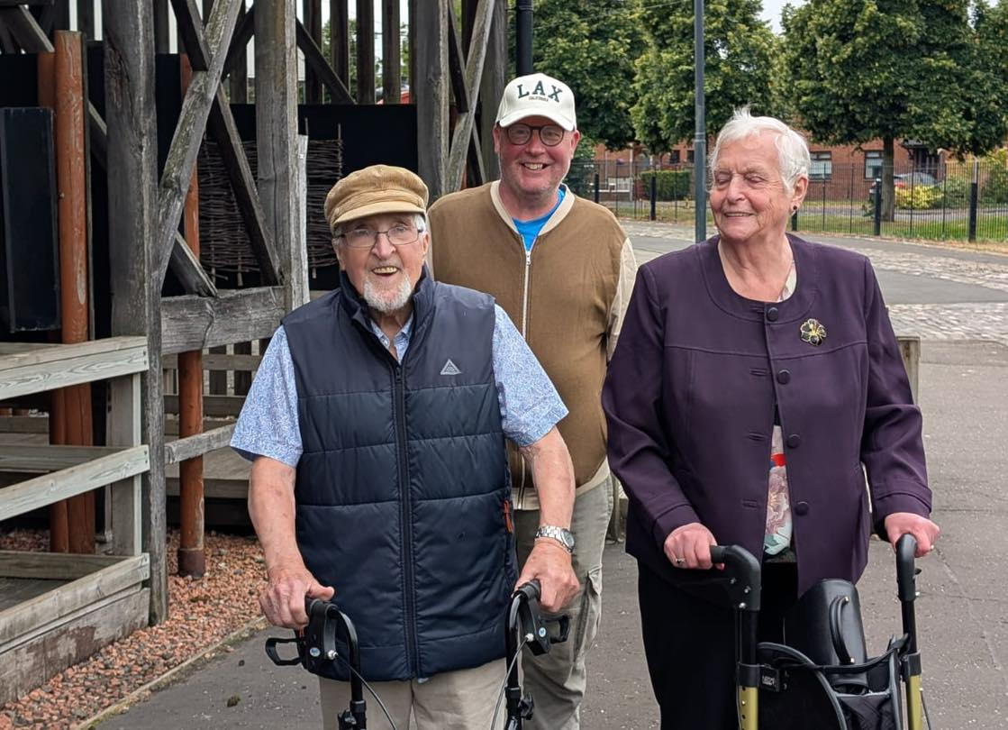

Our Mission, Purpose, Vision, and Values

At Town Break Dementia Support Services, our mission, purpose, vision and values form the foundation of our work. They influence how we deliver our services, guide our decisions and shape the way we support the people who rely on us. These principles define who we are as an organisation and the difference we aim to make within our communities.

Our Mission:

- To inspire and enable people across Forth Valley to live well with dementia.

Our Purpose:
- To provide a highly personal and holistic approach that places the physical, emotional and spiritual wellbeing of people living with dementia and their unpaid carers at our heart. This means that we can achieve something special.
Our Vision:

- To draw on the knowledge, energy and experiences of people living with dementia and their unpaid carers ensuring our service commitment and compassion continues to reflect and meet their individual needs.
- To be creative, vibrant and resourceful in our thinking.
- To seamlessly collaborate with healthcare professionals and other partners to ensure an efficient and timely referral process.
- To be proactive and responsive to an ever-changing dementia landscape.
Our Values:

Our values are our heartbeat. They are at the centre of who we are and run throughout everything we do. They inspire our thinking, guide our actions and ensure we deliver the best for people living with dementia and their unpaid carers.

Bold | we listen, challenge stigma, learn and find better ways to make a difference.
Expert | we continuously develop our knowledge and skills.
Ambitious | we strive to be the very best in our field and positively influence those around us.
Together | we embrace diversity, work collaboratively and provide people with the care, consideration and respect they deserve.

Achieving the charity’s mission, purpose, vision and values:

- Delivering meaningful, person-led support for people living with dementia, while also providing vital respite for unpaid carers.
- Strengthening the knowledge and confidence of our staff and volunteers through ongoing training on dementia related matters.
- Providing clear information, guidance and support to people living with dementia and to unpaid carers.

Our Story

Town Break Dementia Support Services began with a simple idea. People living with dementia and their families should have somewhere welcoming to go, somewhere they could meet others, share experiences and feel part of their community.

More than three decades ago, local partners recognised the need for dedicated support across the region. Working alongside the former Central Regional Council, now Clackmannanshire, Falkirk and Stirling Councils, the aim was to create accessible support for people living with dementia and their unpaid carers.

In September 1992, the first Town Break Dementia Support group took place in Stirling. What started as a small local initiative quickly demonstrated the value of bringing people together in a safe and supportive environment.

From those early beginnings, Town Break has grown into a trusted source of community support across Forth Valley. Our groups provide opportunities for conversation, shared activities and meaningful connection. For many people living with dementia, these spaces offer friendship, enjoyment and the chance to remain active within their communities. For unpaid carers, they provide reassurance and the opportunity to take a short but valuable break from caring responsibilities.

Over the years, thousands of individuals and families have been supported through our services. While the organisation has developed and expanded, the heart of our work remains unchanged. We continue to focus on connection, understanding and ensuring that people affected by dementia feel welcomed and valued.

The community that has grown around Town Break reflects these values. Staff, volunteers, supporters and families all contribute to creating an environment where people feel understood and supported.

As we look to the future, our commitment remains clear. We will continue to work alongside people living with dementia and their unpaid carers, helping to build communities where everyone can continue to live well and feel connected.

Our Impact Since 1992

- 23,100 families supported across Forth Valley
- 1,230 volunteers who have given their time and compassion
- £3.2 million secured in grants and trust funding to sustain our work
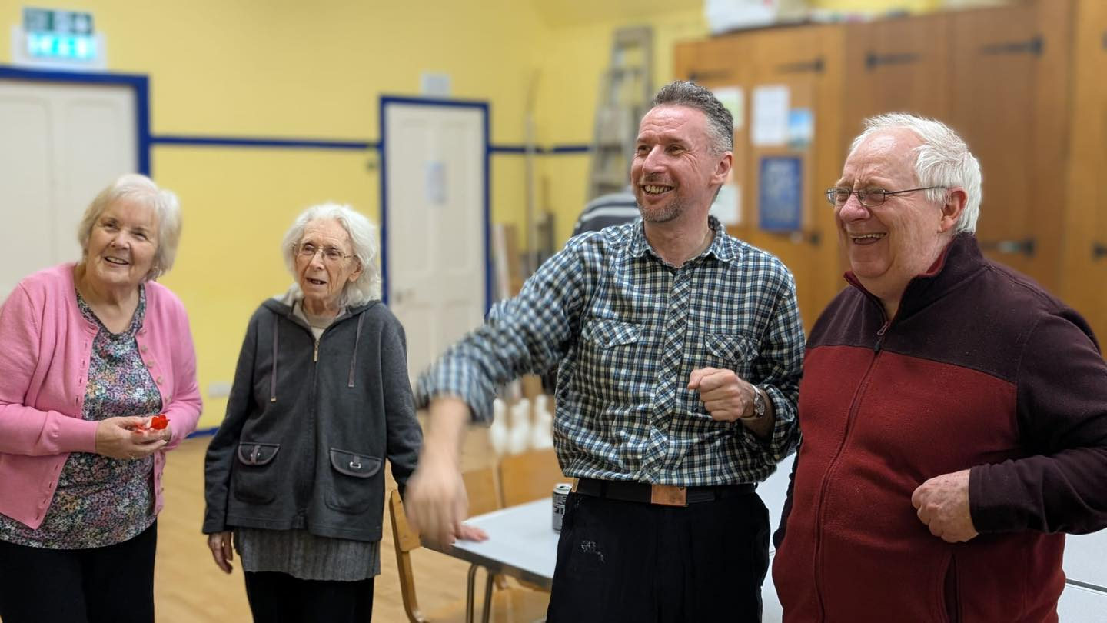

Our Services

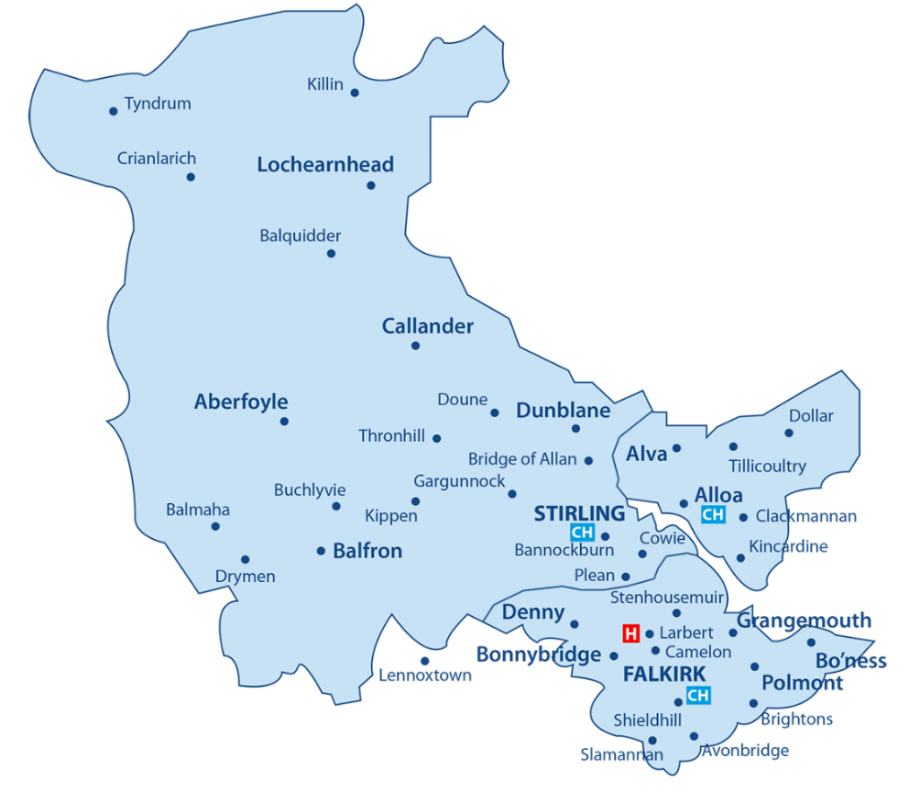

Day | Morning (10:00 – 12:00) | Afternoon (12:00 – 16:00)
Monday | - Bellfield Social Group  - Alva Brunch Group  - Carer Support (Monthly) | - Bellfield Social Group  - Stirling Lunch Group  - Alva Social Group
Tuesday | - Camelon Social Group | - Camelon Lunch Group  - Killearn Social Group
Wednesday | - (Dedicated time for staff meetings, training and service development.) | - NPC Social Group  - Bellfield Lunch Group  - Grangemouth Social Group
Thursday | - Callander Social Group | - Bannockburn Peer Support  - Killearn Social Group  - Toastie Thursday (Monthly)
Friday | - Camelon Time Out | - Camelon Time Out  - Stirling Lunch Group

At Home (Mon – Fri) | Morning (10:00 – 12:00) | Afternoon (12:00 – 16:00)
Forth Valley Wide | - Town Break at Home | - Town Break at Home

Note:

- All services support people living with dementia while providing respite for unpaid carers

2025 Objectives and Achievements

Town Break Dementia Support Services remains committed to delivering meaningful, person-centred support for people living with dementia and their unpaid carers across Forth Valley.

During 2025, our work focused on strengthening community-based support, improving access to services and responding to the changing needs of the people we support. The following outlines our key objectives and the progress made throughout the year.

Strengthening Community-Based Support
Objective:
Continue providing reliable, person-centred services that support people living with dementia and their unpaid carers across Forth Valley.
Achievement:
Throughout 2025, Town Break continued to deliver a wide range of social groups and community-based activities across Stirling, Clackmannanshire and Falkirk. These services provided welcoming environments where people could build friendships, remain socially active and access meaningful support. New initiatives such as Toastie Thursdays, a dementia-friendly community drop-in, further strengthened opportunities for connection and social engagement within local communities.

Improving Access to Services
Objective:
Make it easier for individuals, families and professionals to access Town Break services.
Achievement:
A new online referral system was introduced, simplifying the process for people seeking support and allowing professionals, family members and individuals to make referrals more easily. Alongside this, the launch of a new website improved accessibility to information about our services and made it easier for people across Forth Valley to learn about the support available.

Developing At Home and Personalised Support
Objective:
Continue developing flexible support options that meet the individual needs of people living with dementia and their carers.

Achievement:
The Town Break at Home service continued to develop throughout 2025, providing one-to-one support for individuals within their homes or local communities. This flexible service offers tailored support that reflects the unique needs and preferences of each individual and their family.

Supporting Unpaid Carers

Objective:
Ensure that unpaid carers have access to information, reassurance and opportunities for respite.

Achievement:
Town Break hosted a range of information and engagement events, including a Dementia Information Day at the Bellfield Centre and participation in carers’ information events across the region. These initiatives helped connect carers with local services, advice and peer support while providing valuable opportunities to share experiences and access guidance.

Investing in Our Team and Volunteers

Objective:
Continue supporting the development, wellbeing and engagement of our staff and volunteers.

Achievement:
Staff and volunteers participated in a range of development opportunities, including First Aid training and volunteer engagement sessions. Volunteer events were held to provide updates, share learning and recognise the ongoing contribution of our volunteer community.

Strengthening Partnerships and Community Engagement

Objective:
Build and maintain strong partnerships that enhance the support available to people affected by dementia.

Achievement:
Town Break continued to collaborate with community organisations, local groups and partner agencies across Forth Valley. Engagement included participation in wellbeing events, community information days and partnerships such as Football Memories sessions, which offer reminiscence and social engagement opportunities for people living with dementia.

Advocacy and Representation

Objective:
Ensure the experiences of people living with dementia and unpaid carers are represented in wider policy and strategic discussions.

Achievement:
Town Break representatives attended the Scottish Parliament Cross Party Group on Older People, Age and Ageing, contributing to discussions on issues affecting older people and those living with dementia. This engagement helps ensure that the voices and experiences of families across Forth Valley are reflected in national conversations.
Strengthening Funding and Sustainability

Objective:
Continue securing funding to support the sustainability and development of Town Break services.

Achievement:
During 2025, Town Break received support from a range of funding sources, including funding from the Falkirk Communities Mental Health and Wellbeing Fund and community fundraising initiatives such as the Youth Philanthropy Initiative award from Wallace High School. Donations from local organisations and community supporters also contributed to sustaining our services.

Raising Awareness of Dementia

Objective:
Increase awareness and understanding of dementia across Forth Valley.

Achievement:
Town Break continued to raise awareness through community engagement events, public information sessions and partnerships with organisations supporting people affected by dementia. These activities help promote understanding, reduce stigma and ensure people know where to access support.

Responding to Funding Challenges

Objective:
Ensure continuity of services while responding to changes in the funding landscape.

Achievement:
During 2025, Town Break faced a significant challenge following the withdrawal of funding from Falkirk Health and Social Care Partnership. The organisation has actively sought alternative funding opportunities and continues to work closely with partners and supporters to ensure services can continue for those who rely on them.

Our Impact in 2025

Across Forth Valley, the number of people living with dementia continues to grow. This increasing demand highlights the importance of accessible, community-based support for individuals and families.

Throughout 2025, Town Break Dementia Support Services continued to make a meaningful difference by supporting people to remain connected, active and engaged within their communities.

Strengthening Community-Based Support

- Continued delivering a wide range of social groups across Stirling, Clackmannanshire and Falkirk, providing welcoming spaces for people living with dementia and their carers.
- Introduced Toastie Thursdays, a relaxed dementia-friendly community drop-in in Raploch, creating new opportunities for connection, conversation and peer support.
- Continued developing Town Break at Home, offering personalised one-to-one support in people’s homes or local communities.
- Hosted regular Friendship Groups and social events, bringing people together for activities, conversation and companionship.
- Delivered seasonal and themed events, including our Halloween Friendship Group, encouraging social engagement and shared enjoyment.
Improving Access to Support

- Introduced a new online referral system, making it easier and quicker for individuals, families and professionals to access Town Break services.
- Launched a new charity website, designed to be more accessible, mobile-friendly and easier to navigate for people seeking information and support.
- Published our first Town Break information brochure, providing a clear guide to our services and how people can access support across Forth Valley.
- Continued offering guidance and signposting through community information sessions and support events.
Supporting Carers and Families

- Hosted a Dementia Information Day at the Bellfield Centre, bringing together local organisations to share advice, guidance and support for people affected by dementia.
- Participated in Carers Information Events and wellbeing days, providing opportunities for carers to learn about available support and connect with others in similar situations.
- Promoted educational opportunities for families and carers through partnerships with organisations such as the Dementia Services Development Centre (DSDC).

Investing in Our Team and Volunteers

- Staff members completed First Aid training, strengthening the skills and preparedness of the team supporting our services.
- Hosted Volunteer Engagement Days, providing updates, training opportunities and space for volunteers to share ideas and feedback.
- Continued recognising the essential contribution of our volunteers, whose dedication plays a vital role in delivering our services.
- Engaged with students and young people through events such as the Stirling University Students’ Union Welcome Event, encouraging new volunteering opportunities.
Building Partnerships and Community Connections

- Participated in the CVS Falkirk Wellbeing Open Day, strengthening connections with local organisations and community partners.
- Joined Football Memories sessions at Alloa Stadium, supporting creative and reminiscence-based activities for people living with dementia.
- Worked with community partners to deliver information events, awareness sessions and local engagement activities across Forth Valley.
Advocacy and Strategic Engagement

- Our CEO and Operations Manager attended the Scottish Parliament Cross Party Group on Older People, Age and Ageing, representing the experiences of people living with dementia and carers across Forth Valley.
- Contributed to discussions around key issues including community support, scams affecting older people, accessible voting and the importance of respite for carers.
Funding and Community Support

- Received a £3,000 Youth Philanthropy Initiative award from Wallace High School, supporting the continued delivery of Town Break services.
- Received donations from local supporters including Jobcentre Plus, demonstrating the strong community backing for our work.
- Secured funding from the Falkirk Communities Mental Health and Wellbeing Fund, enabling further development of Town Break at Home and support in rural areas.
- Continued building relationships with local organisations and businesses that support our work.
Sustainability and Future Planning

- Began responding to a significant funding challenge following the withdrawal of funding from Falkirk Health and Social Care Partnership, while actively pursuing alternative funding opportunities.
- Continued strengthening organisational systems, communications and service accessibility to support the long-term sustainability of Town Break.
- Undertook improvements to our office space and working environment to better support staff and service delivery.

Community Engagement and Awareness

- Continued raising awareness of dementia and the importance of community-based support through events, workshops and public engagement.
- Strengthened our communication channels through improved digital resources, social media engagement and accessible information materials.
- Published our Newsletters, sharing updates, stories and opportunities to get involved in Town Break’s work.
Looking Ahead

Despite ongoing challenges within the funding landscape, 2025 has demonstrated the strength of community support and the resilience of Town Break Dementia Support Services.

Through collaboration, innovation and the dedication of our staff, volunteers and partners, we continue to build a supportive network across Forth Valley.

Our commitment remains clear: to inspire and enable people living with dementia and their unpaid carers to live well, remain connected and feel valued within their communities.

Voices from the Community

The impact of Town Break Dementia Support Services is best understood through the experiences of the people who take part in our services. Individuals and families who attend our groups and activities remain at the centre of everything we do.

Living with dementia can bring significant changes, not only for the person diagnosed but also for the family members and friends who support them. By listening to the experiences shared with us, we gain a clearer understanding of the importance of connection, companionship and understanding.

In this section, we share a number of reflections from people who attend our services and from unpaid carers. Their experiences highlight the value of welcoming spaces where individuals feel understood, friendships can grow and support is available when it is needed.

Often it is the smaller moments that make the greatest difference. A conversation over a cup of tea, taking part in a shared activity, or simply spending time with others can bring comfort, confidence and enjoyment.

We are grateful to everyone who has shared their experiences with us. Their voices continue to inform and shape our work as we support people living with dementia and their unpaid carers across Forth Valley.

Connection and Friendship

Many people tell us that attending Town Break helps reduce isolation and provides opportunities to build friendships with others who understand their experiences.

- “Good to know that you are not alone and that others are going through the same thing.”
- “Lots of fun and company with others who understand her situation.”
- “Having somewhere to go every week is so important. We have both made friends and it helps in difficult times.”
- “More social contact within an understanding environment.”
- “Town Break makes them feel cared for, welcome and socially connected.”
Support for Unpaid Carers

For carers, knowing their loved one is safe and supported provides valuable reassurance and an opportunity to take time for themselves.

- “Town Break helps me to have some time to myself and to catch up with the practical tasks I need to get done.”
- “A much-needed break from the responsibility of the caring role.”
- “Has given me a few hours of my life back knowing my loved one is being well cared for.”
- “I so look forward to my ‘time off’ when my husband goes to the Town Break groups.”
- “I know my husband is safe, something I never had before Town Break.”
Confidence and Wellbeing

Regular social interaction, activities and shared experiences can help people living with dementia maintain confidence and enjoy meaningful moments.
- “It gets my dad out of the house for a few hours, giving him a change of scene, stimulation and company.”
- “The stimulating effect of meeting other people in a friendly and caring environment.”
- “Better feeling of wellbeing.”
- “It breaks up our week, and we always look forward to group.”
- “My husband is up, showered and ready on Tuesdays. He never forgets it’s group day.”
Purpose and Community Through Volunteering

Volunteers often tell us that supporting Town Break provides them with a strong sense of purpose and connection to their community.

- “Volunteering with Town Break gives me a purpose in life. I love it.”
- “I feel great satisfaction giving support to the groups.”
- “I feel part of something important.”
- “It has given me a sense of purpose and self-worth supporting people living with dementia and their families.”
- “I benefit as much as the group.”
Trust and Confidence in Town Break

Families consistently tell us that Town Break provides a safe and supportive environment where people feel valued.

- “Town Break is a wonderful charity. The empathy, knowledge and understanding make my dad’s life so much happier.”
- “Support in a safe environment where people accept, she has dementia but still recognise what she can do.”
- “An excellent organisation who put clients and carers first.”
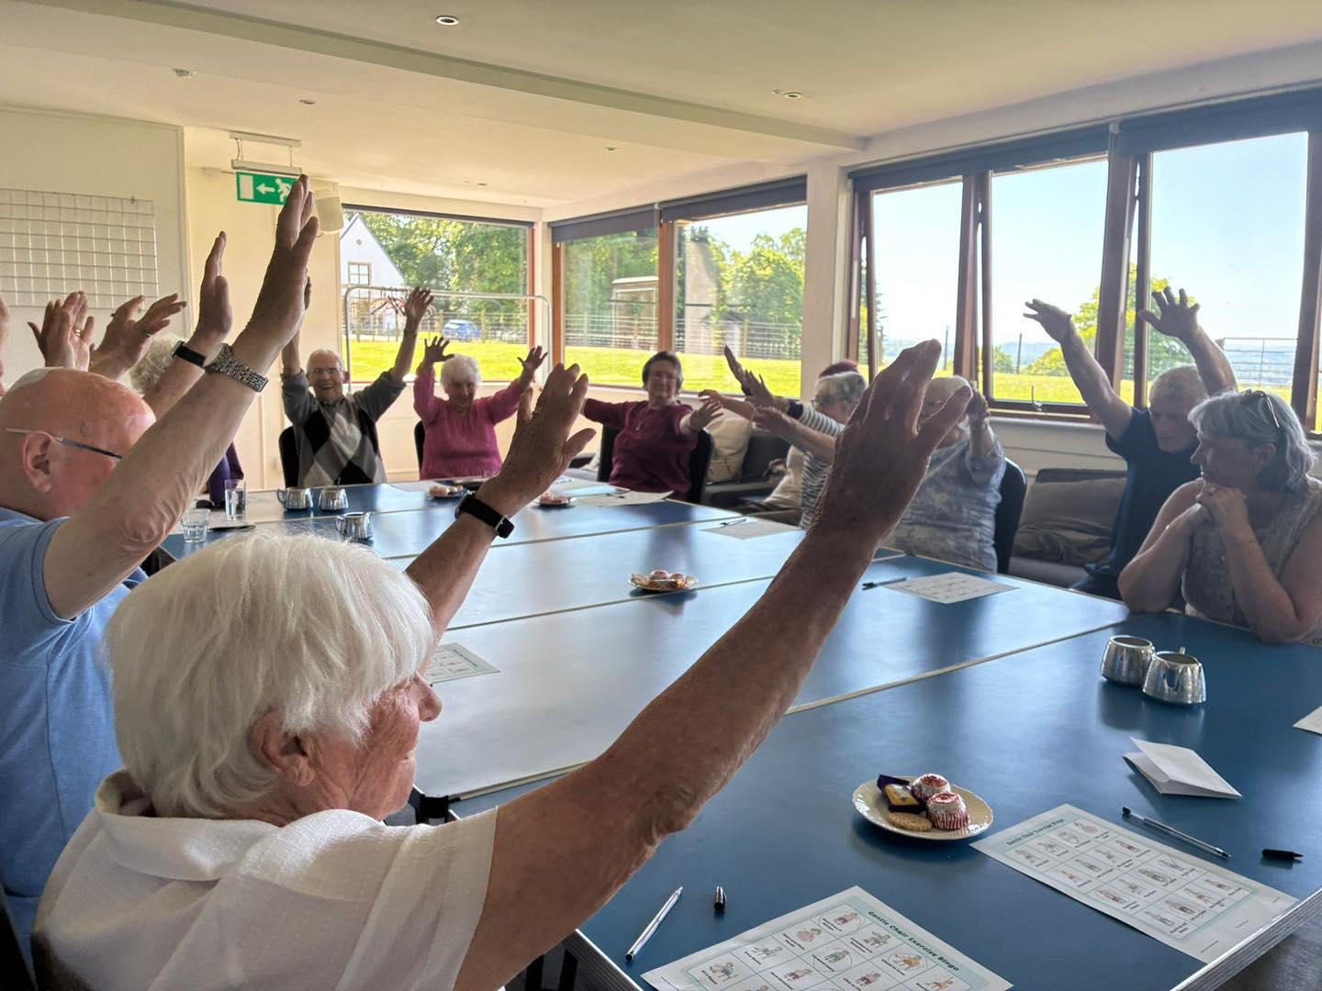

Case Study: Supporting someone living with dementia

For many people living with dementia, social situations that once felt familiar can gradually become more challenging. Changes in memory and communication can affect confidence, and some people begin to step back from activities and community groups they once enjoyed.

One person supported by Town Break Dementia Support Services shared how this change had affected them. After receiving a diagnosis, they became increasingly hesitant about joining social activities. Conversations felt more difficult to follow and they worried about saying the wrong thing. Over time, this led them to withdraw from gatherings and events that had previously been an important part of their life.

Attending a Town Break group marked an important turning point.

From their first visit, they were welcomed into a relaxed and supportive environment where there was no pressure to participate. Activities were inclusive and flexible, allowing people to take part at their own pace.

Over time, their confidence began to grow. They started to join conversations, take part in activities and build friendships with others who understood their experience. The group became something they looked forward to each week.

They later shared that attending Town Break helped them feel connected to their community again:

“I feel myself again. It’s somewhere I can just be me.”

Experiences like this reflect what many people tell us. Having a welcoming space where people feel understood and included can make a meaningful difference, supporting confidence, social connection and continued participation in community life.

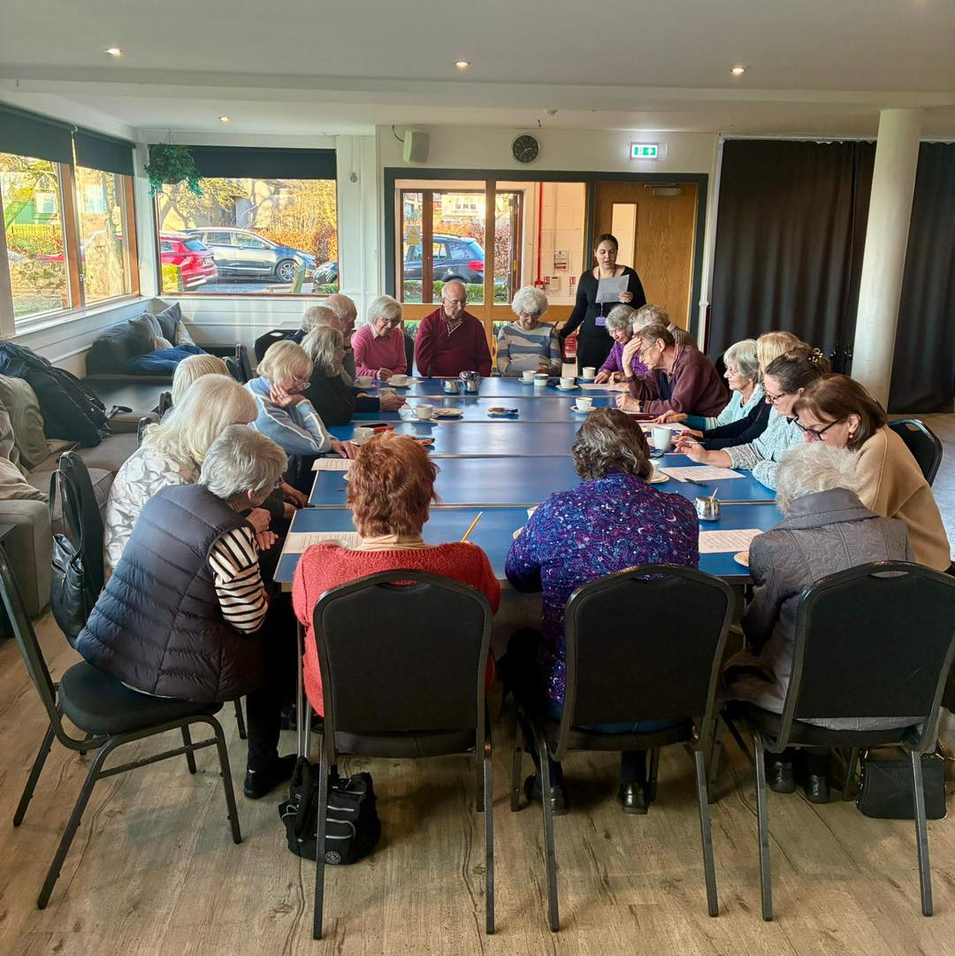

Case Study: Supporting an Unpaid Carer

Caring for a loved one living with dementia can be both meaningful and demanding. For many carers, the responsibility can feel constant, leaving little time to focus on their own wellbeing.

One unpaid carer shared how Town Break has helped them continue in their caring role with greater confidence and support.

Before accessing support, much of their time was taken up with appointments, daily routines and managing the practical realities of dementia. Opportunities to step away, even briefly, were limited, and the responsibility often felt overwhelming.

Through Town Break’s weekly service, their partner now attends a group where they are welcomed and supported by staff and volunteers in a safe and understanding environment. During this time, the carer is able to take a short break, knowing their partner is engaged in meaningful activities and enjoying the company of others.

They described those few hours each week as invaluable:

“It gives me time to breathe and reset, knowing they’re safe and happy.”

This time allows them to attend appointments, manage everyday tasks or simply pause and recharge.

Equally important is the reassurance that their partner returns home relaxed and content. Seeing them enjoy the group and spend time with others has strengthened the carer’s confidence in the support available.

For this carer, Town Break offers more than respite. It provides reassurance, understanding and the knowledge that they are not facing their journey alone.

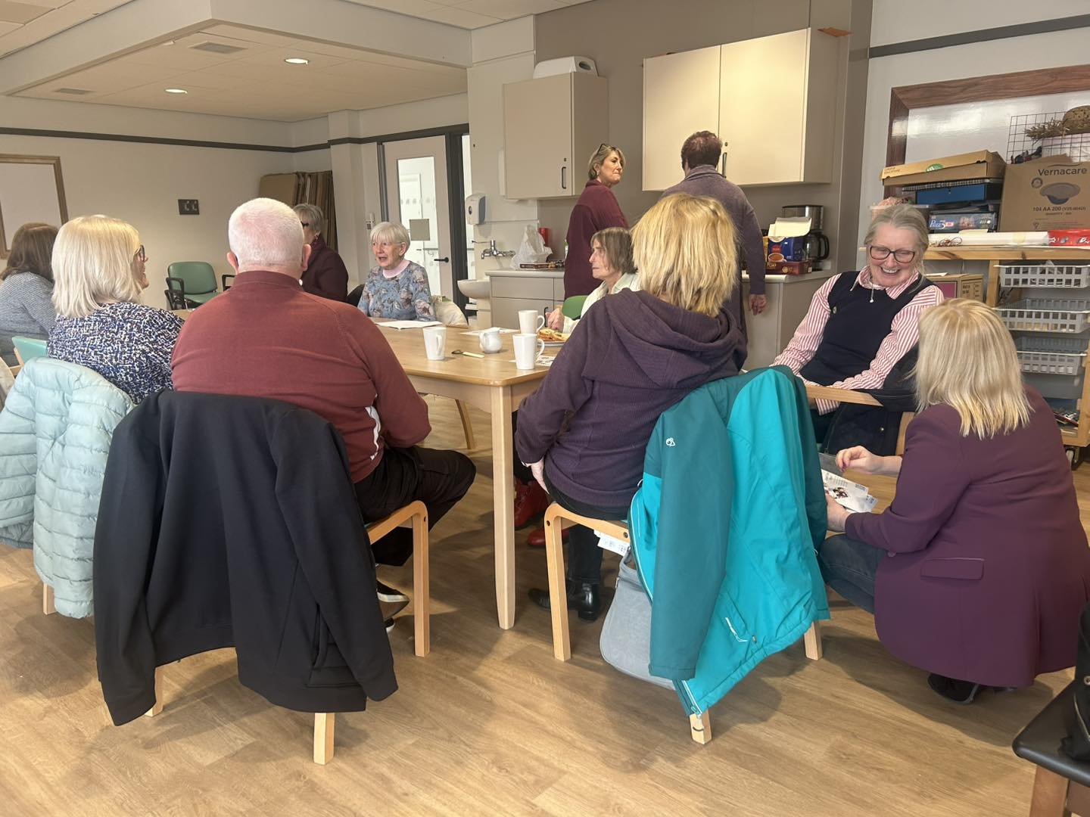

Case Study: The Role of Volunteers

Volunteers play an important role in shaping the welcoming and supportive atmosphere that defines Town Break’s services. Their presence helps create spaces where people feel comfortable, valued and able to enjoy time together.

One volunteer joined Town Break after supporting a family member living with dementia. Having experienced first-hand the challenges that families can face, they were motivated to offer their time and support to others going through a similar experience.

Since becoming involved, they have become a familiar presence within one of the local groups. Whether helping with activities, sharing conversation over a cup of tea or encouraging participation in games and creative sessions, their involvement supports a relaxed and inclusive environment.

They describe volunteering as a rewarding experience:

“It’s the small moments that stay with you. Seeing people relax, laugh and feel part of something.”

Through their involvement, they have seen how regular social interaction can support confidence, connection and a sense of belonging for people attending the group.

For those who attend, volunteers help create a welcoming and supportive community. For the volunteer, being part of Town Break offers a meaningful way to contribute and remain connected to others.

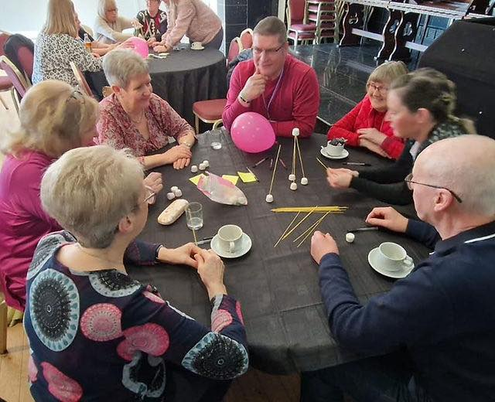

Our People: People Living with Dementia and Unpaid Carers

The people at the centre of Town Break Dementia Support Services are those living with dementia and the unpaid carers who support them each day. Their experiences, resilience and relationships shape the way we deliver our services and continue to guide our work.

People living with dementia bring valuable insight, perspective and individuality. Listening to their voices helps ensure that our services remain meaningful, welcoming and responsive to the needs of the people who take part.

We also recognise the dedication of unpaid carers. Providing care for a loved one can bring both rewards and challenges, and the commitment shown by carers plays an essential role in helping people remain connected to their communities and continue living fulfilling lives.

The relationships between individuals and those who care alongside them are at the heart of Town Break. These connections create the supportive community that defines our services and reflect the values that guide our organisation.

We are grateful for the trust placed in Town Break and proud to support people and families as part of their journey.

Our People: Volunteers

Volunteers are at the heart of Town Break Dementia Support Services. Their time, commitment and compassion help shape every part of our work. From supporting fundraising activities and sharing valuable insights, to helping at local groups, supporting people living with dementia and serving as Trustees, our volunteers play an essential role in the life of the organisation.

During 2025, our volunteers contributed an outstanding 4,300 hours of their time. We are fortunate to be supported by around 50 volunteers, many of whom bring a personal understanding of dementia through their own experiences. Their dedication strengthens our work and supports the continued development of our services as we work towards our strategic priorities.

While it is impossible to fully capture the knowledge, care and encouragement our volunteers bring, their contribution is truly invaluable. Without their support, the impact of our work would not be possible. In 2025 alone, the time given by our volunteers was equivalent to an estimated £81,196.50 in salary costs. This allows us to reinvest resources directly into our services and continue expanding the support available to people living with dementia and their unpaid carers.

To all our volunteers, thank you. Your generosity, commitment and kindness continue to make a meaningful difference in the lives of the people and families who access Town Break Dementia Support Services.
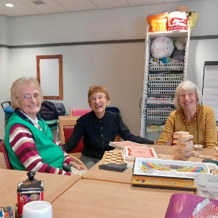
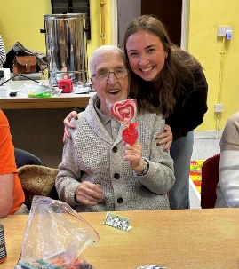
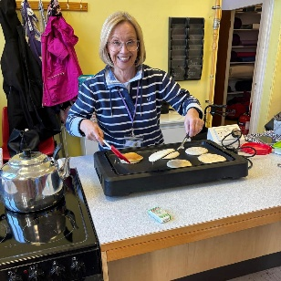
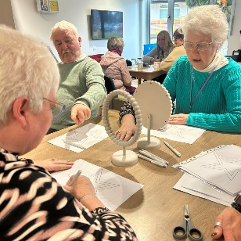

Our People: Staff

The staff team at Town Break Dementia Support Services play a central role in delivering the support that individuals and families rely on each day. Their dedication, professionalism and commitment enable the organisation to provide meaningful services for people affected by dementia across Forth Valley.

Through their knowledge, experience and understanding, our services are delivered with care, respect and compassion. From providing direct support to people living with dementia and their families, to coordinating services and managing the organisation behind the scenes, every member of the team contributes to the strength of our work.

During the year, we also said farewell to Davina Pilley, our Team Leader, who retired after many years of dedicated service. Davina first joined Town Break as a volunteer and progressed through the organisation, making a lasting contribution to both our team and the people we support. Her commitment, knowledge and warmth have left a lasting impact, and she will be greatly missed.

The team’s ongoing efforts help ensure that everyone who comes to Town Break is welcomed into a supportive and understanding environment. The professionalism and care shown each day strengthens the positive impact our services have within the community.

We extend our sincere thanks to the staff team for the dedication, energy and kindness they bring to their roles. Their commitment continues to shape the support we are able to offer to people living with dementia and their unpaid carers.

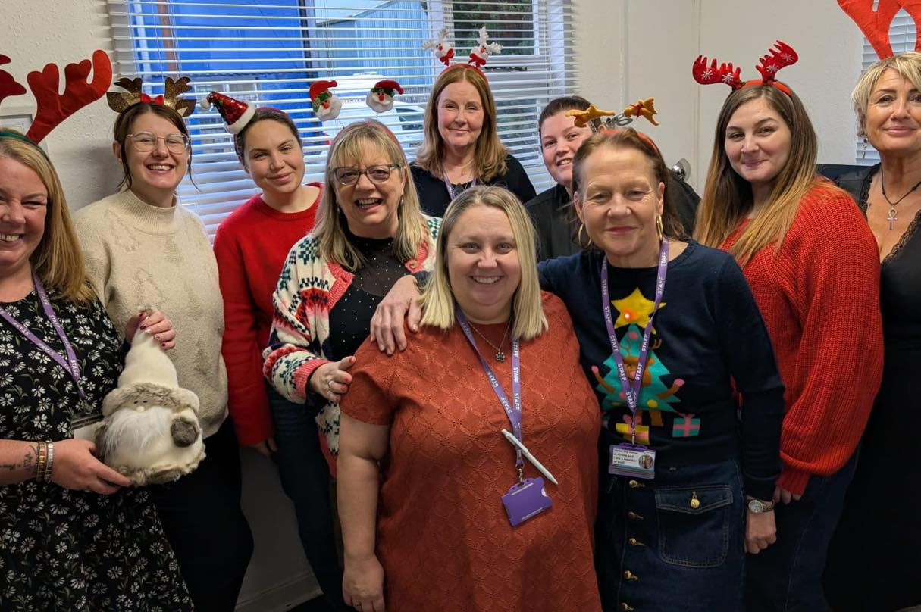

Fundraising and Community Support

Town Break Dementia Support Services has been grateful to receive the support of many individuals and community groups who have taken part in fundraising activities throughout the year. Their generosity and enthusiasm demonstrate the strong community support behind our work and help us continue developing services for people living with dementia and their unpaid carers.

During 2025, supporters raised funds through events including the Kiltwalk and the Youth Philanthropy Initiative (YPI). Many others supported Town Break through personal fundraising efforts and donations made through our online platform, JustGiving.
These activities not only provided valuable financial support but also helped raise awareness of dementia and the importance of community-based support across Forth Valley.

Thanks to the commitment of our supporters, we have been able to continue delivering and strengthening services that reach individuals and families across the region, while maintaining the high standard of care and support that Town Break strives to provide.

To everyone who fundraised, donated or supported our work during 2025, we offer our sincere thanks. Your generosity and community spirit continue to make a meaningful difference in the lives of people affected by dementia.

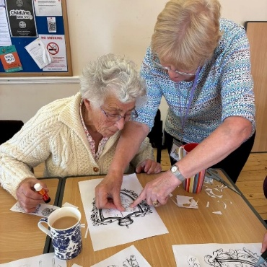
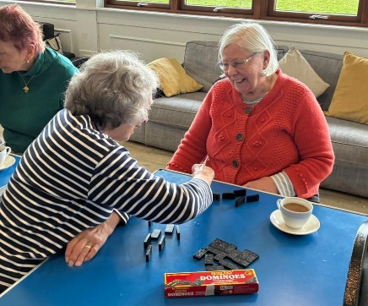

In Remembrance

As we look back on the past year, we take time to remember those who are no longer with us. Their kindness, warmth and generosity have left a lasting impression on Town Break Dementia Support Services and on the many people who had the privilege of knowing them.

Among those we remember are people living with dementia, unpaid carers, volunteers, staff members and supporters. Each person brought their own character, experiences and compassion to the community that surrounds Town Break. Through friendship, shared moments and acts of care, they helped shape the welcoming and supportive environment that defines our services.

The connections they created and the memories they leave behind continue to be felt throughout our organisation. Their presence helped build a community where people felt understood, respected and valued. We honour them by continuing the work that meant so much to them: supporting people living with dementia, providing understanding and respite for carers, and creating spaces where connection and friendship can flourish.

To those we remember, we extend our heartfelt thanks. Their kindness, strength and spirit remain part of the story of Town Break.

Structure, Governance and Management

Town Break Dementia Support Services is a Scottish Charitable Incorporated Organisation (SCIO), registered with the Office of the Scottish Charity Regulator (OSCR) on 20 March 2014. Prior to incorporation, Town Break Stirling Group operated as an unincorporated organisation established in 1992.

The organisation is governed by a Board of Trustees who are responsible for the overall strategic direction, governance and oversight of the charity. The Board normally meets every eight to twelve weeks throughout the year.

The charity’s governing document is its Constitution, which provides for a minimum of five and a maximum of twelve trustees. In accordance with the structure of a single-tier SCIO, the trustees also act as the members of the organisation.

Trustees are appointed in line with the provisions set out in the Constitution. Individuals are not eligible for election or appointment as a trustee if they are disqualified under the Charities and Trustee Investment (Scotland) Act 2005 or if they have been employed by the organisation within the previous twelve months.

Trustees are elected at the Annual General Meeting (AGM). The Board may also co-opt additional trustees between AGMs where this is in the best interests of the organisation.

Trustees are selected based on the skills, knowledge and experience they bring to the Board. Where appropriate, trustees are encouraged to undertake training and development to support them in fulfilling their governance responsibilities. Trustees normally serve a maximum of two terms of three years, unless exceptional circumstances justify a longer period.

Prospective trustees may be invited to attend a Board meeting prior to formal appointment. This provides an opportunity to learn more about the work of the organisation and its governance arrangements, and allows both the individual and the Board to consider whether the role is a suitable fit.

In addition to full Board meetings, a finance sub-committee meets as required to review financial matters and provide additional oversight. Other sub-committees may be established where necessary to address specific areas of work.

The trustees appoint a Chief Officer who is responsible for the day-to-day management of the organisation. The Chief Officer operates under delegated authority from the Board in accordance with the charity’s governance framework and organisational policies.

The Board of Trustees is responsible for ensuring that the organisation operates in accordance with its Constitution and relevant legislation. Trustees oversee the strategic direction of the charity and ensure that resources are managed responsibly in support of its charitable purposes. They also monitor organisational performance and risk to ensure that Town Break Dementia Support Services continues to deliver effective and sustainable support to people living with dementia and their unpaid carers across Forth Valley.

Financial Review

Grant income, our main funding source, decreased by £33,000 to £287,000 for the year, which reflects the difficult times we are experiencing and more competition for grant funding. However, we have identified other sources of income, particularly charging a small fee for some of our services, and a variety of fundraising efforts leading to an increase in charitable income of £13,000 to £60,000 for the year.

The Charity incurred a deficit for the year of £14,000 (2024: surplus of £4,500), leading to retained reserves of £128,000.

The proportion of unrestricted reserves to total reserves increased to 54% compared to 45% last year end. We encourage grantors and donors to give unrestricted funding, which allows the charity to be more flexible in its approach to dementia care as circumstances and treatments change.

The current investment policy is to keep cash reserves in mainstream banks and building societies. Cash balances were kept within the protected limit of £85,000. Since the Chancellor’s last budget this limit has increased to £120,000. Where the limit is exceeded or expected to be exceeded for a significant period a transfer to deposit/savings account at another bank or building society is made.

In-kind donations valued conservatively at over £1,900 (2024: £1,500) were received, which consisted of a variety of items, such as food and refreshments for group meetings, office equipment and prizes for raffles at the special events held in the year.

The charity benefits greatly from the involvement and support from its many dedicated volunteers, without whom the services to our clients and their carers could not be delivered. In accordance with FRS102 and the Charities SORP (FRS 102) the economic contribution of the volunteers is not recognised in these accounts. However, the value of the input from volunteers is estimated at £81,000 (2024: £51,000) based on the living wage.

Reserves Policy and Going Concern

The trustees consider that an unrestricted cash reserve of at least 4 months of unrestricted budgeted spend is sufficient to provide for an orderly managed run down of the charity, should the trustees decide to dissolve the charity. Unrestricted reserves were £70,000 at year end (2024: £70,000) representing 2.1 months (2024: 1.8 months) of total future budget spend. However, there is assured restricted funding for the majority of budget expenditure.

At 31 December 2025 the charity had almost £139,000 of total cash reserves representing over 4.2 months of total budget spend. The charity had net assets of £128,000 (2024: £142,000) at year end. The 2026 budget indicates assured funding will be in place to cover expenditure for the whole of 2026. Accordingly, the trustees consider that funding will continue to be available to enable the charity to continue as a going concern for the foreseeable future.

Risk Statement

Risk is managed through a structured risk register, which is regularly reviewed and updated by staff to reflect emerging and ongoing risks. The risk register is reported to the Board of Trustees, ensuring appropriate oversight and monitoring.

During 2025, the main areas of risk were identified as follows:

Risk | Management
Loss or reduction of funding – including the withdrawal or reduction of funding for core or specific services | The Chief Officer and Finance Sub-Group actively monitor funding and financial performance to identify risks at an early stage. The organisation continues to diversify income sources, strengthen relationships with funders and maintain financial reserves where possible to support sustainability.
Operational disruption due to cyber-attacks or electronic scams | Ongoing staff training is in place to raise awareness and strengthen vigilance. Systems are regularly reviewed and updated to maintain security, and Cyber Essentials Plus accreditation has been achieved to support robust protection of IT infrastructure.
Reduced public trust in the charity sector impacting income | Clear and consistent communication of the organisation’s work and impact is maintained through engagement, reporting and outreach, supporting transparency and public confidence.
Loss of key staff | Workforce planning and structured support are in place to reduce risk, alongside clear employment practices and knowledge sharing across the team.
Loss of volunteers | Recruitment, engagement and structured support of volunteers remain a priority. Ongoing support, communication and development opportunities are provided to maintain an active and committed volunteer base.
Non-compliance with legal or regulatory requirements | Regular trustee meetings and governance processes ensure compliance is monitored. External support, including HR advisory services, is used where appropriate.
Inadequate governance or board capacity | Trustees are supported to access relevant training and development. Recruitment processes ensure a balance of skills, experience and knowledge across the Board.

Future Plans

As we look ahead, Town Break Dementia Support Services will continue to develop in response to the changing needs of people living with dementia and their unpaid carers. Our focus remains on sustaining high-quality support while strengthening our services and ensuring long-term sustainability.

The following priorities will guide our work in the year ahead:

- Developing Tailored Dementia Support Models:
We will continue to develop flexible, person-led approaches that reflect the individual needs of people living with dementia. This includes strengthening our existing services and exploring new ways of delivering support that offer greater choice, independence and accessibility.

- Advocating for Dementia Friendly Communities:
We will work alongside local authorities, partners and community organisations to promote greater understanding of dementia. Through awareness raising and collaboration, we aim to contribute to more inclusive and supportive communities across Forth Valley.

- Ensuring Long Term Impact through Research and Evaluation:
We will continue to develop how we measure and understand the impact of our services. By gathering feedback and evidence, we will improve our support and contribute to wider learning within the dementia sector.

- Sustainability through Strategic Partnerships and Fundraising:
We will strengthen relationships with funders, partners and supporters while seeking new opportunities for collaboration. Securing sustainable funding remains a priority to ensure continuity and future development of our services.
Through these priorities, Town Break will continue to provide meaningful, community-based support while adapting to future challenges. Our aim is to ensure that people living with dementia and their unpaid carers across Forth Valley remain supported, connected and valued.

Post Balance Sheet Events

In late March 2025 Town Break was notified of financial issues affecting the Local Authorities that contribute significant funding for our services. Discussions are ongoing regarding the level of funding that may be made available in 2025/26 and beyond. While future Local Authority funding may be significantly reduced, the Trustees consider that Town Break has the flexibility to tailor services and the opportunity to seek alternative funding options and sources. The Trustees therefore believe that the charity will be able to continue to operate for the foreseeable future.

This report was approved by the trustees on 08.06.2026 and signed on their behalf by:

Name: Paul Cassidy | Name: David Carson
Position: Chair of Trustees | Position: Treasurer (Board of Trustees)
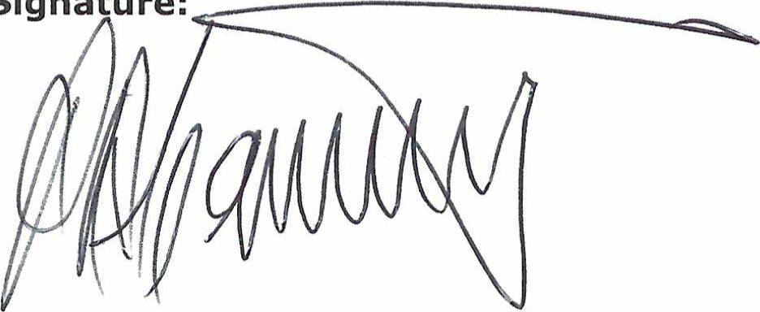  Signature: | Signature: 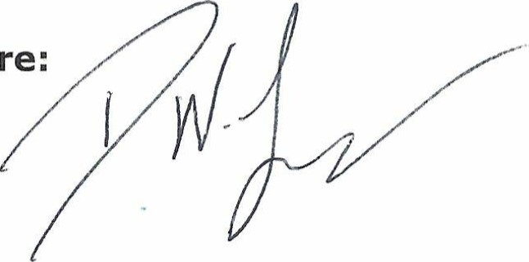
Date: 15/06/2026 | Date: 15/06/2026

Independent Examiner’s Report

I report on the accounts of the charity for the year ended 31 December 2024 which are set out on pages 31 to 47.

Respective responsibilities of trustees and examiner
The charity’s trustees are responsible for the preparation of the accounts in accordance with the terms of the Charities and Trustee Investment (Scotland) Act 2005 ("the 2005 Act") and the Charities Accounts (Scotland) Regulations 2006 (as amended) ("the 2006 Regulations"). The trustees consider that the audit requirement of Regulation (10)(1)(a)-(c) of the 2006 Regulations does not apply.

It is my responsibility to examine the accounts under section (44)(1)(c) of the 2005 Act and to state whether particular matters have come to my attention.

Basis of independent examiner's statement
My examination is carried out in accordance with Regulation 11 of the 2006 Regulations. An examination includes a review of the accounting records kept by the charity and a comparison of the accounts presented with those records. It also includes consideration of any unusual items or disclosures in the accounts and seeks explanations from the trustees concerning any such matters. The procedures undertaken do not provide all the evidence that would be required in an audit, and consequently I do not express an audit opinion on the view given by the accounts.

Independent examiner's statement
In connection with my examination, no matter came to my attention:-

- which gives me reasonable cause to believe that in any material respect, the requirements
- to keep accounting records in accordance with section 44(1)(a) of the 2005 Act and Regulation 4 of the 2006 Regulations, and
- to prepare accounts which accord with the accounting records and comply with Regulation 8 of the 2006 Regulations
have not been met, or

- to which, in my opinion, attention should be drawn in order to enable a proper understanding of the accounts to be reached.

Neil Mackinnon
Arm in Arm Accounting
Chartered Accountants
Alloa Business Centre
The Whins
Alloa
FK10 3SA

Signed: 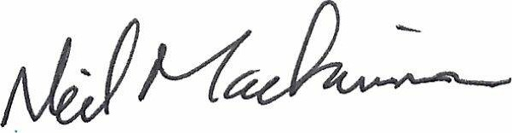

Statement of Financial Activities
 |  |  | Note | Unrestricted Funds |  | Restricted Funds |  | Total Funds |  | Total Funds
 |  |  |  |  |  |  |  | 2025 |  | 2024
 |  |  |  | £ |  | £ |  | £ |  | £
Income
 | Grants and donations |  | 3 | 138,434 |  | 177,417 |  | 315,851 |  | 343,810
 | Income from charitable activities |  | 4 | 60,405 |  | - |  | 60,405 |  | 47,805
 | Investment income |  | 5 | 2,785 |  | - |  | 2,785 |  | 3,650
Total income |  |  |  | 201,624 |  | 177,417 |  | 379,041 |  | 395,265
Expenditure
 | Cost of raising funds |  | 6 | 479 |  | - |  | 479 |  | 2,008
 | Expenditure on charitable activities |  | 7 | 196,120 |  | 196,092 |  | 392,212 |  | 372,788
 | Charitable grants paid |  | 8 | - |  | - |  | - |  | 15,972
Total expenditure |  |  |  | 196,599 |  | 196,092 |  | 392,691 |  | 390,768
Net income and net movement in funds for the year after transfers |  |  |  | 5,025 |  | (18,675) |  | (13,650) |  | 4,497
Reconciliation of funds
Total funds brought forward |  |  |  | 64,578 |  | 77,336 |  | 141,914 |  | 137,417
Total funds carried forward |  |  |  | 69,603 |  | 58,661 |  | 128,264 |  | 141,914

The results relate wholly to continuing operations. There are no unrecognised surpluses or deficits in the current year.

The notes on pages 34 to 47 form part of these accounts.

Statement of Financial Position

 |  | Note |  | 2025 |  | 2024
 |  |  |  | £ |  | £
Tangible assets |  | 14 |  | 5,249 |  | 6,998
Intangible assets |  | 15 |  | 2,682 |  | 3,888
Total non-current assets |  |  |  | 7,931 |  | 10,886
Current assets
Receivables |  | 16 |  | 2,988 |  | 2,988
Cash at bank and in hand |  |  |  | 138,690 |  | 149,825
Total current assets |  |  |  | 141,678 |  | 152,813
Liabilities
Payables due within one year |  | 17 |  | (21,345) |  | (21,785)
Net current assets |  |  |  | 120,333 |  | 131,028
Net assets |  |  |  | 128,264 |  | 141,914
The funds of the charity:
Unrestricted income funds |  | 18 |  | 69,603 |  | 64,578
Restricted income funds |  | 18 |  | 58,661 |  | 77,336
Total charity funds |  |  |  | 128,264 |  | 141,914

These accounts were approved by the trustees on 08.06.2026 and signed on their behalf by:

Name: Paul Cassidy | Name: David Carson
Position: Chair of Trustees | Position: Treasurer
Signature:  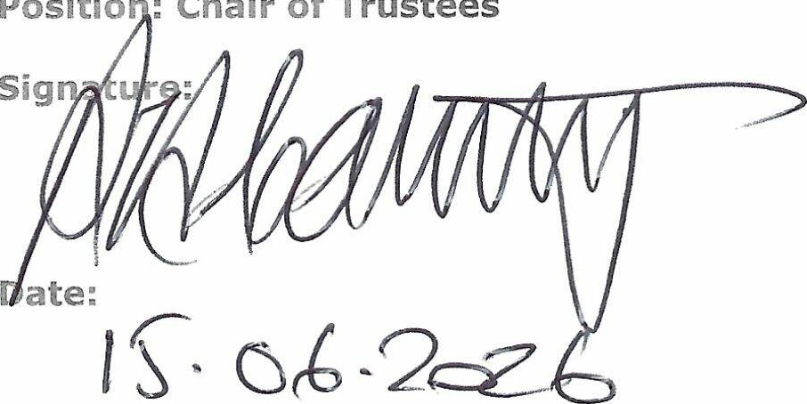 | 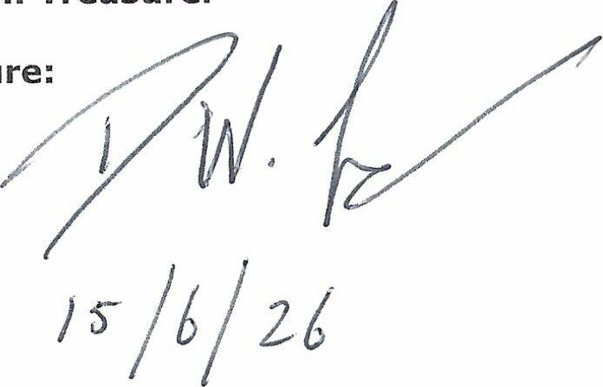  Signature:
Date: | Date:

The notes on pages 34 to 47 form part of these accounts.

Statement of Cash Flows

 |  | Note |  | 2025 |  | 2024
Cash (used in)/generated from operating activities |  | 20 |  | (13,920) |  | 8,337
Cash flows from investing activities:
Purchase of tangible fixed assets |  |  |  | - |  | -
Purchase of intangible fixed assets |  |  |  | - |  | -
Interest income |  |  |  | 2,785 |  | 3,650
Cash generated from investing activities |  |  |  | 2,785 |  | 3,650
(Decrease)/increase in cash and cash equivalents in the year |  |  |  | (11,135) |  | 11,987
Cash and cash equivalents at the beginning of the year |  |  |  | 149,825 |  | 137,838
Total cash and cash equivalents at the end of the year |  |  |  | 138,690 |  | 149,825

The notes on pages 34 to 47 form part of these accounts.

Notes to the Accounts
- Accounting Policies
The principal accounting policies adopted, judgements and key sources of estimation uncertainty in the preparation of the financial statements are as follows:

a) Basis of preparation:
The financial statements have been prepared in accordance with Accounting and Reporting by Charities: Statement of Recommended Practice applicable to charities preparing their accounts in accordance with the Financial Reporting Standard applicable in the UK and Republic of Ireland (FRS 102) (second edition effective 1 January 2019) - (Charities SORP (FRS 102)), the Financial Reporting Standard applicable in the UK and Republic of Ireland (FRS 102), the Charities and Trustee Investment (Scotland) Act 2005 and the Charities Accounts (Scotland) Regulations 2006 (as amended). Town Break SCIO meets the definition of a public benefit entity under FRS 102. Assets and liabilities are initially recognised at historical cost or transaction value unless otherwise stated in the relevant accounting policy note. The accounts have been prepared in pounds sterling, the functional currency of the charity, and are rounded to the nearest pound.

b) Going concern basis:
The trustees are satisfied that the charity is a going concern. The accounts are prepared on the going concern basis.

c) Income:
Income is recognised when the charity has entitlement to the funds, any performance conditions attached to the items of income have been met, it is probable that the income will be received and the amount can be measured reliably. Income from government and other grants, whether ‘capital’ grants or ‘revenue’ grants, is recognised when the charity has entitlement to the funds, any performance conditions attached to the grants have been met, it is probable that the income will be received and the amount can be measured reliably and is not deferred. Income received in advance of a fundraising event is deferred until the criteria for income recognition are met.

d) Donated services, facilities and assets:
Donated professional services, facilities and assets are recognised as income when the charity has control over the item, any conditions associated with the donated item have been met, the receipt of economic benefit from the use by the charity of the item is probable and that economic benefit can be measured reliably. In accordance with the Charities SORP (FRS 102), general volunteer time is not recognised. On receipt, donated professional services, facilities and assets are recognised on the basis of the value of the gift to the charity which is the amount the charity would have been willing to pay to obtain services or facilities of equivalent economic benefit on the open market; a corresponding amount is then recognised in expenditure in the period of receipt.

e) Interest receivable:
Interest on funds held on deposit is included when receivable and the amount can be measured reliably by the charity; this is normally upon notification of the interest paid or payable by the Bank.

f) Fund accounting:
Unrestricted funds are available to spend on activities that further any of the purposes of the charity. Designated funds are unrestricted funds of the charity that the trustees have decided at their discretion to set aside to use for a specific purpose. Restricted funds are donations which the donor has specified are to be solely used for particular areas of the charity’s work. The purposes of the funds are shown in Note 17.

g) Expenditure:
Expenditure is recognised once there is a legal or constructive obligation to make a payment to a third party, it is probable that settlement will be required and the amount of the obligation can be measured reliably. The charity is not registered for VAT; consequently, expenditure is stated inclusive of irrecoverable VAT.

Notes to the Accounts (cont’d)

h) Allocation of governance costs:
Governance costs comprise those costs incurred for the independent examination of the accounts and the costs associated with trustees’ meetings and the Annual General Meeting. The basis on which governance costs have been allocated are set out in note 10.

i) Operating leases:
The charity classifies the rental of office premises as an operating lease. Rental charges are charged on a straight line basis over the term of the lease.

j) Tangible fixed assets:
Individual fixed assets costing £1,000 or more are capitalised at cost and are depreciated over their estimated useful economic lives on a straight line basis as follows:

Leasehold improvements: up to 5 years (remaining length of lease)
Office equipment: 4 years

k) Intangible fixed assets:
Intangible fixed assets costing £1,000 or more are accounted for at cost and are amortised over their expected useful economic lives of 5 years on a straight line basis.

l) Receivables:
Trade and other receivables are recognised at the settlement amount due after any discounts offered. Prepayments are valued at the amount prepaid net of any discounts due.

m) Cash at bank and in hand:
Cash at bank and cash in hand includes cash and short term access bank deposit balances.

n) Creditors, accrued charges and provisions:
Creditors and provisions are recognised where the charity has a present obligation resulting from a past event that will probably result in the transfer of funds to a third party and the amount due to settle the obligation can be measured or estimated reliably. Creditors and provisions are normally recognised at their settlement amount after allowing for any discounts due. Accrued charges are valued at their estimated settlement amount.

o) Financial instruments:
The charity only has financial assets and financial liabilities of a kind that qualify as basic financial instruments. Basic financial instruments are initially recognised at transaction value and subsequently measured at their settlement value.

p) Taxation:
The charity is not subject to corporation tax on its charitable activities. The charity has no other activities that would be subject to taxation.

The charity is not registered for VAT. Input VAT is therefore not recoverable on purchases and is written off in the same category of expenditure as the net cost.

q) Pensions:
Employees of the charity are entitled to join the Nest pension scheme operated by the Nest Corporation, which reports to Parliament. Employees are automatically enrolled into the scheme unless they have exercised their right to opt out of scheme membership. The scheme is accounted for as a defined contribution scheme. The employer’s contributions made to the scheme were 3% of pensionable pay, with employees contributing at least 5% of pensionable pay. The Trustees are satisfied that any foreseeable change in employer’s contributions can be budgeted for without detriment to the Charity’s ongoing activities.

Notes to the Accounts (cont’d)

2. Legal Status
The charity is a Scottish Charitable Incorporated Organisation (SCIO) and has no share capital.

3. Income from donations and legacies
3(a) Analysis of grants by funder and type
Funder |  | Unrestricted Funds |  | Restricted Funds |  | 2025 |  | 2024
 |  | £ |  | £ |  | £ |  | £
General fund |  | - |  | - |  | - |  | 500
Stirling Council |  | 51,726 |  |  |  | 51,726 |  | 83,099
Community Fund |  | - |  | 66,666 |  | 66,666 |  | 66,667
Falkirk Health & Social Care Partnership |  | - |  | 33,751 |  | 33,751 |  | 62,321
Falkirk @Home |  | - |  | 25,000 |  | 25,000 |  | 25,000
CVS Falkirk |  | - |  | 20,000 |  | 20,000 |  | 10,000
UKSPF Falkirk |  | - |  | 5,000 |  | 5,000 |  | -
UKSPF Stirling |  | - |  | 7,000 |  | 7,000 |  | -
Agnes Hunter Trust |  | - |  | 15,000 |  | 15,000 |  | 10,000
Foundation Scotland |  | - |  | 5,000 |  | 5,000 |  | 5,000
Garfield Weston |  | 30,020 |  | - |  | 30,020 |  | -
McLay Dementia |  | 15,000 |  | - |  | 15,000 |  | -
Robert McAlpine Foundation |  | 7,500 |  | - |  | 7,500 |  | 7,500
Hugh Fraser Foundation |  | 50 |  | - |  | 50 |  | 5,000
Souter Trust |  | 3,000 |  | - |  | 3,000 |  | 3,000
YPI |  | 2,500 |  | - |  | 2,500 |  | 3,000
Agnes Watt |  | - |  | - |  | - |  | 450
Yardi |  | - |  | - |  | - |  | 900
Awards for All |  | - |  | - |  | - |  | 20,000
Communities Mental Health & Wellbeing Fund |  | - |  | - |  | - |  | 12,000
Arnold Clark |  | - |  | - |  | - |  | 1,000
Callander Hydro |  | - |  | - |  | - |  | 4,500
Totals |  | 109,796 |  | 177,417 |  | 287,213 |  | 319,937

Notes to the Accounts (cont’d)

3(b) Summary analysis
 |  | 2025 |  | 2024
 |  | £ |  | £
Grants |  | 287,213 |  | 319,937
Donations |  | 28,638 |  | 23,873
 |  | 315,851 |  | 343,810

The analysis between unrestricted and restricted funds is as follows:
Unrestricted |  | 138,434 |  | 128,322
Restricted |  | 177,417 |  | 215,488
 |  | 315,851 |  | 343,810

The income from donations was £28,638 (2024:£23,873) all of which was unrestricted. In accordance with FRS102 and the Charities SORP (FRS102) the economic contribution of general volunteers is not recognised in these accounts.

4. Income from charitable activities

 |  | Unrestricted funds |  | Unrestricted funds
 |  | 2025 |  | 2024
 |  | £ |  | £
Fees for dementia services |  | 49,481 |  | 18,639
Fund raising |  | 5,703 |  | 16,888
Trading income |  | - |  | 6,615
Sundry income |  | 5,221 |  | 5,663
Total income from charitable activities |  | 60,405 |  | 47,805

5. Investment income
 |  | Unrestricted funds |  | Unrestricted funds
 |  | 2025 |  | 2024
 |  | £ |  | £
Interest received |  | 2,785 |  | 3,650

6. Cost of raising funds
 |  | Unrestricted funds |  | Unrestricted funds
 |  | 2025 |  | 2024
 |  | £ |  | £
Cost of raising funds |  | 479 |  | 2,008

Notes to the Accounts (cont’d)

7. Analysis of expenditure on charitable activities
 |  | 2025 |  | 2024
 |  | £ |  | £
Payroll costs |  | 313,285 |  | 291,172
Staff training |  | 600 |  | 46
Governance - Board expenses |  | 200 |  | 8
Governance - accountancy and examination |  | 960 |  | 780
Hall hire |  | 13,496 |  | 11,629
Activities - lunches for clients |  | 12,066 |  | 11,464
Activities - clients |  | 1,155 |  | 989
Activities - special events |  | 3,154 |  | 8,439
Transport |  | 885 |  | 487
Volunteer expenses |  | 1,848 |  | 1,857
Communications - telephone |  | 2,236 |  | 3,317
Communications - post |  | - |  | 54
Property - rent and rates |  | 16,973 |  | 15,375
Property - heat light power |  | 5,955 |  | 5,416
IT - expenditure |  | 9,443 |  | 11,226
Equipment expenditure |  | 831 |  | 824
Depreciation - leasehold improvements |  | - |  | 2,276
Amortisation - database software |  | 1,206 |  | 1,206
Equipment - depreciation |  | 1,750 |  | 1,750
Stationery |  | 1,542 |  | 700
Printing |  | 65 |  | 450
Sundry expenses |  | 4,562 |  | 3,324
Totals |  | 392,212 |  | 372,788

The analysis of unrestricted and restricted expenditure is as follows:

 |  | 2025 |  | 2024
 |  | £ |  | £
Unrestricted |  | 196,120 |  | 167,362
Restricted |  | 196,092 |  | 205,426
Totals |  | 392,212 |  | 372,788

Notes to the Accounts (cont’d)

8. Grant payable

 | 2025 |  | 2024
 | £ |  | £
Grant payable | - |  | 15,972

In 2024 the Charity jointly bid successfully for funding in partnership with Dementia Dunblane. The whole of the funding was paid to the Charity. The grant payable represents Dementia Dunblane’s share of the funding.

9. Summary analysis of expenditure and related income for charitable activities
The table below shows the cost of the main activities and the sources of income directly related to support those activities.
 |  | 2025 |  | 2024
 |  | £ |  | £
Costs |  | 387,062 |  | 368,106
Fee income |  | (49,481) |  | (18,639)
Direct grants |  | (177,417) |  | (215,488)
Donations |  | (28,638) |  | (23,873)
Governance costs (note 10) |  | 5,150 |  | 4,681
Net cost funded from other income |  | 136,676 |  | 114,787

10. Staff
 |  | 2025 |  | 2024
 |  | £ |  | £
Salaries |  | 244,226 |  | 231,742
Social security costs |  | 17,521 |  | 15,447
Pension costs |  | 7,734 |  | 7,246
Totals |  | 269,482 |  | 254,435

No employee was paid in excess of £60,000 (2024: nil).

The Trustees are not remunerated and no expenses were claimed during the year (2024: £nil). No Trustee received payment for professional or other services supplied to the charity (2024: £nil). The key management person is the Chief Officer. The remuneration of the Chief Officer was £39,312 excluding employer pension contributions.

The average monthly number of full time equivalent employees including casual and part time staff during the year was as follows:
 |  | 2025 |  | 2024
 |  | Number |  | Number
 |  | Full time equivalents |  | Full time equivalents
Management |  | 1.9 |  | 1.9
Administration |  | 1.0 |  | 1.1
Operational |  | 7.0 |  | 7.5
Governance |  | 0.1 |  | 0.1
Totals |  | 10.0 |  | 10.6

Notes to the Accounts (cont’d)

11. Governance costs
The charity identifies the direct costs associated with its governance function. Other costs relative to governance are allocated on a time basis. The total governance costs are apportioned to the charitable activities in note 7.

 |  |  |  |  |  | Basis of apportionment
Governance function |  | 2025 |  | 2024
 |  | £ |  | £
General governance costs |  | 200 |  | 8 |  | per invoices
Staff costs |  | 3,990 |  | 3,893 |  | allocation
Independent examiner's fees |  | 960 |  | 780 |  | estimated
Totals |  | 5,150 |  | 4,681

12. Related party transactions
In 2024 a trustee was a member of Stirling Council, which provided revenue grants totalling £83,099 to the Charity in 2024. The trustee retired from the Charity during 2024. There were no related party transactions in 2025.

13. Taxation
The charity is not liable to corporation tax or capital gains tax on its charitable activities.

The charity is not registered for VAT as its fees for services do not exceed the current threshold. Consequently, input VAT is not recoverable on expenditure.

14. Tangible assets
 |  | Leasehold improvements |  | Equipment |  | Total
 |  | £ |  | £ |  | £
Cost
At 1 January 2025 |  | 12,281 |  | 8,748 |  | 21,029
Additions |  | - |  | - |  | -
At 31 December 2025 |  | 12,281 |  | 8,748 |  | 21,029
Depreciation
At 1 January 2025 |  | 12,281 |  | 1,750 |  | 14,031
Charge for the year |  | - |  | 1,750 |  | 1,750
At 31 December 2025 |  | 12,281 |  | 3,499 |  | 15,780
Net book value
At 31 December 2025 |  | - |  | 5,249 |  | 5,249
At 31 December 2024 |  | - |  | 6,998 |  | 6,998

Notes to the Accounts (cont’d)

15. Intangible assets

 |  | Database
 |  | £
Cost
At 1 January 2025 |  | 6,300
Additions |  | -
At 31 December 2025 |  | 6,300
Amortisation
At 1 January 2025 |  | 2,412
Charge for the year |  | 1,206
At 31 December 2025 |  | 3,618
Net book value
At 31 December 2025 |  | 2,682
At 31 December 2024 |  | 3,888

16. Receivables

 | 2025 |  | 2024
 | £ |  | £
Prepayments | 2,988 |  | 2,988
Totals | 2,988 |  | 2,988

17. Payables due within one year

 |  | 2025 |  | 2024
 |  | £ |  | £
Untaken staff leave |  | 6,725 |  | 7,875
Taxation and social security |  | 6,284 |  | 6,348
Accruals |  | 2,736 |  | 1,294
Other payables |  | 5,599 |  | 6,268
Totals |  | 21,345 |  | 21,785

Notes to the Accounts (cont’d)

18. Analysis of charitable funds

Analysis of movements in unrestricted funds:
 |  | Balance at 1 January 2025 |  | Income |  | Expenditure |  | Transfer |  | Balance at 31 December 2025
 |  | £ |  | £ |  | £ |  | £ |  | £
General fund |  | 64,579 |  | 201,624 |  | (196,600) |  | - |  | 69,603
 |  | 64,579 |  | 201,624 |  | (196,600) |  | - |  | 69,603
Unrestricted funds |  | Description, nature and purpose of the fund
General fund |  | Unencumbered reserves after allowing for any designated funds.

Notes to the Accounts (cont’d)

18. Analysis of charitable funds (cont’d)

Analysis of movements in restricted funds:
 |  | Balance at 1 January 2025 |  | Income |  | Expenditure |  | Balance at 31 December 2025
 |  | £ |  | £ |  | £ |  | £
Agnes Hunter |  | - |  | 15,000 |  | (9,325) |  | 5,675
Awards for All |  | 10,903 |  |  |  | (10,470) |  | 433
Communities Mental Health & Wellbeing Fund |  | 12,000 |  | - |  | (11,940) |  | 60
Falkirk Health & Social Care Partnership |  | 695 |  | 33,751 |  | (34,225) |  | 221
Falkirk Round Table |  | 2,382 |  | - |  | (600) |  | 1,782
Inspiring Scotland |  | 1 |  | - |  | - |  | 1
Lintel Trust |  | 400 |  | - |  | (100) |  | 300
CVS Falkirk |  | 3,959 |  | 20,000 |  | (19,421) |  | 4,538
Falkirk @Home |  | 6,302 |  | 25,000 |  | (31,102) |  | 200
Foundation Scotland |  | 158 |  | 5,000 |  | (4,940) |  | 218
National Lottery Fund |  | 3,888 |  | - |  | (1,206) |  | 2,682
Arnold Clark |  | 1,798 |  | - |  | (450) |  | 1,348
Community Fund |  | 32,450 |  | 66,666 |  | (64,510) |  | 34,606
UKSPF Falkirk |  | - |  | 5,000 |  | (3,501) |  | 1,499
UKSPF Stirling |  | - |  | 7,000 |  | (3,702) |  | 3,298
Skipton Building Society |  | 2,400 |  | - |  | (600) |  | 1,800
 |  | 77,336 |  | 177,417 |  | (196,092) |  | 58,661

Notes to the Accounts (cont’d)

18. Analysis of charitable funds (cont’d)

Funds | Description, nature and purpose of the fund
Stirling Council | Unrestricted funding.
Foundation Scotland | Funding of development and delivery of services in the Clackmannanshire Local Authority area.
CVS Falkirk | Funding of development and delivery of Town Break at Home in the Falkirk Local Authority area.
Falkirk Health & Social Care Partnership | Funding towards Falkirk services
Bridge of Allan Round Table | Unrestricted
Falkirk @Home | Funding for delivery of services to clients at home in the Falkirk Local Authority area.
Arnold Clark | Unrestricted towards management salaries.
Mental Health & Wellbeing Fund | Funding of development and delivery of services mainly in the  Clackmannanshire and Local Authority area.
National Lottery Community Fund | Funding towards staff salaries: Service Coordinators delivering services, Operations Manager, hall hire, refreshments and activities.
Awards for All | Funding towards administrative staff salaries.
Agnes Hunter | Funding towards Service Co-ordinator salaries.
UKSPF Falkirk | Falkirk Services.
UKSPF Stirling | Stirling Services.
Callander Hydro | Restricted towards Callander Groups
Arnold Clark | Unrestricted
Hugh Fraser | Funding towards IT, Office Rent, Electricity Bill, Accountancy Bill, Telephone/Broadband, Staff Costs and Core Salaries.
Robert McAlpine | Funding towards IT, Rent, Arrow, Mentor & Core Salaries.
Souter Trust | Funding toward IT, Rent, Phones, Water and Electric.
Agnes Watt | Funding towards electricity.
Yardi | Unrestricted towards service delivery.
Youth Philanthropy Initiative | Unrestricted used towards mileage & volunteer expenses.
Garfield Weston | Unrestricted
McLay Dementia Trust | Unrestricted
The Stafford Trust | Unrestricted
Barrack Charitable Trust | Unrestricted

Notes to the Accounts (cont’d)

19. Analysis of net assets between funds

 |  | General fund |  | Restricted funds |  | Totals
 |  | £ |  | £ |  | £
Non-current assets |  | - |  | 7,931 |  | 7,931
Net current assets |  | 69,603 |  | 50,730 |  | 120,333
Totals |  | 69,603 |  | 58,661 |  | 128,264

20. Cash flow from operating activities

 |  | 2025 |  | 2024
 |  | £ |  | £
Net movement in funds |  | (13,650) |  | 4,497
Add depreciation and amortisation |  | 2,956 |  | 5,231
Deduct interest |  | (2,785) |  | (3,650)
Operating cash flow before movement in working capital |  | (13,479) |  | 6,078
(Decrease)/increase in payables |  | (441) |  | 2,259
Net cash generated from/(used in) operating activities |  | (13,920) |  | 8,337

21. Financial commitments

 |  | 2025 |  | 2024
 |  | £ |  | £
Amounts due:
Within one year |  | 15,013 |  | 8,679
Between one year and five years |  | 10,478 |  | 3,323
 |  | 25,490 |  | 12,002

Notes to the Accounts (cont’d)

22. Comparative Statement of Financial Activities

 |  |  |  | Unrestricted Funds |  | Restricted Funds |  | Total Funds
 |  |  |  |  |  |  |  | 2024
 |  |  | Note | £ |  | £ |  | £
Income
 | Grants and donations |  | 3 | 128,322 |  | 215,488 |  | 343,810
 | Income from charitable activities |  | 4 | 47,805 |  | - |  | 47,805
 | Investment income |  | 5 | 3,650 |  | - |  | 3,650
Total income |  |  |  | 179,777 |  | 215,488 |  | 395,265
Expenditure
 | Cost of raising funds |  | 6 | 2,008 |  | - |  | 2,008
 | Expenditure on charitable activities |  | 7 | 167,362 |  | 205,426 |  | 372,788
 | Charitable grants paid |  | 8 | 15,972 |  | - |  | 15,972
Total expenditure |  |  |  | 185,342 |  | 205,426 |  | 390,768
Net income and net movement in funds for the year |  |  |  | (5,565) |  | 10,062 |  | 4,497
Transfers |  |  |  | (67) |  | 67 |  | -
Net income and net movement in funds for the year after transfers |  |  |  | (5,632) |  | 10,129 |  | 4,497
Reconciliation of funds
Total funds brought forward |  |  |  | 70,210 |  | 67,207 |  | 137,417
Total funds carried forward |  |  |  | 64,578 |  | 77,336 |  | 141,914

23. Comparative Movement in Funds
 | Balance at 1 January 2024 |  | Income |  | Expenditure |  | Transfer |  | Balance at 31 December 2024
 | £ |  | £ |  | £ |  | £ |  | £
General fund | 70,210 |  | 179,777 |  | (185,342) |  | (67) |  | 64,579
 | 70,210 |  | 179,777 |  | (185,342) |  | (67) |  | 64,579

Unrestricted funds
General fund | Description, nature and purpose of the fund
 | Unencumbered reserves after allowing for any designated funds.

Notes to the Accounts (cont’d)

23. Comparative Movement in Funds (continued

Analysis of movements in restricted funds:
 | Balance at 1 January 2024 |  | Income |  | Expenditure |  | Transfer |  | Balance at 31 December 2024
 | £ |  | £ |  | £ |  | £ |  | £
Agnes Hunter | - |  | 10,000 |  | (10,000) |  | - |  | -
Awards for All | - |  | 20,000 |  | (9,097) |  | - |  | 10,903
Stirling Council Challenge Fund | (67) |  | - |  | - |  | 67 |  | -
Communities Mental Health & Wellbeing Fund | 10,000 |  | 12,000 |  | (10,000) |  | - |  | 12,000
Falkirk Health & Social Care Partnership | 4,766 |  | 62,321 |  | (66,392) |  | - |  | 695
Falkirk Round Table | 3,000 |  | - |  | (618) |  | - |  | 2,382
Inspiring Scotland | 1 |  | - |  | (1) |  | - |  | -
Inspiring Scotland | 1 |  | - |  | - |  | - |  | 1
Lintel Trust | 500 |  | - |  | (100) |  | - |  | 400
CVS Falkirk | - |  | 10,000 |  | (6,041) |  | - |  | 3,959
Falkirk @Home | - |  | 25,000 |  | (18,698) |  | - |  | 6,302
Callendar Hydro | - |  | 4,500 |  | (4,500) |  | - |  | -
Foundation Scotland | - |  | 5,000 |  | (4,842) |  | - |  | 158
National Lottery Fund | 5,094 |  | - |  | (1,206) |  | - |  | 3,888
Arnold Clark | 2,248 |  | - |  | (450) |  | - |  | 1,798
Community Fund | 38,665 |  | 66,667 |  | (72,882) |  | - |  | 32,450
Skipton Building Society | 3,000 |  | - |  | (600) |  | - |  | 2,400
Totals | 67,208 |  | 215,488 |  | (205,426) |  | 67 |  | 77,336

Our Thanks
Over the past year, the work of Town Break Dementia Support Services has been strengthened by the support, dedication and goodwill of many people. The progress we have made would not be possible without the collective effort of those who give their time, knowledge and encouragement to our organisation.

Our volunteers continue to play an important role in the life of Town Break. Their generosity, enthusiasm and willingness to help create welcoming spaces for the people who attend our services. The time they give so freely helps ensure our groups and activities remain supportive, engaging and enjoyable.

We are equally grateful to our staff team and Board of Trustees. Their commitment, experience and careful leadership guide the organisation and help ensure our services are delivered with compassion, professionalism and respect.

A special acknowledgement goes to the families who take part in our services. By sharing their experiences and trusting us to support them, they help shape how our work develops and improves. Their voices remain central to everything we do.

We also wish to recognise the individuals, trusts and organisations who support Town Break through donations and fundraising. Their generosity allows us to continue providing much needed services for people living with dementia and their unpaid carers across Forth Valley.

To everyone who has supported Town Break during the past year, whether through time, expertise, fundraising or encouragement, we offer our sincere thanks. Your support strengthens our work and helps us continue building a community where people affected by dementia feel understood, supported and connected.

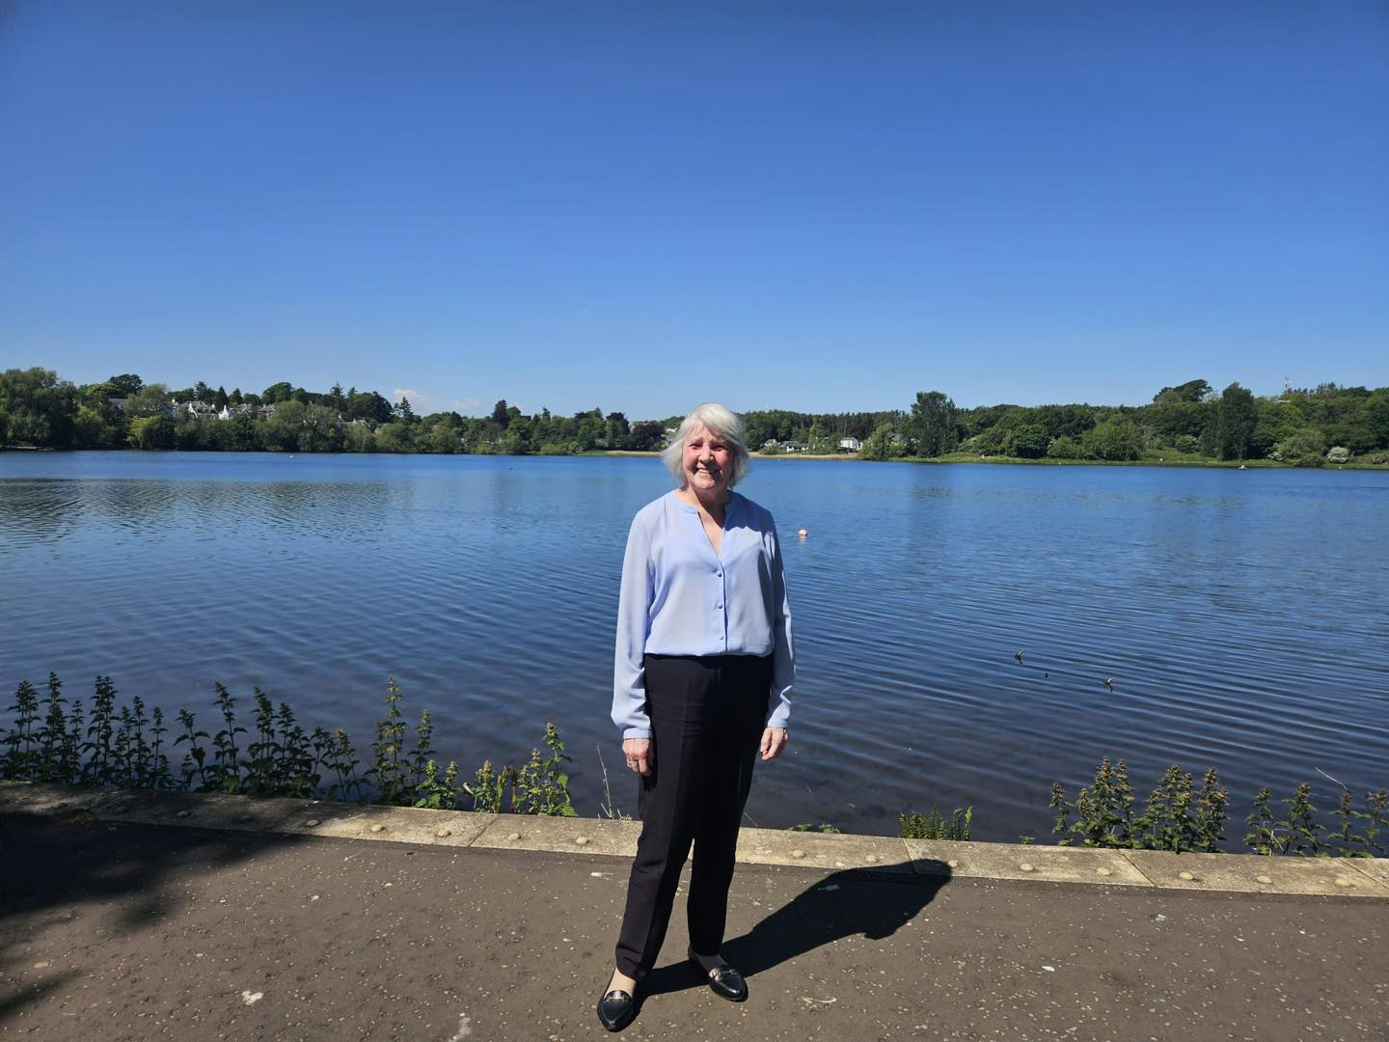

Donors
Stirling Council | Clackmannanshire & Stirling Health & Social Care Partnership
Falkirk Health & Social Care Partnership | CVS Falkirk
Agnes Hunter | Foundation Scotland.
St Ninians Old Parish Church | Souters
McLay Dementia Trust | The Stafford Trust
Barrack Charitable Trust | Youth Philanthropy Initiative
The Robert McAlpine Foundation | Brown Owl Solicitors
Local Primary and High schools | Forresters arms
The Friends of Logie Kirk | Stirling Classic Car Association

Partner Organisations
Art Link Central | Our Connected Neighbourhoods
The Sensory Centre | Stirling University
Dementia Services Development Centre | Stirling Carers Centre
Falkirk & Clackmannanshire Carers Centre | Tesco
Asda | Co-op
Waitrose | Morrison’s
Befriending Networks | Dementia Dogs
The Off Duty Nurses Choir | Drummond Software
Black Frog Technology Services | Bellfield
Stirling Voluntary Enterprise | CTSI
All Stirling Primary & Secondary Schools | Active Stirling
CVS Falkirk | The Inn at Torbrex
Royal Voluntary Service (RVS) | SCVO
Dementia Friendly Dunblane | Worcestershire University
Milton Football Club | Reach Out
Crawford Hall | King Robert Hotel
Mining Landscapes | North Parish Church
Dementia Trust | Banking Companies
Citizen Advise Bureau | Job Centre
Guide Dogs UK | Specsavers
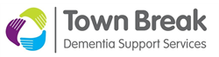
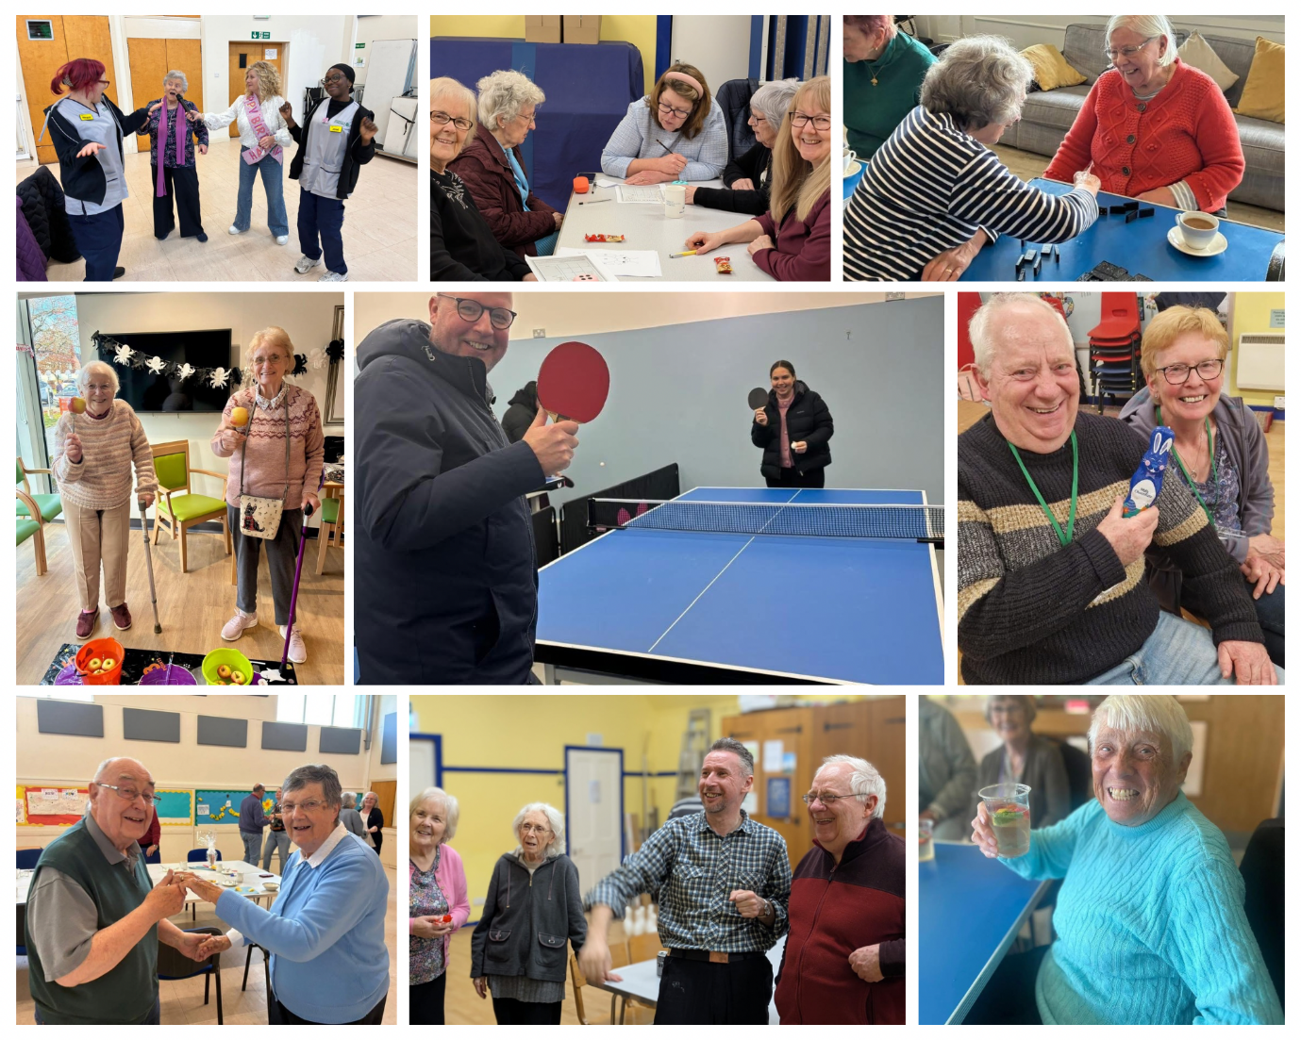

To inspire and enable people across Forth Valley to live well with dementia.

If you would like to learn more about Town Break Dementia Support Services, access support, or find ways to get involved, please get in touch.

Contact us:
Call: 01786 641 541
Email: admin@townbreak.org
Opening Hours: Monday to Friday, 9am until 5pm

Address:
1 Springkerse Road
Stirling
FK7 7SN

Patron:
Events Host and Radio Presenter, Gina McKie

Registered Scottish Charity No. SC020526
(A Scottish Charitable Incorporated Organisation)

