Annual Report for Elgin & District Men`s Shed.
Elgin & District Men`s Shed (EDMS) was set up in 2017 as a charity (Number SC048460) to provide recreational facilities and advance the social needs, Health and Wellbeing of men of all ages and backgrounds living in Elgin and surrounding areas by creating, developing and maintaining a facility, namely a Men`s Shed, offering opportunities for men in the Elgin area to meet and undertake creative, physical, purposeful and recreational activities of their choice, reducing social isolation of men in the area thus contributing to their physical and mental wellbeing. Developing the capacity of men in the Elgin area to share their skills and knowledge with others in the community.
Membership numbers have remained fairly static with a few retiring and a few new faces. A small nucleus of people attend most mornings and undertake projects of various types but mainly building wooden items that have been requested by people in the community. The formal meeting continues to take place on Thursday afternoons with anything between 15 and 20 attending.
Once again the year has been a busy one for a number of members who are using their different skills for the benefit of all who are involved in EDMS.
Many items have been built for members of society, community groups and businesses.
Various requests for our help have been received from out with Elgin but we are happy to help those people anyway.
Our first build this year was unusual. It was a large cage to allow a cat to leave the house by the kitchen window which took it into a large cage where it could play or do whatever cats do without the owner being worried about the cat straying or indeed being stolen as it was an expensive cat.
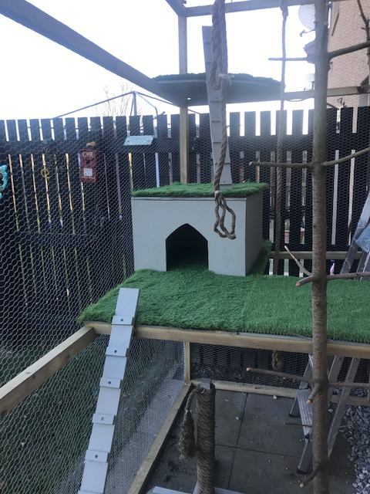
The owner was delighted and later asked for more playthings to be built inside.
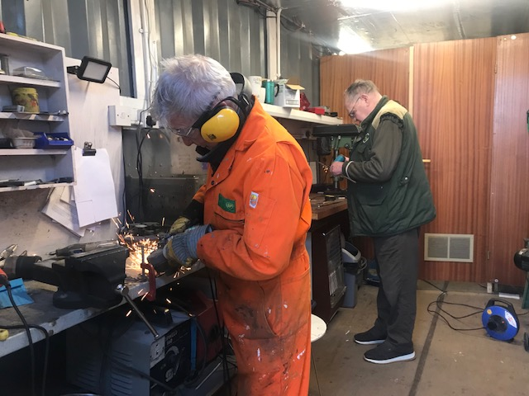
Behind our main building we have a steel container which is used by our metal fabricators. They too are busy and undertake some form of work daily. They have become adept at building novelty pieces from odds and ends of metal, nuts, bolts and pieces of flat bar and threaded rods. There was a problem with condensation so the roof of the container was lined with insulation which resolved the problem.
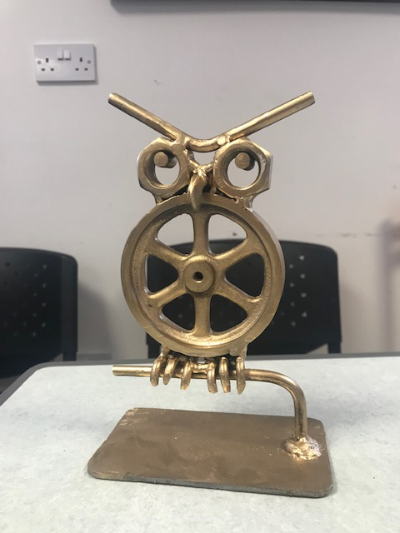

Here`s an example of innovative thinking by the guys in the metalworking unit.

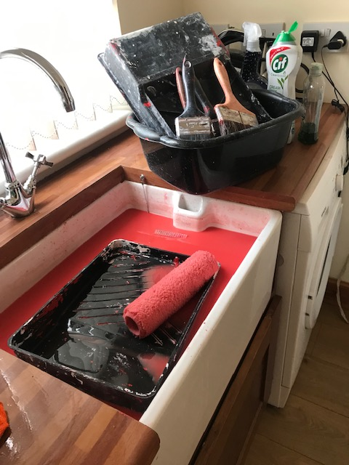

One of the jobs we were asked to undertake was to repair and repaint a beach hut at Findhorn. The repairs were done then the paint was duly slapped on.
It was tempting to simply bin the equipment afterwards. However, we like to be frugal where possible so one member volunteered to clean everything at home. That was rather messy!
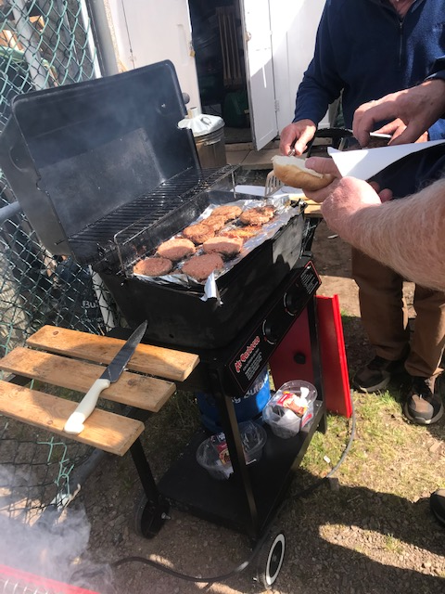

All work and no play makes Jack a dull boy.

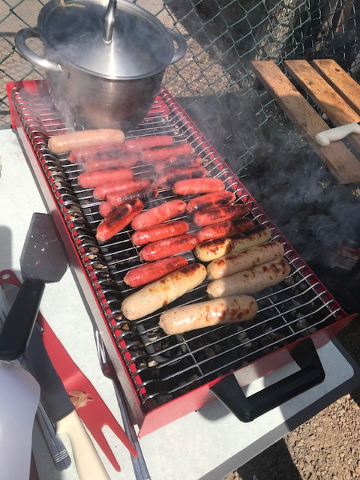
The sun came out so the members decided to hold a barbeque for themselves. Too much was cooked and it couldn`t be wasted so too much was then eaten! It was a fun afternoon enjoyed by all and we were joined by a neighbouring joiner/craftsman.
Another outing was to the local 10 pin bowling alley where it was discovered that EDMS has no particularly skilled bowlers.
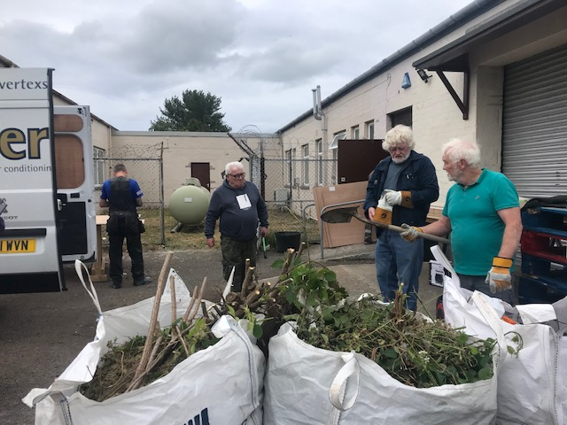
We were offered some unused timber from a local joiner who was moving to a new workshop. Storage of the timber was a problem but a neighbouring business allowed us to store the timber in the area behind his unit. EDMS members weeded and generally tidied the area first – which was hard work. Lots of rubbish was taken to the tip.

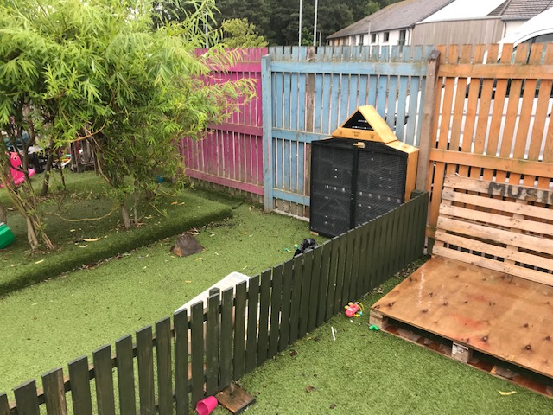

EDMS was asked if they could make a “bug hotel” for a local creche. One of our members used his imagination and produced something special which was very well received.
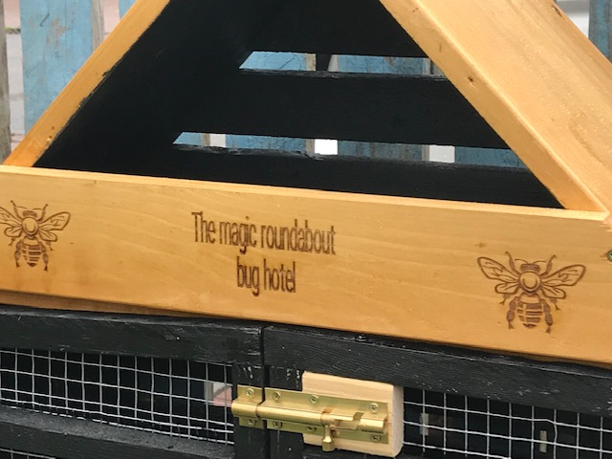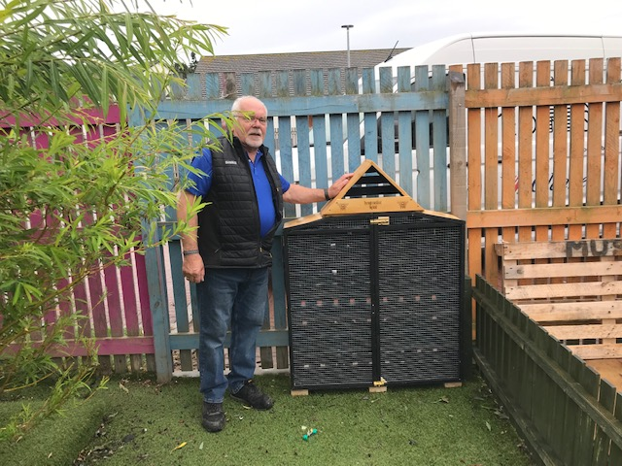

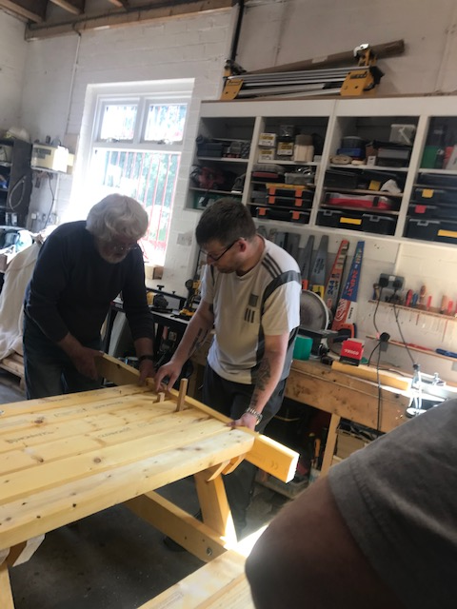
We were asked to build a couple of wheelchair friendly picnic benches for a local agency.
The members rose to the challenge as usual and produced a first-class product as expected.
Here they are obviously being fussy about squaring off the ends.
It was great to have a younger chap coming along and getting stuck in

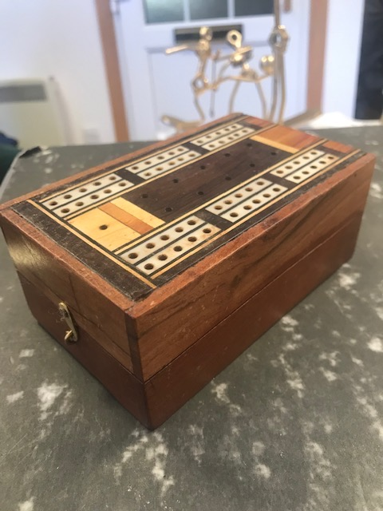
We do indeed get some unusual requests.
One such was when a gentleman arrived with a lovely old cribbage box which had had a corner badly chewed by a young puppy.
Could EDMS do anything with it?
Of course we can! Finished product shown here.
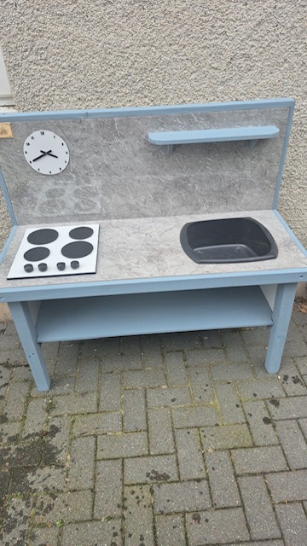
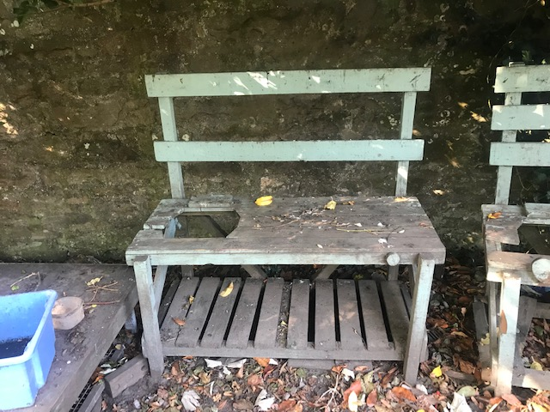

A local school sent us an SOS and could we please visit.
Off we went to find out what the problem was.
The problem was as the above photo shows – their mud kitchen had seen better days. Could we help?
In no time at all the replacement was ready to be delivered.
The school was delighted and we were delighted to have been able to help.
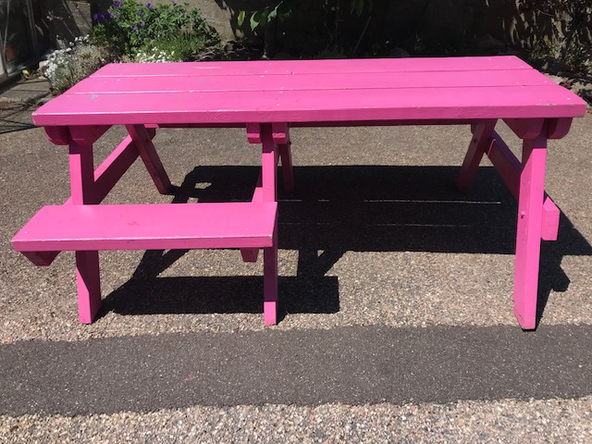
We had worked with Elgin BID on the odd occasion. However, this year saw the end of the BID. We were delighted to accept the donation of a wheelchair friendly picnic bench which was one of four scattered around the centre of Elgin for the use of anyone. The colour was a topic for conversation amongst the members for some time. However, the bench found a new permanent home at The Oaks and it exactly fitted the space that had been kept for seating after the new planters were built.

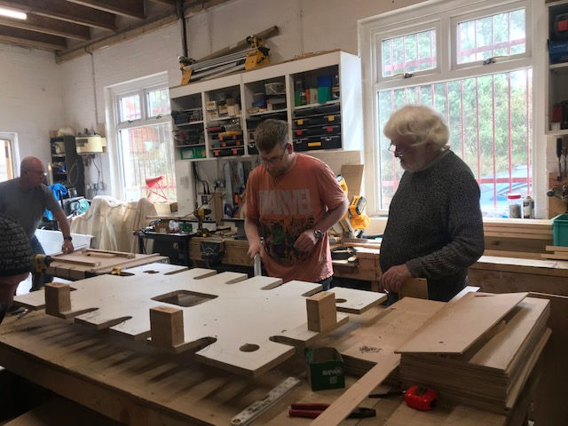
Last year we had been asked to build mink rafts for an agency looking to eradicate wild mink from our rivers. They came back this year asking for another lot. Our guys had it off to a “T” having built a jig previously. Space became a problem as these are quite bulky and take up lots of room when stored ready for collection. Our craftsmen coped as they always do.

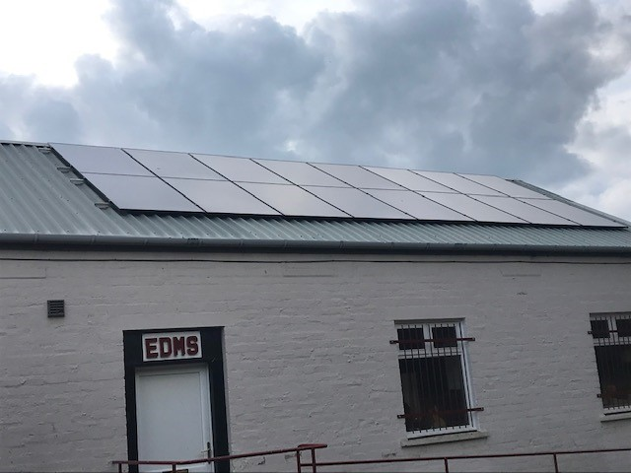

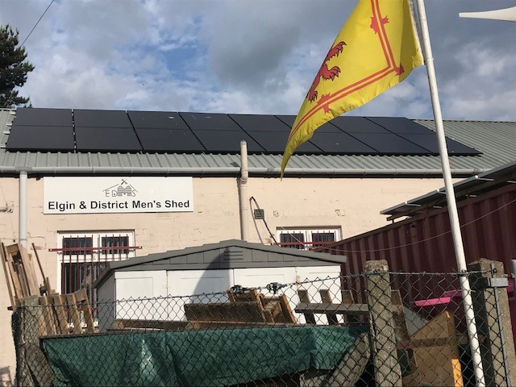
One of our best acquisitions this year was a solar/battery system. This was achieved through a Participatory Budgeting grant. We have a bank of 32 panels – sixteen front and sixteen back. These feed in to a large battery which in turn saves us a substantial amount on electricity charges.
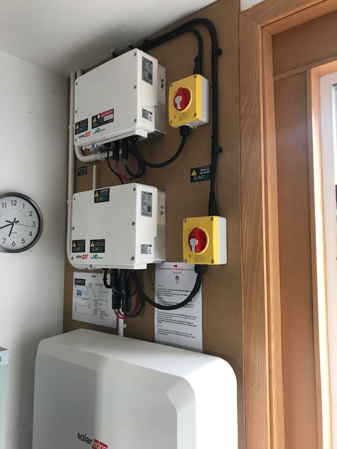
T

he battery and associated switch gear is situated just inside the main door. Although the battery is quite large it is in a handy position and causes no problems.

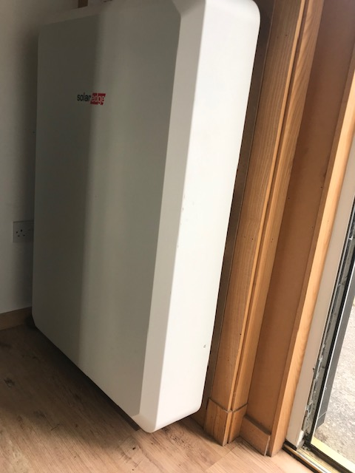

Another view of the fairly large battery. This charges via the panels on the roof and covers much of ther power used in the shed. Excess generated power gets sold through a company as it goes to the grid.

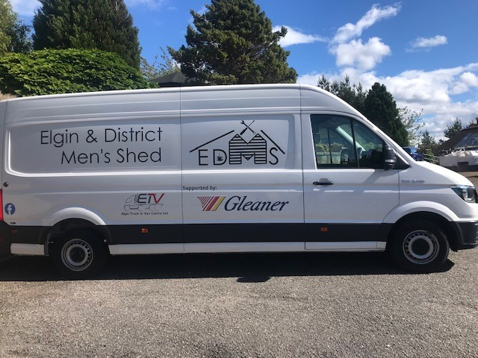
This year we were also delighted to have been awarded a grant to purchase our own van. This was brilliant as members were transporting tools and timber/metal in their own vehicle which wasn`t at all ideal. It`s a long wheelbase so seems cavernous inside.

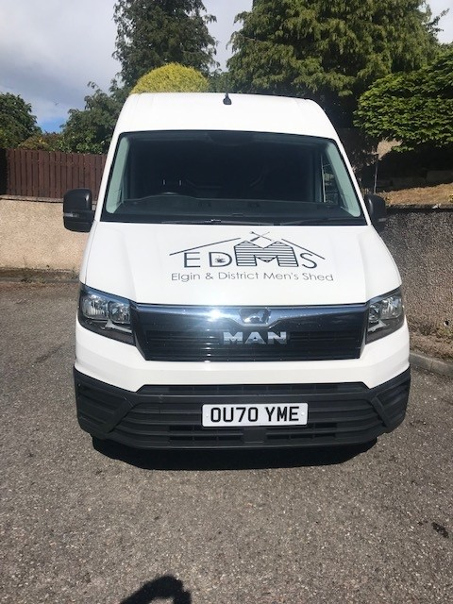
We were lucky enough to agree a psponsorship package with Gleaner of Elgin and Elgin Truck and Van agreed to pay our road tax each year. We`re still on the lookout for a sponsor to cob=ver our annual insurance costs.
Overall his year has been a good year for EDMS with lots going on and many improvements in our position and our ability to continue to run our shed..
We certainly hope this slight upward trend continues as we still have to pay the Local Authority £575.00 per month. Most “sheds” are lucky enough to get more or less free accommodation but we don`t.
However, we live in hope of finding somewhere a bit more spacious and cheaper.
(This report has been compiled to represent activities carried out by members of EDMS in 2024/25 but does not include every single activity)
Signed:-

P Weatherhead - Chair N More - Treasurer A Kennedy - Secretary
P. Weatherhead N More A G Kennedy

