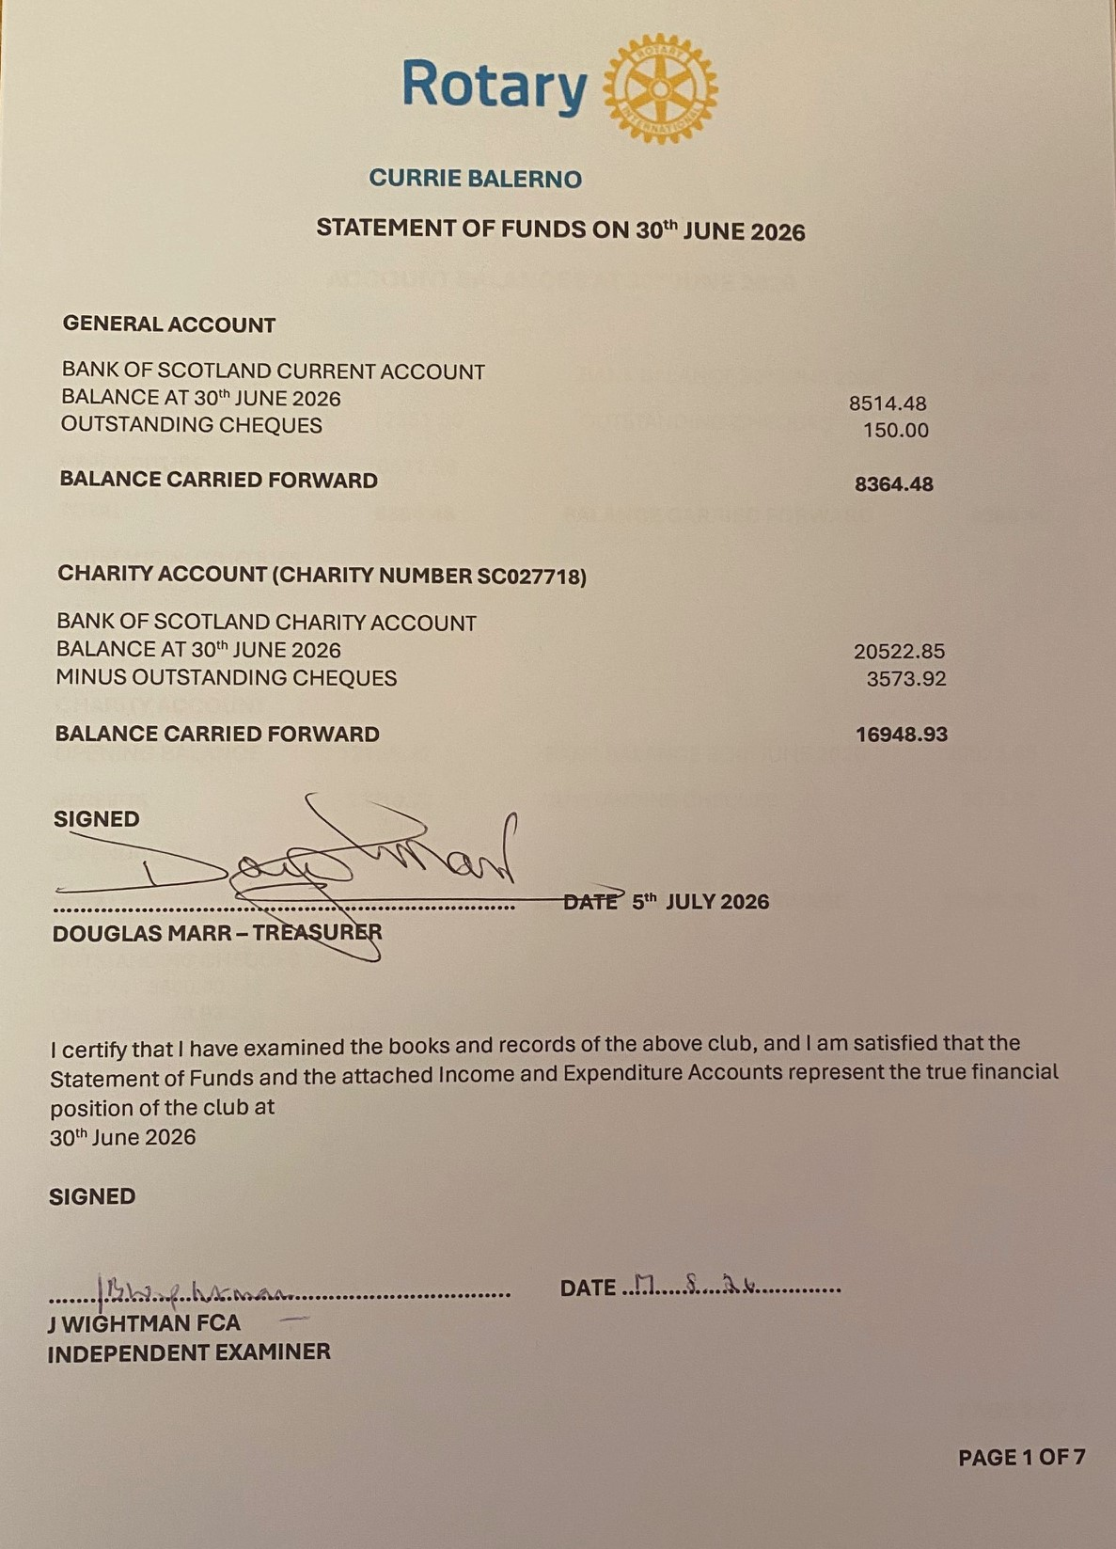

CURRIE BALERNO

ACCOUNT BALANCES AT 30th JUNE 2026
GENERAL ACCOUNT
OPENING BALANCE 6584.66 BANK BALANCE 30th JUNE 2026 8514.48
RECEIPTS 12351.50 OUTSTANDING CHEQUES 150.00
EXPENDITURE 10571.68
TOTAL 8364.48 BALANCE CARRIED FORWARD 8364.48
OUTSTANDING CHEQUES
Chq 268 150.00

CHARITY ACCOUNT
OPENING BALANCE 12125.42 BANK BALANCE 3Oth JUNE 2026 20522.85
RECEIPTS 23710.77 OUTSTANDING CHEQUES 3573.92

EXPENDITURE 18887.26

TOTAL 16948.93 BALANCE CARRIED FORWARD 16948.93

OUTSTANDING CHEQUES
Chq 274 3500.00
Chq 277 73.92

PAGE 2 OF 7

GENERAL ACCOUNTS 2025 / 26
12 months to 30th June 2026

INCOME | 2025 / 2026 | 2024 / 2025 | NOTES
Balance b/f | 6585 | 5889
Member’s Subs | 5107 | 5250
2026/27 Subs paid early | 1500
1 sub paid twice | 150 |  | See refund below
Social 10 06 26 | 760 |  | See separate sheet
Canal Trip 01 07 26 | 400
Christmas Meal | 1664 | 1860
Burn’s event | 1014
Social July 2025 | 72 | 648
RDA Visit meals |  | 330
Donation | 31
Grant for recruitment | 400 |  | Adverts / banners
Sale Rotary Clothing | 10
Missed Meals | 38
Teddies Balerno Gala | 90 | 90
Museum visit |  | 150
Correcting error
Paid to wrong account | 1115
Subtotal income | 12351 | 8328
TOTAL INCOME | 18936 | 14217
EXPENDITURE
RIBI SUBS | 3213 | 2583
DISTRICT SUBS | 887 | 819
Repay overpaid subs | 150
Summer Social 2026 | 410
Christmas meal | 1560 | 1621
Refunds Christmas Meal | 64 | 150
Burns Event | 931
Burns Gratuities / book tokens | 110
RDA Food Costs |  | 228
Summer Social 2025 | 40 | 439
Refunds 2025 social | 72
Guest meals | 828 | 722
Club running Costs | 637 | 721
AV equipment | 349 | -
Recruitment Adverts | 262
Museum Visit Costs |  | 180
Teddies Balerno Gala |  | 148
Bank Charges NEW | 64 | 21
Paid to right account | 995
TOTAL EXPENDITURE | 10572 | 7632
Available funds 30/06 | 8364 | 6585

PAGE 3 OF 7
CHARITY ACCOUNTS 2025 / 26 12 months to 30th JUNE 2026
INCOME | 2025 / 2026 | 2024/2025 | NOTES
Balance b/f | 12125 | 12967
Ukraine (PUSG) | 3701 | 3145
Ukraine Orphans - club | 785
Venezuela Earthquake | 1005
District Grants | 1310 | 1040
Environmental Grant |  | 1702
Council Grant (Planters) |  | 510
Casino Night | 2597
Gift Wrap | 2901 | 2951
Tree of Life | 3661 | 1950
HMRC Gift Aid | 2785 | 2444
Foundation | 1486 | 983
Member’s Meal account | 420 | 420
Farmers Market / Gyle | 1350 | 922
Donations | 540 | 604
Shelterbox | 490 | 100
Balerno Gala | 115 | 150
Christmas Raffle |  | 274
WH Toy appeal |  | 175
Blood Bikes |  | 60
Paid to wrong account | 242
Miscellaneous | 323
Subtotal income | 23711 | 17430
TOTAL INCOME | 35836 | 30397
EXPENDITURE
Ukraine | 2722 | 1800
Ukraine Orphanage from club | 900 | 500
Doddie Foundation | 3500 | 300
Pentland Community Chest | 1000 | 1605
Wester Hailes Food Bank | 2620 | 1100
Community for Food |  | 1072
End Polio Now | 1150 | 1150
Currie flowers / Planters etc. | 354 | 847
Lend with Care |  | 600
Marie Curie ToL project | 250 | 2200
Foundation | 1668 | 778
Retina UK | 250 | 250
Woodland Trust | 50
Edinburgh Children’s Hospital | 1500
Edinburgh Linus Group | 300
Octopus for a Preemie | 300
Shelterbox | 750
Rotary Club of Musselborough | 150
Youth Awards | 400 | 1430
Youth Vision |  | 1040
Youth Grants Dig Deep |  | 500
Balerno Gala | 227
RDA |  | 200
Blood Bikes |  | 200
St John’s |  | 200
Waves Project |  | 200
Repayment District Advance |  | 2015
Charity Expenses | 338 | 285
Bank Service charges | 94
Correcting pay ins wrong a/c | 364
TOTAL EXPENDITURE | 18887 | 18272
Available funds 31/06 | 16949 splits  PUSG 7193  CLUB 9756 | 12125 splits  PUSG 6214  CLUB 5911
Pentland Ukrainian Support Group (PUSG) is under the umbrella of The Rotary Club of Currie Balerno Trust Fund
Pentland Community Chest (PCC) is jointly managed with Balerno Village Trust (BVT) registered charity SC043318
PAGE 4 OF 7


PENTLANDS UKRAINIAN SUPPORT GROUP
SUMMARY FINANCIAL INFORMATION to 30/06/2026
INCOME / EXPENDITURE | 2025 / 26 | 2024 / 25 | NOTES
Balance b/f | 6214 | 4909
Donations via
Direct Debits | 1520 | 1500
Grant Refugee Festival June 26 | 750
CB News sponsorship | 500
Anderson / Donellan sponsorship | 100
Festival of Europe |  | 267
Cash Christmas Event | 210 |  | Money raised for Odessa Orphanage
Sum Up Christmas event | 249 |  | Money raised for Odessa Orphanage
Collection boxes Christmas Event | 140 |  | Money raised for Odessa Orphanage
Sum up donations other events | 82 | 27
St Cuthberts |  | 930
Our Lady (Currie) |  | 323
Other donations | 20 | 40
Collection Boxes May & June 26 | 130 | 18 | 55 and 75 respectively
INCOME | 3701 | 3105
TOTAL inc. Brought forward | 9915 | 8014
EXPENDITURE
Children’s Orphanage Odessa | 600 | 500
Mission of Innocents UK |  | 300
AUGB School Pro100 |  | 300
Transport
Vouchers
Children’s Summer Camp
CCC Hall hire 2026 events | 200
Meet and greet / Christmas | 436 | 267 | @ Currie Community Centre
Food costs etc May 26 event | 508 | 354
Costs Refugee Event June 26 | 978
Float |  | 79
TOTAL EXPENDITURE | 2722 | 1800
Available funds 30/06 | 7193 | 6214
ROTARY CLUB OF CURRIE BALERNO CHARITY TRUST - CHARITY NUMBER SC027718

PAGE 5 OF 7
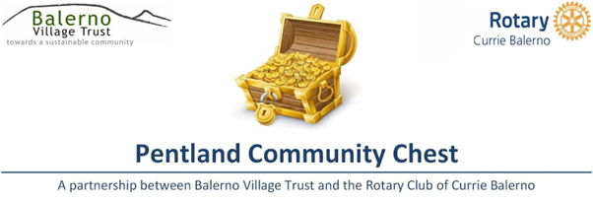

GRANTS TOTALING £9054 WERE MADE THROUGH THE COMMUNITY CHEST SCHEME
Maximum Individual Grant of £600
17 RECIPIENTS
51st Balerno Scout Group | Purchase of 4 heavy duty portable tables
Balerno and District Schools Pipe Band | Purchase of four plastic bagpipe chanters
BTC Productions | Purchase of branded T shirts and hoodies
Currie Football Club | 2012 Pumas: Purchase of tracksuit tops
Currie Primary School PTA | Purchase of four football goals and twenty-four playground balls
Currie Primary School PTA | Purchase of tables, chairs, water feature, lights, pots, compost and plants to create a quiet space
Dean Park Primary School Parent Council | Contribution towards purchase of nonfiction library books
Juniper Green Tennis Club | Contribution towards cost of Clubhouse repairs
Nether Currie Primary School PTA | Purchase of two (out of six) picnic benches
Pentland District Scouts | Purchase of coloured bibs, lanyards and a soup kettle for use at Pentjam 2026 and other Scout events
Pentlands Men's Shed | Purchase of used wood lathe and associated personal protective equipment
Ravelrig Riding for the Disabled | Purchase of 3 equine riding mirrors
Ravelrig Riding for the Disabled | Purchase of horse clippers
The Christopher Cowe Memorial Fund | Purchase of Banner stands, branded feather flags, branded tablecloths and a popup waterproof gazebo
The Mill at St. Joseph's | Contribution towards a replacement refrigerated display unit
Wildfire Explorer Unit | Purchase of 2 Xenon UL plus 2-man tents
Youth Vision | Purchase of 8 hoodies, six short sleeved T-shirts, 6 Long sleeved T-shirts and some winter hats for use by volunteers
BALERNO VILLAGE TRUST - CHARITY NUMBER SC043318 CURRIE BALERNO ROTARY - CHARITY NUMBER SC027718


PAGE 6 OF 7
